**LA LIGA MATCH DATA SCRAPING AND ANALYSIS REPORT**

**Project Overview:**

* This project is a Python-based web scraper that collects match data for La Liga from the official website (fbref.com).   
  The data includes match details such as home/away teams, scores, xG (expected goals), attendance, and venue.
* The scraper utilizes libraries like Requests for HTTP requests, BeautifulSoup for HTML parsing, Pandas for data manipulation, and Matplotlib for visualizing match results.

**Scraping the Data:**

* To extract the match details, we first send an HTTP request to the La Liga schedule page using the Requests library.
* The response content is parsed using BeautifulSoup, where we identify the relevant table and loop through each row to extract match data.
* The data is then organized into a structured format using Pandas for further processing.

**Generating Insights & Visualizations:**

* Once the match data was collected, we focused on extracting the score and splitting it into home and away goals.
* The results were classified into three categories: Home Win, Away Win, and Draw.
* Using Matplotlib, a bar chart was created to visualize the count of each match result, providing insights into the distribution of wins and draws across the league.

**GitHub Repository:**

* You can find the code and other related project files in my GitHub repository at:

<https://github.com/AaronPatrick562004/OSTDS.git>

**Screenshot 1:** **Screenshot 2:**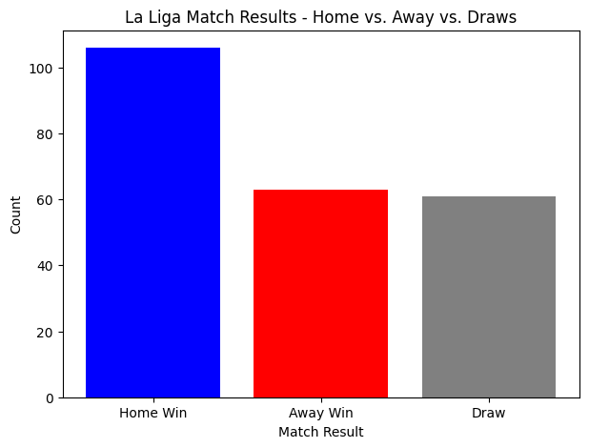

**Screenshot 3:**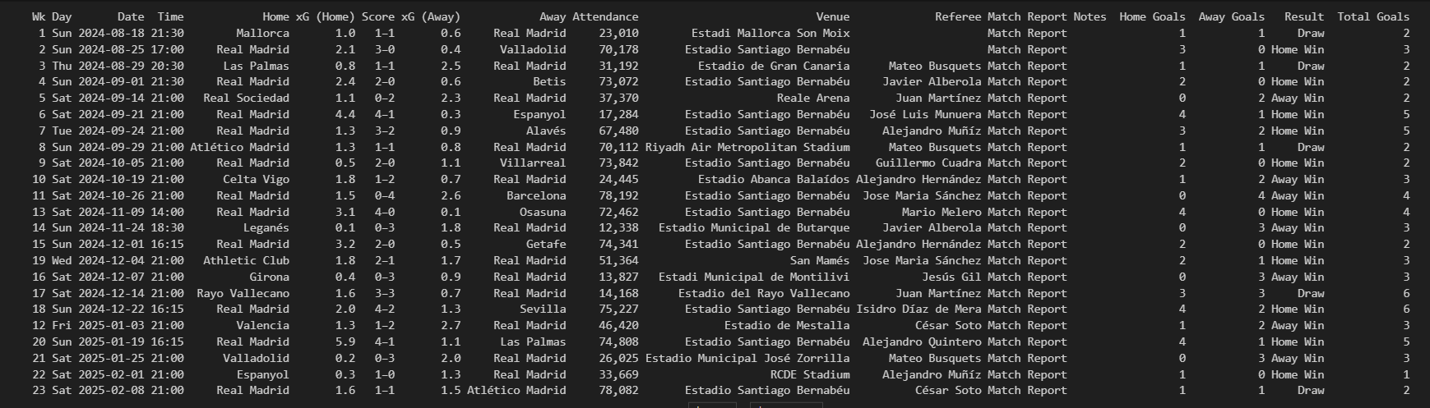

**Screenshot 4: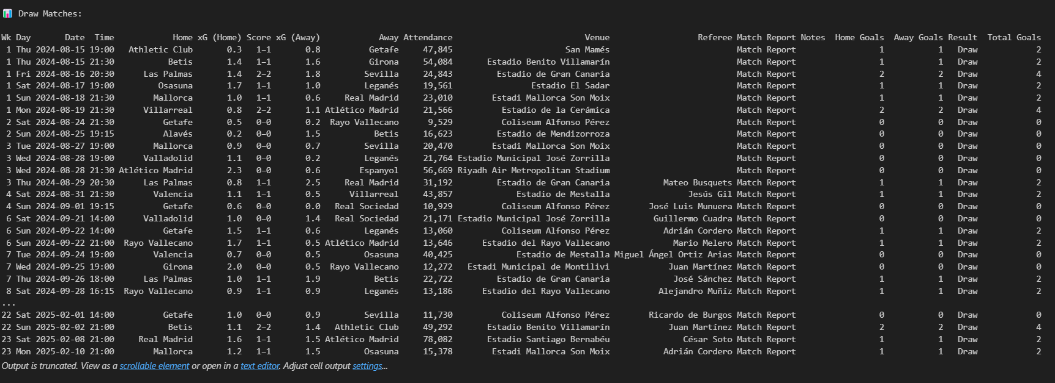 Screenshot 5:**