Vanishing Shadows

Design Team: Aaron Ratcliffe, Garrick White, Brannon Sibounheuang, Zachary Kauffman

# Game overview

## Game Concept

You are a ninja stealthily infiltrating heavily guarded locations without being caught. Your missions will either be theft of a certain object or the assassination of a target.

There will be no combat. You can only complete your missions by seeing the pattern in the guards patrols and sneaking past them.

## Genre

Stealth / Puzzle

## Target Audience

Gamers that enjoy a slower paced stealth game that relies more on thought and planning then on quick reaction and improvisation.

## Look and Feel

A japanese style with a somber theme and quiet music it will make you feel like you're in a place you don’t belong.

# Gameplay

## Gameplay

### Game Progression

Progression will be held on a by level basis. Players will make their way through levels that become progressively more difficult and complex. This will be seen through the number of guards level size and the number of obstacles they face.

### Mission Structure

Each mission will consist of several rooms through which the player will make their way to an end goal, the player will then have to make their way back out of the building where more guards have appeared.

### Puzzle Structure

The puzzles will vary per level and will increase in difficulty as the player progresses. Each stage will have two variations to it, the infiltration portion and the escaping portion. The levels are planned to be designed in such a way that while infiltrating the area, they have the opportunity to get a good look at the area and a grasp of any puzzles while the escape portion tests their ability to react and remember what they’ve learned previously. There will always be more guards present when the player is escaping then when they were infiltrating.

### Objectives

Steal or assassinate your target

Escape the level without being apprehended by the guards

Secondary objective of not being spotted by any guards

## Mechanics

### Movement in the game

Movement in game is done using the wasd keys, This may be switched to point and click movement for the IOS and Android port.

The player is able to move the character in all directions.

The player is also able to move along walls and in rafters depending on the level.

### Objects

Objects within the game will be static items. Certain objects will be interactable in that the player can use them to perform some action such as open or close a door.

### Actions

The player will be able to crouch, allowing them to hide behind the various objects in the game. As well as interact with various predetermined objects. These actions will have a clear result. for example interacting with a broken wall will allow you to climb it.

### Detection

Guards in each level will have a sight cone associated with them. This sight cone will be visible to the player, and if it collides with the player the guard will detect the player character. a visual will be displayed over the guard's head and the sight cone with turn red indicating to the player he has been spotted by the guard. The guard will then move to apprehend the player if the player remains within the guads sight cone. If the player leaves the sight cone the guard will move to the players last known position and search for them by looking around. If the guard spots the player again during this time the guard will resume chasing the player. If the player is able to stay out of sight of the guard for a certain period of time the guard will cease looking for the player and return to their previous patrol route. Guards will move slowly at first and speed up if the player remains in view.

### Apprehension

The player should be making attempts to avoid the guards within the level, in the case the player collides with the guard he is to be apprehended. The player's controls are disabled, then an animation depicting the player being killed occurs. The player will respawn at the last checkpoint after a ready check.

### Screenflow

For the most part, the game will flow together continuously with breaks only in between levels during level selection and when moving from the outside portion of a level to the inside, and vice versa. During the ones at the start of each level, the player will be given a small bit of information relating to the story or the place they are breaking into. The transitioning breaks from inside-outside will give the player hints or tips.

## Game Options

Options include being able to clear your save data.

## Replaying and Saving

Level progress will be stored between missions allowing the player to pick up where they left off. Players will be able to replay any previous level by selecting it in the level select screen available through the main menu.

# Story, Setting and Character

## Story and Narrative

The story follows after a mysterious ninja who’s name is not known. He takes on missions to retrieve valuable items and information with the hopes of restoring honour to his clan. Through his actions he hopes to restore his clan to its former glory.

## Game World

# Levels

## Puzzle Design

Puzzle designs are going to make use of three key mechanics, outside of stealth: Hiding/Crouching, climbing over walls, entering and navigating rafters. By hiding and crouching, the player is able to reduce their ability to be seen, and better avoid guards. Climbing walls and navigating rafters are able to be used to both avoid guards and also further progress through the puzzles in each level.

## Level Sections

Each level will be broken up into two sections with two variations of each.

On entering the level, the player will find themselves positioned outside of whatever location they are to be infiltrating, be a mansion, home, or military complex-like place. From there they need to work their way through whatever outside obstacles and guards there may be before they are able to sneak into the main building. Once there, they will navigate their way through the building until they find the object(s) they are trying to liberate. Once obtained, the player needs to backtrack out of the level to the starting point to successfully escape the level. While escaping, the player will be in the second variation of the level, where the layout and any traps remain the same, but additional guards are now present and the old ones may be on new security patterns based off of the level difficulty.

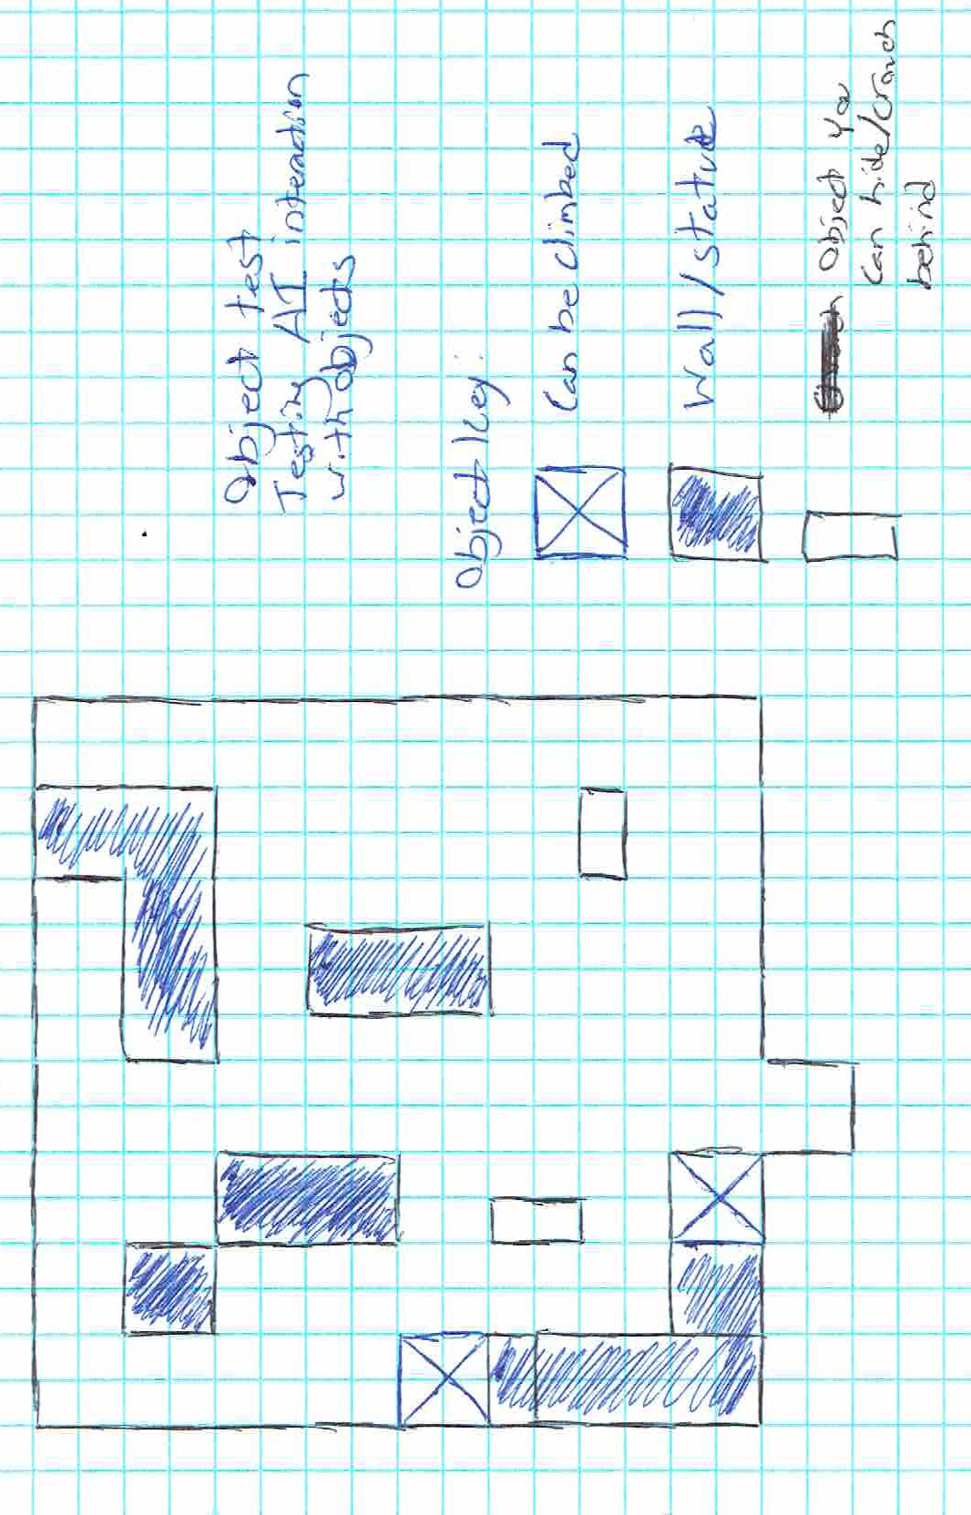

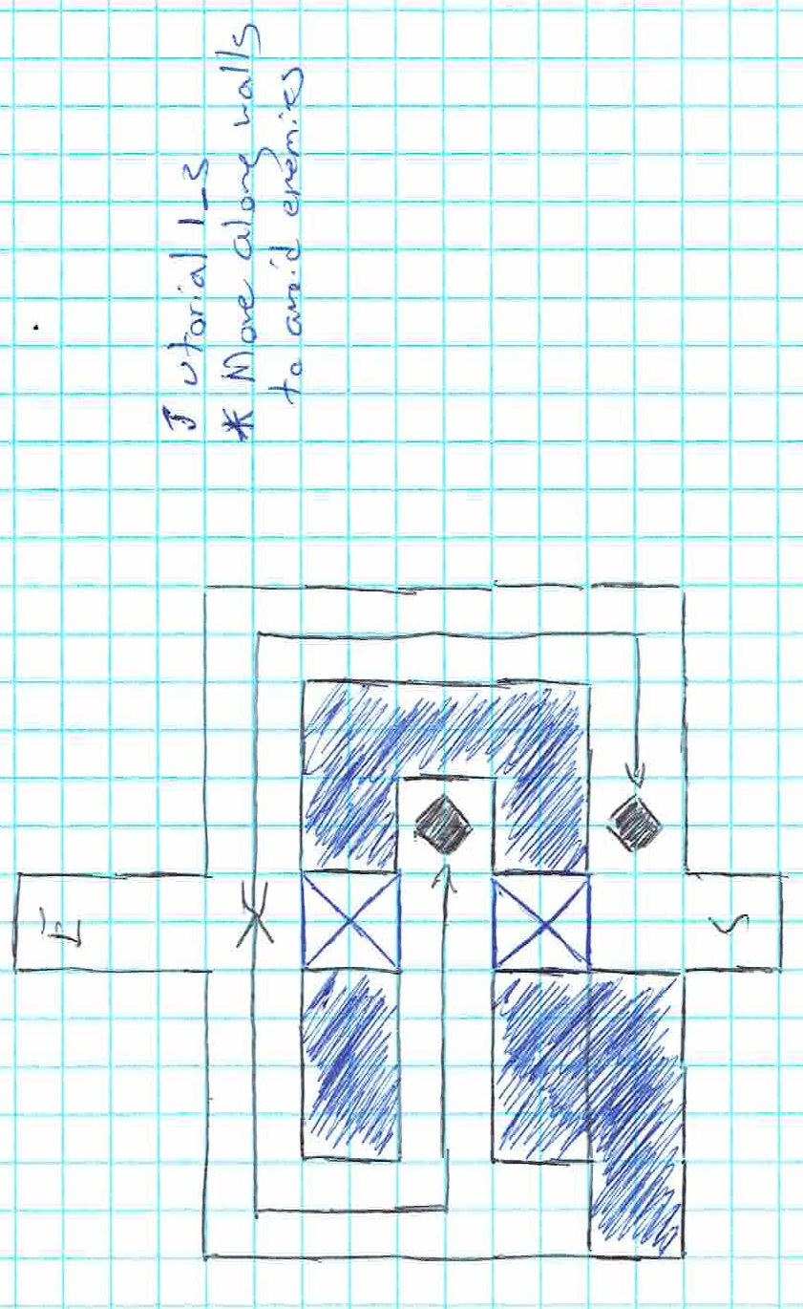

# Interface

## Visual System

The game will be viewed from a top down perspective, with a slight angle.

## Audio, music Sound Effects

Music will be Japanese in theme, sound effects will be used to indicate movement interaction as well as used with the guards to have an audio cue to show you’ve been found.

# Artificial Intelligence

## Guard AI

The guard will either follow a set patrol or stand guard. The guards will only deviate from their set actions if either an object in the environment distracts them or the player enters their sight cone. With the case of an environmental destruction or glimpsing the player, the guard will walk over to the object or the location where the player left their sight cone, and look around the immediate area for a short while. If the player remains in the sight cone for a short time the guard will begin to run at you and alert near by guards as well.

## Support AI

with the implementation of point and click to move the player's path will use the same A* pathfinding that the guards used to avoid collision while they are chasing you.

# Technical

## Target Hardware

Generic PC, Future port to IOS and Android.

## Development Software, and Game Engine

Used Unity for coding, design and Game Engine.

Used Blinder for models and animations.

Used Github for version control and to help with organization.