6/4/2020

aaron smmut

Technical Document

App Development for Mobile Devices

# Each page of the app

## Home page

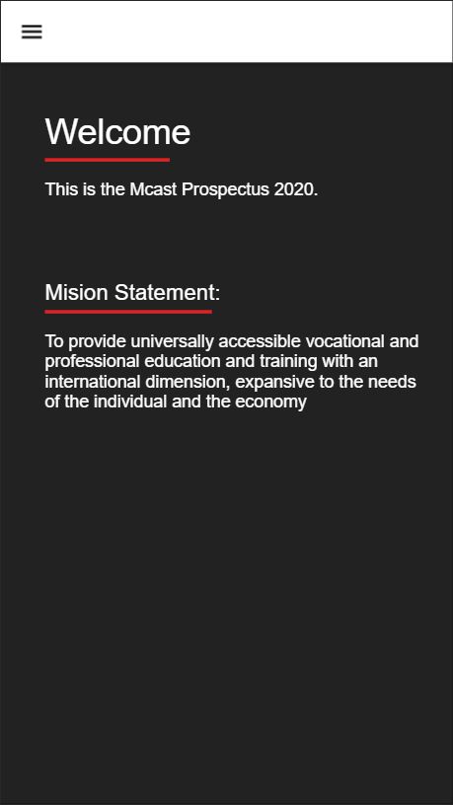

These is the first page that is loaded in the app, in it there will be a short message’s like the mission statement of the prospectus, or some small info to introduce the user to the prospectus. This page has simple UI interface, it also has a header that’s the same for every single page that has the navigation hamburger icon that when its pressed a side navigation bar shows, the only two pages that don’t have this icon are the courses list and course page since they have a back button instead.

The navigation bar will pop out from the left side of the phone and in it there will be listed all the pages and a respective icon that symbolizes that page next to the name. When the user presses a particular page it will load that page and also highlighted with a red colour as seen in the image on the right. To close the navigation the user just has to press outside the navigation where it’s a bit faded and the navigation bar will close, and to reopen it the user just has to click the hamburger icon on the header.

## About page

This page is the about page where in it there will be info about MCAST and the prospectus, where there is the lorem ipsum it would be changed into short description of the app. Also in the about there will be the Principal & CEO and the President messages of MCAST in short so that the reader isn’t board reading.

This page has an ionic slider where the user just has to swipe left and right rather then scrolling down. It also has the navigation button on the header for the user to go to other pages. This page can be also replicated to implement other information like the rules and regulation of MCAST.

## Contact page

This page will contain the contacts detail and a bit of information about them, in here users will find how to contact the cooperate services, support offices, career guidance, Agenzija Zghazagh Youth Club and more. So the title of contact will be replaced with the name of who your going to contact, the paragraph will have details on that contact, the email and phone are how you can contact them. This page information can be linked with a json file, from where it will get the info and show all the contacts in a slide form.

This page has a slide feature that instead of scrolling down the user swipes left or right to see the information. Also another feature it has is that when the user clicks the phone or telephone number it will dial that number in the phones dialler and call it and in the header there is the navigation icon to open the nav bar.

## Student Work page

In these page there will be information on a gallery collection of all the students works and also information on the ICA festival that the students of MCAST Mosta create. Where there is lorem ipsum can be change to the description of the gallery and the festival. When the button “show gallery” it will take the user to a page that has the title of the institute where the students came from and there will be a display using the ionic grid system to be displayed as seen on the image on the far right. Both pages are scrollable and in the gallery page there’s a back button that will take you to the previous page and a navigation icon on the students work page that will open the nav bar.

## Institutes page

In this page the user will find a list of buttons with all the institutes, each button has the institutes respective colour. When these buttons are pressed it will take the user into a different page with all the courses of that institute. This page is linked with json file where it gathers the information of the institute like name, colour and institute code. There’s also a navigation icon to open the nav bar like the other pages.

## Course List page

In these pages the user will find all the courses listed in the course that he or she selects, on top in the toolbar there will be a back button that will take the user back to the institute page. Next to the back button there will be the institutes code. Each course will be displayed in an ionic card where in it there will be an image of the course or it can have no image, the course code as subtitle, the title of the course, a shorter description of the course rather then what is seen since it’s the whole description and a button that will take the users to a course page with all the info on that course. These information is gathered from the json file that there is in the app.

The background colour and the read more button will have the institutes colour so that the user will know which course they are in. A feature that I was going to implement here but had to remove because it was causing a lot of bug issues was the search bar where the user would have written the name of the course and it would find it.

## Course page

These pages will display all the information the user needs in 2 slides where there will be the title, description, the MQF Level, the duration and what is required to enter in that course. The background colour will change according to the institute that the course is in. All the information is grabbed from the json file that is in the app. The header consist of two things a back button to send the user back to the course list and also it will show the course code next to that button.

# Global and unique UI elements

App Requirements

* Screen Resolution: 360px x 640px (Viewport)
* Devices: Android and IOS.
* App Implementations and features (UI):
  + Buttons
  + Navigation
  + Cards
  + Slides
  + Search bar
  + Image Slides

## App Design

* I recoded some of the colours scheme like the primary is the red colour found in the prospectus while secondary is black and tertiary is white.
  + Primary
  + Secondary
  + Tertiary
* Then I added the institutes colours by using their codes, so if you write the code like “ica” the colour of that object will come the colour of that institute.
  + ias
  + ica
  + iet
  + md
  + gc
  + ics
  + ibmc
  + iict
* This is done so that they all have the same colour throughout the app.
* The style is minimalistic and tried to keep and have the same style as the prospectus so that its consistent.
* An element that is seen always is a line after the titles and subtitles where it’s a hidden box having only one border solid. The colour is mainly the primary colour of the app.
* The font of the paragraphs and subtitles have the same default size of <h4> and the <p>, while some titles vary from <h1> to <h2> and also some pages have a specific REM.
* Typography:
  + Title – 32px Helvetica Bold
  + Body Text – 16px Helvetica Regular
  + Sub Text – 14px Helvetica Regular

# Dynamic parts and what should be inserted

## Institute, Course list and Course page:

All the information for these pages is grabbed from a data.json file that is in the app, the information is in an array list of all the instuite with all there details and in that array list there are multiple of arrays for each single course in that institute with all the details.

So for the institute page the buttons have a loop that goes trough the list of institutes and displays a button for each institute with the title and the colour of that institute by grabbing the code and putting it in this manner [color]=”insititute.code”. Depending on the code the colour will change respectively using the colours that I declared in the global variables SCSS script. Then when that button is pressed it will take the user to the course list page.

The course list page will also loop through the json file on that institute that was selected and display all the courses in an ionic card. Each single card of the course will display the course code, title and a short description ( in the app it’s the whole description so there needs to be a shorter version of it ), it also has an image that has to be inputted or it can be removed and not seen in the card. The page has the background colour behind the cards and the buttons with read more in the cards have the same colour of the institute by getting the selected institute code. When the button read more is pressed it takes the user to the respective course it was in.

In the course page it will show all the information listed in the course array found in the json file, on the first slide there’s the title and description, and on the second slide there’s the rest of the info. The background of the page has the same colour of the institute this is done by getting the course [color]=”course.insititute”, it’s the same like the institute page. Also the course code is grabbed and displayed in the header of the app next to the back button.

## Contact Us page:

In this page there’s a slide that’s looping but since there is no json file with the information it just has placeholders to display how the information will be seen, the information that is needed is the title of the contact, a short description, email and phone/telephone number of the contact person. Also it has a feature that when the user presses the number it takes them to the dialler and the number will be dialled.

## About page:

In this page there’s a slide that’s not looping and there is no json file with the information it just has placeholders to display how the information will be seen, the information that is needed is the some description of MCAST Campus and some images, also a short versions of the President and Principal & CEO messages.

## Students Work and Gallery page:

This page is a normal page where for now it has place holders, the information that should be inserted is description of what is the gallery and what it consist of and also a description of the ICA festival. The button “show gallery” will take the user to a different page showing a gallery or collection of the work of the students in different institutes, the images have a URL place holder that can be change for the actual images. The page also has a back button that will take the user to the students work page.