**MAR THOMA PUBLIC SCHOOL KAKKANAD**



**COMPUTER SCIENCE PROJECT REPORT CLASS XI**

**2023-24**

**Group Leader: Aaron Shenny**

**Group Members: Aswin Aravind, Ardith R. , Aaron Jimmy, Rishab Binod**

**CERTIFICATE**

Certified that this is the bonafide record of the Project

Work of

Of Class XI, MAR THOMA PUBLIC SCHOOL,

Submitted for COMPUTER SCIENCE Practical Examination held on _____________during academic year 2023-2024.

Internal Examiner Principal Teacher-in-charge



ACKNOWLEDGEMENT

It is with great honor and gratitude that we extend our heartfelt appreciation to those whose unwavering support, guidance, and expertise have been instrumental in the completion of this project : SHOPIFY – AN ONLINE GROCERY SHOP. Through countless hours of dedication and hard work, our team has navigated challenges, celebrated victories, and embraced the spirit of collaboration. This project stands as a testament to the collective efforts of each member, showcasing the power of teamwork and synergy. We appreciate each other’s contribution and are grateful to our Computer Science teacher Mrs. Reeba John who taught us the python programming language for the past year and with whose guidance we were able to make this project a complete success and our Principal Dr. Sheela Seth, for giving us a golden opportunity to do this project. In closing, we extend our deepest gratitude to all those involved, directly or indirectly, in this project's realization. It has been an enriching journey, one that has not only expanded our knowledge but also forged bonds that will endure beyond this academic pursuit.

INDEX

INTRODUCTION 6

SYSTEM REQUIREMENTS 7

PYTHON CODE 8

OUTPUT 22

BIBLIOGRAPHY 24

# INTRODUCTION

SHOPIFY is an online application for purchasing groceries. In this project we tried to replicate the working of an actual online grocery shop and cover the basic functionality it. This python program is developed with simple function which enables the user of the program to create a bank account with necessary details. To sum up, the project teaches the proper use of file handling and working with multiple modes thus serving as a good reference project.

# SYSTEM REQUIREMENTS

HARDWARE REQUIREMENTS

1. Laptop/Desktop
2. Minimum 1GB of RAM
3. Minimum 100GB of HDD

**SOFTWARE REQUIREMENTS**

1. Windows Operating System
2. Python 3.7 or its equivalent software

# PYTHON CODE

'''

This program is developed by a group of the 5 students.

This program is a vegetable & fruit store management system.

It allows users to create an account, sign in, and buy

Vegetables, and view their receipts

'''

# Import necessary modules

import getpass # Module to input passwords without echoing

import time # Module for time-related functions

from pathlib import Path

# Initialize variables

# Stores user purchases

# The database containing user information, vegetables, and fruits

database = { #The Whole Database .

'user' : {

'aaronshenny':{

'name' : 'Aaron Shenny',

'password' : '123'

},

'user':{ #Default user

'name' : 'Guest',

'password' :'root'

},

'aswinaravind27':{

'name' : 'Aswin Aravind', #User database

'password':'aswi'

},

'admin' : {

'name' : 'ADMIN',

'password' : 'admin'

}

},

'vegetables':{

'tomato' : {

'name' : 'Tomato',

'price' : '₹ 48',

'stock' : 10 #Vegetable Database

},

'onion': {

'name':'Onion',

'price':'₹ 79',

'stock':15

},

'green chilli':{

'name':'Green chilli',

'price':'₹ 46',

'stock':12

},

'beetroot':{

'name':'Beetroot',

'price':'₹ 34',

'stock':14

},

'potato':{

'name':'Potato',

'price':'₹ 40',

'stock':16

},

'cabbage':{

'name':'Cabbage',

'price':'₹ 25',

'stock': 13

},

'carrot':{

'name':'Carrot',

'price':'₹ 39',

'stock':17

},

'corn':{

'name':'Corn',

'price':'₹ 35',

'stock':19

},

'coconut':{

'name':'Coconut',

'price':'₹ 37',

'stock':16

},

'ginger':{

'name':'Ginger',

'price':'₹ 111',

'stock':20

},

'elephant yam':{

'name':'Elephant Yam',

'price':'₹ 34',

'stock':15

},

'brinjal':{

'name':'Brinjal',

'price':'₹ 33',

'stock':18

}

},

'fruits':{

'apple':{

'name':'Apple',

'price':'₹ 190',

'stock':21

},

'banana':{

'name':'Banana',

'price':'₹ 55',

'stock': 24

},

'orange':{

'name':'Orange',

'price':'₹ 65',

'stock':27

},

'mango':{

'name':'Mango',

'price':'₹ 89',

'stock':13

},

'watermelon':{

'name':'Watermelon',

'price':'₹ 28',

'stock':28

},

'grapes':{

'name':'Grapes',

'price':'₹ 150',

'stock':12

},

'papaya':{

'name':'Papaya',

'price':'₹ 35',

'stock':19

},

'guava':{

'name':'Guava',

'price':'₹ 89',

'stock':11

},

'pineapple':{

'name':'Pineapple',

'price':'₹ 35',

'stock':27

},

'pomegranate':{

'name':'Pomegranate',

'price':'₹ 189',

'stock':30

},

'avocado':{

'name':'Avocado',

'price':'₹ 260',

'stock':32

},

'dragonfruit':{

'name':'Dragonfruit',

'price':'₹ 299',

'stock':31

}

}

}

# Function to create a new user account

def create_user(name):

username = input('Username : ')

if username in database['user']: #This will check if the user had already created account

print('Same user has been found in our database. Please login...')

else:

try:

password = getpass.getpass(prompt = 'Create Your Account Password : ')

except Exception as Error:

print('Error : ', Error)

try:

database['user'][username] = {

'name': name, #Adds Name and password into the database

'password': password

}

except Exception as Error:

print('Error : ', Error)

time.sleep(2)

print('Account created successfully...')

# Function for user sign-in

def sign_in():

while True:

print()

print()

print('\t\t\tLOGIN')

print()

username = input('Username : ')

if username == 'admin':

password1 = getpass.getpass(prompt = 'Password : ')

if password1 == database['user'][username]['password']:

login = True

admin = True

return username,login,admin

else:

login = False

admin = False

print('Incorrect Password')

return username,login,admin

elif username in database['user']: #Checking given Username is matching with usernames in databse

password1 = getpass.getpass(prompt = 'Password : ')

if password1 == database['user'][username]['password']: #Checking if the given password is correct with database

time.sleep(1)

print('Account logged in...')

print()

print('Welcome',database['user'][username]['name'])

username1 = username

login = True #Intializing the varible as True

admin = False

return username,login,admin #Returning username and login variable

break

else:

login = False #Intializing the varible as True

admin = False

print('Incorrect Password...')

return username,login,admin #Returning username and login variable

else:

print()

time.sleep(1)

print('Account not found...')

time.sleep(1) #If the account didnt found on the database then create_user() is called

print('Please sign up to continue...')

time.sleep(1)

print()

print('\t\t\tSIGN-UP') #NOTE : Due to the limited knowledge, Now creating an account will be deleted after the program closes. Use the default username and password...')

print()

name = input('Full name : ')

create_user(name)

# Function for purchasing items

def buy(l,username,broughtitems,userbuy):

print(broughtitems)

if broughtitems == [] : #brougthitems = list which containing the product names that user has brougth locally

#userbuy = list containing both product and quantity

brought_items = []

else:

#brought_items = []

brought_items = broughtitems

if user_buy != []:

l = userbuy

print()

while True:

print()

item = input('Enter an item : ').lower() #User enters the product they need

if item == 'exit' or item == '0': #Exiting the loop

break

elif item in brought_items:

print() #Checking the cart if the user had already brougtj

print('Item is already in the cart!!!')

for i in l :

if item.title() == i[0]:

print(f'Product : {i[0]}')

print(f'Quantity : {i[1]}')

print()

change = input('Do you want to change the quantity ? [yes/no] : ')

print() #Asking the user if they want to change the quantity

if change == 'yes':

for i in l:

if item.title() == i[0]:

if i[0].lower() in database['vegetables']:

product,quantity = i #Unpacking the tuple to change

quantity = float(input(f'How much kilo of {database["vegetables"][item]["name"].lower()} do you need ? : ')) #Asking the change

t = product,quantity #Packing the tuple

l.remove(i) #Removing the existing tuple

l.append(t) #Adding the new tuple into list

print(f'Product : {database["vegetables"][item]["name"]}')

print(f'Quantity : {quantity}')

elif i[0].lower() in database['fruits']:

product,quantity = i #Unpacking the tuple to change

quantity = float(input(f'How much kilo of {database["fruits"][item]["name"].lower()} do you need ? : ')) #Asking the change

t = product,quantity #Packing the tuple

l.remove(i) #Removing the existing tuple

l.append(t)

print(f'Product : {database["fruits"][item]["name"]}')

print(f'Quantity : {quantity}')

elif item == '':

print('Enter a vaild product')

else:

for i in l:

if item in i[0]:

print()

print('Item is already added')

else:

try:

if item.lower() in database['vegetables'] or item.lower() in database['fruits']: #Checking the product is in database

if item.lower() in database['vegetables'] :

qut = float(input(f'How much kilo of {database["vegetables"][item]["name"].lower()} do you need ? : ')) #Asking the quantity

if qut < 0:

print('The quantity should be more than 0') #Checking the quantity is more than 0

buy(l,username,broughtitems,userbuy)

break

if qut > database['vegetables'][item]['stock']: #Checking the given quantity is less than the stock

print(f'The quantity should be less than the TOTAL STOCK, Remaining Stock : {database["vegetables"][item]["stock"]}')

buy(l,username,broughtitems,userbuy)

break

brought_items.append(item) #Adding the item into the cart

items = (database['vegetables'][item]['name'],qut)

l.append(items)

database['vegetables'][item]['stock'] = database['vegetables'][item]['stock'] - qut

print(f"Remaining Stocks = {database['vegetables'][item]['stock']} kg")

if database['vegetables'][item]['stock'] == 0:

del database['vegetables'][item]

elif item.lower() in database['fruits']:

qut = float(input(f'How much kilo of {database["fruits"][item]["name"].lower()} do you need ? : '))

if qut < 0:

print('The quantity should be more than 0') #Checking the quantity is more than 0

buy(l,username,broughtitems,userbuy)

break

if qut > database['fruits'][item]['stock']: #Checking the given quantity is less than the stock

print(f'The quantity should be less than the TOTAL STOCK, Remaining Stock : {database["fruits"][item]["stock"]}')

buy(l,username,broughtitems,userbuy)

break

brought_items.append(item) #Adding the item into the cart

items = (database['fruits'][item]['name'],qut)

l.append(items)

database['fruits'][item]['stock'] = database['fruits'][item]['stock'] - qut

print(f"Remaining Stocks = {database['fruits'][item]['stock']} kg")

if database['fruits'][item]['stock'] == 0:

del database['fruits'][item]

else:

print('Item not found')

except ValueError: #Exception handling

print('Please enter a valid value...')

if username in user_buy:

existing_items = user_buy[username]

l1 = existing_items + l

user_buy[username] = l1

addInfo(user_buy)

return user_buy, l , brought_items

else:

user_buy[username] = l

addInfo(user_buy)

return user_buy,l , brought_items

#Function for listing the items

def list1(database):

vegetable_data = database.get('vegetables')

fruits_data = database.get('fruits')

if not vegetable_data:

print("No vegetable data found!") #Checking if the database is empty or not

return

if not fruits_data:

print("No vegetable data found!") #Checking if the database is empty or not

return

print()

print("------------------------------------------\t\t -----------------------------------------")

print("| Vegetable | Price | Stock |\t\t| Fruits | Price | Stock |")

print("------------------------------------------\t\t -----------------------------------------")

veg_keys = list(database['vegetables'].keys())

fru_keys = list(database['fruits'].keys())

for i, j in zip(veg_keys,fru_keys):

veg_name = database['vegetables'][i]['name'].ljust(15)

veg_price = database['vegetables'][i]['price'].ljust(15)

veg_stock = str(database['vegetables'][i]['stock']).ljust(8)

fruit_name = database['fruits'][j]['name'].ljust(15)

fruit_price = database['fruits'][j]['price'].ljust(15)

fruit_stock = str(database['fruits'][j]['stock']).ljust(8)

print(f'|{veg_name}|{veg_price}|{veg_stock}|\t\t|{fruit_name}|{fruit_price}|{fruit_stock}|')

print("------------------------------------------\t\t -----------------------------------------")

def receipt(username,brought_items,broughtitems,userbuy): #Function for printing the receipt

confirm = input('Anything else ? : ').lower() #Asking the user if they want to buy anything else

if confirm == 'yes':

l = userbuy

userbuy, brought_items ,broughtitems = buy(userbuy,username,broughtitems,brought_items)

total_amount = 0 # Initialize the total amount variable

print()

print('=' * 70)

print('RECEIPT'.center(70))

print('=' * 70)

time2 = time.asctime() #Getting the current time

print('Name : ',database['user'][username]['name'],'\t\t\t','Date : ',time2)

print('=' * 70)

print(''.ljust(8),'ITEM'.ljust(19),'RATE'.ljust(14),'QUANTITY'.ljust(17),'TOTAL'.ljust(8))

print('=' * 70)

for i in brought_items:

product_name, quantity = i

price_per_kilo = 0

# Check if the product is a vegetable or a fruit

if product_name.lower() in database['vegetables']:

price_per_kilo = float(database['vegetables'][product_name.lower()]['price'][2:]) # Extract price per kilo

elif product_name.lower() in database['fruits']:

price_per_kilo = float(database['fruits'][product_name.lower()]['price'][2:]) # Extract price per kilo

total_price = price_per_kilo * quantity

total_amount += total_price

print(product_name.ljust(20) ,'|'.ljust(3),'₹',str(price_per_kilo).ljust(5), "/kg".ljust(8) ,'|'.ljust(4),str(quantity).ljust(3) ,"kg".ljust(6) ,'|'.ljust(3),'₹',str(total_price).ljust(5))

print()

print('=' * 70)

print('Total Amount :','₹',total_amount)

def login_checker(login):

if login != True:

main()

def adminf():

print()

print('~~~~~~~~~~~')

print('ADMIN PANEL')

print('~~~~~~~~~~~')

print()

print('1. Change the rate of the product')

print('2. Change the stock of the product')

print('3. ORDERS')

print('0. Exit admin panel')

while True:

print()

try:

choice = int(input('Enter the choice : '))

if choice == 1:

prodName = input('Product Name : ').lower()

if prodName in database['vegetables'] or prodName in database['fruits']:

if prodName in database['vegetables']:

for i in database['vegetables']:

if i == prodName:

rate = input('Enter the revised rate : ')

database['vegetables'][prodName]['price'] = '₹ '+rate

print('Rate updated successfully...')

print(f'PRODUCT : {database["vegetables"][prodName]["name"]}')

print(f'RATE : {database["vegetables"][prodName]["price"]}')

elif prodName in database['fruits']:

for i in database['fruits']:

if i == prodName:

rate = input('Enter the revised rate : ')

database['fruits'][prodName]['price'] = '₹ '+rate

print('Rate updated successfully...')

print(f'PRODUCT : {database["fruits"][prodName]["name"]}')

print(f'RATE : {database["fruits"][prodName]["price"]}')

else:

print('404 Item Not Found')

else:

print('404 Item Not Found')

elif choice == 2:

prodName = input('Product Name : ').lower()

if prodName in database['vegetables'] or prodName in database['fruits']:

if prodName in database['vegetables']:

for i in database['vegetables']:

if i == prodName:

stock = input('Enter the revised stock number : ')

database['vegetables'][prodName]['stock'] = stock

print('Stock updated successfully...')

print(f'PRODUCT : {database["vegetables"][prodName]["name"]}')

print(f'STOCK : {database["vegetables"][prodName]["stock"]}')

elif prodName in database['fruits']:

for i in database['fruits']:

if i == prodName:

stock = input('Enter the revised stock number : ')

database['fruits'][prodName]['stock'] = stock

print('Stock updated successfully...')

print(f'PRODUCT : {database["fruits"][prodName]["name"]}')

print(f'STOCK : {database["fruits"][prodName]["stock"]}')

else:

print('404 Item Not Found')

else:

print('404 Item Not Found')

elif choice ==3:

print()

print('ORDERS')

if not getInfo('user_buy'):

print('No recent Orders')

else:

user_buy1 = eval(getInfo('user_buy'))

#print(user_buy1)

for i in user_buy1:

print()

#print(i)

print('|------------------------------------|')

print('|'.ljust(10),'USERNAME : ',i.upper().ljust(13),'|')

print('|------------------------------------|')

print('|'.ljust(8),'ITEM'.ljust(15),'QUANTITY'.ljust(11),'|')

print('|------------------------------------|')

for j in user_buy1[i]:

#print(' ',j[0].ljust(),j[1])

print('|',j[0].ljust(17) ,'|'.ljust(8),'₹',str(j[1]).ljust(5),'|')

print('|------------------------------------|')

elif choice == 0 :

break

else:

print('Invalid Choice')

except ValueError as Error:

print('Enter the valid input')

def addInfo(var):

for name, value in globals().items(): # Use locals() for local variables

if value is var:

var_name = name

f = open(Path('data.txt'),'w')

f.write(f'{var_name} = {var}\n')

f.close()

def getInfo(var):

file_path = Path('data.txt')

for name, value in globals().items(): # Use locals() for local variables

if value is var:

var_name = name

if not file_path.exists():

var_name = {}

return var_name # or handle as needed if the file doesn't exist

with open(Path('data.txt'), 'r') as file:

# Read each line in the file

for line in file:

# Check if the line contains the variable you want

if line.startswith(var):

# Split the line at '=' to get the value part

variable_value = line.split('=')[-1].strip()

#variable_value = eval(variable_value)

return variable_value

print()

print('='*55)

print()

print(' / ____| | | |/ __ \| __ \_ _| ____\ \ / /')

print(' | (___ | |__| | | | | |__) || | | |__ \ \_/ / ')

print(' \___ \| __ | | | | ___/ | | | __| \ / ')

print(' ____) | | | | |__| | | _| |_| | | | ')

print(' |_____/|_| |_|\____/|_| |_____|_| |_| ')

print()

print('='*55)

if not getInfo('user_buy'):

user_buy={}

# print(user_buy)

else:

user_buy = eval(getInfo('user_buy'))

print()

time.sleep(1)

n=0

def main():

username = None

while True:

time.sleep(1)

username,login, admin = sign_in()

if login == False:

login_checker(login)

else:

time.sleep(1)

if admin == False :

list1(database)

print()

buy_accept = input('Wanna buy something from our store ??? [yes/no] : ').lower() #Asking the user if they want to buy anything..reconfirming

if buy_accept == 'yes':

time.sleep(1)

l = []

print()

print('NOTE : Please enter "0" or "exit" once you have completed adding the products.')

broughtitems = []

userbuy = []

userbuy, l,broughtitems = buy(l,username,broughtitems,userbuy)

if user_buy[username] == []:

pass

else:

receipt(username,l,broughtitems,userbuy)

break

else:

time.sleep(1)

print()

print('\t\t\tThank you for coming!!!')

time.sleep(5)

break

elif admin == True:

adminf()

break

else:

print('ERROR')

if __name__ == "__main__":

main()

while True:

time.sleep(2)

print()

choice = input("Enter 'q' to quit or any other key to proceed to the next customer : ") #Asking the user if they want to quit or proceed to the next customer

print()

if choice.lower() == 'q':

print('\t\t\tThank you for coming!!!')

print('\t\t\t Visit again!!!')

print()

print("Exiting the program...")

print()

break

else:

print('NEXT CUSTOMER PLEASE...')

time.sleep(2)

main()

##END OF THE PROGRAM!!

# OUTPUT

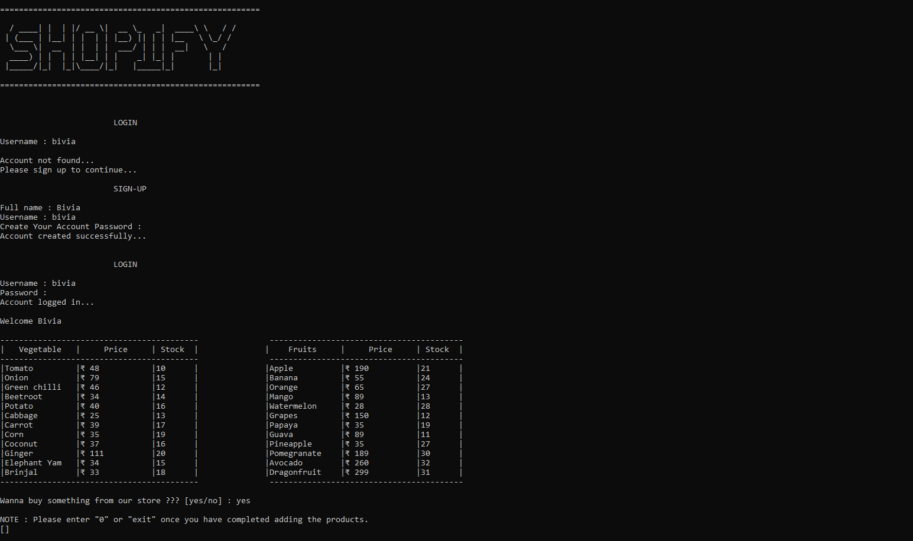

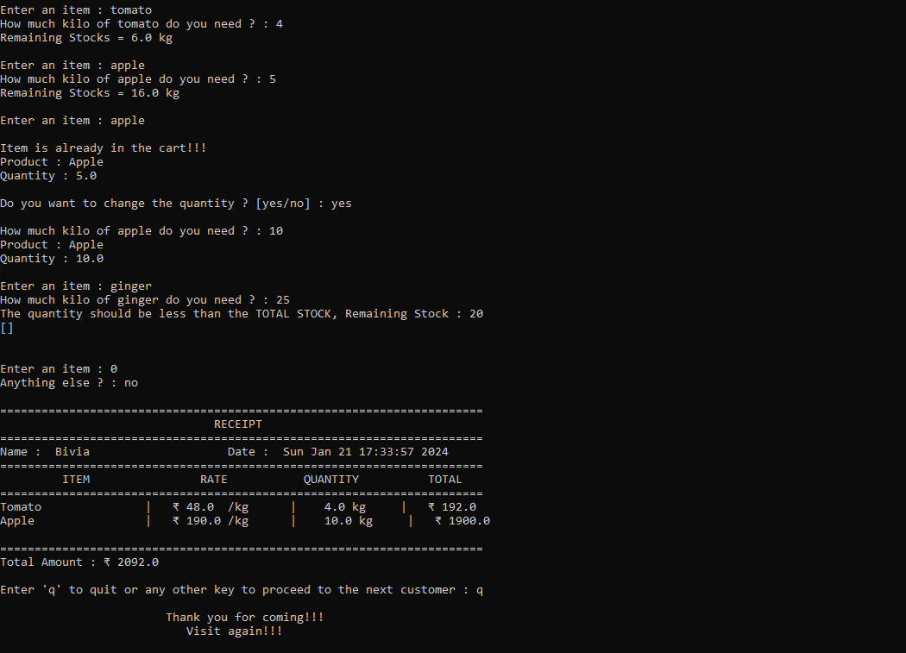

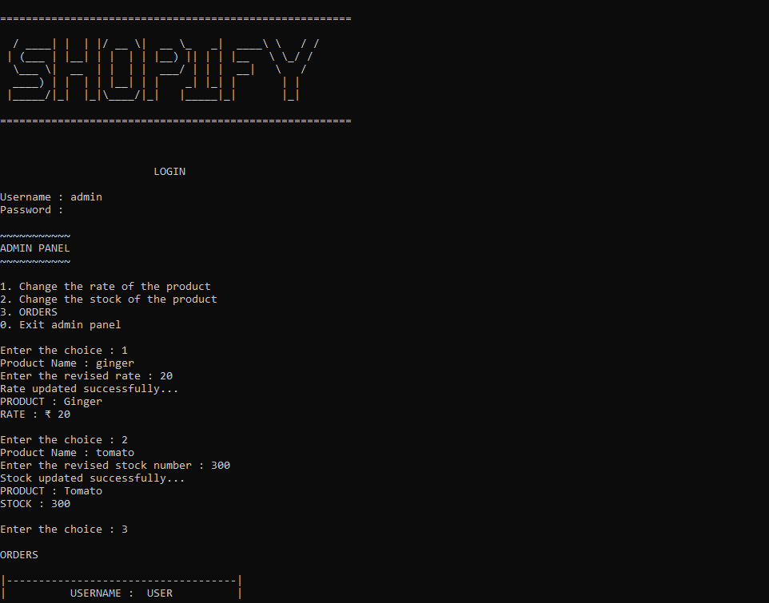

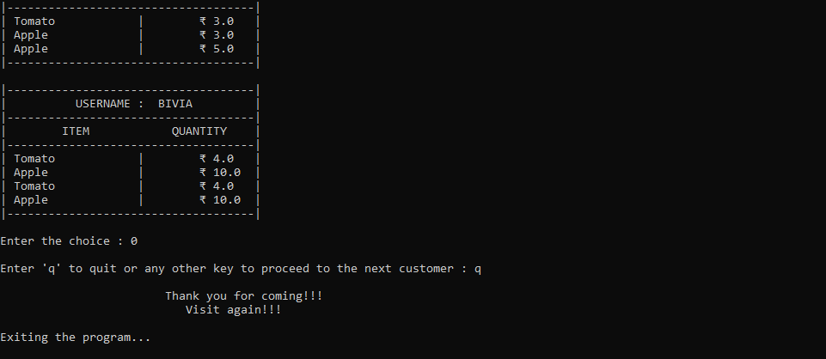

# BIBLIOGRAPHY

1. <https://stackoverflow.com/questions/9632995/how-to-easily-print-ascii-art-text>
2. [https://stackoverflow.com/questions/41816268/printing-multiple-dictionary-keys-](https://stackoverflow.com/questions/41816268/printing-multiple-dictionary-keys-on-one-line) [on-one-line](https://stackoverflow.com/questions/41816268/printing-multiple-dictionary-keys-on-one-line)
3. [https://stackoverflow.com/questions/53513/how-do-i-check-if-a-list-is-](https://stackoverflow.com/questions/53513/how-do-i-check-if-a-list-is-empty%26usg%3DAOvVaw3N6uqwooe6LXI7GipBGFOY) [empty&usg=AOvVaw3N6uqwooe6LXI7GipBGFOY](https://stackoverflow.com/questions/53513/how-do-i-check-if-a-list-is-empty%26usg%3DAOvVaw3N6uqwooe6LXI7GipBGFOY)
4. [https://stackoverflow.com/questions/17610732/error-dictionary-update-sequence-](https://stackoverflow.com/questions/17610732/error-dictionary-update-sequence-element-0-has-length-1-2-is-required-on-dj) [element-0-has-length-1-2-is-required-on-dj](https://stackoverflow.com/questions/17610732/error-dictionary-update-sequence-element-0-has-length-1-2-is-required-on-dj)
5. <https://www.geeksforgeeks.org/how-to-open-and-close-a-file-in-python/>
6. <https://www.geeksforgeeks.org/python-check-if-list-empty-not/>
7. <https://www.geeksforgeeks.org/python-nested-dictionary/>
8. <https://docs.python.org/3/library/time.html>
9. <https://docs.python.org/3/library/getpass.html>
10. <https://www.geeksforgeeks.org/python-ways-to-remove-a-key-from-dictionary/>