**Name**: Aaron Rickards

**Indicated Grade:** D

Overview:

For my custom application I created an application were the user was able to enter a current balance displayed. Create an item which would decrease the balance depending on item price and store that item which would be displayed by a recycler view. That item could be deleted, and the balance would be changed back, edited were the balance would change depending on price or sold were the balance would be added by the items value. The use could then view the graphs that were available being the fluctuation of the current balance and the fluctuation of money invested both in per transaction.

# Evidence:

I have completed the following assignments:  
| 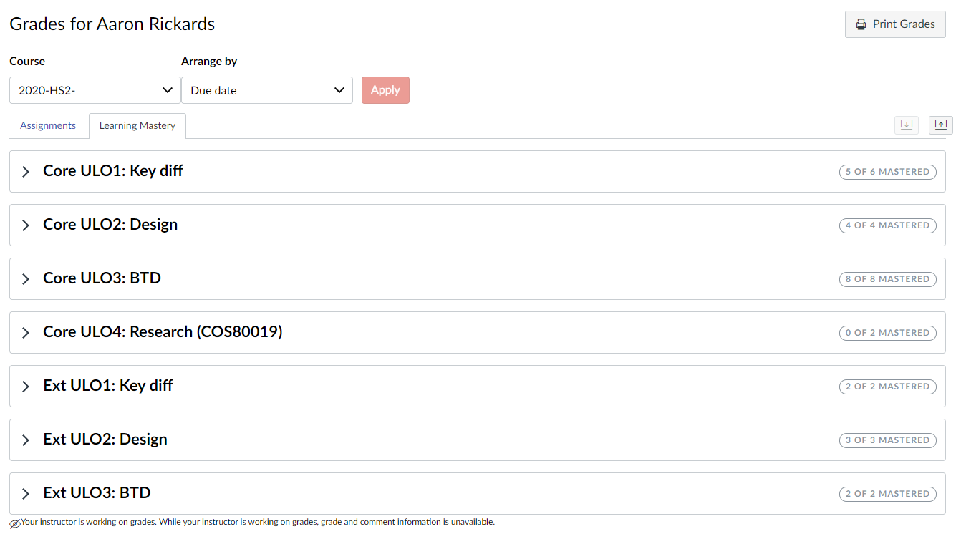

* All Core outcome
* All Extension outcomes
* A project at Level 1

# Learning Summary:

* Explain the key differences between development of systems to run on mobile devices and on typical personal computing or internet-based environments and apply this knowledge in the design of mobile device software.
  + comparing mobile vs web: In this task we were given the task to compare a mobile application with a website. In this task we were to look for the different features that were available between the mobile application and the website. Mainly we looked at the differences between the two with emphasis on using the devices hardware in the application. In my discussion I looked at the PayPal application comparing it to their website and found that on the mobile application there was the ability to scan QR codes to be able to pay another person taking advantage of the camera of the mobile device.
  + Lifecycles Quiz: in this task we had a quiz on the life cycles and states of a mobile application considering the different features that mobile applications must that of web applications. For example, closing the application, what happens to the application when the application is minimised out of focus. As well as the different events that occur on mobile application such as onRestart() and onDestroy().
* Design effective applications for a mobile device by taking into consideration the underlying hardware-imposed restrictions such as screen size, memory size and processor capability.
  + user stories for real world apps: this task had us look at the application that we did in comparing mobile and web applications. For this we created a story for the user and then created an interaction the use would have as well as the response that the application would have to the user’s interactions. Using these methods, we can design a mobile application that considers a user interaction on the hardware and the response that the system will give
  + Performance: in performance we were given the task of comparing different methods to do the same process. We had the aim of seeing which of these methods was the most optimal out of the three using the profiler to track the effect that it had on the performance of the application. This task was able to show us that different design choices can help us to reduce the effect on performance such as stress put on the processors and use of memory.
* Build, test, and debug graphical applications for mobile devices by using the standard libraries that are bundled as part of the developers’ toolkit for the mobile device.
  + UX: in this task we were to look at UI pattern that are found across applications such as pull to refresh, expanding menus and sort by column. The aim was to identify them and indicate their benefits and negatives on the application. The use of this task was for us to be able to understand the benefit that certain UI have in creating a better experience for the user when using the application. Through the process of building and debugging the application testing with different UI in the graphical application to see which has the best benefits for the user.
  + Custom app: For the custom app we were given the task of designing and creating our own application given a set of guidelines to follow. The process of designing and building our own application gave us insight into how we go about building, testing and debugging our own application from an idea to a project using the different methods and techniques we have learned across the year.

# Challenges in Mobile Development:

The aspects that I found to be challenging mainly when working with kotlin was finding example or tutorials when looking to find additional areas to add to an application or fix any errors that you might have. This was mainly occurring in the custom application where I struggled to find additional resources to implement sections such getting an image from gallery or finding graphical libraries for my application. The main issue I found that they would be in java where in some cases you were able to work around it and recreate the code however in others I was unable to and had to find a different resource.

# Assumptions and Expectations

From previous units of software development, I did not think that mobile development would be too much different from other units that I have completed. I found out quickly that it was quite different past units even having its own emulator to run the applications that the user could configure to what they require. The main difference I had between mobile and general software development was with the emulator it was quite different working with a virtual mobile phone which is something I thought was quite refreshing then compared to working on conventional IDEs.

I did not come into the unit with many assumptions or expectations since I had never worked on mobile applications, so I didn’t know what to expect from the unit. The only assumption or expectation that I could say that I had would be I thought that the unit would be similar to previous units that I had done which I found not to be the case.

# Explorations

Explorations that I have made in the unit was for my custom application. In my application I investigated a few extra libraries to satisfy what I wanted in my custom app. I looked at various graphing libraries as well as looked at getting images from the device’s gallery being external storage and saving the image into an object to display it. For the graphing libraries I looked at various libraries that were able to create graphs programmatically using data points that I would generate. Through my exploration I found their to be many outdated libraries that were hard to use but found a graphing library that did the task I needed it to do however found that it didn’t except dates meaning id have to setting for measuring each transaction instead of when the transaction took place. In looking into the images, I found it quite difficult to get in working properly between functions. As I found out it had to do with the permissions that each activity needed to be able to display or handle the image. I attempted to give each activity these permissions however were unable to get the application functioning as intended so I removed the component.

If I were to say an exploration that I would continue exploring it would be to get that section of code to function and gain a better understanding of permission in android applications.

# Final Words

The most useful thing that I found about this unit was the knowledge of another language being Kotlin and the understanding of a different software environment being working on mobile devices and understanding how they function.

**Task 2 User Stories for real world apps:**

**Chosen App:**The app that I have chosen for this discussion is the same app that I chose for the previous discussion task being the PayPal application

**User Story 1:**

As a small business owner, I want to be able to send requests for money to clients

**User Story 2:**

As a frequent I want to be able to pay people using a system were my credit card is safe

**Chosen Use Case:**User story 1

1. First, we start with launching the PayPal application which will bring the user to the Paypal dashboard
2. Next, we locate the request icon located on the toolbar at along the bottom of the screen
3. This brings up a list of contacts from previous transactions the user can either select one of those contacts
4. or enter a specific username, email, or mobile of the client to find the user
5. or the user can copy a link by clicking the button labeled "Share your link to get paid back" to send to a user to receive payment

|  |  |
| --- | --- |
| **User interaction** | **System Response** |
| Launch app | Load Dashboard |
| Click requests icon | Load contacts |
| Click specific contact | Load contact request |
| Enter Requested Amount and click next | Prompt user to send request |
| Send request | Send request to contact |
|  |  |