附录
附录1色谱数据采集卡初步PCB图
以下是色谱数据采集卡PCB板制作过程中生成的中间文件，此图描述了已经完成布线还未完成多边形布铜的PCB图。如图附图1所示。

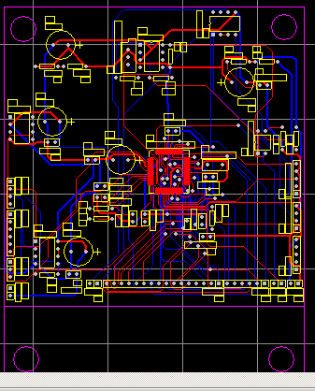
附图1 色谱数据采集卡初步PCB图
Fig1 chart of Chromatograph data acquisition card Preliminary PCB

附录2色谱数据采集卡PCB图
以下是色谱数据采集卡PCB板制作过程中，生成的最终文件，此图描述了完整的PCB图。如图附图2所示。

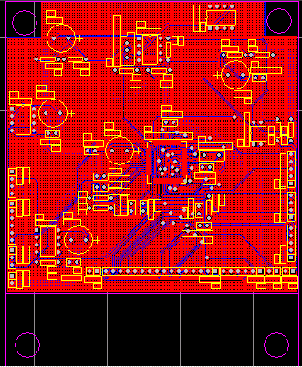
附图2 色谱数据采集卡PCB图
Fig.2 Chromatograph data acquisition card PCB chart

附录3 色谱数据采集卡原理图
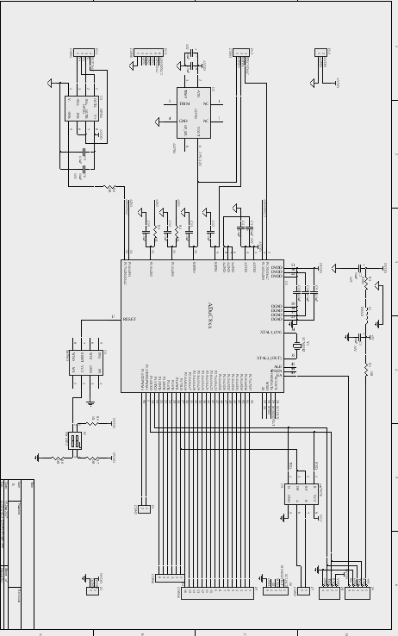
附图3 色谱数据采集卡原理图
Fig.5-4 Schematic diagram of chromatograph data acquisition card

附录4数据采集与串口通讯软件实现
//********************************************************************
// File : 834uart2.c
//
// Hardware : ADuC834
//
// Description : sample program that performs ADC conversions in continuous mode and sends results to a PC via the UART. program also accepts commands from the PC via incoming characters on the UART. an ASCII "0" innitiates a zero-scale calibration, and an ASCII "1" innitiates a full-scale calibration.
//********************************************************************
#include <stdio.h>
#include <ADuC834.h>
sbit LED = 0x0B4;
int recieved;

void delay(int length)
{
while (length >=0)
length--;
}

void calzero()
{
printf("\n\n");
printf("Calibrating zero\n");
RDY0 = 0;
ADCMODE = 0x24;
while (RDY0 == 0);
RDY0 = 0;
printf("End of the calibration\n");
}

void calgain()
{
printf("\n\n");
printf("Calibrating gain\n");
RDY0 = 0;
ADCMODE = 0x25;
while (RDY0 == 0);
RDY0 = 0;
printf("End of the calibration\n");
}
void interrupt_0 () interrupt 0
{
unsigned xdata test[3];
ADCMODE=0x22;
while ( RDY0==0 ) //设置A/D单片机状态转换器主通道状态为已准备好
{
//将采集转换数据信息写入A/D单片机的数据转换结果寄存器
test[0] = ADC0L; //写入数据低8位
test[1] = ADC0M; //写入数据中8位
test[2] = ADC0H; //写入数据高8位
loop++;
}
}

void ADC_int () interrupt 1
{
LED ^= 1;
printf("\n\n");
printf("%bX%bX%bX",ADC0H,ADC0M,ADC0L);
RDY0 = 0;
}

void main (void)
{
//Configure UART
T3CON = 0x82;
T3FD = 0x12;
SCON = 0x52;
//CONFIGURE ADC
SF = 0x200;
ADC0CON = 0x45;
printf("press 0 for zero calibration\n");
printf("press 1 for full-scale calibration\n");
printf("else press another key to start continuous conversion\n");
delay(1000);
while(1)
{
recieved = getkey();
switch (recieved)
{
case '0':
{
EADC = 0; // disable ADC interrupt
EA = 0; // disable interrupt
calzero();
}
case '1':
{
EADC = 0; // disable ADC interrupt
EA = 0; // disable interrupt
calgain();
}
default:{}
}
RDY0 = 0;
EADC = 1; // enable ADC interrupt
EA = 1; // enable interrupt
ADCMODE = 0x23; // start conversion in continuous mode
while(1); // wait for interrupt.
}
}

