外文资料原文
PRIMARY AND AUXILIARY ADC CIRCUIT DESCRIPTION
1 Overview
The ADuC834 incorporates two independent ∑-△ ADCs (primary and auxiliary) with on-chip digital filtering intended for the measurement of wide dynamic range, low frequency signals such as those in weigh-scale, strain gage, pressure transducer, or temperature measurement applications.
2 Primary ADC
This ADC is intended to convert the primary sensor input. The input is buffered and can be programmed for one of eight input ranges from ±20 mV to ±2.56 V being driven from one of three differential input channel options AIN1/2, AIN3/4, or AIN3/2.
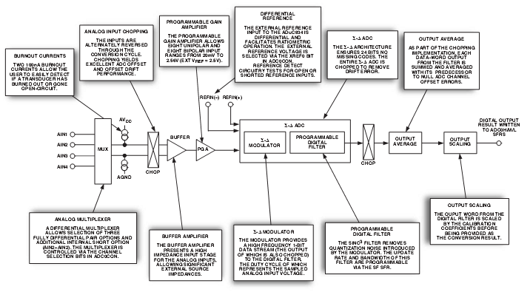
Figure 1 Primary ADC Block Diagram

The input channel is internally buffered, allowing the part to handle significant source impedances on the analog input and allowing R/C filtering (for noise rejection or RFI reduction) to be placed on the analog inputs if required. On-chip burnout currents can also be turned on. These currents can be used to check that a transducer on the selected channel is still operational before attempting to take measurements.
The ADC employs a ∑-△ conversion technique to realize up to 24 bits of no missing codes performance. The ∑-△modulator converts the sampled input signal into a digital pulse train whose duty cycle contains the digital information. A Sinc³ programmable low-pass filter is then employed to decimate the modulator output data stream to give a valid data conversion result at programmable output rates from 5.35 Hz (186.77 ms) to 105.03 Hz (9.52 ms). A chopping scheme is also employed to minimize ADC offset errors. A block diagram of the primary ADC is shown in figure 1.
3 Auxiliary ADC
The auxiliary ADC is intended to convert supplementary inputs such as those from a cold junction diode or thermistor. This ADC is not buffered and has a fixed input range of 0 V to 2.5 V(assuming an external 2.5 V reference). The single-ended inputs can be driven from AIN3, AIN4, or AIN5 Pins, or directly from the on-chip temperature sensor voltage. A block diagram of the auxiliary ADC is shown in Figure 2.

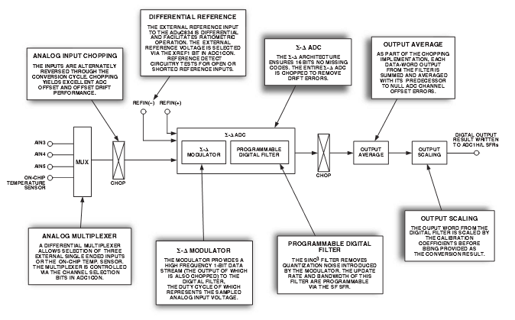
Figure2 Auxiliary ADC Block Diagram
4 Analog Input Channels
The primary ADC has four associated analog input pins (labeled AIN1 to AIN4) that can be configured as two fully differential input channels. Channel selection bits in the ADC0CON SFR detailed in Table VI allow three combinations of differential pair selection as well as an additional shorted input option (AIN2–AIN2).
The auxiliary ADC has three external input pins (labelled AIN3 to AIN5) as well as an internal connection to the on-chip temperature sensor. All inputs to the auxiliary ADC are single-ended inputs referenced to the AGND on the part. Channel selection bits in the ADC1CON SFR previously detailed in Table VII allow selection of one of four inputs.
Two input multiplexers switch the selected input channel to the on-chip buffer amplifier in the case of the primary ADC and directly to the ∑-△ modulator input in the case of the auxiliary ADC. When the analog input channel is switched, the settling time of the part must elapse before a new valid word is available from the ADC.
5 Primary and Auxiliary ADC Inputs
The output of the primary ADC multiplexer feeds into a high impedance input stage of the buffer amplifier. As a result, the primary ADC inputs can handle significant source impedances and are tailored for direct connection to external resistive-type sensors like strain gages or Resistance Temperature Detectors (RTDs).
The auxiliary ADC, however, is unbuffered, resulting in higher analog input current on the auxiliary ADC. It should be noted that this unbuffered input path provides a dynamic load to the driving source. Therefore, resistor/capacitor combinations on the input pins can cause dc gain errors depending on the output impedance of the source that is driving the ADC inputs.
6 Bipolar/Unipolar Inputs
The analog inputs on the ADuC834 can accept either unipolar or bipolar input voltage ranges. Bipolar input ranges do not imply that the part can handle negative voltages with respect to system AGND.
Unipolar and bipolar signals on the AIN(+) input on the primary ADC are referenced to the voltage on the respective AIN(–) input. For example, if AIN(–) is 2.5 V and the primary ADC is configured for an analog input range of 0 mV to 20 mV, the input voltage range on the AIN(+) input is 2.5 V to 2.52 V. If AIN(–) is 2.5 V and the ADuC834 is configured for an analog input range of 1.28 V, the analog input range on the AIN(+) input is 1.22 V to 3.78 V (i.e., 2.5 V ± 1.28 V).
As mentioned earlier, the auxiliary ADC input is a single-ended input with respect to the system AGND. In this context, a bipolar signal on the auxiliary ADC can only span 30 mV negative with respect to AGND before violating the voltage input limits for this ADC.
Bipolar or unipolar options are chosen by programming. the primary and auxiliary Unipolar enable bits in the ADC0CON and ADC1CON SFRs respectively. This programs the relevant ADC for either unipolar or bipolar operation. Programming for either unipolar or bipolar operation does not change any of the input signal conditioning; it simply changes the data output coding and the points on the transfer function where calibrations occur. When an ADC is configured for unipolar operation, the output coding is natural (straight) binary with a zero differential input voltage resulting in a code of 000 . . . 000, a mid-scale voltage resulting in a code of 100 . . . 000, and a full-scale input voltage resulting in a code of 111 . . . 111. When an ADC is configured for bipolar operation, the coding is offset binary with a negative full-scale voltage resulting in a code of 000 . . . 000, a zero differential voltage resulting in a code of 100 . . . 000, and a positive full-scale voltage resulting in a code of 111 . . . 111.
7 Reference Input
The ADuC834’s reference inputs, REFIN(+) and REFIN(–), provide a differential reference input capability. The common mode range for these differential inputs is from AGND to AVDD. The nominal reference voltage, VREF (REFIN(+) – REFIN(–)), for specified operation is 2.5 V with the primary and auxiliary reference enable bits set in the respective ADC0CON and/or ADC1CON SFRs.
The part is also functional (although not specified for performance) when the XREF0 or XREF1 bits are 0, which enables the on-chip internal band gap reference. In this mode, the ADCs will see the internal reference of 1.25 V, therefore halving all input ranges. As a result of using the internal reference voltage, a noticeable degradation in peak-to-peak resolution will result. Therefore, for best performance, operation with an external reference is strongly recommended.
It should also be noted that the reference inputs provide a high impedance, dynamic load. Because the input impedance of each reference input is dynamic, resistor/capacitor combinations on these inputs can cause dc gain errors depending on the output impedance of the source that is driving the reference inputs. Reference voltage sources, like those recommended above (e.g., AD780), will typically have low output impedances and therefore decoupling capacitors on the REFIN(+) input would be recommended. Deriving the reference input voltage across an external resistor, will mean that the reference input sees a significant external source impedance. External decoupling on the REFIN(+) and REFIN(–) pins would not be recommended in this type of circuit configuration.
8 Reference Detect
The ADuC834 includes on-chip circuitry to detect if the part has a valid reference for conversions or calibrations. If the voltage between the external REFIN(+) and REFIN(–) pins goes below 0.3 V or either the REFIN(+) or REFIN(–) inputs is open circuit, the ADuC834 detects that it no longer has a valid reference. In this case, the NOXREF bit of the ADCSTAT SFR is set to a 1. If the ADuC834 is performing normal conversions and the NOXREF bit becomes active, the conversion results revert to all 1s. It is not necessary to continuously monitor the status of the NOXREF bit when performing conversions. It is only necessary to verify its status if the conversion result read from the ADC Data Register is all 1s.
If the ADuC834 is performing either an offset or gain calibration and the NOXREF bit becomes active, the updating of the respective calibration registers is inhibited to avoid loading incorrect coefficients to these registers, and the appropriate ERR0 or ERR1 bits in the ADCSTAT SFR are set. If the user is concerned about verifying that a valid reference is in place every time a calibration is performed, the status of the ERR0 or ERR1 bit should be checked at the end of the calibration cycle.
9 ∑-△ Modulator
A ∑-△ADC generally consists of two main blocks, an analog modulator and a digital filter. In the case of the ADuC834 ADCs, the analog modulators consist of a difference amplifier, an integrator block, a comparator, and a feedback DAC as illustrated in Figure 10.
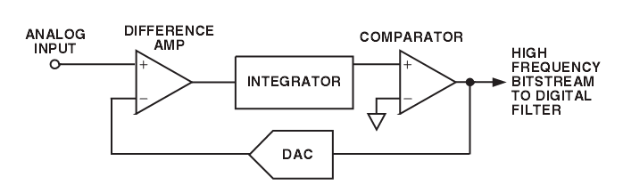
Figure 3 ∑-△Modulator Simplified Block Diagram

In operation, the analog signal sample is fed to the difference amplifier along with the output of the feedback DAC. The difference between these two signals is integrated and fed to the comparator. The output of the comparator provides the input to the feedback DAC so the system functions as a negative feedback loop that tries to minimize the difference signal. The digital data that represents the analog input voltage is contained in the duty cycle of the pulse train appearing at the output of the comparator. This duty cycle data can be recovered as a data-word using a subsequent digital filter stage. The sampling frequency of the modulator loop is many times higher than the bandwidth of the input signal. The integrator in the modulator shapes the quantization noise (which results from the analog-to-digital conversion) so that the noise is pushed toward one-half of the modulator frequency.
10 Calibration
The ADuC834 provides four calibration modes that can be programmed via the mode bits in the ADCMODE SFR detailed in Table V. In fact, every ADuC834 has already been factory calibrated. The resultant Offset and Gain calibration coefficients for both the primary and auxiliary ADCs are stored on-chip in manufacturing-specific Flash/EE memory locations. At power-on or after reset, these factory calibration coefficients are automatically downloaded to the calibration registers in the ADuC834 SFR space. Each ADC (primary and auxiliary) has dedicated calibration SFRs, these have been described earlier as part of the general ADC SFR description. However, the factory calibration values in the ADC calibration SFRs will be overwritten if any one of the four calibration options are initiated and that ADC is enabled via the ADC enable bits in ADCMODE.
Even though an internal offset calibration mode is described below, it should be recognized that both ADCs are chopped. This chopping scheme inherently minimizes offset and means that an internal offset calibration should never be required. Also, because factory 5 V/25°C gain calibration coefficients are automatically present at power-on, an internal full-scale calibration will only be required if the part is being operated at 3 V or at temperatures significantly different from 25°C.
The ADuC834 offers internal or system calibration facilities. For full calibration to occur on the selected ADC, the calibration logic must record the modulator output for two different input conditions. These are zero-scale and full-scale points. These points are derived by performing a conversion on the different input voltages provided to the input of the modulator during calibration. The result of the zero-scale calibration conversion is stored in the Offset Calibration Registers for the appropriate ADC. The result of the full-scale calibration conversion is stored in the Gain Calibration Registers for the appropriate ADC. With these readings, the calibration logic can calculate the offset and the gain slope for the input-to-output transfer function of the converter.

