实验报告2：AES密码处理器密钥扩展模块设计与仿真
一、实验目的
掌握AES密码处理器的密钥扩展模块的设计方法。
二、实验内容
1、利用Verilog HDL设计AES密码处理器的密钥扩展模块。
2、利用Modelsim仿真软件对所设计AES密码处理器的密钥扩展模块进行功能仿真。
三、实验环境
PC机1台、Modelsim仿真软件1套。
四、实验步骤
1、电路结构设计
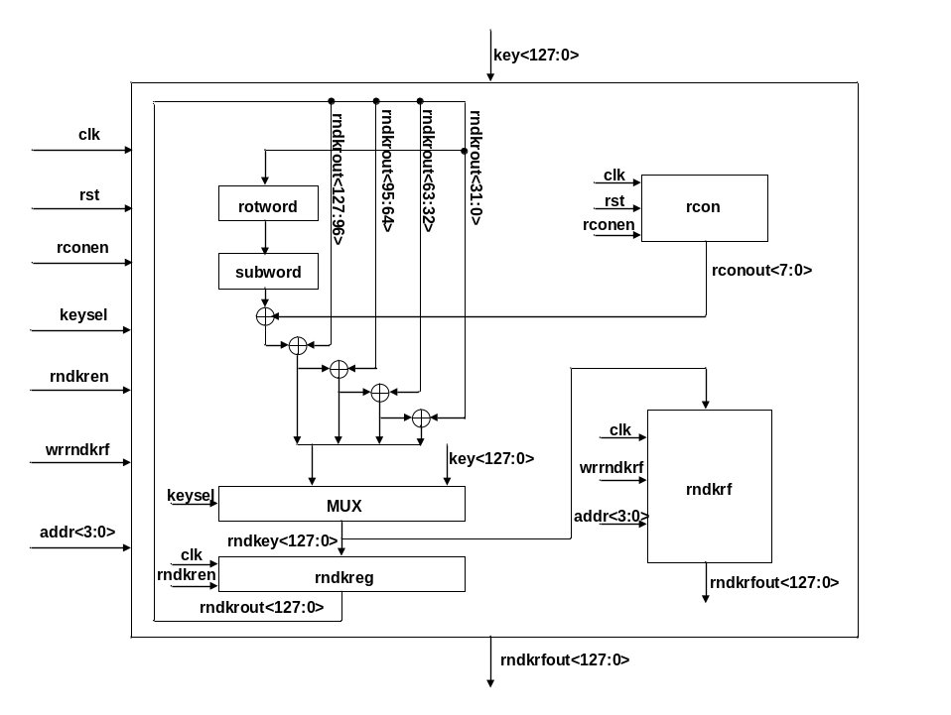
图1 密钥扩展模块的电路结构图
密钥扩展模块的外部信号如下表所示：
表1 密钥扩展模块的外部信号说明
信号名称 | 信号宽度 | 传输方向 | 信号含义
clk | 1位 | 输入 | 时钟信号。
rst | 1位 | 输入 | 复位信号，1有效。有效时使轮常数产生模块输出第一个轮常数。
keysel | 1位 | 输入 | 轮密钥选择信号，keysel=0选择密钥寄存器中的种子密钥，否则，选择经过密钥扩展变换的轮密钥。
rndkren | 1位 | 输入 | 轮密钥寄存器写使能信号，1有效。
wrrndkrf | 1位 | 输入 | 轮密钥寄存器堆写使能信号，1有效。
addr | 4位 | 输入 | 轮密钥寄存器堆地址，表示11个轮密钥寄存器的地址。
rconen | 1位 | 输入 | 轮常数寄存器写使能信号，1有效。当有效时将下一个轮常数写入轮常数寄存器。
key | 128位 | 输入 | 种子密钥，来自于密钥寄存器的输出。
rndkrfout | 128位 | 输出 | 轮密钥寄存器堆的输出，为加解密模块提供需要的轮密钥。
密钥扩展模块由1个128位的轮密钥寄存器rndkreg、1个11*128的轮密钥寄存器堆rndkrf、1个轮常数产生模块rcon、1个字节代替模块subword、1个32位的循环左移移位器rotword、1个128位的二选一选通器MUX以及5个32位异或器构成。
其电路工作原理如下：
在进行密钥扩展之前，首先令复位信号rst=1,以便使轮常数产生模块输出第1个轮常数。
然后，在第1个时钟周期，通过选通器选择种子密钥key作为第1个子密钥，并在本周期结束时的时钟上升沿，将其同时保存到轮密钥寄存器rndkreg和轮密钥寄存器堆rndkrf。
在第2个时钟周期，对保存在轮密钥寄存器rndkreg中的第1个子密钥先后进行循环左移、字节代替变换、异或、选通操作得到第2个子密钥，并在本周期结束时的时钟上升沿，将其同时保存到轮密钥寄存器rndkreg和轮密钥寄存器堆rndkrf。
重复第2个时钟周期的操作10次，就可以得到AES第1-10轮迭代所需要的轮密钥。
这样，经过11个时钟周期之后，AES加密/解密所需的全部11个子密钥就都产生出来了，并且被保存在轮密钥寄存器堆rndkrf中。
其中，循环左移运算实现对一个32位的数据循环左移8位，在电路实现时通过硬件连线即可实现，无须设计专门的移位电路。
字节代替变换由4个8*8 S盒实现，S盒采用查表方式实现。为了充分利用cyclone FPGA中的RAM资源，减少LE（逻辑单元）的使用数量，我们利用cyclone FPGA中的RAM构建了一个8*8的ROM作为S盒，该ROM共有256个的存储单元，每个存储单元存储一个字节，这256个字节就是实现S盒变换的查找表。该ROM可以利用quartus II的megafunction工具自动生成，但需要注意的是该ROM的地址要经寄存器锁存以后才能进入ROM，因此在地址有效的下一个周期才能在ROM的输出端口得到读出的数据。
二选一选通器MUX用于选择外部输入的种子密钥或者内部逻辑产生的数据作为子密钥。
轮密钥寄存器rndkreg是1个128位的寄存器，用于暂时保存当前产生的子密钥，以便产生下一个子密钥时使用。
轮密钥寄存器堆rndkrf共有11个128位的存储单元，用于保存密钥扩展以后的全部11个子密钥，供AES加密/解密使用。
轮常数产生模块rcon由1个8位寄存器和轮常数产生逻辑构成，当复位时，寄存器输出第一个轮常数，当轮常数寄存器写使能信号rconen有效时，将由轮常数产生逻辑产生的下一个轮常数写入轮常数寄存器。
2、建立Verilog模型
module keyexp(clk,rst,keysel,rndkren,wrrndkrf,addr,rconen,key,rndkrfout);
output[127:0] rndkrfout;
input clk,rst,keysel,rndkren,wrrndkrf,rconen;
input[3:0] addr;
input[127:0] key;
wire [127:0] rndkey,rndkrout,rndkrfout;
wire [31:0] w4,w5,w6,w7,rotword,subword,xorrcon;
wire [7:0] rconout;

assign rndkey=(keysel==0) ? key:{w4,w5,w6,w7};
reg_128 rndkreg(clk,rndkren,rndkey,rndkrout);
rndkrf rndkrf(clk,wrrndkrf,addr,rndkey,rndkrfout);

assign rotword={rndkrout[23:0],rndkrout[31:24]};
sbox_mux sbox0(rotword[31:24],subword[31:24]);
sbox_mux sbox1(rotword[23:16],subword[23:16]);
sbox_mux sbox2(rotword[15:8],subword[15:8]);
sbox_mux sbox3(rotword[7:0],subword[7:0]);

rcon rcon(clk,rst,rconen,rconout);
assign xorrcon=subword^{rconout,24'h000000};
assign w4=xorrcon^rndkrout[127:96];
assign w5=w4^rndkrout[95:64];
assign w6=w5^rndkrout[63:32];
assign w7=w6^rndkrout[31:0];
endmodule

module reg_128(clk,write,din,dout);
output [127:0] dout;
input clk,write;
input [127:0] din;
reg [127:0] dout;
always @ (posedge clk)
begin
if(write)
dout<=din;
else
dout<=dout;
end
endmodule

module rcon(clk,rst,write,rconout);
output [7:0] rconout;
input clk,rst,write;
reg [7:0] rconout;
always @ (posedge clk)
begin
if(rst)
rconout<=8'h01;
else if(write)
rconout<=(rconout[7]==0)? (rconout<<1):((rconout<<1)^{8'h1b});
else
rconout<=rconout;
end
endmodule

module rndkrf(clk,wrrndkrf,addr,rndkey,rndkrfout);
input clk,wrrndkrf;
input [3:0] addr;
input [127:0] rndkey;
output [127:0] rndkrfout;
reg [10:0] decout;
wire [10:0] write_reg;
wire [127:0] reg0out,reg1out,reg2out,reg3out,reg4out,reg5out,reg6out,reg7out,reg8out,reg9out,reg10out;
reg [127:0] rndkrfout;
always @ (addr)
case(addr)
4'd0: decout=11'b000_0000_0001;
4'd1: decout=11'b000_0000_0010;
4'd2: decout=11'b000_0000_0100;
4'd3: decout=11'b000_0000_1000;
4'd4: decout=11'b000_0001_0000;
4'd5: decout=11'b000_0010_0000;
4'd6: decout=11'b000_0100_0000;
4'd7: decout=11'b000_1000_0000;
4'd8: decout=11'b001_0000_0000;
4'd9: decout=11'b010_0000_0000;
4'd10: decout=11'b100_0000_0000;
default: decout=11'b000_0000_0000;
endcase
assign write_reg=decout & {wrrndkrf,wrrndkrf,wrrndkrf,wrrndkrf,wrrndkrf,wrrndkrf,wrrndkrf,wrrndkrf,wrrndkrf,wrrndkrf,wrrndkrf};
reg_128 reg0(clk,write_reg[0],rndkey,reg0out);
reg_128 reg1(clk,write_reg[1],rndkey,reg1out);
reg_128 reg2(clk,write_reg[2],rndkey,reg2out);
reg_128 reg3(clk,write_reg[3],rndkey,reg3out);
reg_128 reg4(clk,write_reg[4],rndkey,reg4out);
reg_128 reg5(clk,write_reg[5],rndkey,reg5out);
reg_128 reg6(clk,write_reg[6],rndkey,reg6out);
reg_128 reg7(clk,write_reg[7],rndkey,reg7out);
reg_128 reg8(clk,write_reg[8],rndkey,reg8out);
reg_128 reg9(clk,write_reg[9],rndkey,reg9out);
reg_128 reg10(clk,write_reg[10],rndkey,reg10out);
always @(addr or reg0out or reg1out or reg2out or reg3out or reg4out or reg5out or reg6out or reg7out or reg8out or reg9out or reg10out)
case(addr)
4'd0: rndkrfout=reg0out;
4'd1: rndkrfout=reg1out;
4'd2: rndkrfout=reg2out;
4'd3: rndkrfout=reg3out;
4'd4: rndkrfout=reg4out;
4'd5: rndkrfout=reg5out;
4'd6: rndkrfout=reg6out;
4'd7: rndkrfout=reg7out;
4'd8: rndkrfout=reg8out;
4'd9: rndkrfout=reg9out;
4'd10: rndkrfout=reg10out;
default: rndkrfout=reg10out;
endcase
endmodule

module sbox_mux(in,out);
output[7:0] out;
input[7:0] in;
reg [7:0] out;
always@(in)
case(in)
8'h00: out=8'h63;
8'h01: out=8'h7c;
8'h02: out=8'h77;
8'h03: out=8'h7b;
8'h04: out=8'hf2;
8'h05: out=8'h6b;
8'h06: out=8'h6f;
8'h07: out=8'hc5;
8'h08: out=8'h30;
8'h09: out=8'h01;
8'h0a: out=8'h67;
8'h0b: out=8'h2b;
8'h0c: out=8'hfe;
8'h0d: out=8'hd7;
8'h0e: out=8'hab;
8'h0f: out=8'h76;

8'h10: out=8'hca;
8'h11: out=8'h82;
8'h12: out=8'hc9;
8'h13: out=8'h7d;
8'h14: out=8'hfa;
8'h15: out=8'h59;
8'h16: out=8'h47;
8'h17: out=8'hf0;
8'h18: out=8'had;
8'h19: out=8'hd4;
8'h1a: out=8'ha2;
8'h1b: out=8'haf;
8'h1c: out=8'h9c;
8'h1d: out=8'ha4;
8'h1e: out=8'h72;
8'h1f: out=8'hc0;

8'h20: out=8'hb7;
8'h21: out=8'hfd;
8'h22: out=8'h93;
8'h23: out=8'h26;
8'h24: out=8'h36;
8'h25: out=8'h3f;
8'h26: out=8'hf7;
8'h27: out=8'hcc;
8'h28: out=8'h34;
8'h29: out=8'ha5;
8'h2a: out=8'he5;
8'h2b: out=8'hf1;
8'h2c: out=8'h71;
8'h2d: out=8'hd8;
8'h2e: out=8'h31;
8'h2f: out=8'h15;

8'h30: out=8'h04;
8'h31: out=8'hc7;
8'h32: out=8'h23;
8'h33: out=8'hc3;
8'h34: out=8'h18;
8'h35: out=8'h96;
8'h36: out=8'h05;
8'h37: out=8'h9a;
8'h38: out=8'h07;
8'h39: out=8'h12;
8'h3a: out=8'h80;
8'h3b: out=8'he2;
8'h3c: out=8'heb;
8'h3d: out=8'h27;
8'h3e: out=8'hb2;
8'h3f: out=8'h75;

8'h40: out=8'h09;
8'h41: out=8'h83;
8'h42: out=8'h2c;
8'h43: out=8'h1a;
8'h44: out=8'h1b;
8'h45: out=8'h6e;
8'h46: out=8'h5a;
8'h47: out=8'ha0;
8'h48: out=8'h52;
8'h49: out=8'h3b;
8'h4a: out=8'hd6;
8'h4b: out=8'hb3;
8'h4c: out=8'h29;
8'h4d: out=8'he3;
8'h4e: out=8'h2f;
8'h4f: out=8'h84;

8'h50: out=8'h53;
8'h51: out=8'hd1;
8'h52: out=8'h00;
8'h53: out=8'hed;
8'h54: out=8'h20;
8'h55: out=8'hfc;
8'h56: out=8'hb1;
8'h57: out=8'h5b;
8'h58: out=8'h6a;
8'h59: out=8'hcb;
8'h5a: out=8'hbe;
8'h5b: out=8'h39;
8'h5c: out=8'h4a;
8'h5d: out=8'h4c;
8'h5e: out=8'h58;
8'h5f: out=8'hcf;

8'h60: out=8'hd0;
8'h61: out=8'hef;
8'h62: out=8'haa;
8'h63: out=8'hfb;
8'h64: out=8'h43;
8'h65: out=8'h4d;
8'h66: out=8'h33;
8'h67: out=8'h85;
8'h68: out=8'h45;
8'h69: out=8'hf9;
8'h6a: out=8'h02;
8'h6b: out=8'h7f;
8'h6c: out=8'h50;
8'h6d: out=8'h3c;
8'h6e: out=8'h9f;
8'h6f: out=8'ha8;

8'h70: out=8'h51;
8'h71: out=8'ha3;
8'h72: out=8'h40;
8'h73: out=8'h8f;
8'h74: out=8'h92;
8'h75: out=8'h9d;
8'h76: out=8'h38;
8'h77: out=8'hf5;
8'h78: out=8'hbc;
8'h79: out=8'hb6;
8'h7a: out=8'hda;
8'h7b: out=8'h21;
8'h7c: out=8'h10;
8'h7d: out=8'hff;
8'h7e: out=8'hf3;
8'h7f: out=8'hd2;

8'h80: out=8'hcd;
8'h81: out=8'h0c;
8'h82: out=8'h13;
8'h83: out=8'hec;
8'h84: out=8'h5f;
8'h85: out=8'h97;
8'h86: out=8'h44;
8'h87: out=8'h17;
8'h88: out=8'hc4;
8'h89: out=8'ha7;
8'h8a: out=8'h7e;
8'h8b: out=8'h3d;
8'h8c: out=8'h64;
8'h8d: out=8'h5d;
8'h8e: out=8'h19;
8'h8f: out=8'h73;

8'h90: out=8'h60;
8'h91: out=8'h81;
8'h92: out=8'h4f;
8'h93: out=8'hdc;
8'h94: out=8'h22;
8'h95: out=8'h2a;
8'h96: out=8'h90;
8'h97: out=8'h88;
8'h98: out=8'h46;
8'h99: out=8'hee;
8'h9a: out=8'hb8;
8'h9b: out=8'h14;
8'h9c: out=8'hde;
8'h9d: out=8'h5e;
8'h9e: out=8'h0b;
8'h9f: out=8'hdb;

8'ha0: out=8'he0;
8'ha1: out=8'h32;
8'ha2: out=8'h3a;
8'ha3: out=8'h0a;
8'ha4: out=8'h49;
8'ha5: out=8'h06;
8'ha6: out=8'h24;
8'ha7: out=8'h5c;
8'ha8: out=8'hc2;
8'ha9: out=8'hd3;
8'haa: out=8'hac;
8'hab: out=8'h62;
8'hac: out=8'h91;
8'had: out=8'h95;
8'hae: out=8'he4;
8'haf: out=8'h79;

8'hb0: out=8'he7;
8'hb1: out=8'hc8;
8'hb2: out=8'h37;
8'hb3: out=8'h6d;
8'hb4: out=8'h8d;
8'hb5: out=8'hd5;
8'hb6: out=8'h4e;
8'hb7: out=8'ha9;
8'hb8: out=8'h6c;
8'hb9: out=8'h56;
8'hba: out=8'hf4;
8'hbb: out=8'hea;
8'hbc: out=8'h65;
8'hbd: out=8'h7a;
8'hbe: out=8'hae;
8'hbf: out=8'h08;

8'hc0: out=8'hba;
8'hc1: out=8'h78;
8'hc2: out=8'h25;
8'hc3: out=8'h2e;
8'hc4: out=8'h1c;
8'hc5: out=8'ha6;
8'hc6: out=8'hb4;
8'hc7: out=8'hc6;
8'hc8: out=8'he8;
8'hc9: out=8'hdd;
8'hca: out=8'h74;
8'hcb: out=8'h1f;
8'hcc: out=8'h4b;
8'hcd: out=8'hbd;
8'hce: out=8'h8b;
8'hcf: out=8'h8a;

8'hd0: out=8'h70;
8'hd1: out=8'h3e;
8'hd2: out=8'hb5;
8'hd3: out=8'h66;
8'hd4: out=8'h48;
8'hd5: out=8'h03;
8'hd6: out=8'hf6;
8'hd7: out=8'h0e;
8'hd8: out=8'h61;
8'hd9: out=8'h35;
8'hda: out=8'h57;
8'hdb: out=8'hb9;
8'hdc: out=8'h86;
8'hdd: out=8'hc1;
8'hde: out=8'h1d;
8'hdf: out=8'h9e;

8'he0: out=8'he1;
8'he1: out=8'hf8;
8'he2: out=8'h98;
8'he3: out=8'h11;
8'he4: out=8'h69;
8'he5: out=8'hd9;
8'he6: out=8'h8e;
8'he7: out=8'h94;
8'he8: out=8'h9b;
8'he9: out=8'h1e;
8'hea: out=8'h87;
8'heb: out=8'he9;
8'hec: out=8'hce;
8'hed: out=8'h55;
8'hee: out=8'h28;
8'hef: out=8'hdf;

8'hf0: out=8'h8c;
8'hf1: out=8'ha1;
8'hf2: out=8'h89;
8'hf3: out=8'h0d;
8'hf4: out=8'hbf;
8'hf5: out=8'he6;
8'hf6: out=8'h42;
8'hf7: out=8'h68;
8'hf8: out=8'h41;
8'hf9: out=8'h99;
8'hfa: out=8'h2d;
8'hfb: out=8'h0f;
8'hfc: out=8'hb0;
8'hfd: out=8'h54;
8'hfe: out=8'hbb;
8'hff: out=8'h16;
endcase
endmodule

3、设计测试文件
`timescale 1ns / 1ns
module keyexp_tb;
wire[127:0] rndkrfout;
reg clk,rst,keysel,rndkren,wrrndkrf,rconen;
reg [3:0] addr;
reg [127:0] key;

keyexp kexp(clk,rst,keysel,rndkren,wrrndkrf,addr,rconen,key,rndkrfout);

//clock generation
initial clk = 1;
always #50 clk = ~clk;

initial
begin
#20 rst=1;
#100 rst=0;
keysel=0;
rndkren=1;
wrrndkrf=1;
addr=4'd0;
rconen=0;
key=128'h2b7e1516_28aed2a6_abf71588_09cf4f3c;
#100 addr=4'd1;
rconen=1;
keysel=1;
#100 addr=4'd2;
#100 addr=4'd3;
#100 addr=4'd4;
#100 addr=4'd5;
#100 addr=4'd6;
#100 addr=4'd7;
#100 addr=4'd8;
#100 addr=4'd9;
#100 addr=4'd10;

#100 rndkren=0;
wrrndkrf=0;
rconen=0;

#100 addr=4'd0;
#100 addr=4'd1;
#100 addr=4'd2;
#100 addr=4'd3;
#100 addr=4'd4;
#100 addr=4'd5;
#100 addr=4'd6;
#100 addr=4'd7;
#100 addr=4'd8;
#100 addr=4'd9;
#100 addr=4'd10;

#1020 rst=1;
#100 rst=0;
keysel=0;
rndkren=1;
wrrndkrf=1;
addr=4'd0;
rconen=0;
key=128'ha32bf2a3d443c60771230a2214575088;
#100 addr=4'd1;
rconen=1;
keysel=1;
#100 addr=4'd2;
#100 addr=4'd3;
#100 addr=4'd4;
#100 addr=4'd5;
#100 addr=4'd6;
#100 addr=4'd7;
#100 addr=4'd8;
#100 addr=4'd9;
#100 addr=4'd10;

#100 rndkren=0;
wrrndkrf=0;
rconen=0;

#100 addr=4'd0;
#100 addr=4'd1;
#100 addr=4'd2;
#100 addr=4'd3;
#100 addr=4'd4;
#100 addr=4'd5;
#100 addr=4'd6;
#100 addr=4'd7;
#100 addr=4'd8;
#100 addr=4'd9;
#100 addr=4'd10;
#200 $stop;
end
endmodule

4、将设计文件和测试文件输入Modelsim仿真工具，并进行编译和功能仿真。
5、观测仿真波形图，分析结果是否正确。若有错误，则修改设计文件或测试文件，重新编译和仿真。
五、实验结果
参见Modelsim中的仿真波形图,列出下列实验结果表：
种子密钥 | 仿真得到的扩展密钥 |  | 仿真结果是否正确
key=128'h2b7e151628aed2a6abf7158809cf4f3c; | 子密钥1 | 2b7e151628aed2a6abf7158809cf4f3c | 正确
key=128'h2b7e151628aed2a6abf7158809cf4f3c; | 子密钥2 | a0fafe1788542cb123a339392a6c7605 | 正确
key=128'h2b7e151628aed2a6abf7158809cf4f3c; | 子密钥3 | f2c295f27a96b9435935807a7359f67f | 正确
key=128'h2b7e151628aed2a6abf7158809cf4f3c; | 子密钥4 | 3d80477d4716fe3e1e237e446d7a883b | 正确
key=128'h2b7e151628aed2a6abf7158809cf4f3c; | 子密钥5 | ef44a541a8525b7fb671253bdb0bad00 | 正确
key=128'h2b7e151628aed2a6abf7158809cf4f3c; | 子密钥6 | d4d1c6f87c839d87caf2b8bc11f915bc | 正确
key=128'h2b7e151628aed2a6abf7158809cf4f3c; | 子密钥7 | 6d88a37a110b3efddbf98641ca0093fd | 正确
key=128'h2b7e151628aed2a6abf7158809cf4f3c; | 子密钥8 | 4e54f70e5f5fc9f384a64fb24ea6dc4f | 正确
key=128'h2b7e151628aed2a6abf7158809cf4f3c; | 子密钥9 | ead27321b58dbad2312bf5607f8d292f | 正确
key=128'h2b7e151628aed2a6abf7158809cf4f3c; | 子密钥10 | ac7766f319fadc2128d12941575c006e | 正确
key=128'h2b7e151628aed2a6abf7158809cf4f3c; | 子密钥11 | d014f9a8c9ee2589e13f0cc8b6630ca6 | 正确
key=128'ha32bf2a3d443c60771230a2214575088; | 子密钥1 | 2b7e151628aed2a6abf7158809cf4f3c | 正确
key=128'ha32bf2a3d443c60771230a2214575088; | 子密钥2 | a32bf2a3d443c60771230a2214575088 | 正确
key=128'ha32bf2a3d443c60771230a2214575088; | 子密钥3 | a0fafe1788542cb123a339392a6c7605 | 正确
key=128'ha32bf2a3d443c60771230a2214575088; | 子密钥4 | f97836592d3bf05e5c18fa7c484faaf4 | 正确
key=128'ha32bf2a3d443c60771230a2214575088; | 子密钥5 | f2c295f27a96b9435935807a7359f67f | 正确
key=128'ha32bf2a3d443c60771230a2214575088; | 子密钥6 | 7fd4890b52ef79550ef7832946b829dd | 正确
key=128'ha32bf2a3d443c60771230a2214575088; | 子密钥7 | 3d80477d4716fe3e1e237e446d7a883b | 正确
key=128'ha32bf2a3d443c60771230a2214575088; | 子密钥8 | 17714851459e31044b69b22d0dd19bf0 | 正确
key=128'ha32bf2a3d443c60771230a2214575088; | 子密钥9 | ef44a541a8525b7fb671253bdb0bad00 | 正确
key=128'ha32bf2a3d443c60771230a2214575088; | 子密钥10 | 2165c48664fbf5822f9247af2243dc5f | 正确
key=128'ha32bf2a3d443c60771230a2214575088; | 子密钥11 | d4d1c6f87c839d87caf2b8bc11f915bc | 正确

波形图如下：
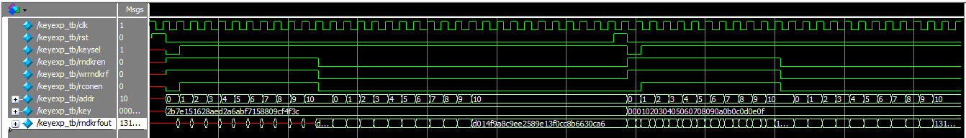
六、实验结论
本实验设计了AES密码处理器的密钥扩展模块的Verilog模型及其测试程序，并选择了两个不同的种子密钥对其进行了密钥扩展功能仿真，仿真结果全部正确，这说明所设计的密钥扩展模块的功能是正确的。
仿真时将两个子密钥放在同一激励快中进行同时仿真，可以比较直观的观察数值的显示及变化过程，仿真波形图将种子密钥与产生的子密钥转换为16进制显示，使得结果数据更加直观方便。

