# CS278 ASSIGNMENT #5: Loops and Arrays

Due 3/17

## NAME:

**GRADE:**

|  |  |  |
| --- | --- | --- |
| **CATEGORY** | **POINTS** |  |
| EX05_01_Convert |  | 10 |
| EX05_02_Exchange |  | 20 |
| EX05_03_Fibonacci |  | 20 |
| EX05_04_Reverse_String |  | 25 |
| EX05_05_Shift_Array |  | 25 |
| **TOTAL** |  | 100 |

## EXERCISES:

* For ALL of these exercises, you **will** **need** **the** **Debugger** to verify that your code is working correctly.
* Secondly, **your MUST document your code**. Describe the approach your code is taking, how it's doing what it's doing. Up to 5 points per problem may be deducted if you don't describe what you are doing in a way that someone else reading your code can understand what your code is doing.
* One suggestion is to document your code with the equivalent C++ syntax (e.g. if statements, for loop, etc.)
* You MUST use indenting to format loops so that we can follow your code. Make loop and variable labels descriptive.

**EX05_01_Convert –** Do Programming Exercises Problem 4.10.1.

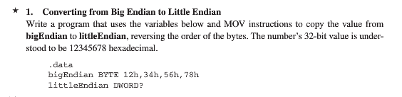

**EX05_02_Exchange –** Do Programming Exercises Problem 4.10.2

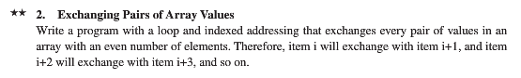

**EX05_03_Fibonacci –** Do Programming Exercises Problem 4.10.5

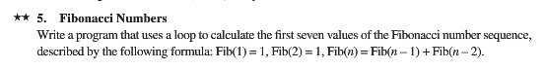

**EX05_04_Reverse_String –** Do Programming Exercises Problem 4.10.7

NOTE: The challeng here is how to deal with the NULL terminator for the string!

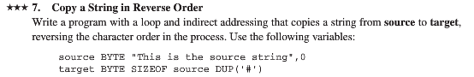

**EX05_05_Shift_Array –** Do Programming Exercises Problem 4.10.8

