Final project proposal

Caleb Grode & Aaron Borjas

Our project will be tic tac toe in a console window. If we have time, we would like to make a tic tac toe ultimate version where there are 9 games at once and whoever wins one game gets an X or O on their board.

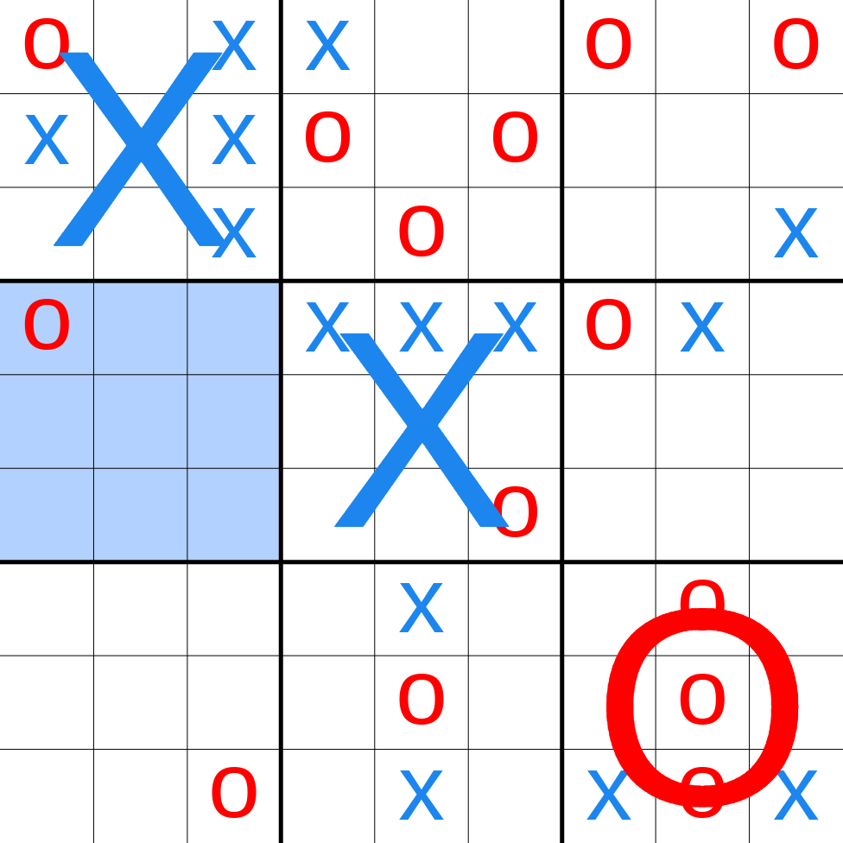

**Ultimate Tic Tac Toe**

Our approach to solving this problem will be to start with a basic game of tic tac toe where it could be person versus person OR person versus computer. Once we have that figuring out we can get more complicated.

Some anticipated problems for the normal version of tic tac toe would be placing a letter, switching “turns”, managing the win condition, figuring out 2D arrays in assembly, and the art.

Some anticipated problems for ultimate tic tac toe are selecting each board, figuring out who won on each board, managing the win condition, and the art.

**List of features**:

* Turn
  + Plays the full set of two player turns
* AccessBoard
  + Access a certain location on the board
* DrawBoard
  + Prints all the characters on the board
* Place(x,y)
  + Places an item on the board
* CheckWin
  + Checks if either the X player has won, or the O player has won