CS 278 Study Guide #2
GRADE:

EXERCISES:
CATEGORY | POINTS
EX01_32 |  | 25
EX01_64 |  | 25
TOTAL |  | 50

Getting Started with MASM and Visual Studio Code
All of the lab machines in the labs have the Microsoft Assembler (MASM) installed. If you have Visual Studio installed on your personal machine, then you already have MASM!

HANDS ON EXERCISE EX01_32: A Visual Studio Code 32 Bit Assembler Project

Learning Goals for this Exercise
- Understand how to use WhitGit to submit assignments for this class.
- Understand how to user Visual Studio Code to edit assembly language programs.
- Understand how to compile, and build an assembly language program.

Submitting assignments on Whitgit!

Accessing Irvine Library Code for this CLASS

- Every machine in the lab has a C:\Irvine folder with files that you will need to use in your projects. If you need to access these files for your personal computer you can download them from http://asmirvine.com/

Installing VS Code with Whitgit extensions

- Open a web browser and point it to http://whitgit.whitworth.edu. Click the Groups pulldown menu and select Explore Groups. From there click Tutorials, then quick-start-to-vscode. Follow the instructions to install VS Code and the extensions.

Creating a VS Code Assembler Project and configuring VS Code to work with it.

- Create a new folder EX01_32. Open it in VS Code as the current project folder.

- You must have the vs code package "Whitworth Visual Code Utilities 1.0.3" installed to work. Click on the packages icon to see if that's the version you have. If you have 1.0.1 or 1.0.2, uninstall it, and then download the latest *.vsix from whitgit. To install the new version, click on the packages / extensions icon, the 3 dots (More actions menu) up at the top of the window to the left of EXTENSIONS. Select "Install from VSIX" and install the whitcode-extension-1.0.3.vsix file.

- In the Whitworth Extensions “tab”, click “Make 32 Bit Assembler Project Files in the Current Folder”.

- Using a different windows explorer tab or window, browse to the folder C:\Irvine\ch03 on your local machine. NOTE: If you are not on a school computer you will need to install the Irvine library from step 4 above on your computer before you can find these files!

- Copy the C:\Irvine\Ch03\AddTwo.asm file into your folder/source/

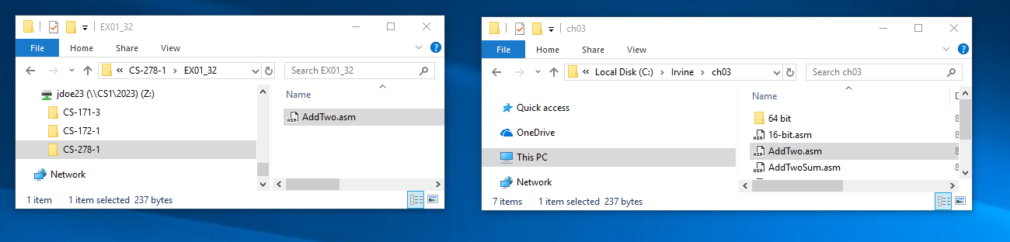
Copy AddTwo.asm from C:\Irvine\Ch03 to your new EX01_32 on CS1

- NOTE: If you can’t see the .asm extension for the files, open the new EX01_32 folder then, in the View tab of windows explorer, make sure and check the two boxes that will allow you to see file name extensions and hidden items.

- Once you open an assembler project, select View | Command Pallette (CTRL+SHIFT+P)

- In the command palette type "Terminal: Select Default Shell", then select "Powershell" as the default shell.

- Now, start a new powershell window by selecting Terminal | New Terminal (CTRL+SHIFT+`)

- In the new terminal window that appears, type the following: Set-ExecutionPolicy Unrestricted -Scope CurrentUser

Assembling 32 Bit Visual Studio Code Assembler

- To assemble (compile) our code (after moving our file into the source folder)
From the menu select Terminal | Run Task… | Assemble Assembly Code | Continue without scanning the task output…
To debug our assembly code (after assembling it!)
From the menu select Tasks | Run Task… | Debug Assembly Code with … | Continue without scanning …
Again, you willl see a warning you are about to run a script.
Click in the terminal window and type R to continue running the script…

This is a new step for all of us this semester! Bear with each other and the prof, laughing where necessary.

