WORKLOG for 2010 Bowhead whale call classification:

/Users/thode/Projects/Greeneridge_bowhead_detection/Call_classification

August 29, 2006, Site 4.

The data in BowheadCallDatabases/Delphine_standard_databases/ Whale_Train
Identical to HMM_ delphineNotSortedbySNR /Whale_Train, but in the former a ‘SNR’ field is present.

delphineNotSortedbySNR should be used instead of HMM_parsed: the latter is incomplete.

April 4, 2011

The image processing challenge is multipath and reverbation. Makes peak-picking difficult.

Case example , sample 16 in Icall=42 (see image below).
Some options:
-Set minimum SNR and then pick ridges and points within 3dB of local peaks (default).
Issues: trailing reverberation. Multipath may dB less than main signal
But still higher than cutoff, so reverberation ridges and multipath persist.

-Define a “horiztonal SNR” limit, i.e. define cutoff SNR with respect to global SNR.
Issue: dynamic range of a given segment can be very large, so end up with short “clips”

Otsu’s method does not seem to be superior…
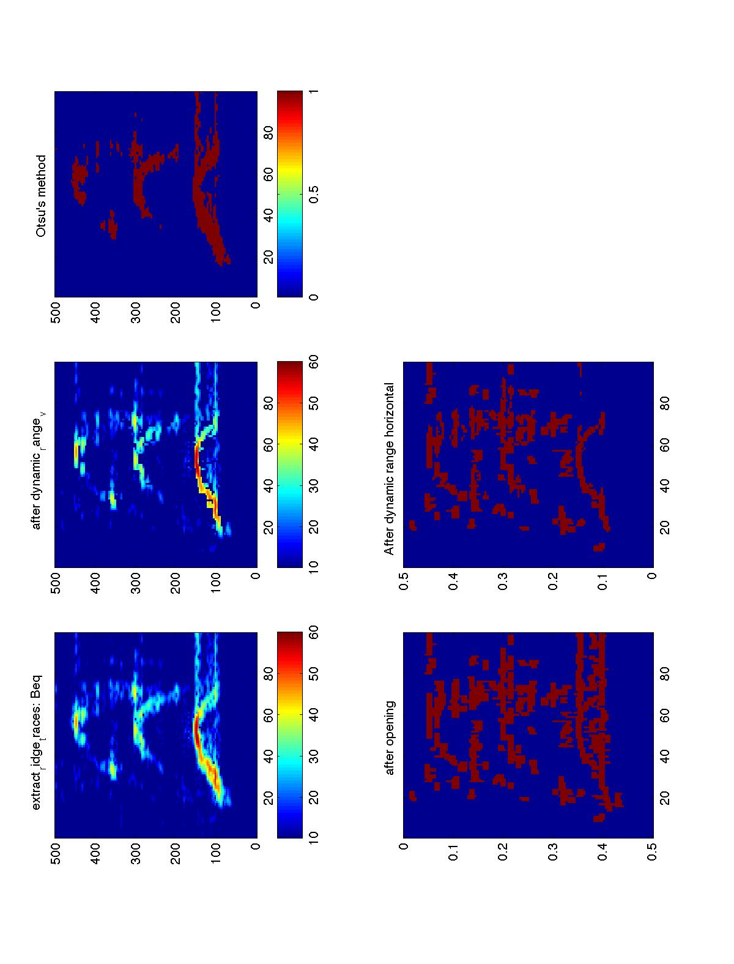

I’ve decided I need to construct dataset from scratch. 2007, one site one day is not enough, and I could use better equalized data…

Created a new version of all_processing_CollectManualSnippets.m and process_one_unit_CollectManualSnippets.m that loads snips files from manual matches:
/Users/thode/Projects/Greeneridge_bowhead_detection/Macmussel_Mirror/2010_Arctic_Analysis/BulkProcessing.dir. SVN stored in Automated_Arctic_Processing/CallClassification.dir

April 5, 2011. Running the revised all_processing_CollectManualSnippets.m and process_one_unit_CollectManualSnippets.m on macmussel in 2010_Arctic*/Bulk* directory. Most missed calls are 9 dB or less (when the JAVA detector threshold is 6 dB).

Files stored are of form ‘CallSnips_20100815_20100927_Site3_summary’ and ‘CallSnips_20100815_20100927_Site3’, with the latter storing the time series snippets.
best_call_count(Idate,Istation,Iwctype)
date_str{1}={'20100815','20100821','20100829','20100905','20100913','20100927'};

April 6, 2011
create_wctype_database.m written, which extracts a certain number of calls of each type from the 2010 dataset listed above, with the number of samples proportional to the relative frequency of occurance on each site/day. Also notes number of stations participating in a call.

----------------------------------------------------------------------
wctype Call Classification
----------------------------------------------------------------------
1.0 Up Sweep(/)
2.0 Down Sweep(\)
3.0 Near Constant tone(-)
4.0 Undulation(U)
5.0 Undulation(^)
6.0 Undulation(other)
7.0 Complex Call
8.0 Bearded Seal
9.0 Walrus
10.0 Man-made
11.0 Uncertain(Marine Mammal)
12.0 Unknown(Not Whale)
1.x Call Sequence: Up Sweep(/)
2.x Call Sequence: Down Sweep(\)
3.x Call Sequence: Near Constant tone(-)
4.x Call Sequence: Undulation(U)
5.x Call Sequence: Undulation(^)
6.x Call Sequence: Undulation(other)
7.x Call Sequence: Complex Call
8.x Call Sequence: Bearded Seal
9.x Call Sequence: Walrus
10.x Call Sequence: Man-made
11.x Call Sequence: Uncertain,Marine Mammal
12.x Call Sequence: Unknown(Not Whale)

Then wrote review_database.m, which adds a ‘review’ field and records results of manual review. Have also a field t

April 7, 2011
Selecting highest SNR detection for a call linkage is not the best idea. For example, Site 3B, 2010-09-13 00:58:51 has SNR 16.9 but no harmonics, while 3G has 8.7 SNR but harmonics.

Added a “dB_level” field to best_calls database; better judge of high-quality signal. Will have to rebuild all databases from scratch. Dang…

Criteria for manual review: two overlapping calls in time rejected.. Blobs rejected. Marginal calls detected on only one DASAR rejected.

Often a faint precursor or postcursor that influences whether an inflected ID or not.

Idea, deconvolution attempt to remove multipath…

“Staircases” of flat tones not uncommon…

“Common” determined in part by relative length of zero slope part. Some upsweeps have “flat” codas or precursors.

Complex has two local minima or more regardless of relative position….

“Split Us” frequency at high intensity—a downsweep, short puase, rapid upsweep

N-calls some strong ones have “lambda” shape with gap in middle.
Note there are 800 samples of n-shaped calls in database.

What is the difference between “undalation” and “complex” category? The latter is a catch-all, the former seems to consistently have two local minima-my mental definition of “complex”.

April 9, 2011
Finished first pass at reclassifying training data set. Wrote “review_database_multipath” to add a “multipath” field to log presense of modal arrivals. 16.5% of all calls reviewed had multipath. Constant and complex calls not reviewed for multipath.

Logged multipath as a number greater than zero that reps guess as to relative TOA of multipath. If form of input is .X1, then I think sample provides good visual example of multipath. If input is .X11 I think this is an excellent (publishable) example of multipath.

TrainingNValidationData2010_500samples now has a lot of work, and has ‘review’ and ‘multipath’ fields added for traiing data set.

April 12, 2011, polynomial spline attempted, Runge's phenomenon encountered. Will switch
To cubic spline…

Not much improvement—I need time to think about how to handle false minima. Should I do multiple-order polynomial fits plus residuals to feed into classifier?

