**Instructions for annotating files: Bowhead Sound Level Project**

**Aaron Thode**

This document explains the motivation behind the manual analysis for the “bowhead sound level project.” A group of analysts will review acoustic data collected by six recorders in the Arctic Ocean in 2010. The data will be used to investigate the source level distribution of bowhead whales, whether this distribution changes as the background wind-driven background noise levels change, and whether the apparent source level or number of harmonics change when measured from in front or behind the whales.

The analysis will use so-called “GSI” files collected form six “DASARS” between August and October, 2010. Each GSI file covers one day, beginning at midnight. These recorders have the ability to measure the bearing of a sound, as well as detect it. A computer program has been trained to recognize bowhead whale sounds and localize them using triangulation between recorders. The manual analyst will review these automated detections, fix any mistakes made by the computer, and add some additional information that will aid the final analysis.

The automated results will be divided into “East,” “Center,” and “West” sets, depending on whether the whale localizations contained occur to the east, within, or to the west of the six recorder array. These sets are stored as “annotation” files, which can be loaded and displayed in a software program called “Ulysses,” which is written in MATLAB. A call “event” is defined as a specific time and place where a whale sound is generated. A single event can be detected on several DASARS, which are called “call detections”. The estimated position derived from these detections is called a “localization,” and each DASAR contributing a bearing to the localization is called a “link”.

A companion document, “Instructions for Annotating Linked Detections,” provides step by step instructions on how these annotations are viewed and edited. The rest of this document details the specific information that must be logged for every event within a particular set of annotations (East, West, or Center).

**Items to do for each call event**

For a given day, start with DASAR G. After working your way through all the annotations on G, then start with DASAR E, etc. You should have fewer and fewer annotations to edits as you work your way down the list. Things work best if you view 60 seconds of data at a time. FFT size should be 256 or 512 with 90% overlap.

A: *Review each localization, add missing links, fix incorrect links.*

As detailed in the companion document, when the annotation files are loaded it is possible to jump between DASARs and check that the same event is indeed being detected for each localization. The first order of business is for the manual analyst to click through these links, then add links that may have been missed by the computer, and then fix links that are pointing to the wrong call event.

B: *Readjust bounding boxes*

The computer may not have drawn the “bounding box” correctly around an individual call detection, or may be drawing one box around several “harmonics” of a call (see below for definition of harmonics). These bounding boxes need to be fixed.

C: *Edit bounding boxes, including listing # of harmonics*

A key goal of the project is to see whether harmonics are directional; that is, whether they are more easily detected in front of the whale vs. behind it. Figure 1 below illustrates a call that has several harmonics. Harmonics are simply bands of energy whose frequency is an integer (or rational) multiple of the call’s fundamental frequency.

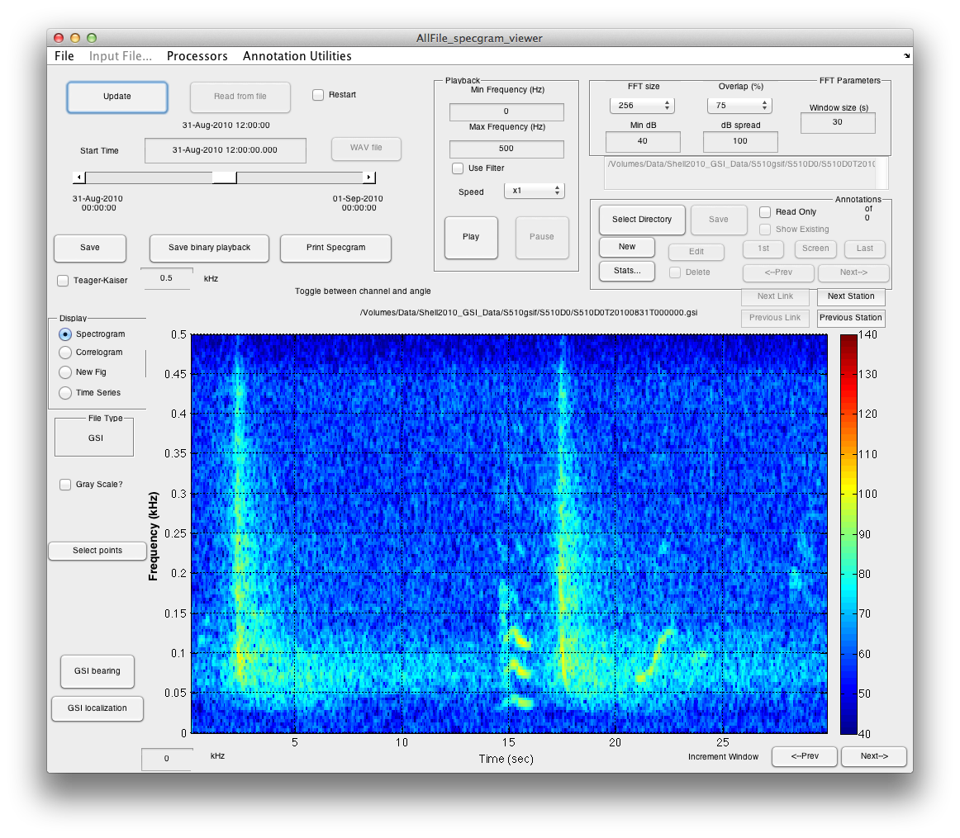

Figure 2: Call with harmonics (15-17 sec). The fundamental sound is at 30 Hz, with harmonics at 75, 125, and 175 Hz.

Once all linkages have been fixed and boundary boxes adjusted so that only the fundamental is covered, the annotation must be edited:

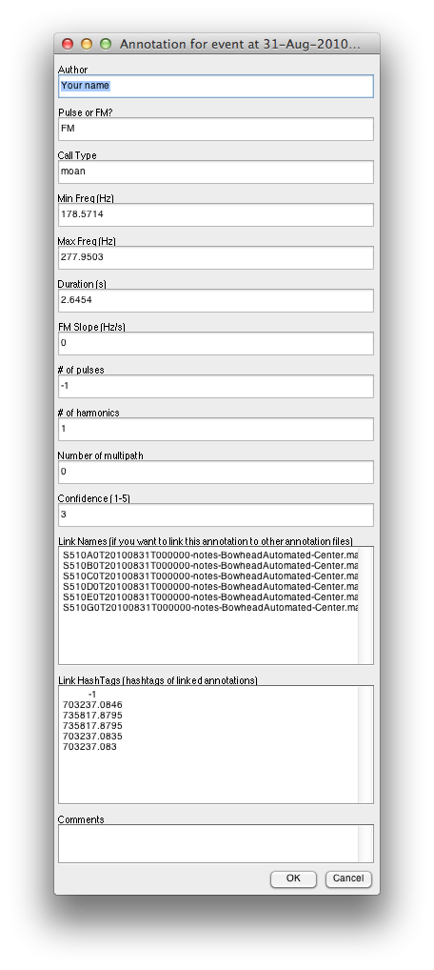

Enter your name under “Your name,” (you should only have to do this once per localization) and under “# of harmonics” enter the number of harmonic components you are going to have (including the fundamental). Thus a call with no harmonics will have the number “1,” and the call in Fig.1 will have the number “5” for the fundamental plus the four additional harmonics visible.

Three additional pieces of information are the call type, the number of multipath present, and the call slope.

C1: *Call types*

Under “call type,” enter “US” if call frequency is continuously increasing, (an “upsweep”), enter “DS” if call frequency is continuously decreasing (a “downsweep”), “UU” if call frequency pattern looks like a capital “U”, “NN” if pattern looks like a capital “N”, and “other” if the pattern is more complex. This information only needs to be entered at the DASAR closest to the call (as can be determined by the map).

C2: *Number of multipath present*

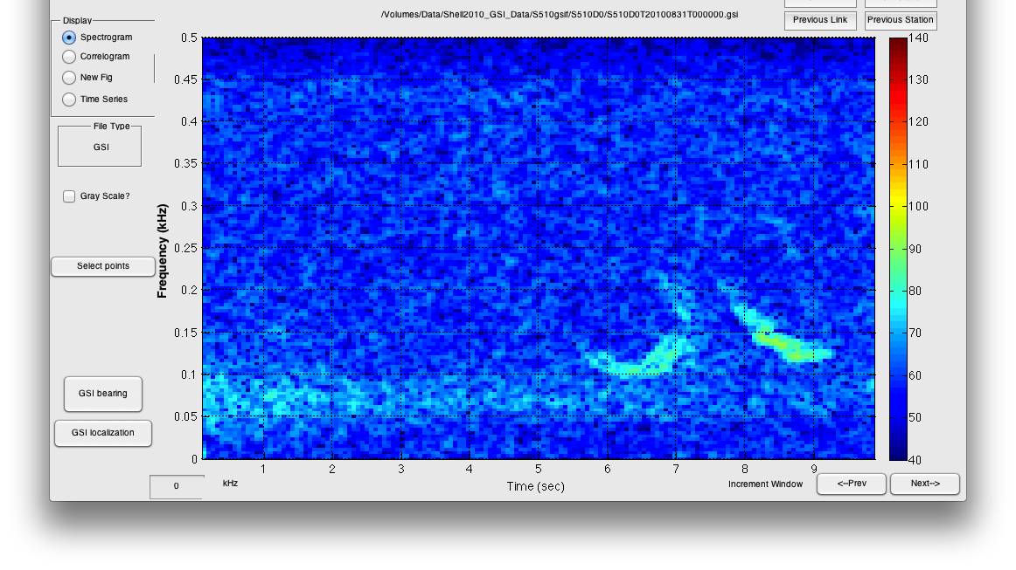

A call detection can be accompanied by “echoes,” or multiple arrives of the same signals. These echoes have the same pattern as the main signal, but arrive at a slightly later time. As the figure above shows (red arrow points to a multipath), multipath arrivals are different from harmonics: a multipath arrival covers the same frequency band as the original signal, but the arrival time is shifted, while a harmonic occupies a completely different frequency band, but has no time delay relative to the fundamental.

Enter the number of multipath observed in the “number of multipath” field. Hit OK to register your changes so far.

C: Add harmonic bounding boxes

As detailed in the companion document, you will then add one bounding box for each harmonic (using the “Adding harmonic” button). All the information you entered into part “C” above will automatically be copied into the harmonic annotations.

And that’s it for a particular localization! Click the links button until you are back to the original DASAR you began with. Now wash, rinse, and repeat. The changes you make should be saved frequently onto your laptop. Please note the annotation number and DASAR you are working on whenever you quit a session, so that you can easily pick up where you left off. I would recommend starting with DASAR ‘G’ and working your way down through station ‘A’. As you work your way through the DASARs for a particular day, you should find that you need to make fewer edits, because the changes you made on previous DASARs should be reflected in other DASARs.

Even though the annotation ‘note’ files are saved every time you hit a ‘Link’ or ‘Station’ button, I also recommend backing up your ‘notes’ files in a ‘Backuup’ folder, so that if you do run into real trouble, you don’t lose all your work for that day.