# Lego Star Wars Set Tracker Site Plan

## [Tyler Muir]

## WDD 130

## Overview

### Purpose

Provide a website to track your Lego Star Wars collection

### Audience

Lego fans and Star Wars nerds

## Branding

### Website Logo

## Style Guide

### Color Palette

|  |  |  |  |
| --- | --- | --- | --- |
| **Primary** | **Secondary** | **Accent 1** | **Accent 2** |
| #1B1F3B | #D62828 | #F7E733 | #A8DADC |

### Typography

#### Heading Font: ‘Orbitron’, sans-serif

#### Paragraph Font: ‘Roboto’, sans-serif

### Navigation

Home Page2 Page3

**Content**

**All pages:**

Header with logo on the left. Home, News, Ideas on the right

Footer with a copyright symbol LegoStarWarsTracker, and Contact Us. The pictures have an about but I changed my mind.

Home:

Has a search bar (doesn’t need to function, just look nice)

Side bar with filters for owned sets, wish list, retired sets, and UCS sets. (again, this doesn’t work, just looks nice)

The home page has a ‘set of the day’ (razor crest).

The description on the set of the day is:

Razor Crest

Item #75331

Minifigures: 5

Pieces: 6187

Dimensions – H:10”, W:20”, D: 29”

Price $599.99

News:

Has 3 boxes that each have a picture of a set, a headline, and a description.

**Headline: New! Jango Fett’s Starship!**

Paragraph: The new Jango Fett’s Starship set launches is just 2 months! Pre-order yours now. It’s just $600. So what if your family doesn’t eat.

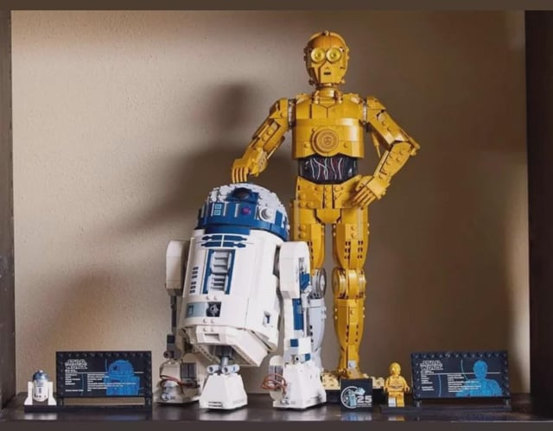

**Headline: Are these the droids you’re looking for?**

Paragraph: Yes! These are definitely the droids you’re looking for. Add them to your collection today.

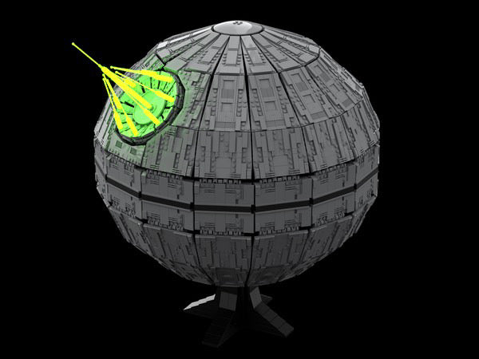

**Headline: Time shares on Alderaan have dropped to an all-time low!**

Paragraph: Find out why yourself. Grab the new Lego Death Star today.

Ideas Page:

Big centered button for users to submit their own idea (doesn’t work, just looks nice)

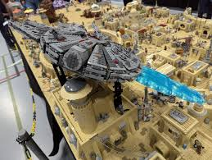

**User: legonoob Title: super easy Mos Eisley set you can build at home**

Description: I threw this thing together in a couple hours and thought I’d leave this here.

**User: legobatman Title: Storm Trooper Shooting range**

Description: I need help making this AI picture of a storm trooper shooting range come to life!

**Wireframes**

**Home, News, Ideas**

