|  |  |  |  |  |  |  |  |  |  |  |  |  |  |  |  |  |
| --- | --- | --- | --- | --- | --- | --- | --- | --- | --- | --- | --- | --- | --- | --- | --- | --- |
|  | Specific Code | Background | Midground | Enemy_01 Art | Enemy_01 Audio | Enemy_02 Art | Enemy_02 Audio | Enemy_03 Art | Enemy_03 Audio | Enemy_04 Art | Enemy_04 Audio | Enemy_05 Art | Enemy_05 Audio | Specific Art | Intro Audio | Background Audio |
| Level_000 |  |  |  |  |  |  |  |  |  |  |  |  |  |  |  |  |
| Level_001 |  |  |  |  |  |  |  |  |  |  |  |  |  |  |  |  |
| Level_002 |  |  |  |  |  |  |  |  |  |  |  |  |  |  |  |  |
| Level_003 |  |  |  |  |  |  |  |  |  |  |  |  |  |  |  |  |
| Level_004 |  |  |  |  |  |  |  |  |  |  |  |  |  |  |  |  |
| Level_005 |  |  |  |  |  |  |  |  |  |  |  |  |  |  |  |  |
| Level_006 |  |  |  |  |  |  |  |  |  |  |  |  |  |  |  |  |
|  |  |  |  |  |  |  |  |  |  |  |  |  |  |  |  |  |

# To Do List – Public Beta

Aaron

1. Share to facebook
2. Share to twitter
3. Toxic glow behind kellia background (green-yellow )

Milos (Focus Dune)

1. Dune Enemy_05
2. Dune Enemy_04
3. Plasma explosion
4. Blood Splatter
5. Rhea planet icon
6. Dune background specific art

# Story

Basically you are exploring a solar system that is very hostile. Every planet you land on has natives who are attacking your ship.

# Characters

Player –

**Mercenary** – Need a bit of help wielding all that fire power on your ship? Hiring mercenaries will allow you to make use of your ships weapons.

**Engineer** – Is your forcefield taking a bit of a beating? Engineers will help repair your forcefield, even when underfire.

**Scientist** – Found yourself a blueprint? Shame those squiggles mean nothing to you, hire a scientist and they may know what is means.

Enemies

Meele – Runs all the way up to the forcefield and attacks it with their hands or a melee weapon.

Gunman – Walks to a distance away from the forcefield then periodically fires weapon.

Suicider – Runs fast at the forcefield, when they do they die in some sort of explosion that kills them, damages enemies close to them and damages the wall.

Vehicle Land – Drives / Hovers to a firing distance then fires its weapon periodically (hits harder then standard gunman). Has a high armour level.

Rocketman – Acts similar to a gunman however fires rockets at the wall. The rockets can be shot down mid flight.

Vehicle Air – Flies to a firing distance then fires it weapon periodically. If fired upon the vehicle flies either along the x axis or the y (but not both)

# Level Design

Planets

**Astaria – Easy (7.34)** – This world has never before seen extra-terrestrial life, they were quite content with the idea that they were alone in the universe and never tried to pursue space exploration. Therefore their technology is rather lacking, limited to melee weapons and gun powder based weapons.

The alien inhabitants of this planet are reptilian humanoids, they walk on two legs, have arms and pretty much look like green humans with scales and pointy heads.

Blueprints – 2 (1 ship / 1 weapons)

**Patiess – Easy** – Patiess is a fairly modern civilisation, themselves having fought several global scale wars have become quite technologically advanced and have progress the beginning of space travel. Although unaware of extra-terrestrial life they presume there are aliens and have armies on standby to deal with such threats.

Blueprints – 3 (2 / 1)

**Kellia –** **Medium** – Kellia is a world inhabited by synthetic AIs. They were originally created by the natives of Rhea, When a war broke out between them the AIs fled to Kellia when they calculated they would lose the war. The AI do everything by night as they spend the day re-charging their energy supplies using solar panels

Blueprints – 3 (2/ 1)

**Dune –** **Medium (5.34)** – Dune is a planet comprising of vast deserts, because of this its inhabitants are survival hardened people. Their weaponry and technology consists of a mismatch of salvaged tech from over the years, and their many wars. The alien species are feline-humanoids, an extremely distant relative of the lynx.

Blueprints – 4 (1 / 3)

**Maia –** **Hard** – Maia used to be a modern eden, a land of beauty. Now it is a hive of those outcast from Rhea. Maia has no governing bodies but territories are controlled by varying gang factions, one things the gangs do agree on is ‘Outsiders are not welcome’. Nowadays looks like an industrial swampland.

Blueprints – 4 (2 / 2)

**Rhea –** **Hard** – A technologically advanced, militaristic world. Their military is heavily augmented and hits hard. The inhabitants of Rhea is the only human colony in the area, however at this point the human race is extremely technologically advanced and have adapted themselves with bionic enhancements and exo-skeletons, becoming a mixture of man & machine.

Blueprints – 4 (2 / 2)

# Gameplay

Enemy Drops

Fuel – Fuel is a pick up generated from the death of enemies, It is automatically collected on the enemies death if dropped. Fuel allows the player to move between different planets (levels). Incremental value, with a 60% chance of dropping. The fuel value is a random integer between 2 and 13 (inclusive).

Blueprint – Blueprints are dropped on the death of an enemy and is automatically collected (player is notified however). The blueprint will be specific to that world and will allow the player to research one of the weapons / ship upgrades specific to that world. There is a 0.5% chance of a blueprint dropping on the death of an enemy. The blueprint will pick a random upgrade of those available for that planet.

Weapons – 11

**Blaster 3000X** – Default – Single – 75

**Carmack Rifle** – Astaria – Single – 100

**M24 Assault Rifle** – Patiess – Auto – 50

**Zeus Rifle** – Kellia – Single

**Skull Crusher** – Dune – Single

**Scar** – Dune – Auto

**Eden** – Dune – Single

**Temp** – Maia – Auto

**Temp** – Maia – Auto

**Proton Rifle** – Rhea – Single

**The ‘Dominator’** –Rhea – Auto

Ship Upgrades – 10

**Field Booster I**

**Crew Quarters I**

**Ship Weapons I**

**Refinery**

**Field Booster II**

**Crew Quarters II**

**Ship Weapons II**

**Field Booster III**

**Laboratory**

**Crew Quarters III**

# Art

Astaria - Landing area is next to a small village

* Sky – Day to night
* Background – Small village, consisting of small houses and shacks’ made of wood
* Midground – Flat Grasslands with maybe a small lake/pond (make pond a separate asset)

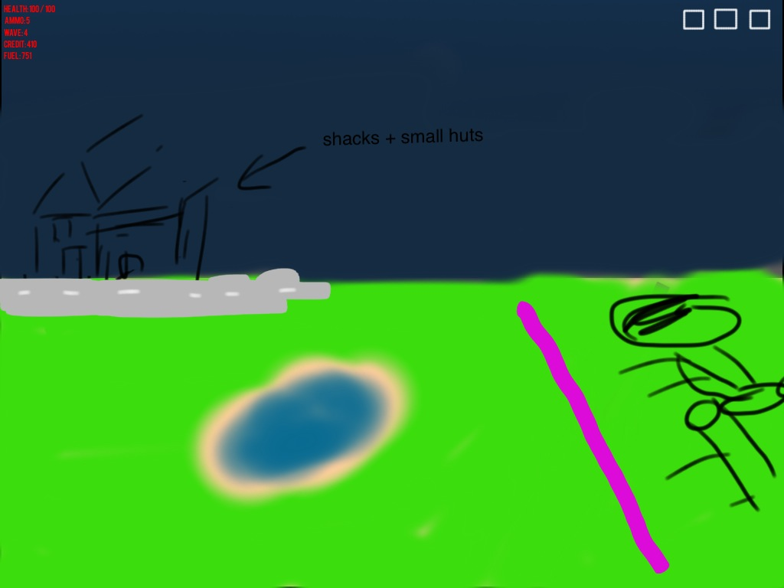

* Melee Enemy – (Run/Attack/Die) – Reptilian villager, wearing an old fashioned (Amish style) clothes, carrying a pitchfork as a weapon. When it reaches the barrier it repeatedly thrusts the pitchfork at the barrier.
  + <http://i.imgur.com/dv4dJ.png>
  + <http://reprog.files.wordpress.com/2010/05/picture-31.png>
* Gunman Enemy – (Walk/Shoot/Die) – Same reptilian appearance, wearing an old fashioned army uniform (similar to Austro-Hungarian), carries a musket in both hands. When reaching place to fire, changes into a firing stance and begins periodically firing.
  + [http://upload.wikimedia.org/**wikipedia**/commons/4/45/KuK_Kavallerie_1898.jpg](http://upload.wikimedia.org/wikipedia/commons/4/45/KuK_Kavallerie_1898.jpg)
  + <http://www.taylorsfirearms.com/media/catalog/category/Muscet-Categoy-Page462.jpg>
* Suicide Enemy – Ignore this enemy for now, thinking of removing.
* Grenadier Enemy (Move/Throw/Die) – Appears like the gunman, same uniform, however has no gun and carries a backpack instead. The enemy throw lit tnt sticks at the wall which damages a large area around them.
  + Rocketman tnt stick – just a little tnt stick with a lit fuse animation.
* Vehicle Enemy – (Move/Shoot/Die) – Enemy solider pushing a Gatling gun, when they get to a set position from the wall they stop and enter fire mode. Fires three shot burst then rests.
* Vehicle Enemy – (Move/Shoot/Die) – Enemy solider pushing a cannon, when they get to a set distance they stop enter firing mode. Periodically light a fuse on the cannon which then fires a cannonball projectile at the forcefield.
  + http://upload.wikimedia.org/wikipedia/commons/2/21/Cannon-IMG_1780.jpg
* Flying Vehicle Enemy – There won’t be a flying enemy in the first level

Patiess – Landed in a open area in the middle of a metropolis

* Sky – Day to Night
* Background – Tall modern buildings (However must still be able to see the sky)
* Midground – You have landed in a small park with green grass. The park is about the size of the ship and square. Infront of the park and extending left to the edge of the screen is a road.

Kellia –

* Sky – Night to Day
* Background – Hubs between which are many dark cables. Occasional sparks fly out from the connections between hubs and cables etc.
* Midground – Platform surrounding just the ship and the forcefield, platform is made of a dark metal, has booster on it enabling it to hover.

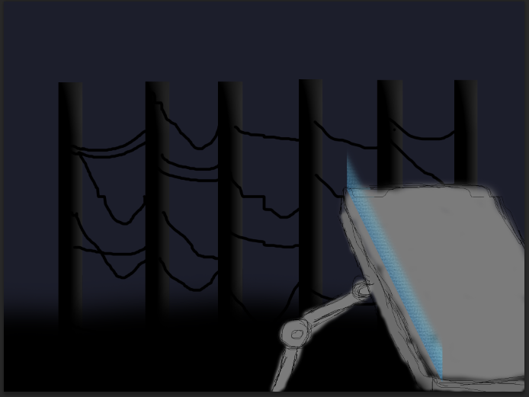

Dune –

* Sky – Day to Night (very red dusk)
* Background – Sand Dunes with some boulders & cliffs.
* Midground – Sand plain
* Meele Enemy – (Run/Attack/Die) - (Use feline alien 3-01.png with the scarf from feline alien-01.png) for a weapon the alien uses a electromagnetic sword (basically a lightsabre)
* Gunman Enemy
* Grenadier Enemy – (Run/Throw/Die) – Appears in the same standard bandit style outfit, carries a belt with frag grenades on it. Throws frag grenades with a standard explosion.
  + Frag grenade – little spinning frag grenade.
* Gunman Enemy
* Vehicle Enemy – (Move/Shoot/Die) – Quad bike with mounted turret machine gun. When dying the vehicle explodes(explosion fire will be added in game).

Maia

* Sky
* Background
* Midground - swamplands

Rhea – Landed near what appears to be a military area / spaceport.

* Sky – Day to Night
  + <http://img2.wikia.nocookie.net/__cb20100721191415/masseffect/images/d/d7/MassEffect2Citadel.jpg>
  + <http://fc03.deviantart.net/fs70/f/2011/262/f/6/f6ec7a1302855d64927fa757b7ed9dac-d4aagve.jpg>

Explosions

* Small Explosion
* Medium Explosion

Weapons

Planet Portraits

Crew Portraits

* Mercenary
* Scientist
* Engineer

Game iOS Icon

# Audio

# UI / Controls

# Save Format

Wave (int)

Planet (int)