PU Learning – Learning from Positive and Unlabelled Data

| Aaron Ward  ATC  Dublin, Ireland  Aaron_ward@optum.com |
| --- |

# ABSTRACT

## It is often the case that companies want to carry out some machine learning task to perform classification on data, but are cursed with problem of having insufficient or unreliable labels. Alternatively, you could hand label your data, but hand labelling data can be a demanding task which could also lead to human bias or erroneous mistakes. What if it is the case that you only have labelled data for the positive class, but you have a lot of unknown cases in your unlabeled data?

## Author Keywords

# *ai, machine learning, unlaballed data, weak supervision*

# INTRODUCTION

PU Learning, which stands for positive and unlabeled learning, is a semi supervised binary classification method which recovers labels from the unknown cases in the data. It does this by learning from the positive cases in the data and applying what it has learned to relabel the unknown cases. This approach provides benefits to any machine learning problem which requires binary classification on unreliable data, regardless of the domain.

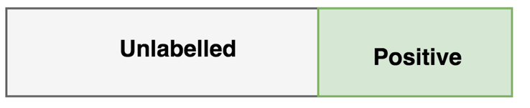

# Description

There are two main approach to applying PU Learning. These include *PU Bagging* and the *Two-Step-Approach*.

**PU Bagging**

PU Bagging is a parallelizable method which takes random subsamples of the unknown cases and creates an ensemble of classifiers to output a score for each sample. The steps include:

1. Randomly sample subsets of the unlabeled data and all positives.
2. Build an ensemble of classifiers with this "bootstrapped" dataset - treating positive as 1 and unknown as 0
3. Predict probability scores of unknowns that were **not** sampled in training - known as the out-of-bag samples (OOB)
4. Repeat many times and calculate the average OOB scores

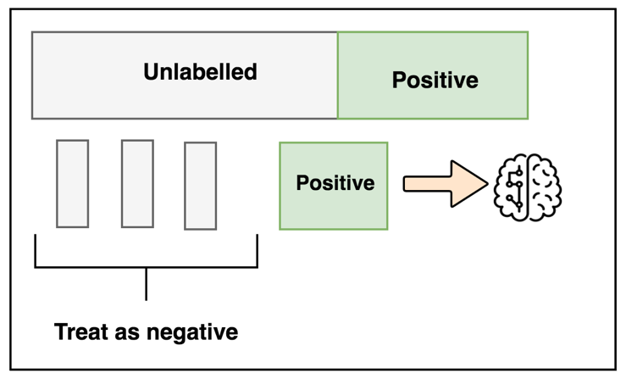

**Two-Step Approach**

The two-step approach is a more complex method or PU Bagging that uses machine learning techniques to relabels data while training. The steps for implementation are as follows:

1. *Step one*
   1. Train a classifier on positive and unlabelled cases.
   2. Get a score range for definite positive cases to label definite "not positives"
2. *Step Two*
   1. Train a second classifier on your newly labelled dataset and repeat this process iteratively until a criterion is met

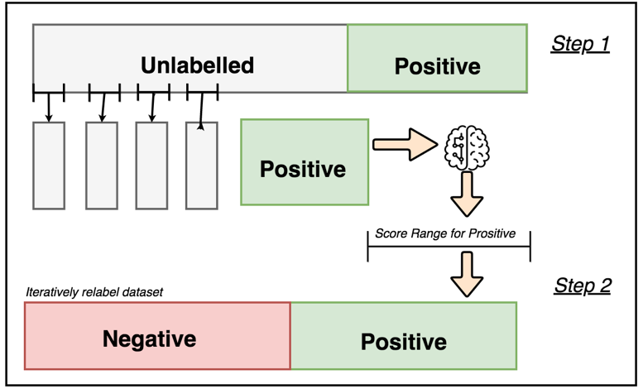

# Conclusion

Not all datasets are labelled, but through informed weak supervision accurate machine learning models can still be implemented.

These methods can be applied in many areas, an example of which is detecting spam email - where you would want to find positive cases of spam within the unknown sample (IE: emails that were not originally caught as spam).

So far this has been experimented only with *random* *forests*. future work would involve investigating multiclass PU Learning and other implementations to achieve more reliable relabeling such as

# REFERENCES

1. PU Learning workshop (2017) - U-Tokyo (<https://niug1984.github.io/paper/niu_ibisml030.pdf>
2. Blog (Roy Wright) discussing PU state of the art (circa 2014-15), with Python examples. (<https://roywright.me/2017/11/16/positive-unlabeled-learning/>)
3. A Robust Ensemble Approach to Learn From Positive and Unlabeled Data Using SVM Base Models by Claesen Et Al. (<https://arxiv.org/abs/1402.3144>)