9 | 10 | 11 | 12 | 13
8 | 9 | 10 | 11 | 12
7 |  |  | 12 | 13 |  |  | T
6 |  |  | 13
5 |  |  |  |  | U
4 |  |  |  |  | 13 | 12 | 11 |  | 13
3 |  |  |  |  |  |  | 10 |  | 12
2 |  |  |  |  |  |  | 9 | 10 | 11
1 | S |  |  | 5 | 6 | 7 | 8 | 9 | 10
2 | 1 | 2 | 3 | 4 | 5 | 6 | 7 | 8 | 9

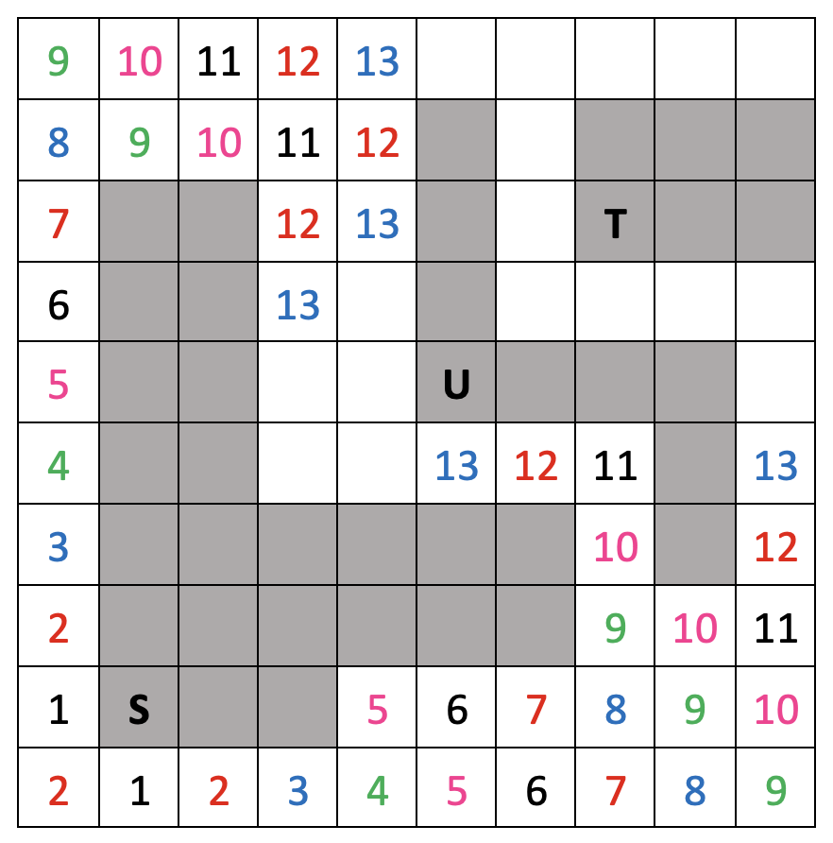

3 | 1 | 2 | 3 | 1 | 2 | 3
2 | 3 | 1 | 2 | 3 |  | 1
1 |  |  | 3 | 1 |  | 2 | T(3)
3 |  |  | 1 | 2 |  |  | 2 | 1 | 3
2 |  |  | 2 |  | U |  |  |  | 2
1 |  |  |  | 2 | 1 | 3 | 2 |  | 1
3 |  |  |  |  |  |  | 1 |  | 3
2 |  |  |  |  |  |  | 3 | 1 | 2
1 | S |  |  | 2 | 3 | 1 | 2 | 3 | 1
2 | 1 | 2 | 3 | 1 | 2 | 3 | 1 | 2 | 3

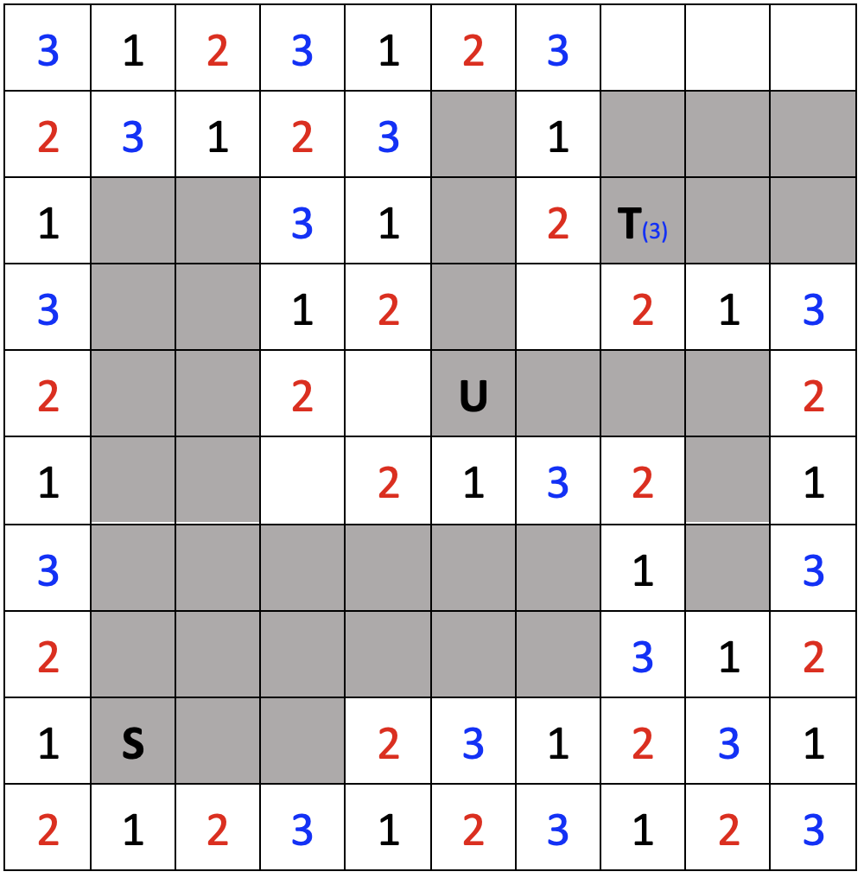

1 | 1 | 2 | 2 | 1 | 1 | 2
2 | 1 | 1 | 2 | 2 |  | 2
2 |  |  | 2 | 1 |  | 1 | T
1 |  |  | 1 | 1 |  |  | 1 | 2 | 2
1 |  |  | 1 |  | U |  |  |  | 1
2 |  |  |  | 1 | 1 | 2 | 2 |  | 1
2 |  |  |  |  |  |  | 1 |  | 2
1 |  |  |  |  |  |  | 1 | 1 | 2
1 | S |  |  | 1 | 1 | 2 | 2 | 1 | 1
1 | 1 | 1 | 2 | 2 | 1 | 1 | 2 | 2 | 1

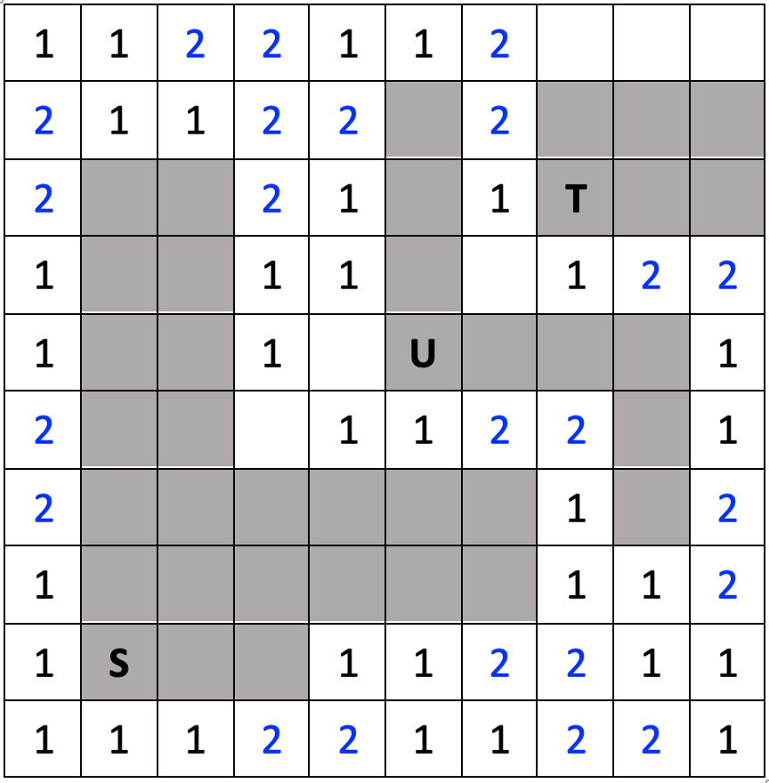

 |  |  |  | 3 | 3 | 3 | 3
 |  |  |  | 2 |  | 3
 |  |  |  | 1 |  | 3 | T
 |  |  |  | 1
 |  |  |  | 1 | U
 |  |  |  |  | 1 | 1 | 1
 |  |  |  |  |  |  | 2
 |  |  |  |  |  |  | 3
 | S

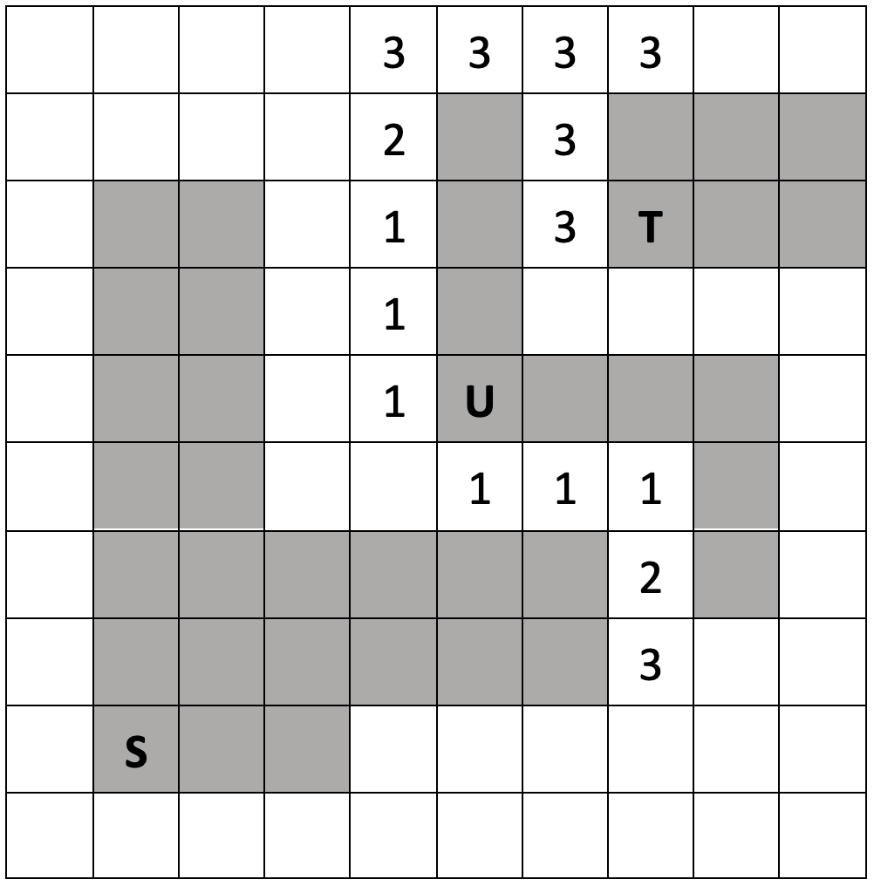

・
T
U
S

