Nasa Lab 10
B13901011 吳亞倫
- Server
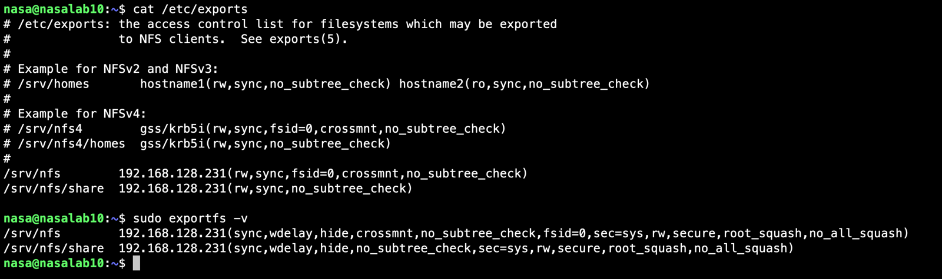
- Client
