A Multi-Paradigm Benchmark of Molecular Docking: From Physics to Co-folding and Hybrid Models
Ao Xu,† Jordy Homing Lam,‡ Aiichiro Nakano,†,‡,¶ and Vsevolod Katritch*,‡,§,‖
†Thomas Lord Department of Computer Science, University of Southern California, Los Angeles, CA, USA
‡Department of Quantitative and Computational Biology, University of Southern California, Los Angeles, CA, USA
¶Department of Physics and Astronomy, University of Southern California, Los Angeles, CA, USA
§Department of Chemistry, University of Southern California, Los Angeles, CA, USA
‖Department of Pharmacology and Pharmaceutical Sciences, University of Southern California, Los Angeles, CA, USA
E-mail: katritch@usc.edu

Abstract
Generalizability of molecular docking predictions across novel protein targets and distinct small-molecule chemotypes is key to the successful application of deep learning co-folding approaches in drug discovery, as highlighted by recent benchmarks, including Runs-n-Poses.¹ To compare generalizability across physics-based, hybrid rescoring models, and co-folding approaches, we systematically benchmarked several molecular docking tools representing these paradigms. Our results support previous observations that co-folding approaches show superior performance on targets resembling their training datasets. However, they deteriorate sharply to unacceptably low 25–40% success rates on novel systems, consistent with memorization. In contrast, physics-based and hybrid methods exhibit greater out-of-distribution robustness, maintaining more than 60% success rates for docking protein–ligand complexes with minimal similarity to previously known complexes. Our results highlight the complementarity of AI-based approaches and methods based on physical sampling in all-atom models, in terms of their applicability range, and argue for the benefits of tighter integration.

Introduction
The prediction and characterization of interactions between small molecules and their biological targets are central to modern drug discovery and structural biology. These computational tasks, collectively referred to as molecular docking, aim to predict the dominant binding mode(s) of a ligand within a receptor binding site and to estimate the associated binding affinity.^{2,3} Within structure-based drug design, docking enables screening of chemical libraries and spaces that can now reach billions and trillions of compounds. It is a central tool in prioritizing candidates for experimental follow-up^{4–6} as well as the starting point for advanced simulation methods such as free energy perturbation. By providing atomic-level details of protein–ligand complexes, docking also offers intuitive insights into molecular recognition mechanisms, including hydrogen bonding, hydrophobic packing, and electrostatic complementarity, which are crucial for rational optimization and understanding drug action and resistance.
Molecular docking methods have evolved substantially over the past decades (Figure 1), progressing from classical search-and-score engines, to hybrid pipelines that rescore physics-generated poses with learned models, to diffusion-based generative pose samplers, and finally to end-to-end co-folding systems that predict protein–ligand complexes directly. This evolution reflects a broader shift in computational approaches from explicit physics-based models to data-driven deep learning.⁷ Tools such as AutoDock Vina⁸ and Molsoft ICM⁹ employ stochastic global search, which combine acceptance ratio sampling with local optimization to explore the translational, rotational, and conformational degrees of freedom of a ligand within a specified binding region. Typically, the search is performed on a semi-empirical force field defined by internal coordinates, which includes empirical and physics-based scoring functions that approximate van der Waals interactions, electrostatics, hydrogen bonding, and desolvation terms. Their grounding in physicochemical principles tends to constrain predictions to physically plausible configurations, and as a result they do not rely on prior training data. However, their accuracy remains limited due to their crude functional forms, which only partially capture the thermodynamics of binding,^{10,11} and by the computational expense of sufficiently thorough sampling.
Hybrid docking methods bridge classical physics-based sampling with machine learning–based scoring. A representative example is GNINA,¹² which first employs the AutoDock Vina search engine to generate candidate binding poses and then applies convolutional neural networks (CNN) to rescore these poses. In this framework, the deep learning component operates purely as a rescoring layer and does not perform pose generation itself. Consequently, GNINA’s ultimate performance remains fundamentally constrained by the quality and diversity of the initial pose ensemble produced by AutoDock Vina; for example, full rigidity of the binding pocket model cannot be remedied by the CNN rescoring stage alone.
More recently, docking has been reframed from a search-and-score procedure into a conditional generative modeling problem. In these approaches, the goal is to learn a probability distribution over ligand poses conditioned on the protein structure, and to sample from this distribution using a learned gradient predictor rather than explicit gradient computation. Denoising diffusion probabilistic models (DDPMs),¹³ as implemented in tools such as DiffDock,¹⁴ SurfDock,¹⁵ and DynamicBind,¹⁶ are generative models that operate on the SE(3) (or closely related SO(3)-based) manifold of molecular configurations. Starting from noise-like initial poses, the conformation is iteratively denoised through a learned reverse diffusion process to generate candidate binding modes. These methods have shown strong performance on retrospective benchmarks that resemble their training distribution and offer a statistical view of pose generation. However, because they rely on training data to induce physical validity, physical constraints are not strictly enforced. Hence, their behavior on novel targets and chemotypes is not guaranteed and can exhibit failure modes in out-of-distribution settings.
The latest frontier of the field is represented by end-to-end co-folding models, inspired by the success of AlphaFold2 in single-chain protein structure prediction.¹⁷ Methods such as AlphaFold3,¹⁸ Chai-1,¹⁹ Boltz-2,²⁰ and NeuralPlexer²¹ aim to predict the full three-dimensional structure of a protein–ligand complex directly from sequence-level or graph-level inputs, often requiring only a protein sequence and a ligand identifier (e.g., SMILES). By folding the protein in the presence of the ligand, these models implicitly address protein flexibility and can, in principle, tackle fully blind docking scenarios in which the binding site is unknown a priori. However, such end-to-end systems are at particular risk of hallucinating interactions based on patterns memorized from training data, rather than on transferable physical principles, complicating their use in genuinely prospective applications.
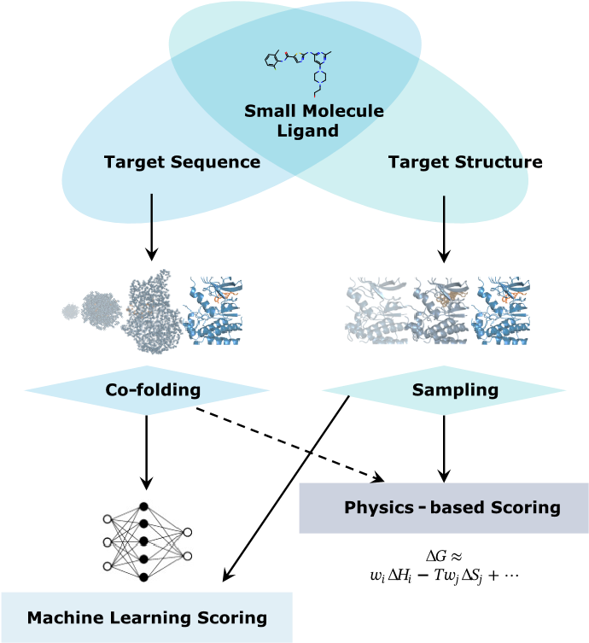
Figure 1: An Overview of Different Molecular Docking Approaches.
Despite impressive reported accuracies, a central unresolved question for AI-based docking and co-folding models is their ability to generalize beyond their training distribution. Many existing evaluations rely on test sets with substantial overlap or high similarity to training data, making it difficult to distinguish genuine learning of transferable principles of molecular recognition from sophisticated pattern matching or memorization.¹ To explicitly probe generalization, the Runs N’ Poses dataset was introduced.¹ It comprises high-resolution protein–ligand complexes released after the widely adopted training cutoff date of 30 September 2021 through 5 January 2025, and provides annotations quantifying each target’s similarity to its nearest pre-2021 structural neighbor. However, existing analyses using Runs N’ Poses focus exclusively on co-folding models and do not evaluate physics-based or hybrid docking approaches, precluding a unified comparison across paradigms.
More broadly, prior benchmarking studies either report aggregate accuracy metrics without accounting for training-set similarity,^{22–24} or restrict their analysis to a narrow subset of modeling paradigms. In this work, we leverage Runs N’ Poses¹ to systematically benchmark three major classes of molecular docking methods—classical physics-based engines, diffusion-based generative models, and end-to-end co-folding approaches—under a unified, similarity-stratified evaluation framework. By analyzing performance as a continuous function of similarity to pre-2021 training data, we directly quantify how docking accuracy degrades with increasing novelty and contrast generalization behavior across paradigms. We find that AI-driven models achieve their strongest gains on targets closely resembling their training data but exhibit pronounced performance deterioration on novel systems, consistent with a reliance on memorized structural patterns. In contrast, physics-based and hybrid methods display substantially greater robustness in out-of-distribution regimes. Together, these results underscore the continued importance of explicit physical potentials and sampling, and argue for tighter integration of data-driven learning with well-founded physicochemical principles.

Results and Discussion
Docking paradigm performance comparison
To evaluate diverse docking paradigms, we selected a representative suite of tools spanning physics-based, hybrid, and co-folding approaches. For physics-based engines, we utilized AutoDock Vina⁸ as a standard open-source baseline. We also included Uni-Dock, a GPU-accelerated implementation of Vina, to enable a parallel comparison of computational efficiency and accuracy, which, as shown in Figure 2, faithfully reproduces the accuracy profile of Vina. Additionally, we selected Molsoft ICM,⁹ a commercial package that has demonstrated superior sampling capabilities in prior benchmarks.²⁵ For hybrid models, which augment classical sampling with deep learning rescoring, we employed GNINA;¹² this tool uses MCMC for conformational search followed by a CNN-based rescoring function. Similarly, we evaluated Molsoft ICM-RTCNN, which couples the ICM sampling engine with a machine learning–based rescoring module. For co-folding models, we chose AlphaFold3,¹⁸ Chai-1,¹⁹ Boltz-1,²⁶ and Protenix,²⁷ which offer accessible alternatives with similar architectural principles. We did not include Boltz-2²⁰ because its training set overlaps the test set benchmarked here. Detailed implementation protocols, including version numbers and command-line parameters, are provided in the Supporting Information.
All methods were executed using publicly released versions and recommended inference protocols. Docking search spaces were defined consistently across physics-based and hybrid methods, and no method-specific tuning was performed on the test set.
Performance of all methods was assessed using the Runs N’ Poses benchmark,¹ comprising high-resolution structures deposited after September 30, 2021. This temporal split ensures a zero-shot evaluation for models trained prior to this date. To quantify generalization, test targets were stratified by novelty using the SuCOS score,²⁸ which combines Tanimoto ligand similarity and similarity of shape-based pocket coverage relative to the pre-2021 training data. Success was defined as a root-mean-square deviation (RMSD) < 2.0 Å between the predicted and experimental ligand poses.
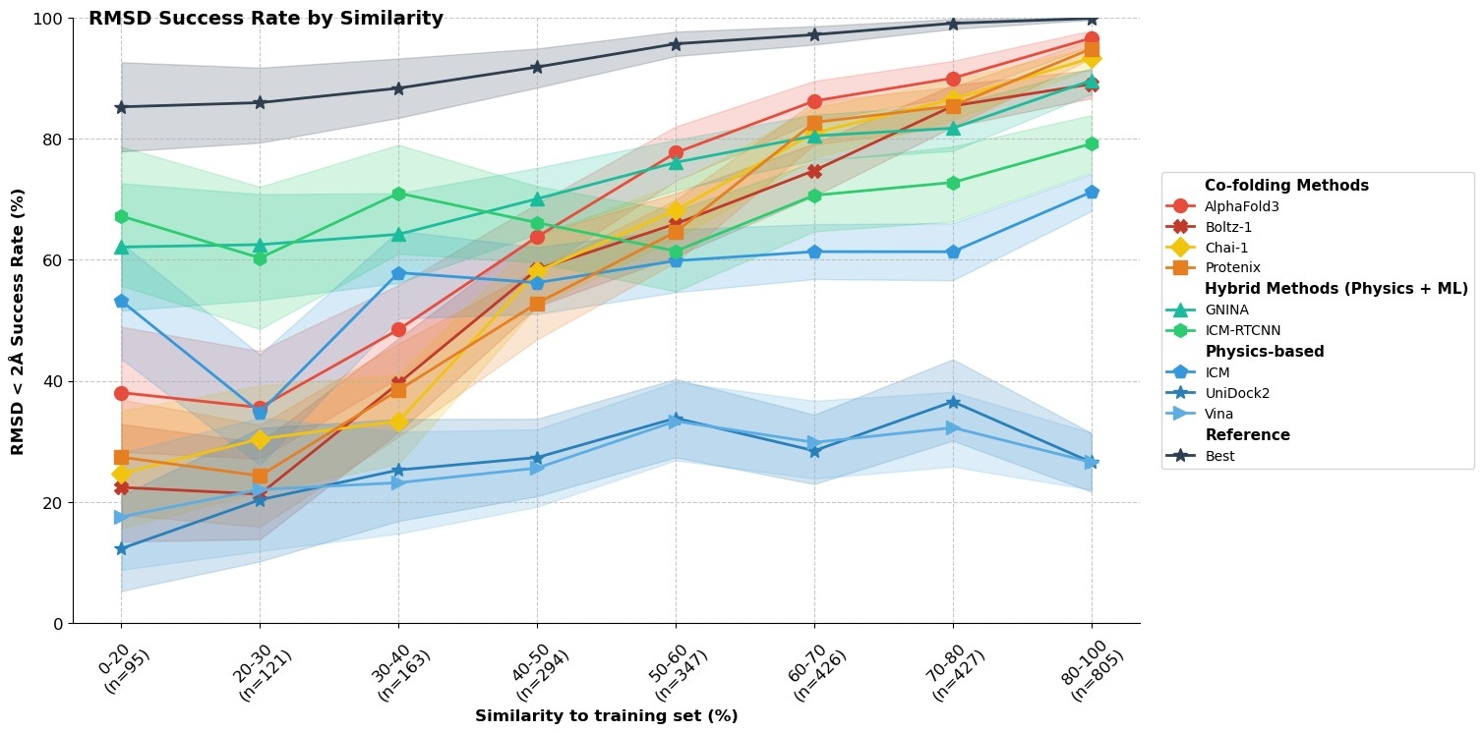
Figure 2: RMSD success rate as a function of similarity to the training set. RMSD ≤ 2 Å success rates are shown for each docking method across bins of ligand–protein similarity to the method’s training data (x-axis; bin size 10%, with number of systems indicated below each bin). Curves and markers denote different method families (co-folding, hybrid physics+ML, and purely physics-based), and the “Best” reference line shows the success rate achieved by selecting the best pose across all methods. Shaded bands indicate variability across systems within each similarity bin.
Our analysis reveals that docking performance is modulated by similarity to the training set, revealing critical differences between modeling paradigms. Performance for every method increases systematically from the lowest similarity bin (0–20%) to the highest (80–100%), confirming that dataset similarity is a confounding variable in benchmarking. While all methods improve with similarity, the degree of this dependence, reflecting sensitivity and out-of-distribution (OOD) robustness, differs substantially. Co-folding models (e.g., AF3, Boltz-1, and Chai-1) are the most similarity-sensitive. They exhibit steep performance curves, starting modestly at roughly 20–35% success in the lowest-similarity bins and then surging to the highest peak accuracies (≈ 90–96%) for the highest-similarity complexes. This pattern implies a strong dependence on precedents in the training set and comparatively limited OOD generalization.
Physics-based methods (e.g., Vina and Uni-Dock) exhibit the gentlest slopes, indicating weaker dependence on training-data similarity, yet their performance ceilings are substantially lower than those of ML-based approaches across all bins. Notably, ICM achieves noticeably better performance than other physics-based engines. Finally, hybrid models (GNINA and ICM-RTCNN) demonstrate overall good performance with greater OOD robustness. They establish a substantially higher performance baseline, achieving roughly 55–65% success even in the lowest-similarity bins, as compared with 20–35% success for co-folding models. The performance of these hybrid models remains superior up to approximately the 50% similarity range. Their performance curves show a steadier, less dramatic rise, reaching accuracies of 80–85% in the highest-similarity bin, where they are surpassed by co-folding models approaching 95% accuracy.
A critical observation from our analysis is the performance crossover between model classes, indicating that the ranking of docking methods is not static but rather depends on pocket similarity. For low-similarity (OOD) structures, physics-based hybrids such as ICM-RTCNN and GNINA emerge as the top performers, whereas in the high-similarity (in-distribution) regime co-folding models such as AF3 achieve superior accuracy. This complementarity is effectively illustrated by the “Best Success Rate” curve in Figure 2, computed as the rate at which at least one evaluated model succeeds for a given target, which reaches approximately 90–100% across all similarity bins. This ceiling suggests that failures across current methods are often disjoint and that a synergistic integration of different paradigms could substantially elevate the global docking success rate.
Table 1: Success Rates and Generalization Gaps by Method. Success rates from the RMSD < 2 Å analysis for the lowest (0–20%) and highest (80–100%) similarity bins. The generalization gap (Δ) indicates the dependence on training-set similarity.
Category | Method | Success 0–20% (%) | Success 80–100% (%) | Gap (Δ) (pp)
Reference | Best Possible | 89 | 100 | +11
Co-folding | AlphaFold3 | 38 | 96 | +58
 | Boltz-1 | 22 | 94 | +72
 | Chai-1 | 25 | 94 | +69
 | Protenix | 27 | 92 | +65
Hybrid (Physics + ML) | GNINA | 62 | 89 | +27
 | ICM-RTCNN | 67 | 79 | +12
Physics-based | ICM | 53 | 71 | +18
 | Vina | 18 | 31 | +13
 | Uni-Dock | 12 | 27 | +15
These findings carry direct implications for the design of fair benchmarks and the practical deployment of docking tools. First, stratification by similarity is essential. Given the crossover effect, benchmarks must report metrics stratified by training-set similarity (e.g., low/mid/high bins or continuous curves) rather than relying on a single global average that obscures distinct capability profiles. Second, to more strictly quantify a model’s reliance on interpolation versus its capacity for extrapolation, we propose reporting the “generalization gap” as a standard indicator,
Δ = success_{80–100%} − success_{0–20%}.
The results are summarized in Table 1. The co-folding methods (Boltz-1, Chai-1, Protenix, and AF3) show massive gaps ranging from 58 to 72 percentage points, confirming their extreme sensitivity to training-data similarity. By contrast, ICM-RTCNN shows the smallest gap among high-performing methods (Δ = 12), starting very strongly at 0–20% (67%) but gaining less benefit from high similarity than the co-folding models. This observation is not surprising, because physics-based sampling and scoring functions do not rely on model training and have only a few tunable parameters. The scoring functions in hybrid models such as GNINA and ICM-RTCNN, although trained on known datasets, are more focused on specific atom-type interactions and have dramatically fewer weight parameters than co-folding models, reducing their propensity for overtraining.
In general, our results suggest that optimal docking-tool selection can be contingent on assessed similarity to the known training sets of a method. For targets with high similarity to known data (interpolation), co-folding models offer the highest peak accuracy, whereas for novel targets or true OOD screening (extrapolation), physics-based or hybrid models may represent a more robust choice.
Mechanistic Drivers of Docking Performance
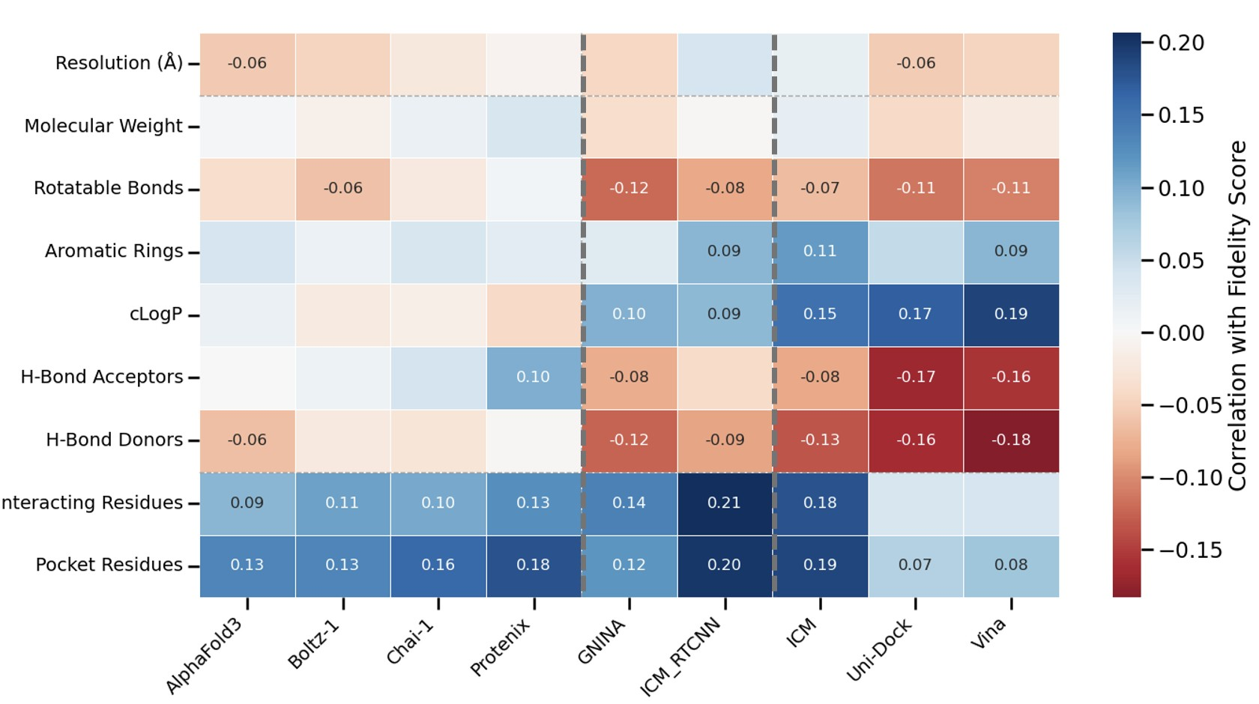
Figure 3: Univariate correlations between molecular and pocket properties and docking fidelity across methods. Different classes of methods are separated by a colored dashed line. Cells show Pearson correlation coefficients (ρ) between each property and the RMSD-based docking fidelity score, and statistically significant associations (p < 0.05) are annotated with their numerical values.
We further investigated mechanistic drivers of performance by correlating docking outcomes with molecular and pocket properties across multiple method–feature pairs (Figure 3). Standard RMSD values present a challenge for linear analysis: any deviations beyond 5 Å represent equally meaningless failures, yet this variance can skew regression models. Therefore, instead of raw RMSD, we use a continuous docking fidelity score S(r) = 1/(1 + exp(a(r − b))), with a = 3 and b = 3, which maps near-native poses to values close to 1 (e.g., S(2 Å) ≈ 0.88), assigns S(3 Å) = 0.5 at the conventional success threshold, and compresses clearly incorrect poses (r ≳ 5 Å) toward 0. Thus, higher values of S correspond to higher docking fidelity while very large RMSD values are down-weighted.
Using this score, we observe that pocket “complexity”—as quantified by the pocket residue count and the total number of protein–ligand interactions—shows a modest but consistent positive correlation with docking fidelity across nearly all paradigms (Pearson ρ ≈ 0.1–0.2). Rather than imposing a universal penalty, interaction-rich pockets appear to provide more redundant opportunities for forming a high-fidelity pose. In contrast, ligand flexibility and polarity emerge as the primary adverse factors, especially for physics-based and hybrid approaches. Thus, the number of rotatable bonds exhibits weak but systematic negative correlations with fidelity (typically ρ ≈ −0.1 to −0.2), indicating that highly flexible ligands remain intrinsically harder to dock accurately. This trend is more pronounced for physics-based and hybrid models that employ explicit sampling of the ligand, the complexity of which grows exponentially with each rotatable bond. Notably, other size-related descriptors such as molecular weight and ring count show at most weak or method-specific trends.
A natural hypothesis is that the lower docking fidelity observed for more flexible molecules might reflect undersampling and could be rescued by increasing search thoroughness. We tested this directly by re-docking all 215 failure cases (initial RMSD > 2.0 Å) using GNINA with substantially increased sampling effort (exhaustiveness=64). As shown in Figure 4, increased exhaustiveness rescued 80 of 215 cases (37.2%), bringing them below the 2.0 Å RMSD threshold. Crucially, the rescue rate depended strongly on ligand flexibility (Spearman ρ = −0.613, p = 1.54 × 10⁻²³): ligands with 0–2 rotatable bonds were rescued at 69.7% (n = 33), and ligands with 3–5 rotatable bonds at 69.4% (n = 62), whereas more flexible ligands with 6–10 and ≥ 11 rotatable bonds were rescued at only 14.0% (n = 86) and 5.9% (n = 34), respectively. A stochasticity control experiment, in which the same 215 cases were re-run at the original exhaustiveness setting, confirmed that the observed rescues at exhaustiveness=64 are attributable to genuine improvements in sampling rather than run-to-run variability (Supplementary Figure S1). The rescue rate plateau observed across a broad range of exhaustiveness levels (Supplementary Figure S2) further indicates that the sampling gains saturate quickly. These results demonstrate that, for rigid to moderately flexible ligands, insufficient conformational sampling is a correctable bottleneck and that more thorough search can recover near-native poses. In contrast, for highly flexible ligands, increasing exhaustiveness alone is insufficient, pointing instead to limitations in the scoring function’s ability to correctly rank the exponentially growing number of candidate conformers.
In Figure 3, we also observe a mild favorable trend for high-logP ligands (more lipophilic) and a negative trend for more polar ligands (more H-bond acceptors and donors) in physics-based and hybrid methods, whereas this trend is largely absent in purely AI-driven, data-based methods. This pattern is consistent with scoring functions that strongly reward hydrophobic burial: ICM, for example, uses a generalized Born approximation to calculate electrostatic solvation energy and its gradient dynamically during local and global optimization,⁹ while AutoDock Vina accounts for solvent effects indirectly through an empirical hydrophobic term that approximates desolvation as a pairwise attractive potential between hydrophobic atoms.⁸ These design choices likely make highly lipophilic ligands somewhat easier—not harder—to rank correctly in hydrophobic pockets, while the negative correlations with flexibility and polar features suggest that accurately balancing directional polar interactions and entropic costs remains a key limitation of current scoring functions. This result suggests that scoring, rather than sampling, is the dominant bottleneck even for ostensibly simple ligands.
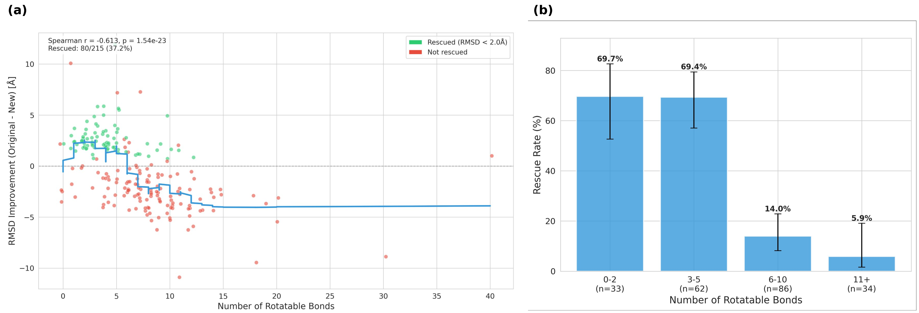
Figure 4: Impact of increased sampling exhaustiveness on docking accuracy for difficult cases. Combined rescue analysis for GNINA re-docking runs with exhaustiveness=64. The figure summarizes both the per-case RMSD improvement as a function of ligand rotatable-bond count and the corresponding rescue rates stratified by ligand flexibility. Increased sampling preferentially rescues rigid and moderately flexible ligands, whereas highly flexible ligands remain difficult.

Conclusions
In this work, we systematically benchmarked physics-based, hybrid, diffusion-based, and co-folding docking paradigms on recent, similarity-stratified protein–ligand benchmarks. Our benchmark reveals that no single paradigm reigns supreme. A “reality gap” exists in which AI models achieve low RMSD through memorization but fail to generalize to OOD targets. Apparent performance is strongly regime-dependent and modulated by target similarity. Co-folding models achieve the highest peak accuracies on in-distribution targets but exhibit large generalization gaps, consistent with a substantial reliance on memorized structural precedents. By contrast, hybrid and diffusion models maintain markedly higher success rates on low-similarity (OOD) systems, while purely physics-based engines offer the most similarity-agnostic but lowest overall performance ceiling.
These trends are further shaped by molecular and pocket properties. Across all paradigms, larger, contact-rich pockets show modestly higher docking fidelity, whereas highly flexible and strongly polar ligands remain systematically harder to dock. We also observe systematic sensitivities of physics-based and hybrid methods to solvation-related descriptors (e.g., logP), highlighting that solvation and hydrophobic modeling remain key determinants of performance and potential sources of bias.
Our findings therefore argue for context-dependent deployment rather than a single-method monopoly. For targets with high structural similarity (e.g., > 50% SuCOS) to existing PDB complexes, co-folding models such as AlphaFold3 are often the method of choice. For novel or genuinely OOD targets, hybrid and diffusion approaches (e.g., GNINA and SurfDock) likely provide a higher probability of success. Methodologically, we recommend that future evaluations report performance stratified by similarity and include simple generalization metrics, such as the success-rate difference between high- and low-similarity bins, rather than relying on a single aggregated score. Conceptually, our study highlights that the most promising path forward lies in the synergistic integration of data-driven learning with robust, transferable principles of physical chemistry, combining the expressiveness of modern AI with the reliability of well-founded physical models.

Associated Content
Data Availability Statement
The benchmarking dataset, input PDB files, and processed docking poses generated in this study are openly available at https://zenodo.org/records/16754298. The source code used for the benchmarking can be found at https://github.com/AaronXu9/CogligandBench.

Author Information
Corresponding Author
Vsevolod Katritch – Department of Quantitative and Computational Biology; Department of Chemistry; Department of Pharmacology and Pharmaceutical Sciences, University of Southern California, Los Angeles, CA, USA; Email: katritch@usc.edu
Authors
Ao Xu – Thomas Lord Department of Computer Science, University of Southern California, Los Angeles, CA, USA; Email: aoxu@usc.edu
Jordy Homing Lam – Department of Quantitative and Computational Biology, University of Southern California, Los Angeles, CA, USA; Email: homingla@usc.edu
Aiichiro Nakano – Thomas Lord Department of Computer Science; Department of Quantitative and Computational Biology; Department of Physics and Astronomy, University of Southern California, Los Angeles, CA, USA; Email: anakano@usc.edu
Author Contributions
A.X. conceptualized the study, developed the benchmarking pipeline, performed the molecular docking simulations and statistical analysis (including the generalization-gap quantification), and drafted the original manuscript. J.H.L. assisted in writing and validating the manuscript. V.K., A.N., and J.H.L. provided supervision, project administration, and resources. All authors have read and agreed to the published version of the manuscript.

Funding
This research was supported by the National Institutes of Health grant R35GM153437.
Notes
The authors declare no competing financial interest.

Acknowledgments
The authors acknowledge the Center for Advanced Research Computing (CARC) at the University of Southern California for providing computing resources that contributed to the research results reported in this publication. URL: https://carc.usc.edu.

References
(1) Skrinjar, P.; Eberhardt, J.; Durairaj, J.; Schwede, T. Have protein-ligand co-folding methods moved beyond memorisation? BioRxiv 2025, 2025–02.
(2) Sousa, S. F.; Fernandes, P. A.; Ramos, M. J. Protein–ligand docking: current status and future challenges. Proteins: structure, function, and bioinformatics 2006, 65, 15–26.
(3) Ferreira, L. G.; Dos Santos, R. N.; Oliva, G.; Andricopulo, A. D. Molecular docking and structure-based drug design strategies. Molecules 2015, 20, 13384–13421.
(4) Chen, G.; Seukep, A. J.; Guo, M. Recent advances in molecular docking for the research and discovery of potential marine drugs. Marine drugs 2020, 18, 545.
(5) Agu, P. C.; Afiukwa, C. A.; Orji, O.; Ezeh, E.; Ofoke, I.; Ogbu, C.; Ugwuja, E. I.; Aja, P. Molecular docking as a tool for the discovery of molecular targets of nutraceuticals in diseases management. Scientific reports 2023, 13, 13398.
(6) Medel-Lacruz, B.; Herrero, A.; Martin, F.; Herrero, E.; Luque, F. J.; Vazquez, J. Synthon-Based Strategies Exploiting Molecular Similarity and Protein–Ligand Interactions for Efficient Screening of Ultra-Large Chemical Libraries. Journal of Chemical Information and Modeling 2025, 65, 7569–7583.
(7) Sadybekov, A. V.; Katritch, V. Computational approaches streamlining drug discovery. Nature 2023, 616, 673–685.
(8) Trott, O.; Olson, A. J. AutoDock Vina: improving the speed and accuracy of docking with a new scoring function, efficient optimization, and multithreading. Journal of computational chemistry 2010, 31, 455–461.
(9) Abagyan, R.; Totrov, M.; Kuznetsov, D. ICM—A new method for protein modeling and design: Applications to docking and structure prediction from the distorted native conformation. Journal of computational chemistry 1994, 15, 488–506.
(10) Mark, A. E.; Van Gunsteren, W. F. Decomposition of the free energy of a system in terms of specific interactions: implications for theoretical and experimental studies. Journal of molecular biology 1994, 240, 167–176.
(11) Smith, P. E.; van Gunsteren, W. F. When are free energy components meaningful? The Journal of Physical Chemistry 1994, 98, 13735–13740.
(12) McNutt, A. T.; Francoeur, P.; Aggarwal, R.; Masuda, T.; Meli, R.; Ragoza, M.; Sunseri, J.; Koes, D. R. GNINA 1.0: molecular docking with deep learning. Journal of cheminformatics 2021, 13, 43.
(13) Ho, J.; Jain, A.; Abbeel, P. Denoising diffusion probabilistic models. Advances in neural information processing systems 2020, 33, 6840–6851.
(14) Corso, G.; Stärk, H.; Jing, B.; Barzilay, R.; Jaakkola, T. Diffdock: Diffusion steps, twists, and turns for molecular docking. arXiv preprint arXiv:2210.01776 2022.
(15) Cao, D.; Chen, M.; Zhang, R.; Wang, Z.; Huang, M.; Yu, J.; Jiang, X.; Fan, Z.; Zhang, W.; Zhou, H.; others SurfDock is a surface-informed diffusion generative model for reliable and accurate protein–ligand complex prediction. Nature Methods 2025, 22, 310–322.
(16) Lu, W.; Zhang, J.; Huang, W.; Zhang, Z.; Jia, X.; Wang, Z.; Shi, L.; Li, C.; Wolynes, P. G.; Zheng, S. DynamicBind: predicting ligand-specific protein-ligand complex structure with a deep equivariant generative model. Nature Communications 2024, 15, 1071.
(17) Jumper, J.; Evans, R.; Pritzel, A.; Green, T.; Figurnov, M.; Ronneberger, O.; Tunyasuvunakool, K.; Bates, R.; Zídek, A.; Potapenko, A.; others Highly accurate protein structure prediction with AlphaFold. Nature 2021, 596, 583–589.
(18) Abramson, J.; Adler, J.; Dunger, J.; Evans, R.; Green, T.; Pritzel, A.; Ronneberger, O.; Willmore, L.; Ballard, A. J.; Bambrick, J.; others Accurate structure prediction of biomolecular interactions with AlphaFold 3. Nature 2024, 630, 493–500.
(19) team, C. D.; Boitreaud, J.; Dent, J.; McPartlon, M.; Meier, J.; Reis, V.; Rogozhonikov, A.; Wu, K. Chai-1: Decoding the molecular interactions of life. BioRxiv 2024, 2024–10.
(20) Passaro, S.; Corso, G.; Wohlwend, J.; Reveiz, M.; Thaler, S.; Somnath, V. R.; Getz, N.; Portnoi, T.; Roy, J.; Stark, H.; others Boltz-2: Towards accurate and efficient binding affinity prediction. BioRxiv 2025, 2025–06.
(21) Qiao, Z.; Nie, W.; Vahdat, A.; Miller III, T. F.; Anandkumar, A. State-specific protein–ligand complex structure prediction with a multiscale deep generative model. Nature Machine Intelligence 2024, 6, 195–208.
(22) Hitawala, M.; Gray, J. J. Benchmarking all-atom biomolecular structure prediction with AlphaFold3. *Details pending formal publication*, 2025.
(23) Haid, M.; otros Benchmarking cross-docking strategies for structure-informed machine learning. Journal of chemical information and modeling 2023, 63, 7406–7420.
(24) Huang, J.; otros Re-Dock: Towards Flexible and Realistic Molecular Docking with Diffusion Bridge. *Details pending formal publication*, 2024.
(25) Neves, M. A.; Totrov, M.; Abagyan, R. Docking and scoring with ICM: the benchmarking results and strategies for improvement. Journal of computer-aided molecular design 2012, 26, 675–686.
(26) Wohlwend, J.; Corso, G.; Passaro, S.; Getz, N.; Reveiz, M.; Leidal, K.; Swiderski, W.; Atkinson, L.; Portnoi, T.; Chinn, I.; others Boltz-1 democratizing biomolecular interaction modeling. BioRxiv 2025, 2024–11.
(27) Team, B. A. A.; Chen, X.; Zhang, Y.; Lu, C.; Ma, W.; Guan, J.; Gong, C.; Yang, J.; Zhang, H.; Zhang, K.; others Protenix-advancing structure prediction through a comprehensive AlphaFold3 reproduction. BioRxiv 2025, 2025–01.
(28) Leung, S.; Bodkin, M.; Von Delft, F.; Brennan, P.; Morris, G. SuCOS is better than RMSD for evaluating fragment elaboration and docking poses. 2019.

