PROFAB
PROJECT LIFECYCLE
JF Requirements Traceability & Verification
L1 clarity • L2 process control • L3 forms & matrices
CONTROLLED REVIEW COPY
30 August 2026 | Version 1.0
Prepared for ProFab / JF management review

01 / EXECUTIVE ASSURANCE

Lifecycle implemented and verified
Outcome
The application now implements the source-definable JF lifecycle as a connected three-layer operating model: a simple 13-node L1, a 14-node L2 with a distinct G1 and bounded commercial route, and an L3 containing all 52 controlled form records, two matrices, eight Gate/final controls, and enforceable completion logic.

13  L1 lifecycle nodes | 14  L2 process nodes | 52  L3 controlled forms | 79  functional & UI checks

What is complete
- Exact Initial Contact → Final Close high-level lifecycle with five primary Gates.
- Evidence → Rules → Eligibility → Route → Score qualification logic; no score can override a hard rule.
- All 52 indexed/supplemental documents represented as operational L3 records, each with a 10-field controlled schema.
- Approval Matrix: 52 forms + 5 Gates = 57 rows across six approval-role columns.
- Responsibility Matrix: 18 whole-project delivery areas across four core-party columns.
- Completion, signature, approval, task, applicability and N/A controls tested for bypass resistance.
- Production build, console/network health, responsive layouts and accessible control naming verified.

Important qualification
No policy was invented
The provided Master Requirements explicitly leaves several legal, payment, signing and release decisions as TBD. The system exposes working control points but does not silently convert those open decisions into final company policy. Section 9 lists every retained TBD.

Report map
Section | Contents
1 | Executive assurance
2 | Evidence basis & source integrity
3 | Three-layer lifecycle architecture
4 | JF requirement traceability
5 | Complete L3 form & matrix register
6 | Gate 1 enforcement design
7 | Scenario and regression verification
8 | Bug & UI review
9 | Retained management decisions (TBD)
10 | Acceptance conclusion

02 / EVIDENCE BASIS

Source integrity and interpretation rules
Quotation basis
The left-hand wording in the traceability table is quoted verbatim from JF_Master_Requirements_All_Conversations_2026-08-29.docx. That file describes itself as a compiled Master Requirements summary, not a word-for-word conversation transcript. Accordingly, this report labels the text as source wording from the Master summary—not as a direct transcript quote.

Evidence source | Use in this review | Observed condition
JF_Master_Requirements_All_Conversations_2026-08-29.docx | Requirements, working directions and explicit TBDs | 12 rendered pages; internally coherent summary
Combined Forms.pdf | Controlled index, included form bodies, revisions and numbering | 193 pages; forms usable through page 178; pages 179–193 corrupted binary render
Current PROFAB Project Lifecycle application | Existing architecture, implementation target and verification surface | Production build and browser flows tested locally

Controlled-form reconciliation
52  digital L3 records | 21  included templates | 30  index-only templates | 1  supplemental template

- The nine-page PDF register contains 51 indexed entries.
- SMO 2.13.1 exists on PDF pages 114–116 but is omitted from that index; it is preserved as the 52nd supplemental controlled record.
- The 21 Included records use the source form pages/revisions as evidence; 30 Index Only records receive a controlled operational digital schema without pretending that a missing PDF body was supplied.
- PDF pages 179–193 render embedded XLSX/DOCX binary data and are not treated as forms.
- DC/CD and SOW/PSO/WMA numbering conflicts are exposed to users rather than silently normalized away.
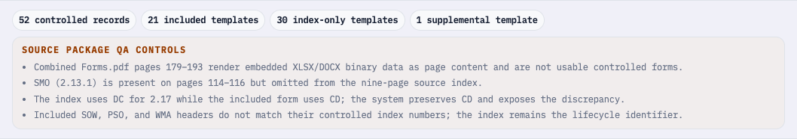
Figure 1. L3 source-package QA visible inside the live Approval Matrix.

03 / THREE-LAYER ARCHITECTURE

L1 is simple; L2 explains; L3 executes
Layer contract
L1 answers ‘where is the project?’ L2 answers ‘what process and Gate comes next?’ L3 answers ‘what evidence, form, matrix, signature, approval or task makes that status true?’

L1 — exact high-level lifecycle
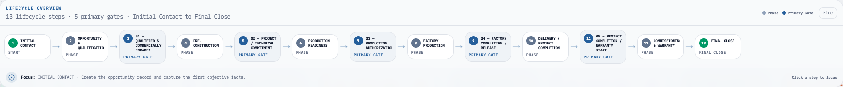
Figure 2. The complete 13-node L1 lifecycle and five primary Gates.
# | Type | L1 node | Linked L2 node(s)
1 | Start | INITIAL CONTACT | Project Start
2 | Phase | OPPORTUNITY & QUALIFICATION | Opportunity & Qualification
3 | Primary Gate | G1 — QUALIFIED & COMMERCIALLY ENGAGED | G1 — Qualified & Commercially Engaged
4 | Phase | PRE-CONSTRUCTION | Commercial Pathway + Pre-Construction
5 | Primary Gate | G2 — PROJECT / TECHNICAL COMMITMENT | G2 — Project / Technical Commitment
6 | Phase | PRODUCTION READINESS | Production Readiness
7 | Primary Gate | G3 — PRODUCTION AUTHORIZATION | G3 — Production Authorization
8 | Phase | FACTORY PRODUCTION | Factory Production
9 | Primary Gate | G4 — FACTORY COMPLETION / RELEASE | G4 — Factory Completion / Release
10 | Phase | DELIVERY / PROJECT COMPLETION | Delivery / Project Completion
11 | Primary Gate | G5 — PROJECT COMPLETION / WARRANTY START | G5 — Project Completion / Warranty Start
12 | Phase | COMMISSIONING & WARRANTY | Commissioning & Warranty
13 | End | FINAL CLOSE | Final Close
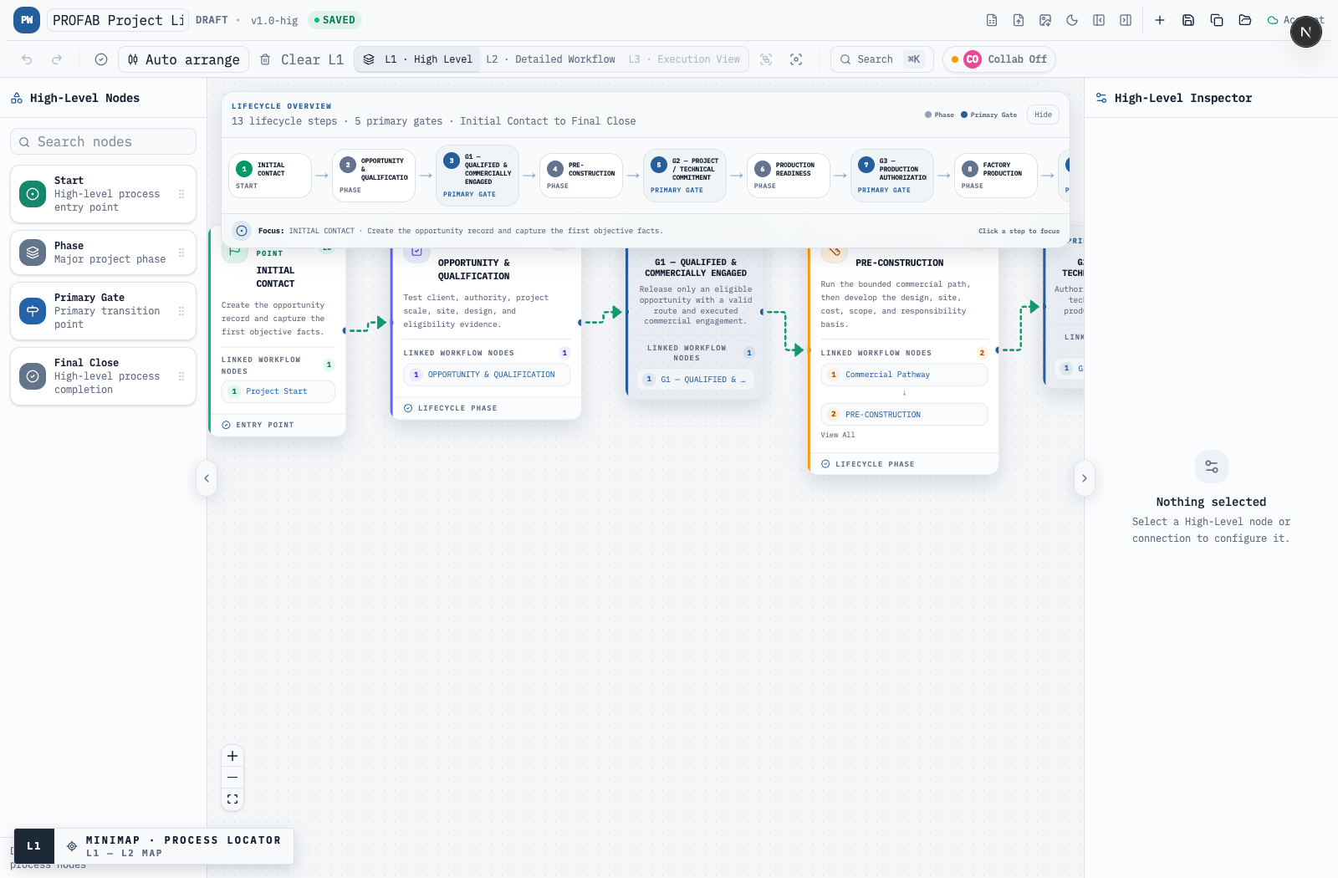
Figure 3. L1 phase cards show explicit links into their L2 process nodes.

03 / THREE-LAYER ARCHITECTURE

L2 — bounded process with independent Gates
L2 node | Purpose | L1 parent
Project Start | Entry record and project identifier | L1 Initial Contact
Opportunity & Qualification | Six-step Gate 1 evidence and routing workspace | L1 Opportunity
G1 — Qualified & Commercially Engaged | Independent release point; no bypass | L1 G1
Commercial Pathway | Bounded CSA → Class D → PCS, governed LOI modifier | L1 Pre-Construction
Pre-Construction | Design, site, estimating, scope and responsibilities | L1 Pre-Construction
G2 — Project / Technical Commitment | Class C basis and project/technical commitment | L1 G2
Production Readiness | Drawings, PSO, materials, permit, payment, schedule and changes | L1 Production Readiness
G3 — Production Authorization | Controlled factory release | L1 G3
Factory Production | Production, QC, inspection and rework | L1 Factory Production
G4 — Factory Completion / Release | Completion evidence plus transport/site readiness | L1 G4
Delivery / Project Completion | Site, delivery, set, interfaces, deficiencies | L1 Delivery
G5 — Project Completion / Warranty Start | Acceptance, deficiency disposition and warranty basis | L1 G5
Commissioning & Warranty | Startup, handover, claims and expiry tracking | L1 Commissioning & Warranty
Final Close | Commercial and obligation reconciliation | L1 Final Close
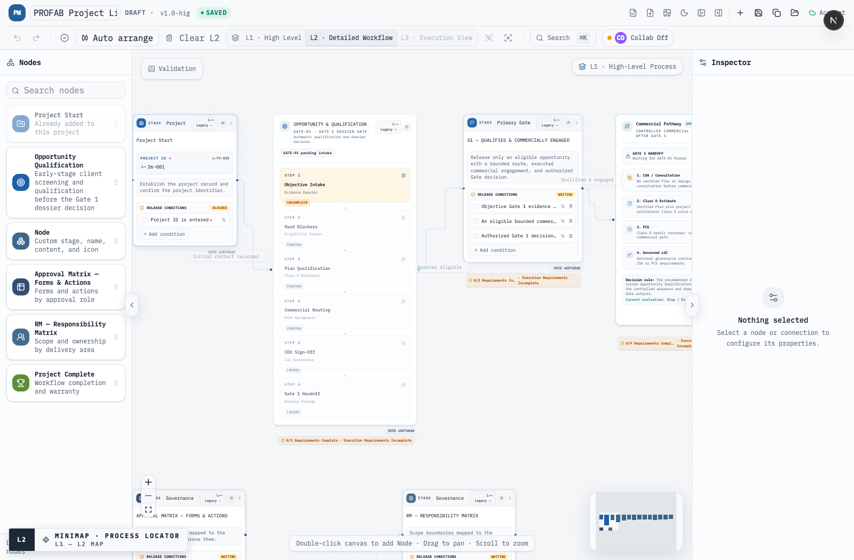
Figure 4. Opportunity cannot bypass G1; the controlled commercial pathway begins only after release.

03 / THREE-LAYER ARCHITECTURE

L3 — controlled evidence, not a document dump
Every catalog form opens inside the L3 execution layer with a controlled identity, revision, language, applicability decision, lifecycle links, source reference and ten operational fields. Form values are not enough on their own: required signature, approval, task and status controls must also pass.
Control | Effective behavior
Applicability | Required is always applicable; Conditional/Triggered begin Pending; Optional/Supporting do not gate by default.
Required data | All required form fields must contain objective values before Complete/Passed becomes selectable.
N/A | Not Applicable requires an objective reason; blank or whitespace evidence remains incomplete.
Signature | Signed is mandatory where configured; Partially Signed is not complete; Rejected is blocked.
Approval | Approved is mandatory where configured; Rejected is blocked.
Protection | Catalog forms and Gate controls cannot be deleted; Clear L3 only removes custom items.
Roll-up | Only effective L3 progress counts in the L2 status summary.
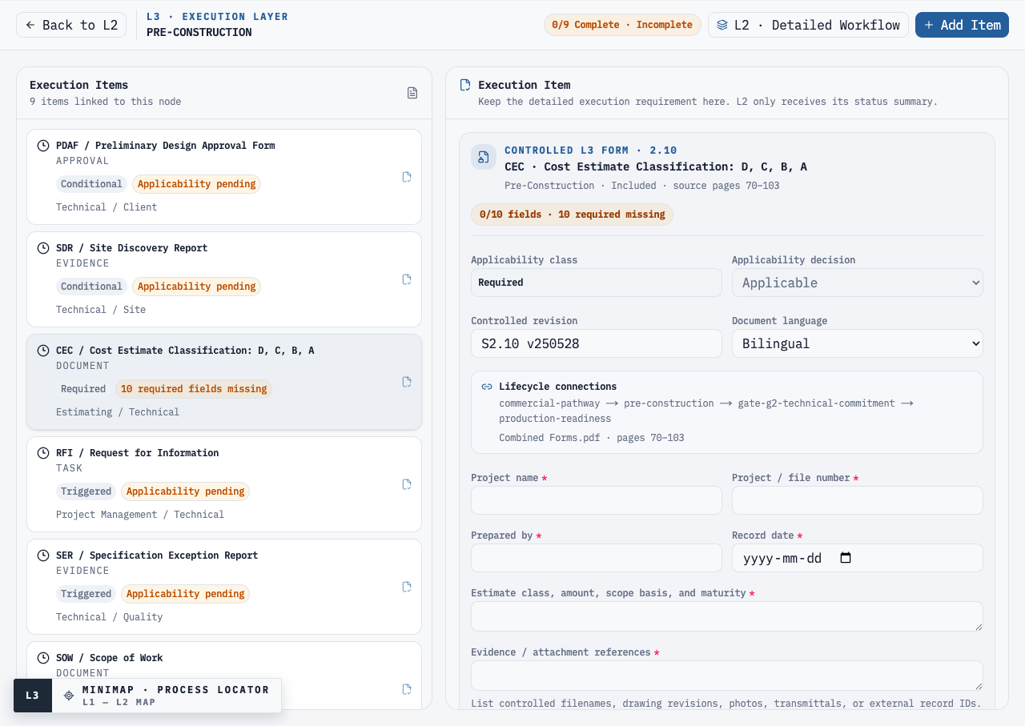
Figure 5. A live CEC form shows revision, language, lifecycle links, required fields and blocking status.

04 / REQUIREMENT TRACEABILITY

JF source wording → implemented node/control
The left column preserves the Master Requirements summary wording. The right column identifies the corresponding live node/control and its verification evidence.
JF source wording (verbatim from Master Requirements summary) | Implemented node(s), control and evidence
§3 · Master summary | Implemented  System architecture: L1 defines the whole lifecycle; L2 defines process and Gates; L3 owns forms, signatures, approvals and versions. Evidence: Figs. 1–4.
§3 · Master summary | Implemented  L1 contains exactly five primary Gates. Technical, commercial, payment, design and release conditions stay in L2/L3. Evidence: Figs. 1–3.
§3 · Master summary | Implemented  Five Gate nodes are independent L2 release points. Forms supply evidence but no form is used as the Gate itself.
§3 · Master summary | Implemented  Commercial Pathway limits early routing to CSA, Class D, PCS, governed LOI, Hold or No-Go; direct Opportunity → Commercial bypass is removed. Evidence: Fig. 3.
§3 · Master summary | Implemented  Gate 1 collects named authority, role, approval path, scale, site, design, budget, funding and team evidence. Missing authority evidence is a hard Hold. Evidence: Fig. 5.
§3 · Master summary | Implemented  L1/L2 include site, delivery, commissioning, warranty and Final Close; the 18-row Responsibility Matrix tracks civil/foundation/site interfaces.
§3 · Master summary | Implemented  Progressive L1 → L2 → L3 disclosure; status summaries roll from L3 to L2. Gate 1 explains route, Hold reason, risks and next action.
§3 · Master summary | Implemented  Every catalog form has a locked index/code/title, controlled revision and language. Matrix/source QA exposes discrepancies. Evidence: Figs. 4 and 6.
§3 · Master summary | Implemented  63 rule tests, 9 interaction tests and 7 responsive/accessibility tests exercise hard stops, route abuse, form bypasses and UI regressions.
§4 · Master summary | Implemented  L1 is the exact 13-node Initial Contact → Final Close view with five highlighted primary Gates. Evidence: Figs. 1–2.
§4 · Master summary | Implemented  Only G1–G5 are primary Gates. PDAF, SA, PSO, payment and procurement controls remain linked L3 records/conditions.
§5 · Master summary | Implemented  Each Gate has release conditions, an approval execution item, responsible authority and GO/HOLD status aggregation.
§5 · Master summary | Implemented  Each form has lifecycle touchpoints; CEC, SOW, RM, changes, incidents and warranty records link across multiple L2 stages.
§6 · Master summary | Implemented  Opportunity & Qualification implements six ordered steps: evidence, hard blockers, plan qualification, route, LOI governance, Gate dossier. Score cannot release a hard stop.
§6 · Master summary | Implemented  G1 handoff requires identity, full authority evidence, storeys + GFA, site, design and assigned/executed eligible route; other facts remain visible as actions/risks.
§6.1 · Master summary | Implemented  Storeys and GFA are mandatory positive values for G1/Class D readiness; either missing value blocks. Module count remains optional.
§6.1 · Master summary | Implemented  Design maturity and modular compatibility are separate fields/rules. Permit/IFC without modular review requires Technical Review and blocks G1.
§6.1 · Master summary | Implemented  Funding In Process, Not Secured and Unknown produce visible risk flags and actions; none independently produces No-Go.
§6.2 · Master summary  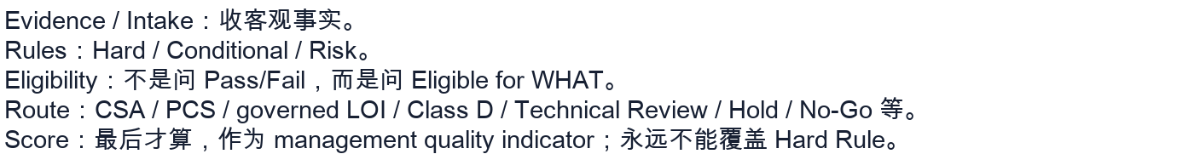 | Implemented  The rule engine follows this exact order. Eligibility and route are deterministic; score is calculated last and never overrides a Hard rule.
§6.2 · Master summary | Implemented  All four examples are encoded and tested: authority Hold; No Design → CSA; funding risk; permit-incompatible → Hold/No-Go.
§6.3 · Master summary | Implemented  Candidate/Multiple/Unassigned/No Site routes to bounded CSA; plan routes to Class D; recorded Class D routes to PCS; governed LOI cannot shortcut the sequence.
§6.3 · Master summary | Implemented  LOI is unavailable to Standard relationships unless policy enables it; it requires Class D evidence, scope/time caps, conversion trigger, review date and executive sign-off.
§7 · Master summary | Implemented  Gate 1 records route readiness only and does not require or invent a Class D amount. The controlled CEC form records the later estimate basis and disclaimer evidence.
§7 · Master summary | Implemented  Missing or non-positive storeys/GFA blocks qualification. No synthetic estimate or default $/sq.ft. amount is generated.
§8 · Master summary | Implemented  Commercial Pathway converges early variants into the Pre-Construction/CEC stream; G2 accepts a common Class C-ready technical/scope basis.
§9 · Master summary | Implemented  Opportunity can be re-evaluated at any step; status/rules are derived from saved evidence. L3 recurring/triggered controls preserve loops and exceptions without spaghetti.
§10 · Master summary | Implemented  PSO is a required signed/approved L3 control linked to Production Readiness and G3; final funds/approver policy remains a documented TBD.
§11 · Master summary | Implemented  Production Readiness aggregates drawings, PSO, materials, permit, payment, MPS and changes; G3 is a separate approval release.
§11 · Master summary | Implemented  G4 separates Factory Completion from Release. MSO, QC, inspection, transport and site-readiness evidence remain prerequisites.
§12 · Master summary | Implemented  G5 records warranty start; Commissioning & Warranty tracks WMA/support/notices; Final Close reconciles open obligations and acceptance.
§13.2 · Master summary | Implemented  All 52 forms carry one home node plus one-or-more lifecycle touchpoints and one of six applicability classes; Conditional/Triggered records require an explicit decision.
§14 · Master summary   | Implemented  The L3 Responsibility Matrix stays at 18 high-level delivery areas/4 core parties; SOW is a separate detailed controlled form for exact boundaries.
§19 · Master summary | Implemented  L1 is intentionally concise; L2 adds process/gates; L3 exposes forms, matrices, fields, approvals and evidence. Responsive behavior was verified at five widths.
§21 · Master summary | Implemented  Complete 52-record L3 catalog, source QA, revision/language/signature/approval controls, plus automated replay scenarios and full UI tests.

05 / L3 CONTROLLED REGISTER

Every form has an operational schema
The digital form is intentionally more than a file link. Each of the 52 records has six common evidence fields plus four fields selected by its operational profile. If an Optional or Supporting form is used, its required internal fields still apply; its optionality only prevents it from becoming an automatic Gate prerequisite.
Schema | Controlled fields
All profiles | Project name; Project/file number; Prepared by; Record date; form-specific primary record; Evidence/attachment references
Presentation | Intended audience; Purpose/call to action; Content revision; Release status
Agreement | Counterparty; Scope/commercial basis; Effective date; Execution state
Meeting | Meeting date; Attendees/organizations; Decisions; Open actions/owners/dates
Analysis | Analysis/estimate basis; Assumptions/exclusions; Findings; Recommendation/next action
Approval | Approval subject/revision; Authorized approver; Approval date; Decision
Register | Record/issue reference; Action owner; Target/response date; Record status
Report | Module/area/subject; Inspection/event date; Findings/evidence; Disposition
Instructions | Applicable revision; Prerequisites; Controlled sequence; Issued to/acknowledged by
Schedule | Baseline date; Period/milestone range; Critical constraints; Schedule status
Service | Service request; Owner; Response date; Service status
Package | Contents/index; Revision/change basis; Transmittal; Acceptance status
Notice | Recipient/authority; Event date; Impact; Response deadline
Applicability distribution: Conditional 18, Optional 2, Required 17, Supporting 4, Triggered 11.

05 / L3 CONTROLLED REGISTER

Complete 52-form register
Index / code | Controlled title & operational focus | L2 home | Lifecycle touchpoints | Applicability / controls | Source / owner / approvers
1.1  — | Corporate Presentation  Focus: Capabilities and project evidence presented | Opportunity & Qualification | Opportunity | Supporting · Document  10 fields | Index Only  Owner: Sales / Marketing  Approvers: Sales, Management
1.2  EOI | Expression of Interest  Focus: Client interest and intended next step | Opportunity & Qualification | Opportunity → G1 | Optional · Document  10 fields | Index Only  Owner: Sales  Approvers: Sales
2.1  CSA | Consultation Services Agreement  Focus: Consultation deliverables and boundaries | Commercial Pathway | Commercial → Pre-Con | Conditional · Agreement  10 fields · signature | Included pp. 10–17  S2.1 v250528  Owner: Technical / Sales  Approvers: Sales, Technical, Client
2.1.1  — | Meeting #1  Focus: Initial goals, requirements, and expectations | Commercial Pathway | Commercial → Pre-Con | Conditional · Evidence  10 fields | Index Only  Owner: Technical / Sales  Approvers: Technical
2.1.2  — | Meeting #2  Focus: Progress reviewed and scope refinements | Commercial Pathway | Commercial → Pre-Con | Conditional · Evidence  10 fields | Index Only  Owner: Technical / Sales  Approvers: Technical
2.2  NDA | Non-Disclosure Agreement  Focus: Protected information and permitted disclosure | Commercial Pathway | Commercial → Pre-Con | Conditional · Agreement  10 fields · signature | Index Only  Owner: Management / Legal  Approvers: Management, Client
2.3  LOI | Letter of Intent  Focus: Intent, limits, conversion trigger, and exclusions | Commercial Pathway | Commercial → Pre-Con | Conditional · Agreement  10 fields · signature · approval | Included pp. 18–21  S2.3 v250604  Owner: Sales / Management  Approvers: Management, Client
2.4  FS | Feasibility Study  Focus: Feasibility question and decision boundary | Commercial Pathway | Commercial → Pre-Con → G2 | Conditional · Document  10 fields | Included pp. 22–27  S2.4 v250604  Owner: Technical  Approvers: Technical, Management
2.5  SA | Sales Agreement  Focus: Contract scope, price basis, and key conditions | Commercial Pathway | Commercial → G2 → Prod. Ready | Conditional · Agreement  10 fields · signature · approval | Included pp. 28–53  S2.5 v250624  Owner: Sales / Management  Approvers: Management, Client
2.6  EDAT | Electronic Document Authorization & Transfer  Focus: Authorized electronic document set and transfer method | Commercial Pathway | Commercial → Pre-Con → Prod. Ready | Conditional · Approval  10 fields · approval | Included pp. 54–56  S2.6 v250409  Owner: Document Control  Approvers: Technical, Client
2.7  PCS | Pre-Construction Services  Focus: Authorized services, deliverables, fee basis, and limits | Commercial Pathway | Commercial → Pre-Con → G2 | Conditional · Agreement  10 fields · signature · approval | Included pp. 57–66  S2.7 v250626  Owner: Technical / Project Management  Approvers: Technical, Management, Client
2.8  PDAF | Preliminary Design Approval Form  Focus: Design package, revision, assumptions, and exceptions | Pre-Construction | Pre-Con → G2 | Conditional · Approval  10 fields · signature · approval | Included pp. 67–69  S2.8 v250409  Owner: Technical / Client  Approvers: Technical, Client
2.9  SDR | Site Discovery Report  Focus: Site observations, measurements, and constraints | Pre-Construction | Pre-Con → G2 → Delivery | Conditional · Evidence  10 fields | Index Only  Owner: Technical / Site  Approvers: Technical
2.10  CEC | Cost Estimate Classification: D, C, B, A  Focus: Estimate class, amount, scope basis, and maturity | Pre-Construction | Commercial → Pre-Con → G2 → Prod. Ready | Required · Document  10 fields · approval | Included pp. 70–103  S2.10 v250528  Owner: Estimating / Technical  Approvers: Technical, Management
2.11  RFI | Request for Information  Focus: Question, drawing/specification reference, and impact | Pre-Construction | Pre-Con → Prod. Ready → Factory → Delivery | Triggered · Task  10 fields | Included pp. 104–105  S2.11 v250409  Owner: Project Management / Technical  Approvers: Technical
2.12  SER | Specification Exception Report  Focus: Specification exception, reason, and affected scope | Pre-Construction | Pre-Con → Prod. Ready → Factory | Triggered · Evidence  10 fields · approval | Included pp. 106–108  S2.12 v250409  Owner: Technical / Quality  Approvers: Technical, Client
2.13  SOW | Scope of Work  Focus: Scope boundaries, interfaces, inclusions, and exclusions | Pre-Construction | Pre-Con → G2 → Prod. Ready → Delivery | Required · Document  10 fields · approval | Included pp. 109–113  S2.12 v250626  QA: The included form header is numbered S2.12 while the controlled index assigns 2.13.  Owner: Project Management / Technical  Approvers: Technical, Management, Client
2.13.1  SMO | Scope & Modular Responsibility Overview  Focus: Delivery model, responsibility transfer, and interfaces | Pre-Construction | Pre-Con → G2 → Delivery | Supporting · Document  10 fields | Supplemental pp. 114–116  S2.13.1 v260629  QA: Present in the source package but omitted from the nine-page controlled index.  Owner: Technical / Project Management  Approvers: Technical, Management
2.14  RM | Responsibility Matrix  Focus: Core parties, scope lines, and unassigned interfaces | Pre-Construction | Pre-Con → G2 → Prod. Ready → Delivery → Warranty | Required · Document  10 fields · approval | Included pp. 117–149  S2.14 v250716  Owner: Project Management  Approvers: Technical, Management, Client
2.15  PSO | Product Signoff Form  Focus: Products/materials, selections, substitutions, and revision | Production Readiness | Pre-Con → Prod. Ready → G3 | Required · Approval  10 fields · signature · approval | Included pp. 150–151  S2.2 v250409  QA: The included form header is numbered S2.2 while the controlled index assigns 2.15.  Owner: Technical / Client  Approvers: Technical, Management, Client
2.16  PS | Project Summary  Focus: Project goals, success criteria, and current baseline | Pre-Construction | Pre-Con → Prod. Ready → Delivery → Final Close | Supporting · Document  10 fields | Included pp. 152–154  S2.16 v250409  Owner: Project Management  Approvers: Management
2.17  CD | Change Directive  Focus: Directed change, reason, affected scope, and interim authority | Production Readiness | Pre-Con → Prod. Ready → Factory → Delivery | Triggered · Approval  10 fields · signature · approval | Included pp. 155–157  S2.17 v250416  QA: The controlled index shows code DC; the included form header uses CD. CD is retained as the actual form code and the discrepancy is exposed.  Owner: Project Management  Approvers: Management, Client
2.18  CO | Change Order  Focus: Change description, price, schedule, and contract impact | Production Readiness | Pre-Con → Prod. Ready → Factory → Delivery → Final Close | Triggered · Agreement  10 fields · signature · approval | Included pp. 158–161  S2.18 v250416  Owner: Project Management / Commercial  Approvers: Management, Client
2.18.1  CT | CD and CO Tracker  Focus: Change reference, type, scope, cost, and schedule impact | Production Readiness | Pre-Con → Prod. Ready → Factory → Delivery → Final Close | Triggered · Task  10 fields | Included pp. 162  S2.18.1 v250409  Owner: Project Management / Process Coordinator  Approvers: Management
2.19  ODN | Occupancy Delay Notification  Focus: Delay cause, responsibility, evidence, and required cure | Delivery / Project Completion | Pre-Con → Prod. Ready → Delivery | Triggered · Evidence  10 fields · approval | Included pp. 163–164  S2.19 v250416  Owner: Project Management / Commercial  Approvers: Management, Client
3.1  MPS | Module Production Schedule  Focus: Module sequence, release dates, and production constraints | Production Readiness | Prod. Ready → G3 → Factory → G4 | Required · Document  10 fields · approval | Index Only  Owner: Factory Planning  Approvers: Factory, Project Management
3.2  MQC | Module Quality Control  Focus: Quality checkpoint, acceptance criteria, and evidence | Factory Production | Factory → G4 | Required · Evidence  10 fields · approval | Index Only  Owner: Factory Quality  Approvers: Factory, Quality
3.3  MIR | Module Inspection Report  Focus: Module ID, inspection scope, deficiencies, and evidence | Factory Production | Factory → G4 | Required · Evidence  10 fields · approval | Index Only  Owner: Factory Quality  Approvers: Factory, Quality
3.4  TRR | Transport Readiness Report  Focus: Module IDs, route, permits, protection, and release constraints | Factory Production | Factory → G4 → Delivery | Required · Evidence  10 fields · approval | Index Only  Owner: Logistics / Factory  Approvers: Factory, Project Management
3.5  MSO | Module Sign-Off  Focus: Module ID, inspection references, open punch items, and release decision | G4 — Factory Completion / Release | Factory → G4 → Delivery | Required · Approval  10 fields · signature · approval | Included pp. 165–167  S3.5 v250409  Owner: Factory / Quality  Approvers: Factory, Technical, Client
4.1  SSP | Site Safety Plan  Focus: Site hazards, controls, access, and emergency arrangements | Delivery / Project Completion | G4 → Delivery | Conditional · Document  10 fields · approval | Index Only  Owner: General Contractor / Site Safety  Approvers: Site, Management
4.2  MDR | Module Delivery and Receipt Form  Focus: Module IDs, carrier, delivery time, and received condition | Delivery / Project Completion | G4 → Delivery | Required · Evidence  10 fields · signature · approval | Index Only  Owner: Site / Logistics  Approvers: Site, Project Management
4.3  MAI | Module Assembly Instruction  Focus: Module type, assembly limits, interfaces, and hold points | Delivery / Project Completion | G4 → Delivery | Supporting · Document  10 fields | Index Only  Owner: Technical / Site  Approvers: Technical
4.4  MIC | Module Installation Checklist  Focus: Module ID, installation sequence, hold points, and incomplete work | Delivery / Project Completion | Delivery → G5 | Conditional · Evidence  10 fields · approval | Index Only  Owner: Site / Technical  Approvers: Site, Technical
4.5  MSI | Module Site Inspection Report  Focus: Module/site area, inspection criteria, deficiencies, and photos | Delivery / Project Completion | Delivery → G5 | Required · Evidence  10 fields · approval | Index Only  Owner: Technical / Site Quality  Approvers: Technical, Site
4.6  MALR | Module Alignment & Leveling Report  Focus: Module grid, survey readings, tolerances, and corrections | Delivery / Project Completion | Delivery → G5 | Conditional · Evidence  10 fields · approval | Index Only  Owner: Site / Survey / Technical  Approvers: Technical, Site
4.7  WSVR | Weatherproofing & Seal Verification Report  Focus: Joints/areas inspected, test method, leakage, and corrective work | Delivery / Project Completion | Delivery → G5 → Warranty | Conditional · Evidence  10 fields · approval | Index Only  Owner: Envelope / Site Quality  Approvers: Technical, Site
4.8  UCV | Utility Connection Verification  Focus: Utility system, test result, authority, and outstanding work | Delivery / Project Completion | Delivery → G5 → Warranty | Conditional · Evidence  10 fields · approval | Index Only  Owner: MEP / Site  Approvers: Technical, Site, Consultants
4.9  MDAR | Module Damage Assessment Report  Focus: Module ID, damage location, cause, severity, and photos | Delivery / Project Completion | G4 → Delivery → Warranty | Triggered · Evidence  10 fields · approval | Included pp. 168–172  S4.9 v250409  Owner: Site / Quality / Logistics  Approvers: Technical, Management
4.10  IRF | Incident Report Form  Focus: Incident facts, location, persons, evidence, and immediate action | Delivery / Project Completion | Factory → Delivery → Warranty | Triggered · Evidence  10 fields · approval | Index Only  Owner: Site Safety / Project Management  Approvers: Site, Management
4.10.1  IRL | Incident Response Log  Focus: Incident reference, response entry, evidence, and closure criterion | Delivery / Project Completion | Factory → Delivery → Warranty → Final Close | Triggered · Task  10 fields | Index Only  Owner: Project Management / Safety  Approvers: Management
5.1  DDSS | Delegated Design Service Statement  Focus: Delegated discipline, party, scope, deliverable, and seal requirement | Commissioning & Warranty | Pre-Con → Prod. Ready → Delivery → Warranty | Conditional · Document  10 fields · approval | Index Only  Owner: Technical / Consultants  Approvers: Technical, Consultants
5.2  MISS | Module Installation Support Service  Focus: Installation issue, requested support, urgency, and boundaries | Commissioning & Warranty | Delivery → Warranty | Conditional · Task  10 fields | Index Only  Owner: Technical Service  Approvers: Technical, Project Management
5.3  DPLR | Deficiency & Punch List Report  Focus: Deficiency, location, responsibility, evidence, and acceptance criterion | Delivery / Project Completion | Delivery → G5 → Warranty → Final Close | Required · Task  10 fields · approval | Index Only  Owner: Project Management / Site Quality  Approvers: Technical, Client
5.4  FIR | Final Inspection Report  Focus: Inspection scope, authority, accepted work, and residual deficiencies | Commissioning & Warranty | Delivery → G5 → Warranty | Required · Evidence  10 fields · approval | Index Only  Owner: Technical / Site Quality  Approvers: Technical, Client, Consultants
5.5  WMA | Warranty & Maintenance Agreement  Focus: Warranty start, coverage, exclusions, maintenance, and claim route | Commissioning & Warranty | G5 → Warranty → Final Close | Required · Agreement  10 fields · signature · approval | Included pp. 173–178  S2.5 v250409  QA: The included form header is numbered S2.5 while the controlled index assigns 5.5.  Owner: Warranty / Management  Approvers: Management, Client
5.6  PCR | Project Closeout Report  Focus: Completion basis, lessons learned, and final unresolved obligations | Final Close | Warranty → Final Close | Required · Document  10 fields · approval | Index Only  Owner: Project Management  Approvers: Management, Client
5.7  ABDP | As-Built Documentation Package  Focus: As-built disciplines, revision status, deviations, and completeness | Commissioning & Warranty | Delivery → Warranty → Final Close | Required · Document  10 fields · approval | Index Only  Owner: Document Control / Technical  Approvers: Technical, Client, Consultants
5.8  CSHF | Client Satisfaction & Handover Form  Focus: Handover package, training, satisfaction, and reservations | Commissioning & Warranty | G5 → Warranty → Final Close | Required · Approval  10 fields · signature · approval | Index Only  Owner: Project Management / Client  Approvers: Management, Client
5.9  PMRF | Photography & Media Release Form  Focus: Media assets, permitted uses, restrictions, and expiry | Final Close | Warranty → Final Close | Optional · Approval  10 fields · signature · approval | Index Only  Owner: Marketing / Client  Approvers: Management, Client
5.10  NOC | Notice of Concern  Focus: Concern, facts, contract reference, requested remedy, and urgency | Final Close | Pre-Con → Factory → Delivery → Warranty → Final Close | Triggered · Task  10 fields | Index Only  Owner: Client / Project Management  Approvers: Client
5.11  RNOC | Response to Notice of Concern  Focus: NOC reference, response position, corrective plan, and closure evidence | Final Close | Pre-Con → Factory → Delivery → Warranty → Final Close | Triggered · Task  10 fields · approval | Index Only  Owner: Project Management / Management  Approvers: Management, Client

05 / L3 MATRICES & RELEASE CONTROLS

Matrices connect documents to accountable roles
Matrix | Size | Columns | Purpose
Approval Matrix — Forms & Actions | 57 rows | Sales; Technical; Project Mgmt; Factory/Site; Management; Client/Consultants | 52 controlled forms + G1–G5
RM — Responsibility Matrix | 18 rows | GC/Builder; ProFab/Guildcrest; Client/Owner; Consultants | Whole-project responsibilities from authority/design through warranty/final close

Eight non-form L3 controls
- Gate 1 objective evidence dossier
- Gate 1 commercial engagement confirmation
- G1 qualified & commercially engaged approval
- G2 project / technical commitment approval
- G3 production authorization
- G4 factory completion / release approval
- G5 project completion / warranty start approval
- Final close commercial and obligation reconciliation

06 / GATE 1 CLIENT ENFORCEMENT

Evidence—not score—stops non-compliant clients
Gate 1 step | Release logic
1. Objective Intake | Client, relationship, authority status, storeys, GFA, site and design basis are recorded.
2. Hard Blockers | Authority, full decision group, named role evidence, approval path, scale, fatal site and modular incompatibility are enforced.
3. Plan Qualification | No design → CSA; Plan + scale → Class D; no amount is invented.
4. Commercial Routing | Assigned route must be one of the currently eligible bounded routes.
5. LOI Governance | When used: eligible relationship/policy, named executive, bounded scope/days/hours, review date and paid conversion trigger.
6. G1 Handoff | All prior checks plus an Executed commercial instrument; dossier records rules, route, score, risks and open actions.
Hard-rule precedence: The score is a management quality indicator only. A 100/100 opportunity remains Hold, Blocked or No-Go whenever a hard rule is active.
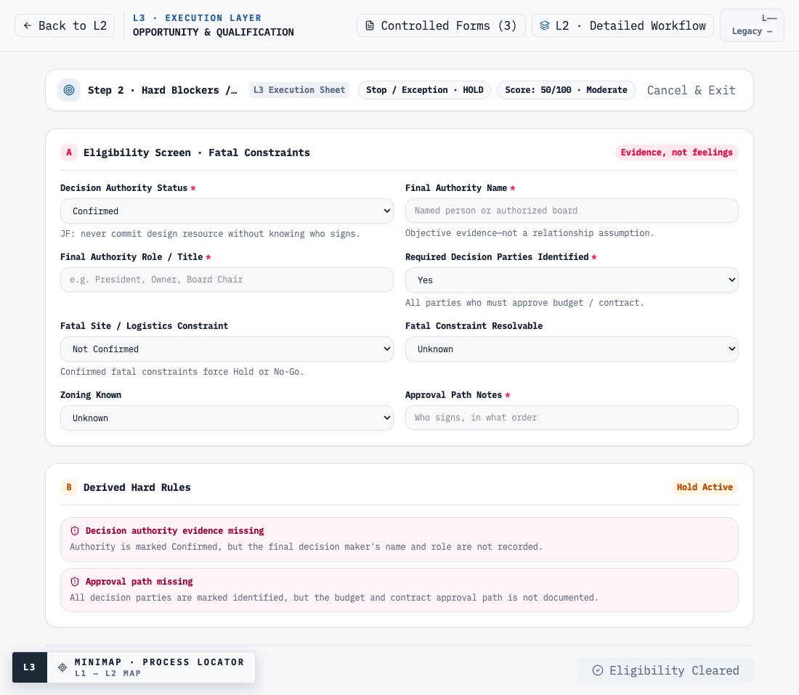
Figure 6. Confirmed authority cannot pass without a named role and documented approval path; Eligibility Cleared remains disabled.

07 / VERIFICATION

Representative enforcement scenario matrix
The table below lists 48 representative qualification and form-bypass paths. The automated rule suite contains 63 checks; browser interaction and UI suites add 16 further checks.
ID | Scenario | Expected enforcement | Verified result
Q01 | Valid confirmed authority + Plan + scale | Class D route; G1 may pass without a pre-G1 estimate amount | PASS — Class D; G1 passes
Q02 | No Design | Route to paid CSA; never automatic No-Go | PASS — CSA; G1 can pass
Q03 | Decision authority Unknown | Hard Hold regardless of score | PASS — HOLD
Q04 | Decision authority Partially Confirmed | Hard Hold; cannot be treated as final | PASS — HOLD
Q05 | Final authority explicitly No | Hard Hold | PASS — HOLD
Q06 | Authority marked Confirmed; name/role blank | Objective-evidence Hold | PASS — HOLD
Q07 | Decision parties Yes; approval path blank | Approval-path Hold | PASS — HOLD
Q08 | Required decision parties No/Unknown | Hard Hold | PASS — HOLD
Q09 | Storeys and GFA both missing | Block; no fake Class D | PASS — BLOCKED
Q10 | Storeys missing; GFA present | Block incomplete scale | PASS — BLOCKED
Q11 | GFA missing; storeys present | Block incomplete scale | PASS — BLOCKED
Q12 | Candidate Site | Bounded CSA route + site risk | PASS — CSA
Q13 | Multiple Sites | Bounded CSA route + site risk | PASS — CSA
Q14 | Municipal land not assigned | Bounded CSA route + site risk | PASS — CSA
Q15 | No Site | Bounded CSA/site-feasibility route | PASS — CSA
Q16 | Fatal site/logistics issue, not resolvable | No-Go; archive route | PASS — NO-GO
Q17 | Fatal issue potentially resolvable | Hold pending approved resolution | PASS — HOLD
Q18 | Permit Issued + Not Compatible + no corrective path | No-Go; maturity cannot override compatibility | PASS — NO-GO
Q19 | Permit Issued + Not Reviewed | Technical Review required; G1 blocked | PASS — TECH REVIEW
Q20 | IFC/Construction Ready + Not Reviewed | Technical Review required; G1 blocked | PASS — TECH REVIEW
Q21 | Partially Compatible | Technical Review required | PASS — TECH REVIEW
Q22 | Major Rework Likely | Technical Review required | PASS — TECH REVIEW
Q23 | Not Compatible + corrective path Unknown | Hold for technical decision | PASS — HOLD
Q24 | Funding In Process | Risk only; not automatic No-Go | PASS — risk visible
Q25 | Funding Not Secured | Distinct risk; no false ‘in process’ label | PASS — risk visible
Q26 | Funding Unknown | Risk and action | PASS — risk visible
Q27 | Client budget missing | Action; no synthetic price; not No-Go | PASS — ACTION REQUIRED
Q28 | Budget amount present; basis missing | Commercial action; route preserved | PASS — action visible
Q29 | Class D shows major budget gap | Commercial review action | PASS — Major Gap
Q30 | Aggressive/Unrealistic/Review timeline | Visible risk; no silent pass | PASS — three variants
Q31 | Existing controlled Class D result | Advance primary route to PCS | PASS — PCS
Q32 | Stale Class D amount while availability = No | Ignore stale amount; cannot bypass to PCS | PASS — Class D remains
Q33 | No Design plus stale Class D amount | CSA remains primary route | PASS — CSA
Q34 | Standard client selects LOI; policy disabled | Route unavailable; G1 blocked | PASS — blocked
Q35 | Returning client selects LOI before Class D | Cannot shortcut Class D | PASS — blocked
Q36 | Returning client + Class D + bounded LOI | LOI available only with governance | PASS — eligible
Q37 | LOI missing caps/trigger/review/sign-off | G1 blocked | PASS — blocked
Q38 | Assigned route does not match eligible route | G1 blocked | PASS — blocked
Q39 | Commercial instrument not Executed | G1 blocked | PASS — blocked
Q40 | High score + fatal hard rule | Hard rule wins | PASS — NO-GO
F01 | Form status Complete; required fields blank | Effective status remains incomplete | PASS — blocked
F02 | All fields complete; approval pending | Cannot complete | PASS — incomplete
F03 | Agreement executed; signature pending | Cannot complete | PASS — incomplete
F04 | Conditional/Triggered applicability Pending | Gates until determination | PASS — incomplete
F05 | N/A selected; reason blank/whitespace | N/A cannot bypass | PASS — incomplete
F06 | N/A selected with objective reason | Non-applicability accepted | PASS — complete
F07 | Approval or signature Rejected | Hard blocked state | PASS — blocked
F08 | Attempt to delete a controlled form | Deletion control unavailable | PASS — protected

07 / VERIFICATION

Automated and manual QA evidence
Verification layer | Result | Coverage
Deterministic rules | 63/63 passed | Qualification hard rules, routing, LOI, score precedence, L1/L2/L3 structure, 52-form catalog, completion/N/A/signature/approval loopholes
Browser interaction | 9/9 passed | App load, exact lifecycle, all 52 forms opening, controlled-form regression, N/A, document metadata, client hard block, matrix, mobile
Responsive & accessibility | 7/7 passed | L1/L2/L3 at five widths; visible inputs/buttons named; duplicate IDs absent on Gate, form and matrix screens
Report screenshots | 5/5 passed | Deterministic capture of L1, L2, L3, hard blocker and source QA
Static quality | Passed | TypeScript, ESLint, git diff check
Production build | Passed | Next.js 16.3 optimized static build
Console/network | Passed | No browser console errors and no HTTP 4xx/5xx on clean load
Dependency note
npm audit reports two Moderate entries that are the same transitive chain: exceljs 4.4.0 → uuid 8.3.2. ExcelJS uses uuid v4 without the advisory's v3/v5/v6 buffer argument, so the current export path is not the affected call pattern. No forced downgrade was applied because npm's suggested fix would move ExcelJS to 3.4.0 and risks breaking exports. There are zero High or Critical findings.

08 / BUG & UI REVIEW

Issues found and corrected
Finding | Failure risk | Correction in current system
L1 structure drift | G1 was not a distinct L1/L2 control and the commercial path could appear as a peer L1 phase. | Restored exact 13-node L1; Commercial Pathway lives under Pre-Construction; G1 is a distinct Gate.
Route bypass | Opportunity could connect directly to Commercial Pathway. | Canonical edge is Opportunity → G1 → Commercial Pathway; migration removes the bypass.
Authority-state mismatch | Partially Confirmed could be visually blocked but pass the underlying Gate decision. | Partially Confirmed is now a deterministic Hard Hold in both UI and rule engine.
‘Confirmed’ without evidence | No name/role or approval path was required. | Final Authority Name, Role/Title and Approval Path are mandatory hard-control evidence.
Class D misuse | A price could be treated as a pre-G1 prerequisite or fabricated from defaults. | G1 only assigns route; storeys + GFA are mandatory; no amount/formula is invented.
Maturity shortcut | Permit/IFC maturity could be mistaken for modular compatibility. | Separate fields and Technical Review/No-Go rules block incompatible or unreviewed design.
Controlled-form gaps | The previous L3 model did not expose every indexed/source form consistently. | 52 unique catalog forms are seeded once and open from their linked L2 nodes.
Form completion bypass | Status could be set Complete while required fields, signature or approval were missing. | Effective progress derives from fields + status + signature + approval + task state.
N/A bypass | Conditional/triggered records could disappear without evidence. | Pending applicability gates; N/A requires an objective reason.
Controlled form deletion | A catalog record could be removed and silently reduce the control set. | Catalog forms and Gate controls cannot be deleted; Clear L3 removes custom items only.
Uncontrolled collaboration | The page automatically connected to a public relay. | Collaboration is Off/Local unless a user explicitly creates or opens a share link.
Auth-bypass request error | Local bypass mode still called a missing /api/auth/me endpoint. | Cloud controls skip that request in bypass mode; no failed response remains.
Missing favicon | Browser requested a non-existent icon. | A controlled app icon now eliminates the 404.
Unlabelled controls | 11 Gate 1 secondary inputs had visual labels but no programmatic accessible name. | All 11 were associated with labels/ARIA; deep L3 and matrix scans now pass.
Responsive density | Dense L2/L3 layouts risked document-level horizontal overflow. | L1/L2/L3 verified at 390, 768, 1024, 1440 and 1920 px without document overflow.
Source naming drift | SER/MALR/ODN/PCR names and DC/CD/SOW/PSO/WMA numbering could conflict. | Controlled titles corrected; source discrepancies remain visible as QA notes.

08 / UI ACCEPTANCE

Current UI acceptance result
5  verified viewport widths | 0  document overflows | 0  unnamed visible controls | 0  clean-load request errors

- L1 remains visually simple and includes a compact 13-step overview.
- L2 makes G1 and the bounded Commercial Pathway visually explicit.
- L3 exposes all documents, matrices, source notes and operational fields without changing L2 into a document dump.
- The mobile layout uses internal scrolling where required but never causes document-level horizontal overflow.
- Collaboration state is clearly labelled Off/Local until explicitly activated.
- Controlled forms show immediate blocker text when values regress after completion.

09 / MANAGEMENT DECISIONS RETAINED

Explicit TBDs were preserved—not guessed
These items are copied from the Master Requirements TBD list. They require JF/Management/legal/commercial approval before the working control becomes final policy.
JF / Management TBD (source wording) | Current system treatment
 | Working G1–G5 names and approval rows are visible; final authority remains management-controlled.
 | G2 working conditions are present; exact contractual trigger is not declared final.
 | SA is mapped across Commercial/G2/Readiness as Conditional; legal hierarchy remains open.
 | Represented as an L2 hard-control topic; no invented payment threshold.
 | All maturities are tracked separately from compatibility; final trigger remains open.
 | CEC supports D/C/B/A evidence; no permanent B/A policy mapping is fabricated.
 | Current minimum objective controls are implemented; configurable policy can evolve after sign-off.
 | Current engine permits paid-route qualification with a visible budget action; final policy remains open.
 | G2 contains a working Class C-ready basis; exact minimum remains a management decision.
 | No formula/default is invented; tolerance is a configurable rule and CEC records assumptions.
 | PCS fee basis is document-controlled, not hard-coded.
 | No customer-specific amount or policy is encoded.
 | Working bounded logic and signatures exist; business-rule/signing policy stays configurable.
 | G3/PSO/MPS controls are present; absolute prerequisite/approver awaits sign-off.
 | Payment remains a release condition placeholder; no amount or milestone is fabricated.
 | G5/WMA/closeout track the basis and dates; contractual trigger remains project/policy controlled.
 | Current project identifier supports the workflow; final enterprise hierarchy remains separate work.
 | Lifecycle status supports future reporting; threshold/notification policy is not invented in this release.
 | Proof of concept remains local/web-ready; enterprise integration is intentionally outside this deliverable.

10 / ACCEPTANCE CONCLUSION

Ready for controlled review and project replay
Acceptance position
All source-definable lifecycle, Gate 1, form-register, matrix and completion-control requirements in scope are implemented and verified. The remaining limitations are not hidden software defects: they are damaged/missing source artifacts, explicitly open management policies, and enterprise modules intentionally outside this lifecycle release.

Recommended next controlled actions
- JF/Management reviews and signs the 19 retained TBD decisions in Section 9.
- Document Control replaces the 30 index-only records with approved bilingual source masters as those templates are formally issued.
- The source owner repairs/re-exports Combined Forms.pdf pages 179–193 and resolves controlled numbering discrepancies.
- Run one past-project replay and one live-project soft launch; capture real hold durations, role conflicts and missing evidence before broad rollout.
- After policy sign-off, lock the final Gate authority, payment/release mapping, warranty triggers and enterprise ID/time-tracking integration.

Definition of done achieved in this release
Acceptance criterion | Result
Three layers connected | Yes — 13 L1 nodes link to 14 L2 nodes; every L3 record has a valid L2 home/touchpoint.
All forms in L3 | Yes — 52/52 controlled records, including supplemental SMO.
Matrices in L3 | Yes — 57-row Approval Matrix and 18-row Responsibility Matrix.
Non-compliant client blocking | Yes — authority, decision group, scale, fatal site, modular compatibility, route and engagement hard controls.
Form loophole blocking | Yes — fields, applicability, N/A evidence, signature, approval, task and deletion protections.
UI/bug review | Yes — responsive, accessible, clean-load and production-build checks passed.
No invented policy | Yes — all explicit source TBDs remain visible for authorized decision.
End of controlled report.

