Analyizing the Behavioral Data of Experimental 1

Chuan-Peng Hu

Sunday, Aug 31, 2016

This script is

# Experiment 1a

## Participants

38 participants were recruited from local university (24 female, age: 20.84 $±$ 4.43), all participants had normal vision or corrected-to-normal vision and right handed except one. Data from 4 participants were excluded from analysis because they are not native Chinese speakers. Also, data from 3 participants were excluded from analysis due to less than 60% overall accuracy, leaving 31 participants (18 female, age: 20.74 $±$ 4.73 years).

## Results

Correct responses shorter than 200 ms were excluded from the analysis, eliminated 6.5% of the trials overall. Table 1 shows the accuracy and Reaction times(RTs) of paired trials in Experiment 1.

### Analaysis of d prime

The effect of morality: *F*(2, 60) = 3.361, *p* = 0.0413, $η_{g}^{2}$ = 0.0294

Then we conducted sample effect analysis for (see figure 1).

Moral (*d'* = 2.37 $±$ 0.81) vs immoral (*d'* = 2.01 $±$ 0.84) association: *t*(30) = 2.515, *p* = 0.01748, *Cohen's $d_{z}$* = 0.4518, 95% CI [0.0366 0.8241]

Moral (*d'* = 2.37 $±$ 0.81) vs. Average (*d'* = 2.14 $±$ 0.92) Association: *t*(30) = 1.408, *p* = 0.16955, *Cohen's $d_{z}$* = 0.2528, 95% CI [-0.1182 0.6357]

Immoral (*d'* = 2.01 $±$ 0.84) vs. Average (*d'* = 2.14 $±$ 0.92) association: *t*(30) = -1.182, *p* = 0.24658, *Cohen's $d_{z}$* = -0.2123, 95% CI [-0.5765 0.1654]

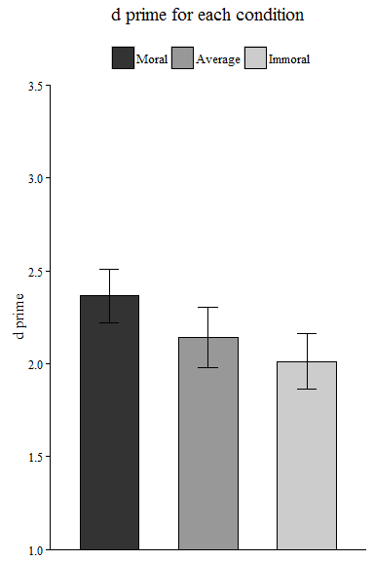

### Analaysis of reaction time

We conducted two repeated measure ANOVA for RT of matched trials and mismatched trials separately For the matched trials, The effect of morality: *F*(2, 60) = 5.797, *p* = 0.005, $η_{g}^{2}$ = 0.0659

For the nonmatched trials, The effect of morality: *F*(2, 60) = 1.134, *p* = 0.3286, $η_{g}^{2}$ = 0.0027

Then we conducted sample effect analysis for the matched trials.

Moral (RT = 699 $±$ 79) vs immoral (RT = 747 $±$ 72) association : *t*(30) = -3.363, *p* = 0.00212, *Cohen's $d_{z}$* = -0.6039, 95% CI [-1.0689 -0.1819]

Moral (RT = 699 $±$ 79) vs. average (RT = 727 $±$ 72) association: *t*(30) = -1.684, *p* = 0.10257, *Cohen's $d_{z}$* = -0.3024, 95% CI [-0.6796 0.0742]

Immoral (RT = 747 $±$ 72) vs. average (RT = 727 $±$ 72) association: *t*(30) = 1.804, *p* = 0.08132, *Cohen's $d_{z}$* = 0.324, 95% CI [-0.061 0.6746]

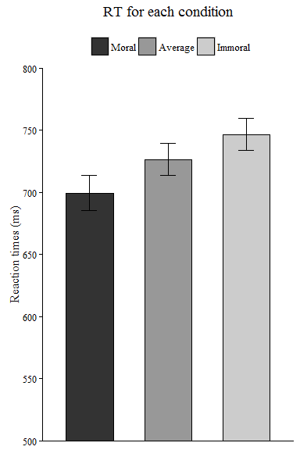

The above is the reaction time for each condition

# Experiment 1b

## Participants

39 participants were recruited from local university (23 female, age: 20.08 $±$ 2.42), all participants had normal vision or corrected-to-normal vision and right handed. Also, data from 12 participants were excluded from analysis due to less than 60% overall accuracy, leaving 27 participants (17 female, age: 20.07 $±$ 2.79 years).

## Results

Correct responses shorter than 200 ms were excluded from the analysis, eliminated 4.8% of the trials overall. Table 1 shows the accuracy and Reaction times(RTs) of paired trials in Experiment 1.

### Analaysis of d prime

The effect of morality: *F*(2, 52) = 5.927, *p* = 0.0048, $η_{g}^{2}$ = 0.0478

Then we conducted sample effect analysis for (see figure 1).

Moral (*d'* = 2.3 $±$ 0.74) vs immoral (*d'* = 2.08 $±$ 0.79) association: *t*(26) = 1.516, *p* = 0.14147, *Cohen's $d_{z}$* = 0.2918, 95% CI [-0.0926 0.6607]

Moral (*d'* = 2.3 $±$ 0.74) vs. Average (*d'* = 1.89 $±$ 0.79) Association: *t*(26) = 3.787, *p* = 0.00081, *Cohen's $d_{z}$* = 0.7289, 95% CI [0.3247 1.166]

Immoral (*d'* = 2.08 $±$ 0.79) vs. Average (*d'* = 1.89 $±$ 0.79) association: *t*(26) = 1.894, *p* = 0.06946, *Cohen's $d_{z}$* = 0.3644, 95% CI [-0.0519 0.7998]

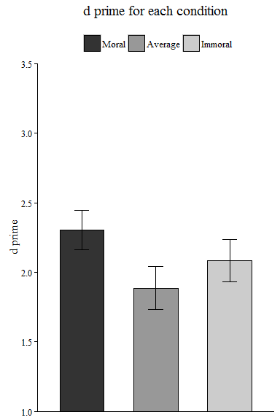

### Analaysis of reaction time

We conducted two repeated measure ANOVA for RT of matched trials and mismatched trials separately For the matched trials, The effect of morality: *F*(2, 52) = 14.281, *p* = 0, $η_{g}^{2}$ = 0.0927

For the nonmatched trials, The effect of morality: *F*(2, 52) = 2.367, *p* = 0.1038, $η_{g}^{2}$ = 0.0087

Then we conducted sample effect analysis for the matched trials.

Moral (RT = 671 $±$ 74) vs immoral (RT = 717 $±$ 72) association : *t*(26) = -3.788, *p* = 0.00081, *Cohen's $d_{z}$* = -0.7291, 95% CI [-1.0299 -0.4129]

Moral (RT = 671 $±$ 74) vs. average (RT = 726 $±$ 84) association: *t*(26) = -5.17, *p* = 0.00002, *Cohen's $d_{z}$* = -0.995, 95% CI [-1.4274 -0.6101]

Immoral (RT = 717 $±$ 72) vs. average (RT = 726 $±$ 84) association: *t*(26) = -0.935, *p* = 0.35851, *Cohen's $d_{z}$* = -0.1799, 95% CI [-0.6673 0.2425]

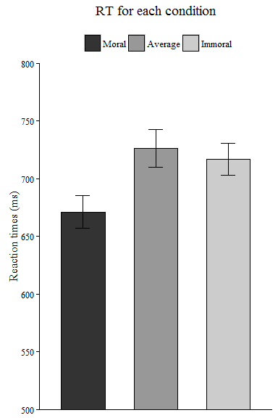

The above is the reaction time for each condition

# combine the results of experiment 1a and 1b

### Analysis of d prime

We conducted a 2 (experiment: 1a vs. 1b) by 3 (morality: moral,immoral neutral) mixed ANOVA, with experiment as between subject variable, and the morality as within subject variable. we found that the interaction between experiment and morality was not siginalficant: *F*(2, 112) = 1.546, *p* = 0.2176, $η_{g}^{2}$ = 0.0068. These resutls showed that the familiarity of words doesn't matter, therefore, we combined data from these two experiment.

An repeated measure ANOVA for the combined data showed a significant effect for morality : *F*(2, 114) = 7.039, *p* = 0.0013, $η_{g}^{2}$ = 0.0304

Then we conducted sample effect analysis for (see figure 1). Moral (*d'* = 2.34 $±$ 0.77) vs immoral (*d'* = 2.04 $±$ 0.81) association: *t*(57) = 2.899, *p* = 0.00531, *Cohen's $d_{z}$* = 0.3806, 95% CI [0.1089 0.6462]

Moral(*d'* = 2.34 $±$ 0.77) vs. Average (*d'* = 2.02 $±$ 0.86) Association: *t*(57) = 3.157, *p* = 0.00255, *Cohen's $d_{z}$* = 0.4146, 95% CI [0.1356 0.7047]

Immoral(*d'* = 2.04 $±$ 0.81) vs. Average (*d'* = 2.02 $±$ 0.86) association: *t*(26) = 1.894, *p* = 0.06946, *Cohen's $d_{z}$* = 0.0363, 95% CI [-0.2272 0.3007]

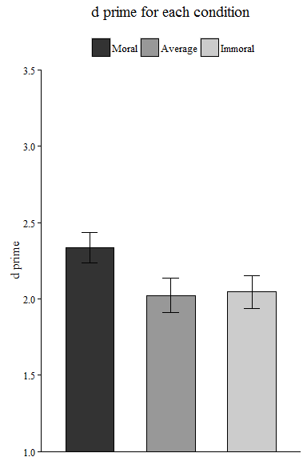

### Analaysis of reaction time

We also analyzed the RT data, using 2 (experiments: 1a vs.1b) by 3 ( morality) mixed ANOVA for RT of matched trials and mismatched trials separately For the matched trials, The interaction of experiments and morality was not significant for matched trials: *F*(2, 112) = 1.677, *p* = 0.1916, $η_{g}^{2}$ = 0.0083. The interaction of experiments and morality was not significant for mismatched trials either: *F*(2, 112) = 1.031, *p* = 0.3602, $η_{g}^{2}$ = 0.0015.

Then we conducted sample effect analysis for the matched trials.

Moral (RT = 686 $±$ 77.4) vs immoral (RT = 733 $±$ 72.8) association : *t*(57) = -5, *p* = 0.00001, *Cohen's $d_{z}$* = -0.6566, 95% CI [-0.9466 -0.3603]

Moral (RT = 686 $±$ 77.4) vs. average (RT = 727 $±$ 76.7) association: *t*(57) = -3.996, *p* = 0.00019, *Cohen's $d_{z}$* = -0.5247, 95% CI [-0.8099 -0.2268]

Immoral (RT = 733 $±$ 72.8) vs. average (RT = 727 $±$ 76.7) association: *t*(57) = 0.797, *p* = 0.42866, *Cohen's $d_{z}$* = 0.1047, 95% CI [-0.1595 0.3546]

