Analyizing the Behavioral Data of Experimental 2

Chuan-Peng Hu

2016.09.05

This script is

# Experiment 2

## Participants

35 participants were recruited from local university (17 female, age: 21.66 $±$ 3.03), all participants had normal vision or corrected-to-normal vision and right handed. Data from 1 participants were excluded from analysis because she has a slightly injured right middle finger, which is used for response.Data from 1 participants were excluded from analysis due to less than 60% overall accuracy, leaving 33 participants (17 female, age: 21.82 $±$ 3.05 years).

## Results

Correct responses shorter than 200 ms were excluded from the analysis, eliminated 1.1% of the trials overall. Table 1 shows the accuracy and Reaction times(RTs) of paired trials in Experiment 1.

### Analaysis of d prime

The effect of morality: *F*(2, 64) = 13.577, *p* = 0, $η_{g}^{2}$ = 0.0673

Then we conducted sample effect analysis for (see figure 1).

Moral (*d'* = 2.86 $±$ 1.01) vs immoral (*d'* = 2.48 $±$ 0.8) association: *t*(32) = 3.968, *p* = 0.00038, *Cohen's $d_{z}$* = 0.6907, 95% CI [0.2722 1.1241]

Moral (*d'* = 2.86 $±$ 1.01) vs. Average (*d'* = 2.28 $±$ 0.91) Association: *t*(32) = 4.522, *p* = 0.00008, *Cohen's $d_{z}$* = 0.7872, 95% CI [0.4513 1.1373]

Immoral (*d'* = 2.48 $±$ 0.8) vs. Average (*d'* = 2.28 $±$ 0.91) association: *t*(32) = 1.774, *p* = 0.08564, *Cohen's $d_{z}$* = 0.3087, 95% CI [-0.0292 0.634]

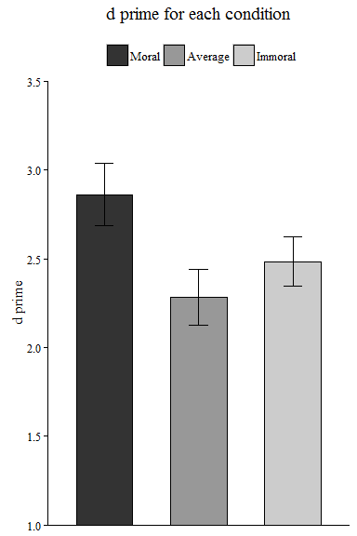

### Analaysis of reaction time

We conducted two repeated measure ANOVA for RT of matched trials and mismatched trials separately For the matched trials, The effect of morality: *F*(2, 64) = 10.561, *p* = 0.0001, $η_{g}^{2}$ = 0.0694

For the nonmatched trials, The effect of morality: *F*(2, 64) = 0.162, *p* = 0.8511, $η_{g}^{2}$ = 0.0005

Then we conducted sample effect analysis for the matched trials.

Moral (RT = 550 $±$ 55) vs immoral (RT = 585 $±$ 58) association : *t*(32) = -4.005, *p* = 0.00035, *Cohen's $d_{z}$* = -0.6971, 95% CI [-1.0883 -0.2898]

Moral (RT = 550 $±$ 55) vs. average (RT = 583 $±$ 64) association: *t*(32) = -3.771, *p* = 0.00066, *Cohen's $d_{z}$* = -0.6565, 95% CI [-1.0455 -0.2368]

Immoral (RT = 585 $±$ 58) vs. average (RT = 583 $±$ 64) association: *t*(32) = 0.264, *p* = 0.79355, *Cohen's $d_{z}$* = 0.0459, 95% CI [-0.3096 0.409]

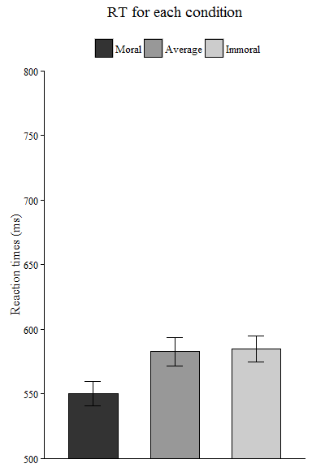

The above is the reaction time for each condition