Analyizing the Behavioral Data of Experimental 3

Chuanpeng Hu

2016.09.07

This script is aimed at making the analysis of experiments reproducible.

# experiment 3

## Participants

38 college students (15 female, age: 21.92 $±$ 2.16) participated in experiment 3. All partcipants were right handed, and all had normal or corrected-to-normal vision. Informed consent was obtained from all partcipants prior to the experiment according to procedure approved by a local ethics committee. 2 of the participant didn't finish the experiment, and 1 of the participants data were excluded from the analysis because of less than 60% overall accuracy, leaving 35 participants (13 female, age: 22.11 $±$ 2.13 years).

## Results

### Analaysis of d prime

ANOVA for *d'* with moral character and self-relatedness as within-subjects factors.

The main effect of Morality, *F*(2, 68) = 10.478, *p* = 0.0001, $η_{g}^{2}$ = 0.0431.

The main effect of Identity: *F*(1, 34) = 2.944, *p* = 0.0953, $η_{g}^{2}$ = 0.0122

The interaction between Morality:Identity: *F*(2, 68) = 2.804, *p* = 0.0676, $η_{g}^{2}$ = 0.0191.

Then we conducted sample effect analysis for self- and other- association separately for the matched trials (see figure 1).

A separate repeated ANOVA for self trials showed that the effect of Morality, *F*(2, 68) = 13.138, *p* = 0, $η_{g}^{2}$ = 0.1335.

post-hoc comparision showed that moral self (2.241 $±$ 0.745) vs immoral self (1.711 $±$ 0.576): *t*(34) = 3.707, *p* = 0.00074, *Cohen's $d_{z}$* = 0.6267, 95% CI [0.2109 1.0057]

Moral self (2.241 $±$ 0.745) vs. Average self(1.721 $±$ 0.586): *t*(34) = 4.39, *p* = 0.0001, *Cohen's $d_{z}$* = 0.742, 95% CI [0.3234 1.1809]

Immoral self (1.711 $±$ 0.576) vs. Average self (1.721 $±$ 0.586): *t*(34) = -0.12, *p* = 0.90508, *Cohen's $d_{z}$* = -0.0203, 95% CI [-0.3543 0.3282]

Moral other (2.124 $±$ 0.82) vs immoral other (2.051 $±$ 0.641): *t*(34) = 0.554, *p* = 0.5831, *Cohen's $d_{z}$* = 0.0937, 95% CI [-0.2502 0.4276]

Moral other (2.124 $±$ 0.82) vs. Average other (1.973 $±$ 0.898): *t*(34) = 1.01, *p* = 0.31959, *Cohen's $d_{z}$* = 0.1707, 95% CI [-0.1808 0.4792]

Immoral other (2.051 $±$ 0.641) vs. Average other(1.973 $±$ 0.898): *t*(34) = 0.543, *p* = 0.59088, *Cohen's $d_{z}$* = 0.0917, 95% CI [-0.2668 0.4306]

repeated ANOVA for other trials showed that the effect of Morality, *F*(2, 68) = 0.567, *p* = 0.5699, $η_{g}^{2}$ = 0.0061.

To examine the effect of self-relatedness, we also conducted t-test for self-other pair for each moral condition. moral self (2.241 $±$ 0.745) vs. moral other (2.124 $±$ 0.82): *t*(34) = 0.591, *p* = 0.55861, *Cohen's $d_{z}$* = 0.0998, 95% CI [-0.2302 0.4555]

Average self (1.721 $±$ 0.586) vs. Average other (1.973 $±$ 0.898): *t*(34) = -1.866, *p* = 0.07067, *Cohen's $d_{z}$* = -0.3154, 95% CI [-0.6157 0.0237] immoral self (1.711 $±$ 0.576) vs. immoral other (2.051 $±$ 0.641): *t*(34) = -3.436, *p* = 0.00157, *Cohen's $d_{z}$* = -0.5808, 95% CI [-0.952 -0.1883]

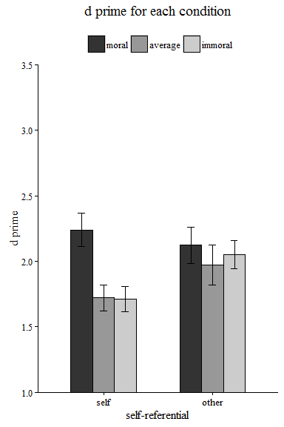

The above figure shows the d prime for each condition (way 1)

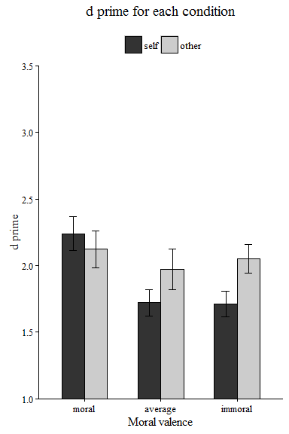

The above figure shows the d prime for each condition (way 2)

### Analaysis of reaction times

We conducted a 3 * 2 rmANOVA for RT For the matched trials, The effect of Morality: *F*(2, 68) = 35.762, *p* = 0, $η_{g}^{2}$ = 0.079

The effect of Identity: *F*(1, 34) = 0.197, *p* = 0.66, $η_{g}^{2}$ = 0.0007

The effect of Morality:Identity: *F*(2, 68) = 3.886, *p* = 0.0252, $η_{g}^{2}$ = 0.0194.

For the nonmatched trials, The effect of Morality: *F*(2, 68) = 0.399, *p* = 0.6724, $η_{g}^{2}$ = 0.0006

The effect of Identity: *F*(1, 34) = 3.429, *p* = 0.0728, $η_{g}^{2}$ = 0.0041

The effect of Morality:Identity: *F*(2, 68) = 2.417, *p* = 0.0968, $η_{g}^{2}$ = 0.007.

Then we conducted sample effect analysis for self- and other- association separately for the matched trials. A separate ANOVA for self trials showed that the effect of Morality: *F*(2, 68) = 30.386, *p* = 0, $η_{g}^{2}$ = 0.1587

A separate ANOVA for other trials showed that the effect of Morality: *F*(2, 68) = 2.849, *p* = 0.0648, $η_{g}^{2}$ = 0.0243

Moral self (713 $±$ 71) vs immoral self (772 $±$ 60): *t*(34) = -5.658, *p* = 0, *Cohen's $d_{z}$* = -0.9563, 95% CI [-1.3379 -0.5636]

Moral self (713 $±$ 71) vs. average self (776 $±$ 70): *t*(34) = -7.396, *p* = 0, *Cohen's $d_{z}$* = -1.2502, 95% CI [-1.6206 -0.8729]

Immoral self (772 $±$ 60) vs. average self (776 $±$ 70): *t*(34) = -0.481, *p* = 0.63335, *Cohen's $d_{z}$* = -0.0814, 95% CI [-0.4158 0.2693]

Moral other (735 $±$ 79) vs immoral other (760 $±$ 62): *t*(34) = -5.658, *p* = 0, *Cohen's $d_{z}$* = -0.9563, 95% CI [-1.3465 -0.5619]

Moral other (735 $±$ 79) vs. average other (755 $±$ 62): *t*(34) = -7.396, *p* = 0, *Cohen's $d_{z}$* = -1.2502, 95% CI [-1.6009 -0.8596]

Immoral other (760 $±$ 62) vs. average other(755 $±$ 62): *t*(34) = -0.481, *p* = 0.63335, *Cohen's $d_{z}$* = -0.0814, 95% CI [-0.4268 0.2593]

To examine the effect of self-relatedness, we also conducted t-test for self-other pair for each moral condition.

moral self (713 $±$ 71) vs. moral other (735 $±$ 79) : *t*(34) = -1.37, *p* = 0.17964, *Cohen's $d_{z}$* = -0.2316, 95% CI [-0.591 0.1387]

average self (776 $±$ 70) vs. average other (755 $±$ 62): *t*(34) = 1.998, *p* = 0.05381, *Cohen's $d_{z}$* = 0.3377, 95% CI [-0.0102 0.6913]

immoral self (772 $±$ 60) vs. immoral other (760 $±$ 62): *t*(34) = 1.232, *p* = 0.22631, *Cohen's $d_{z}$* = 0.2083, 95% CI [-0.1431 0.5336]

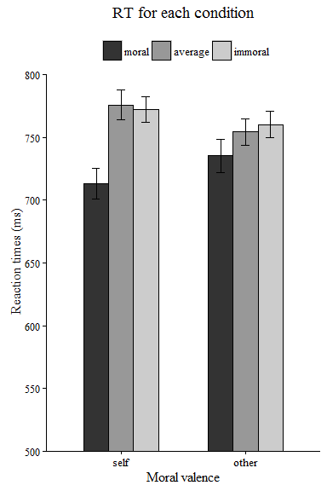

The above is the reaction time for each condition

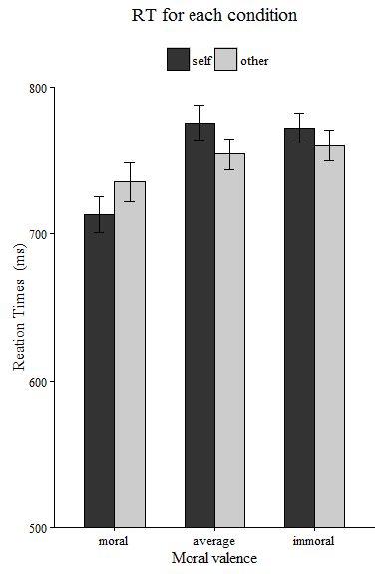

The above is another way to plot.