Analyizing the Behavioral Data of Experimental 4

Chuanpeng Hu

2016.09.10

This script is aimed at making the analysis of experiments reproducible.

# experiment 4

## Participants

31 college students (15 female, age: 19.39 $±$ 1.23) participated in experiment 4. All partcipants were right handed, and all had normal or corrected-to-normal vision. Informed consent was obtained from all partcipants prior to the experiment according to procedure approved by a local ethics committee. 3 of the participants data were excluded from the analysis because of less than 60% overall accuracy, leaving 28 participants (13 female, age: 19.46 $±$ 1.2 years).

## Results

### Analaysis of d prime

ANOVA for *d'* with moral character and self-relatedness as within-subjects factors.

The main effect of Morality, *F*(2, 54) = 0.115, *p* = 0.8915, $η_{g}^{2}$ = 0.0003.

The main effect of Identity: *F*(1, 27) = 49.67, *p* = 0, $η_{g}^{2}$ = 0.2543

The interaction between Morality:Identity: *F*(2, 54) = 0.658, *p* = 0.5222, $η_{g}^{2}$ = 0.0022.

self (2.798 $±$ 0.754) vs.other (1.906 $±$ 0.783): *t*(27) = 7.048, *p* = 0, *Cohen's $d_{z}$* = 1.3319, 95% CI [0.92 1.8207]

Then we conducted sample effect analysis for self- and other- association separately for the matched trials (see figure 1).

A separate repeated ANOVA for self trials showed that the effect of Morality, *F*(2, 54) = 0.22, *p* = 0.8036, $η_{g}^{2}$ = 0.0014.

post-hoc comparision showed that moral self (2.837 $±$ 0.809) vs immoral self (2.775 $±$ 0.824): *t*(27) = 0.569, *p* = 0.57376, *Cohen's $d_{z}$* = 0.1076, 95% CI [-0.2741 0.5008]

Moral self (2.837 $±$ 0.809) vs. Average self(2.781 $±$ 0.643): *t*(27) = 0.589, *p* = 0.56058, *Cohen's $d_{z}$* = 0.1114, 95% CI [-0.2722 0.5143]

Immoral self (2.775 $±$ 0.824) vs. Average self (2.781 $±$ 0.643): *t*(27) = -0.054, *p* = 0.95772, *Cohen's $d_{z}$* = -0.0101, 95% CI [-0.3966 0.3822]

Moral other (1.854 $±$ 0.702) vs immoral other (1.967 $±$ 0.846): *t*(27) = -1.141, *p* = 0.26392, *Cohen's $d_{z}$* = -0.2156, 95% CI [-0.6173 0.1878]

Moral other (1.854 $±$ 0.702) vs. Average other (1.898 $±$ 0.818): *t*(27) = -0.503, *p* = 0.61924, *Cohen's $d_{z}$* = -0.095, 95% CI [-0.459 0.2986]

Immoral other (1.967 $±$ 0.846) vs. Average other(1.898 $±$ 0.818): *t*(27) = 0.558, *p* = 0.58146, *Cohen's $d_{z}$* = 0.1054, 95% CI [-0.2957 0.4767]

repeated ANOVA for other trials showed that the effect of Morality, *F*(2, 54) = 0.594, *p* = 0.5556, $η_{g}^{2}$ = 0.0036.

To examine the effect of self-relatedness, we also conducted t-test for self-other pair for each moral condition. moral self (2.837 $±$ 0.809) vs. moral other (1.854 $±$ 0.702): *t*(27) = 6.859, *p* = 0, *Cohen's $d_{z}$* = 1.2963, 95% CI [0.8706 1.7695]

Average self (2.781 $±$ 0.643) vs. Average other (1.898 $±$ 0.818): *t*(27) = 6.25, *p* = 0, *Cohen's $d_{z}$* = 1.1811, 95% CI [0.756 1.5984] immoral self (2.775 $±$ 0.824) vs. immoral other (1.967 $±$ 0.846): *t*(27) = 4.588, *p* = 0.00009, *Cohen's $d_{z}$* = 0.8671, 95% CI [0.4813 1.2835]

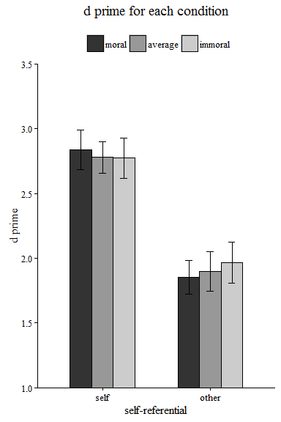

The above figure shows the d prime for each condition (way 1)

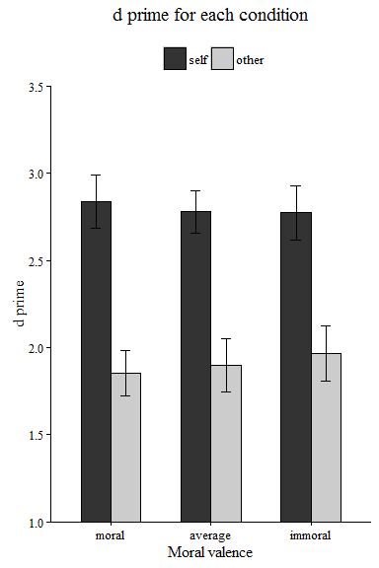

The above figure shows the d prime for each condition (way 2)

### Analaysis of reaction times

We conducted a 3 * 2 rmANOVA for RT.

**For the matched trials**. The effect of Morality: *F*(2, 54) = 1.404, *p* = 0.2544, $η_{g}^{2}$ = 0.0033

The effect of Identity: *F*(1, 27) = 103.946, *p* = 0, $η_{g}^{2}$ = 0.2943

The effect of Morality:Identity: *F*(2, 54) = 3.957, *p* = 0.0249, $η_{g}^{2}$ = 0.006.

**For the nonmatched trials**, The effect of Morality: *F*(2, 54) = 0.737, *p* = 0.4833, $η_{g}^{2}$ = 0.0011

The effect of Identity: *F*(1, 27) = 0.486, *p* = 0.4919, $η_{g}^{2}$ = 0.0009

The effect of Morality:Identity: *F*(2, 54) = 0.012, *p* = 0.9878, $η_{g}^{2}$ = 0.

Then we conducted sample effect analysis for self- and other- association separately for the matched trials. A separate ANOVA for **self** trials showed that the effect of Morality: *F*(2, 54) = 7.245, *p* = 0.0016, $η_{g}^{2}$ = 0.0173

A separate ANOVA for **other** trials showed that the effect of Morality: *F*(2, 54) = 0.079, *p* = 0.9244, $η_{g}^{2}$ = 0.0004

Moral self (634 $±$ 70) vs immoral self (655 $±$ 67): *t*(27) = -4.228, *p* = 0.00024, *Cohen's $d_{z}$* = -0.799, 95% CI [-1.1712 -0.4239]

Moral self (634 $±$ 70) vs. average self (650 $±$ 66): *t*(27) = -2.67, *p* = 0.01269, *Cohen's $d_{z}$* = -0.5045, 95% CI [-0.9262 -0.0945]

Immoral self (655 $±$ 67) vs. average self (650 $±$ 66): *t*(27) = 0.726, *p* = 0.47379, *Cohen's $d_{z}$* = 0.1373, 95% CI [-0.2397 0.54]

Moral other (732 $±$ 63) vs immoral other (730 $±$ 64): *t*(27) = -4.228, *p* = 0.00024, *Cohen's $d_{z}$* = -0.799, 95% CI [-1.1614 -0.4292]

Moral other (732 $±$ 63) vs. average other (730 $±$ 70): *t*(27) = -2.67, *p* = 0.01269, *Cohen's $d_{z}$* = -0.5045, 95% CI [-0.9412 -0.1055]

Immoral other (730 $±$ 64) vs. average other(730 $±$ 70): *t*(27) = 0.726, *p* = 0.47379, *Cohen's $d_{z}$* = 0.1373, 95% CI [-0.2615 0.5406]

To examine the effect of self-relatedness, we also conducted t-test for self-other pair for each moral condition.

moral self (634 $±$ 70) vs. moral other (732 $±$ 63) : *t*(27) = -11.324, *p* = 0, *Cohen's $d_{z}$* = -2.14, 95% CI [-2.7349 -1.5592]

average self (650 $±$ 66) vs. average other (730 $±$ 70): *t*(27) = -7.805, *p* = 0, *Cohen's $d_{z}$* = -1.4751, 95% CI [-2.0685 -0.9611]

immoral self (655 $±$ 67) vs. immoral other (730 $±$ 64): *t*(27) = -7.384, *p* = 0, *Cohen's $d_{z}$* = -1.3955, 95% CI [-1.934 -0.7331]

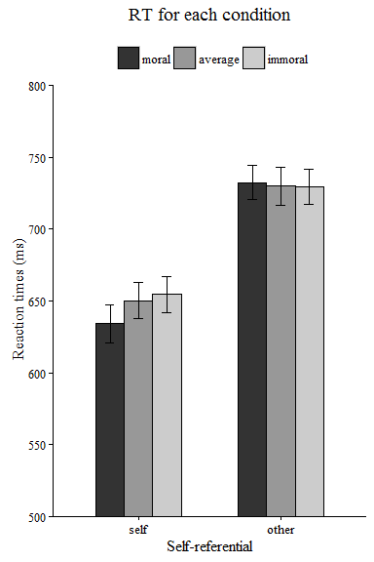

The above is the reaction time for each condition

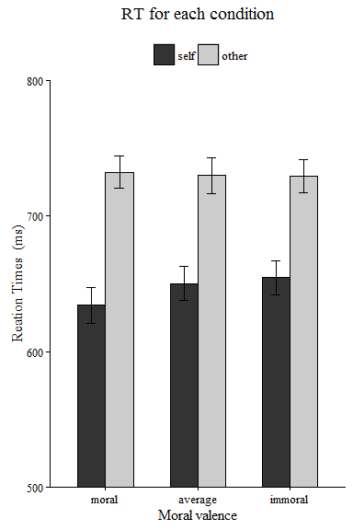

The above is another way to plot.