Analyizing the Behavioral Data of Experimental 5

Chuanpeng Hu

09,2016

This script is aimed at making the analysis of experiments reproducible.

## Participants

34 college students (26 female, age: 21.26 $±$ 1.78) participated in experiment 5. All partcipants were right handed, and all had normal or corrected-to-normal vision. Informed consent was obtained from all partcipants prior to the experiment according to procedure approved by a local ethics committee. 2 of the participants data were excluded from the analysis because of less than 60% overall accuracy, leaving 32 participants (25 female, age: 21.28 $±$ 1.76 years).

## Results

### Analaysis of d prime

ANOVA for *d'* with moral character and self-relatedness as within-subjects factors.

The main effect of Morality, *F*(2, 62) = 1.925, *p* = 0.1545, $η_{g}^{2}$ = 0.0131.

The main effect of Identity: *F*(1, 31) = 0.047, *p* = 0.8298, $η_{g}^{2}$ = 0

The interaction between Morality:Identity: *F*(2, 62) = 3.123, *p* = 0.051, $η_{g}^{2}$ = 0.0049.

Then we conducted sample effect analysis for self- and other- association separately for the matched trials (see figure 1).

A separate repeated ANOVA for **self trials** showed that the effect of Morality, *F*(2, 62) = 3.674, *p* = 0.0311, $η_{g}^{2}$ = 0.0316.

repeated ANOVA for **other trials** showed that the effect of Morality, *F*(2, 62) = 0.638, *p* = 0.5317, $η_{g}^{2}$ = 0.0051.

post-hoc comparision showed that moral self (2.609 $±$ 0.864) vs immoral self (2.28 $±$ 0.778): *t*(31) = 2.268, *p* = 0.03048, *Cohen's $d_{z}$* = 0.4008, 95% CI [-0.0335 0.8556]

Moral self (2.609 $±$ 0.864) vs. Average self(2.343 $±$ 0.761): *t*(31) = 2.478, *p* = 0.01888, *Cohen's $d_{z}$* = 0.438, 95% CI [0.0371 0.8276]

Immoral self (2.28 $±$ 0.778) vs. Average self (2.343 $±$ 0.761): *t*(31) = -0.473, *p* = 0.63948, *Cohen's $d_{z}$* = -0.0836, 95% CI [-0.4733 0.2782]

Moral other (2.484 $±$ 0.817) vs immoral other (2.434 $±$ 0.869): *t*(31) = 0.331, *p* = 0.7426, *Cohen's $d_{z}$* = 0.0586, 95% CI [-0.2968 0.4458]

Moral other (2.484 $±$ 0.817) vs. Average other (2.34 $±$ 0.844): *t*(31) = 1.319, *p* = 0.19669, *Cohen's $d_{z}$* = 0.2332, 95% CI [-0.137 0.6038]

Immoral other (2.434 $±$ 0.869) vs. Average other(2.34 $±$ 0.844): *t*(31) = 0.751, *p* = 0.45827, *Cohen's $d_{z}$* = 0.1328, 95% CI [-0.2266 0.4957]

To examine the effect of self-relatedness, we also conducted t-test for self-other pair for each moral condition. moral self (2.609 $±$ 0.864) vs. moral other (2.484 $±$ 0.817): *t*(31) = 1.582, *p* = 0.12373, *Cohen's $d_{z}$* = 0.2797, 95% CI [-0.128 0.6807]

Average self (2.343 $±$ 0.761) vs. Average other (2.34 $±$ 0.844): *t*(31) = 0.028, *p* = 0.97803, *Cohen's $d_{z}$* = 0.0049, 95% CI [-0.3474 0.3759] immoral self (2.28 $±$ 0.778) vs. immoral other (2.434 $±$ 0.869): *t*(31) = -2.393, *p* = 0.02294, *Cohen's $d_{z}$* = -0.4231, 95% CI [-0.7267 -0.0733]

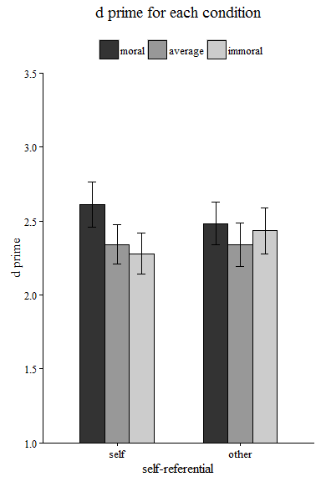

The above figure shows the d prime for each condition (way 1) 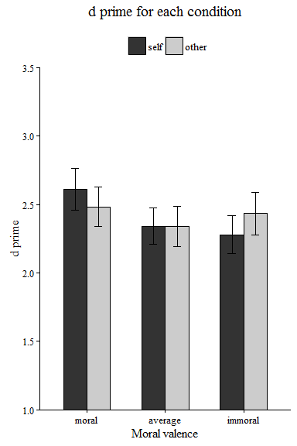

The above figure shows the d prime for each condition (way 2)

### Analaysis of reaction times

We conducted a 3 * 2 rmANOVA for RT.

**For the matched trials**, The effect of Morality: *F*(2, 62) = 8.75, *p* = 0.0004, $η_{g}^{2}$ = 0.0728

The effect of Identity: *F*(1, 31) = 0, *p* = 0.9949, $η_{g}^{2}$ = 0

The effect of Morality:Identity: *F*(2, 62) = 5.108, *p* = 0.0088, $η_{g}^{2}$ = 0.0055.

**For the nonmatched trials**, The effect of Morality: *F*(2, 62) = 6.914, *p* = 0.0019, $η_{g}^{2}$ = 0.0144

The effect of Identity: *F*(1, 31) = 0.749, *p* = 0.3936, $η_{g}^{2}$ = 0.0004

The effect of Morality:Identity: *F*(2, 62) = 0.064, *p* = 0.9384, $η_{g}^{2}$ = 0.0001.

Then we conducted sample effect analysis for self- and other- association separately for the matched trials. A separate ANOVA for **self** trials showed that the effect of Morality: *F*(2, 62) = 11.474, *p* = 0.0001, $η_{g}^{2}$ = 0.1028

A separate ANOVA for **other** trials showed that the effect of Morality: *F*(2, 62) = 4.928, *p* = 0.0103, $η_{g}^{2}$ = 0.0476

Moral self (670 $±$ 64) vs immoral self (715 $±$ 58): *t*(31) = -3.875, *p* = 0.00052, *Cohen's $d_{z}$* = -0.6849, 95% CI [-1.1721 -0.2469]

Moral self (670 $±$ 64) vs. average self (709 $±$ 57): *t*(31) = -4.524, *p* = 0.00008, *Cohen's $d_{z}$* = -0.7997, 95% CI [-1.2378 -0.3679]

Immoral self (715 $±$ 58) vs. average self (709 $±$ 57): *t*(31) = 0.535, *p* = 0.59624, *Cohen's $d_{z}$* = 0.0946, 95% CI [-0.2709 0.4549]

Moral other (682 $±$ 65) vs immoral other (712 $±$ 45): *t*(31) = -3.007, *p* = 0.0052, *Cohen's $d_{z}$* = -0.5315, 95% CI [-0.984 -0.1303]

Moral other (682 $±$ 65) vs. average other (701 $±$ 58): *t*(31) = -2.032, *p* = 0.0508, *Cohen's $d_{z}$* = -0.3592, 95% CI [-0.7424 0.0179]

Immoral other (712 $±$ 45) vs. average other(701 $±$ 58): *t*(31) = 1.149, *p* = 0.25932, *Cohen's $d_{z}$* = 0.2031, 95% CI [-0.1524 0.5531]

To examine the effect of self-relatedness, we also conducted t-test for self-other pair for each moral condition.

moral self (670 $±$ 64) vs. moral other (682 $±$ 65) : *t*(31) = -2.588, *p* = 0.01455, *Cohen's $d_{z}$* = -0.4576, 95% CI [-0.7615 -0.133]

average self (709 $±$ 57) vs. average other (701 $±$ 58): *t*(31) = 2.598, *p* = 0.01422, *Cohen's $d_{z}$* = 0.4593, 95% CI [0.0559 0.8836]

immoral self (715 $±$ 58) vs. immoral other (712 $±$ 45): *t*(31) = 0.537, *p* = 0.59502, *Cohen's $d_{z}$* = 0.095, 95% CI [-0.2767 0.4275]

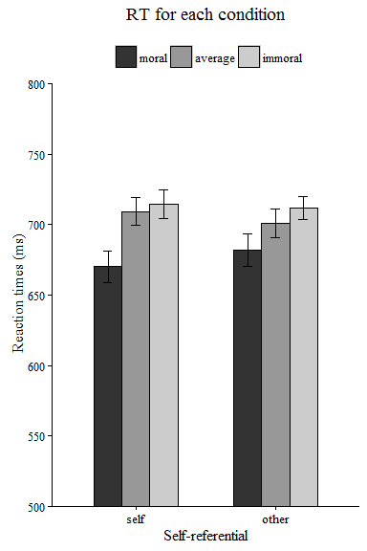

The above is the reaction time for each condition

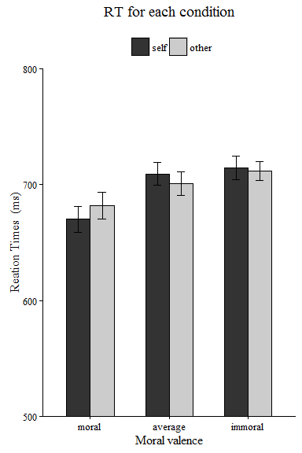

The above is another way to plot.