Digital Image Processing Exercise Report

Instructor: MITSUGAMI IKUHISA

Student ID: 81322400098

Student Name: GARCIA AARON CALVIN

Date: 2024 05 28

**Summary/Discussion:**

**Gaussian-Laplacian**

Gaussian-Laplacian is an algorithm (or in this case, a combination of algorithms) used to enhance the “edges” of the image in order to enhance image clarity specifically for computer vision. In this case, we start with the Gaussian, which is responsible for reducing noise within the image quality by effectively blurring the image. For the kernel, I played around with it before settling on 15 x 15 with a sigma-X of 1. We then apply the Laplacian to produce the edges of the image. However, we can see that the lines are still quite thick. In order to make them more clear for the computer to be able to process the image more clearly, we turn to the Canny Edge Detector algorithm.

**Canny**

The Canny edge detection algorithm is a popular method used in computer vision to identify edges within an image, specifically because it expanded on the previous algorithm by including it, and processing it using a more few mathematical equations. Firstly, we use thin the edges of the image by detecting maximum position in the gradient direction- this is called Non-Maximum suppression. (If a value at an (x,y) coordinate is smaller than the 2 value surrounding it- and the values in that sequence show a change of rate, then set it to zero. Otherwise, keep it.) Afterwards, we typically include two thresholds, which control the sensitivity of the edge detection- that is- if weak edge are discarded in the final product if they do not connect to those with gray-scale values falling within that range. Lower values detect more edges, and higher values detect fewer edges.

This is were the last two tests differ- one was created with predefined threshold of a lower bound of-100, higher bound of 200, and the last one was created to be set dynamically- that is, the lower threshold is set to 33% below the median gray-scale value of all pixels in the pre-processed image, and the upper threshold is set to 33% above the median. This dynamic range means we can test multiple images seamlessly, as seen in the last example.

**Results**

Laplacian+Gaussian

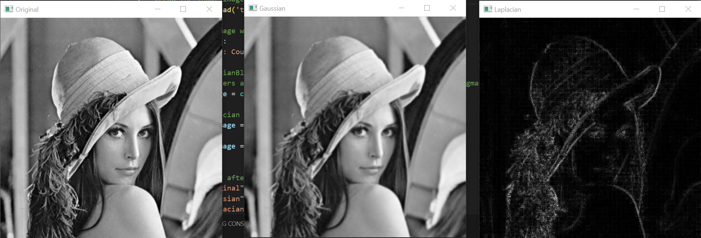Canny (without auto-thresh[min=100,max=200])

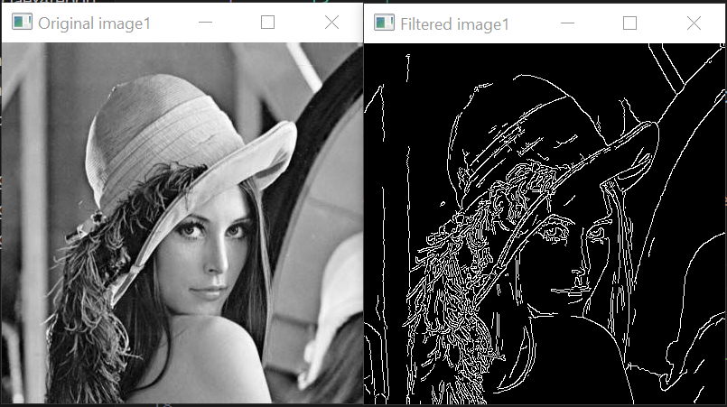Canny (with auto-thresh)

image1

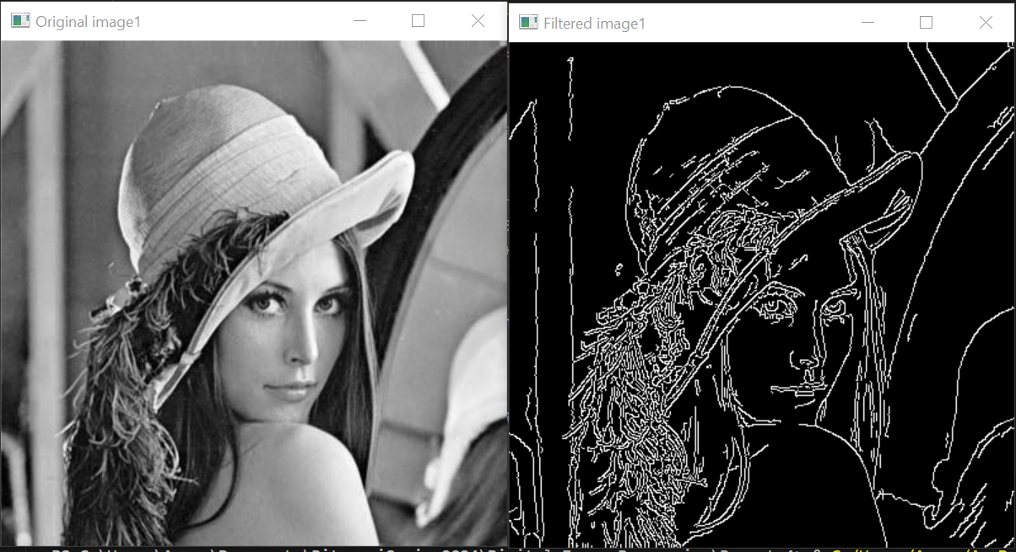

image2

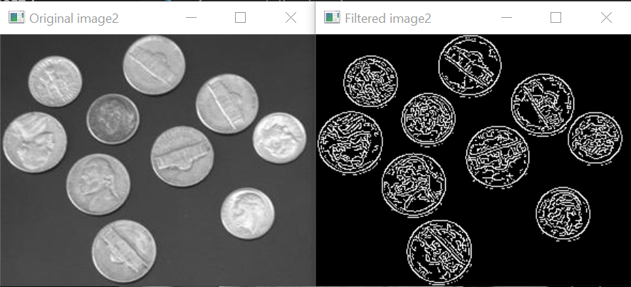

image3

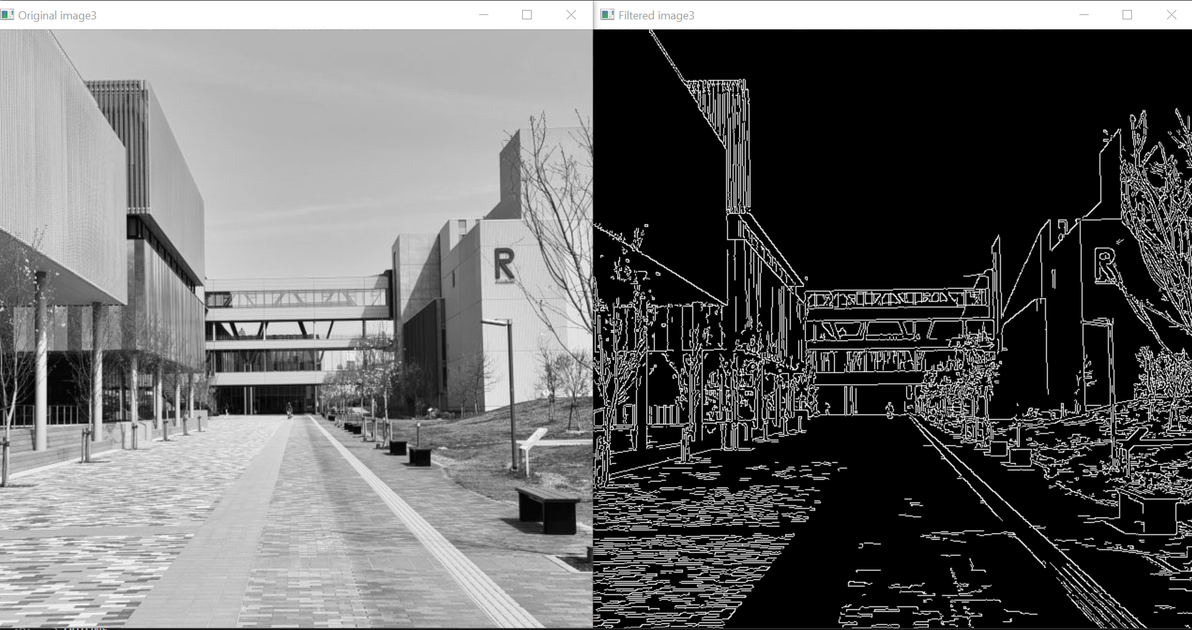**References**

1. Week 7 Slides