D1 Adult Soccer League

Paying for a Season in MindBody

The following guide shows how to pay for a season of D1 Adult Soccer League through MindBody. If you’ve visited MindBody before, you may be able to skip the first step.

1. Select ‘Online Store’ to be taken to the D1 Services Purchase Page

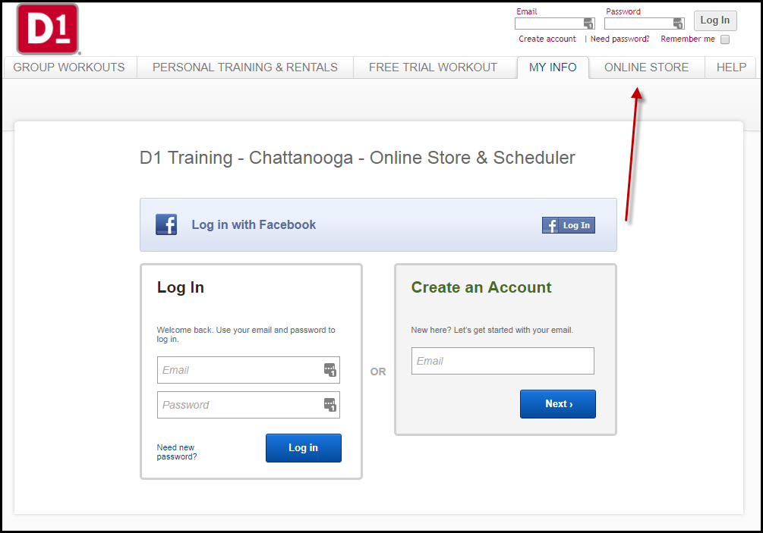

1. Select ‘Adult Soccer League’ from the dropdown. You may have to click ‘Services’ first, if not already directed to that section.

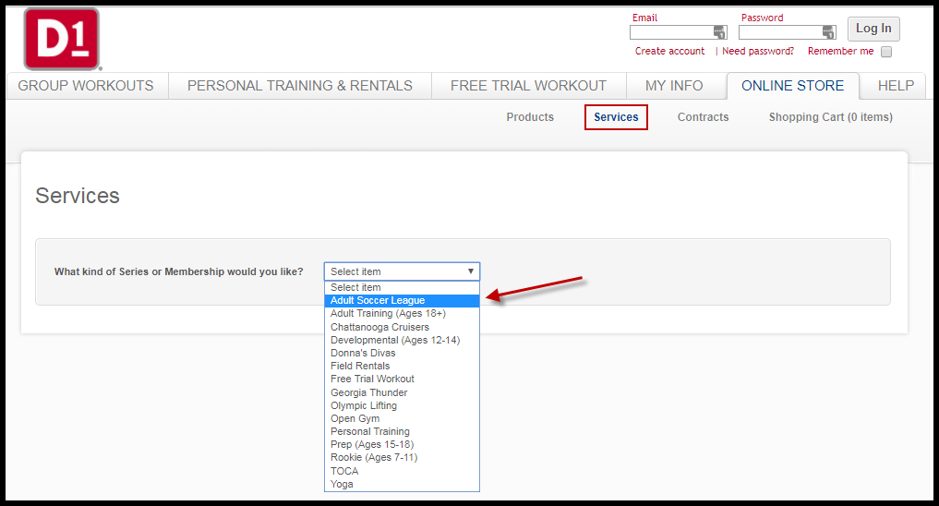

1. Click on the arrow to add this to your cart.

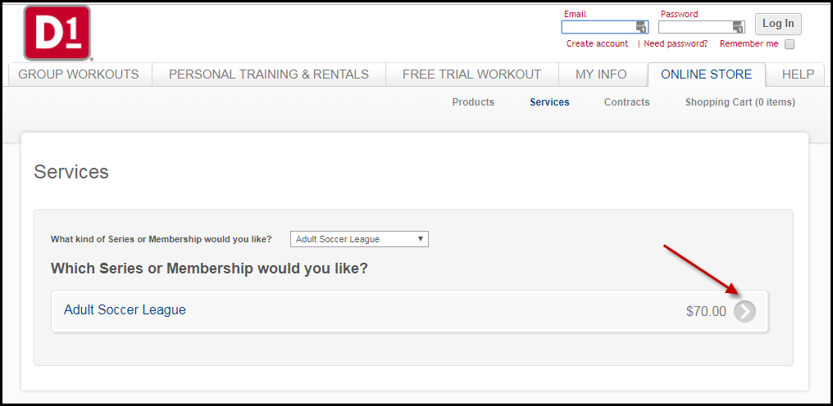

1. Select ‘Check Out’

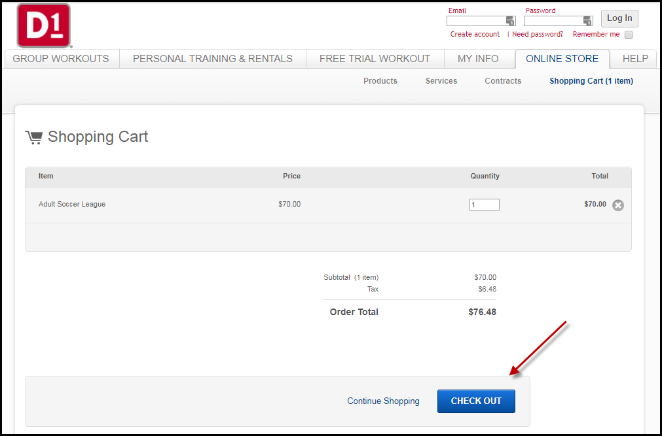

1. Sign in or register if you haven’t previously set up an account with MindBody. When setting up an account with MindBody, be sure to use the same name you used on D1ChattSoccer.com so that we are able to track your payment.

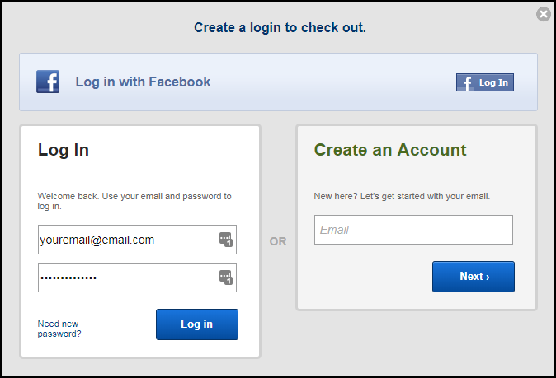

1. After signing in, you should be directed back to your shopping cart where you can proceed to check out and pay for the season.

Payments made in MindBody may take a week or two to show up as ‘paid’ in D1ChattSoccer.com. Do not worry: you are still able to play as long as you have signed a waiver and paid for the season.