North Carolina (NOC) NERR Water Quality Metadata
January 1, 2023 – December 31st, 2023
Latest Update: April 15th, 2024

Note: This is a provisional metadata document; it has not been authenticated as of its download date. Contents of this document are subject to change throughout the QAQC process and it should not be considered a final record of data documentation until that process is complete. Contact the CDMO (cdmosupport@baruch.sc.edu) or reserve with any additional questions.

I. Data Set and Research Descriptors

1) Principal investigator(s) and contact persons –
Justin Ridge, Research Coordinator
400 Commerce Ave.
Morehead City, NC 28557
Phone: (252) 838-0851
Fax: (252) 247-3330
Email: justin.ridge(at)ncdenr.gov

Byron Toothman, Research Associate
5600 Marvin K. Moss Lane
Wilmington, NC 28409
Phone: (910) 962-2334
Fax: (910) 962-2410
Email: toothmanb(at)uncw.edu

Heather Wells, Research Associate
5600 Marvin K. Moss Lane
Wilmington, NC 28409
Phone: (910) 962-2335
Fax: (910) 962-2410
Email: wellsh(at)uncw.edu

2) Entry verification –
Deployment data are uploaded from the YSI data logger to a personal computer with Windows 7 or newer operating system. Files are exported from EcoWatch in a comma-delimited format (.CDF), EcoWatch Lite in a comma separated file (CSV) or KOR Software in a comma separated file (CSV) and uploaded to the CDMO where they undergo automated primary QAQC; automated Depth/Level corrections for changes in barometric pressure (cDepth or cLevel parameters); and become part of the CDMO’s online provisional database. All pre- and post-deployment data are removed from the file prior to upload. During primary QAQC, data are flagged if they are missing or out of sensor range. The edited file is then returned to the reserve for secondary QAQC where it is opened in Microsoft Excel and processed using the CDMO’s NERRQAQC Excel macro. The macro inserts station codes, creates metadata worksheets for flagged data and summary statistics, and graphs the data for review. It allows the user to apply QAQC flags and codes to the data, remove any overlapping deployment data, append files, and export the resulting data file for upload to the CDMO. Upload after secondary QAQC results in ingestion into the database as provisional plus data, recalculation of cDepth or cLevel parameters, and finally tertiary QAQC by the CDMO and assimilation into the CDMO’s authoritative online database. Where deployment overlap occurs between files, the data produced by the newly calibrated sonde is generally accepted as being the most accurate. For more information on QAQC flags and codes, see Sections 11 and 12. All QA/QC by the Reserve are performed by Heather Wells and Byron Toothman.

3) Research objectives – Four long-term water quality monitoring stations have been established within the estuaries bordering Masonboro and Zeke’s Islands of North Carolina’s National Estuarine Research Reserve. Instruments are deployed vertically at all sites except East Cribbings, which was anchored to the bottom for the majority of 2012. The East Cribbings site was converted to a vertical deployment structure on December 4, 2012. Measurements are taken at 15-minute intervals for approximately two to six week periods continuously throughout the year. Parameters measured include Depth, Temperature, Salinity, Specific Conductivity, pH, Dissolved Oxygen, and Turbidity. The goal is to assess short-term variability and long-term changes (i.e., localized impacts of seasonal storm events, inter-annual differences from rainfall, magnitude of climatic influence from El Nino/La Nina events, etc.) in estuarine water parameters within relatively pristine sites.

4) Research methods –
The Estuarine Water Quality Monitoring Program began on March 2, 1992 at the Research Creek site of the Masonboro Island component. A second Masonboro Island site, Loosin Creek, was added on February 26, 2002. Data collection started on May 19, 1994 at the Zeke's Island component (East Cribbings site) and an additional site, Zeke's Basin, was added March 1, 2002. The procedures described below were instituted in June 1995 and thus do not cover data recorded previously.

Two data loggers are assigned to each of the four permanent monitoring stations and are generally not interchanged among sites unless malfunctions occur. Before each YSI EXO2 sonde is deployed, calibration and maintenance is performed following the manufacturer's instructions. Calibration standards are required for pH, turbidity and salinity; all other parameter calibrations are performed as described in the manual. Buffer solutions for a two-point pH calibration (pH 7 and 10) are purchased pre-made from a scientific supply house. The conductivity and turbidity standards are obtained from YSI. Chlorophyll probes are calibrated with deionized water and Rhodamine WT as a 2-point calibration. All sites have been monitored using with optical dissolved oxygen probes since 2009, prior to that time rapid pulse dissolved oxygen probes were used.

Data sondes are stored and transported wet in their calibration cup with and placed in a cooler for transport to the site. Monitoring stations are accessed using a small boat equipped with an outboard motor. During deployment the weather conditions and tide stage are recorded in the field observation log. The water quality instrument is placed inside a locked PVC tube that is attached to a piling if vertical deployment, and a steel cage if anchored horizontally approximately (15cm off the bottom). Every 15 minutes measurements are taken for Temperature, Specific Conductance, Salinity, Dissolved oxygen saturation, Dissolved oxygen concentration, Depth, pH, and Turbidity. All data are recorded in Eastern Standard Time. Vertical deployment structures were utilized at Research Creek beginning in 2008-2009, at Loosin Creek in 2009, and at Zeke’s Basin in August 2010. Research Creek and East Cribbings vertical deployment structures were destroyed by Hurricane Isaias approximately 3 August 2020 and the stations were temporarily redeployed using the original anchored cinderblock style stations causing some mobility of the instrument with tide and currents. The temporary East Cribbings station was lost and the sonde recovered in 2021 and has not been redeployed since, pending the construction of new storm resilient stations in 2023. Nutrient samples continue to be collected at all stations.

During 2022, chlorophyll data was collected at East Cribbings, Loosin Creek, Research Creek, and Zeke’s Basin stations. A 2-ppoint (0 NTU) chlorophyll calibration using DI water and Rhodamine WT was performed prior to sonde deployments. Chlorophyll spikes and negative values were rejected, while elevated values may be flagged as suspect depending on field conditions. We currently calibrate with a known concentration Rhodamine solutions.

At the end of the sample period the water quality instrument is exchanged with a freshly calibrated instrument and transported back to the laboratory wrapped in a wet, white towel. The weather and water quality measurements are again noted in the field observation log. The calibration drift and the effect of biofouling on the water quality instrument are documented by post-calibration protocols. The water quality data are then uploaded, and sent to CDMO for primary QAQC, and the instrument is cleaned and calibrated as noted previously.

A STORM3 transmitter was installed at the Research Creek and Zekes Basin stations on mm/dd/yy and transmits data to the NOAA GOES satellite, NESDIS ID #3B032698. The transmissions are scheduled hourly and contain four (4) data sets reflecting fifteen-minute data sampling intervals. Upon receipt by the CDMO, the data undergoes the same automated primary QAQC process detailed in Section 2 above. The “real-time” telemetry data become part of the provisional dataset until undergoing secondary and tertiary QAQC and assimilation in the CDMO’s authoritative online database. Provisional and authoritative data are available at www.nerrsdata.org.

5) Site location and character –
The components of North Carolina's National Estuarine Research Reserve (from north to south) are: Currituck Banks, Rachel Carson, Masonboro Island, and Zeke's Island. They are located along the southeast Atlantic coast of the United States. Currently, only data from Masonboro Island and Zeke's Island components are transferred to the CDMO. The four monitoring sites are:

A. Research Creek, Masonboro Island
The first Masonboro Island site (formerly called Masonboro Island (MS)) is 0.72 km north east from the mouth of Whiskey Creek, and east of the Intracoastal Waterway (ICW), in a small navigable channel called Research Creek at 34°09'21.7" latitude and 77° 50'59.9" longitude. The site typically has a salinity range of 20-35 ppt and a tidal range that averages around 1.2 meters. The sole source of freshwater is rain and salinity values as little as 10 ppt have been recorded during periods of heavy rain. The creek bottom is characterized by sand and detritus based sediment with areas of soft mud with a depth ranging from 0.2 to 2.6 m. Spartina spp. marsh and dunes surround the site, which is relatively unimpacted by manmade perturbations and it is not accessible to road traffic. The site experiences minimal boat traffic.

B. Loosin Creek, Masonboro Island
The second Masonboro Island site (added in 2002) is 1.2 km east of the ICW, and 2.5 km south west of Masonboro Inlet, in a small navigable channel called Loosin Creek at 34° 10'20.0" latitude and 77° 49'58.1" longitude. The site generally has a salinity range of 22-35 ppt and a tidal range that averages 1.2 meters. The sole source of freshwater is rain and salinity values as little as 15 ppt have been recorded during periods of heavy rain. The creek bottom is characterized by sand and detritus based sediment with areas of soft mud with a depth ranging from 0.1 to 2.5 m. Spartina spp. marsh and dunes surround the site, which is relatively unimpacted by manmade perturbations and it is not accessible to road traffic. The site experiences minimal boat traffic.

C. East Cribbings, Zeke's Island
The first Zeke's Island site (formerly called Zeke's Island (ZI)) is located 1.8 km south of Federal Point boat launch in a tidal basin estuary at 33° 56'23.5" latitude and 77° 56'28.1" longitude. This site receives minimal freshwater input from leakage of the Cape Fear River through the 5.6 km rock jetty that separates the two bodies of water. The site typically has a salinity range of 15-33 ppt, although values as little as 10 ppt have been recorded. Tidal range averages 1.2 meters. Depth varies, but usually can be found to range from 0.5 to 2.7 meters. Bottom type substratum consists of large rocks (“the cribbings”) with sand and detritus based sediment. There are no pollutants from land. Marsh and dunes surround the site. It is not accessible to road traffic but experiences minimal boat traffic.

D. Zeke's Basin, Zeke's Island
The second Zeke's Island site (added in 2002) is located 0.8 km south east of the Federal Point boat launch in a tidal basin estuary at 33° 57'17.0" latitude and 77° 56'6.0" longitude. This site receives minimal freshwater input from leakage of the Cape Fear River through the 5.6 km rock jetty that separates the two bodies of water The site has a characteristic salinity range of 12-30 ppt, but values below 10 ppt have been observed and are often associated with periods of heavy rainfall. Tidal range averages 1.2 meters. Depth varies, but typically it can be found to range from 0.1 to 1.8 meters. Bottom type substratum consists of sand and detritus based sediment with a layer of soft sulfuric mud. Marsh and dunes surround the site. It is not accessible to road traffic but experiences minimal boat traffic.

Station Code | SWMP Status | Station Name | Location | Active Dates | Reason Decommissioned | Notes
NOCECWQ | P | East Cribbing | 33° 56' 23.64 N, 77° 56' 27.96 W | 01/01/2002 00:00 - | NA | NA
NOCLCWQ | P | Loosin Creek | 34° 10' 19.92 N, 77° 49' 58.08 W | 02/01/2002 00:00 - | NA | NA
NOCRCWQ | P | Research Creek | 34° 9' 21.60 N, 77° 50' 59.64 W | 01/01/2002 00:00 - | NA | NA
NOCZBWQ | P | Zeke's Basin | 33° 57' 16.92 N, 77° 56' 6.00 W | 03/01/2002 00:00 - | NA | NA

6) Data collection period –
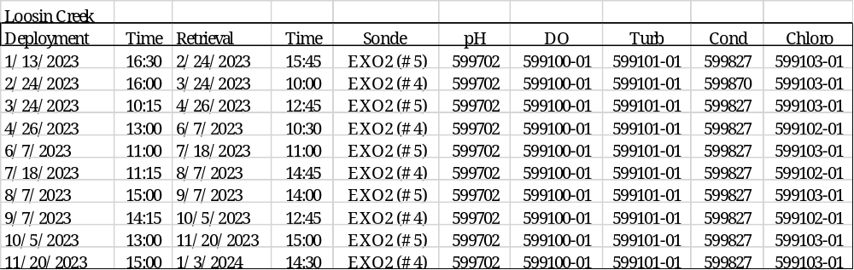

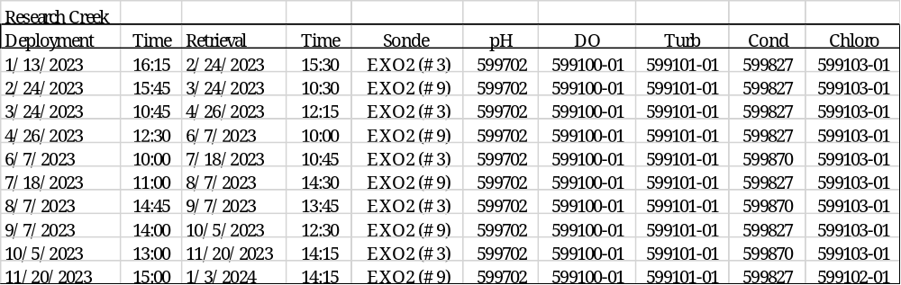

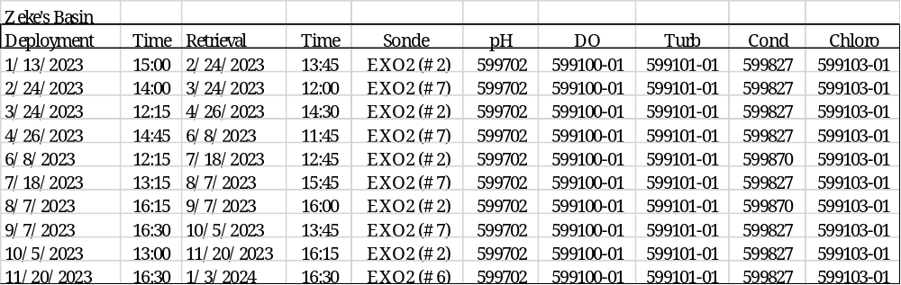

7) Distribution –
NOAA retains the right to analyze, synthesize and publish summaries of the NERRS System-wide Monitoring Program data. The NERRS retains the right to be fully credited for having collected and processed the data. Following academic courtesy standards, the NERR site where the data were collected should be contacted and fully acknowledged in any subsequent publications in which any part of the data are used. The data set enclosed within this package/transmission is only as good as the quality assurance and quality control procedures outlined by the enclosed metadata reporting statement. The user bears all responsibility for its subsequent use/misuse in any further analyses or comparisons. The Federal government does not assume liability to the Recipient or third persons, nor will the Federal government reimburse or indemnify the Recipient for its liability due to any losses resulting in any way from the use of this data.

Requested citation format:
NOAA National Estuarine Research Reserve System (NERRS). System-wide Monitoring Program. Data accessed from the NOAA NERRS Centralized Data Management Office website: http://www.nerrsdata.org/; accessed 12 October 2022.

Also include the following excerpt in the metadata which will address how and where the data can be obtained.

NERR water quality data and metadata can be obtained from the Research Coordinator at the individual NERR site (please see Principal Investigators and Contact Persons), from the Data Manager at the Centralized Data Management Office (please see personnel directory under the general information link on the CDMO home page) and online at the CDMO home page www.nerrsdata.org. Data are available in comma delimited format.

8) Associated researchers and projects –

As part of the SWMP long-term monitoring program, NOC NERR also collects 15-minute meteorological data and monthly grab and diel samples for nutrient/pigment data which may be correlated with this water quality dataset. These data are available at www.nerrsdata.org.

Additional research projects are ongoing and continually changing. Check with the Research Coordinator or other contact person for an updated list of research.

II. Physical Structure Descriptors

9) Sensor specifications –
NOC NERR deployed Xylem Analytics EXO data sondes at all sites in 2020. All sondes used are the same model (EXO2) and employ the same sensor configuration.

YSI EXO Sonde:

Parameter: Temperature
Units: Celsius (C)
Sensor Type: CT2 Probe, Thermistor
Model#: 599870
Range: -5 to 50 C
Accuracy: -5 to 35: +/- 0.01, 35 to 50: +/- .005
Resolution: 0.01 C

Parameter: Conductivity
Units: milli-Siemens per cm (mS/cm)
Sensor Type: CT2 Probe, 4-electrode cell with autoranging
Model#: 599870
Range: 0 to 200 mS/cm
Accuracy: 0 to 100: +/- 0.5% of reading or 0.001 mS/cm; 100 to 200: +/- 1% of reading
Resolution: 0.001 mS/cm to 0.1 mS/cm (range dependant)

Parameter: Salinity
Units: practical salinity units (psu)/parts per thousand (ppt)
Sensor Type: CT2 probe, Calculated from conductivity and temperature
Range: 0 to 70 psu
Accuracy: +/- 1.0% of reading pr 0.1 ppt, whichever is greater
Resolution: 0.01 psu

OR

Parameter: Temperature
Units: Celsius (C)
Sensor Type: Wiped probe; Thermistor
Model#: 599827
Range: -5 to 50 C
Accuracy: ±0.2 C
Resolution: 0.001 C

Parameter: Conductivity
Units: milli-Siemens per cm (mS/cm)
Sensor Type: Wiped probe; 4-electrode cell with autoranging
Model#: 599827
Range: 0 to 100 mS/cm
Accuracy: ±1% of the reading or 0.002 mS/cm, whichever is greater
Resolution: 0.0001 to 0.01 mS/cm (range dependent)

Parameter: Salinity
Units: practical salinity units (psu)/parts per thousand (ppt)
Model#: 599827
Sensor Type: Wiped probe; Calculated from conductivity and temperature
Range: 0 to 70 ppt
Accuracy: ±2% of the reading or 0.2 ppt, whichever is greater
Resolution: 0.01 psu

Parameter: Dissolved Oxygen % saturation
Sensor Type: Optical probe w/ mechanical cleaning
Model#: 599100-01
Range: 0 to 500% air saturation
Accuracy: 0-200% air saturation: +/- 1% of the reading or 1% air saturation, whichever is greater 200-500% air saturation: +/- 5% or reading
Resolution: 0.1% air saturation

Parameter: Dissolved Oxygen mg/L (Calculated from % air saturation, temperature, and salinity)
Units: milligrams/Liter (mg/L)
Sensor Type: Optical probe w/ mechanical cleaning
Model#: 599100-01
Range: 0 to 50 mg/L
Accuracy: 0-20 mg/L: +/-0.1 mg/l or 1% of the reading, whichever is greater
20 to 50 mg/L: +/- 5% of the reading
Resolution: 0.01 mg/L

Parameter: Non-vented Level - Shallow (Depth)
Units: feet or meters (ft or m)
Sensor Type: Stainless steel strain gauge
Range: 0 to 33 ft (10 m)
Accuracy: +/- 0.013 ft (0.004 m)
Resolution: 0.001 ft (0.001 m)

Parameter: pH
Units: pH units
Sensor Type: Glass combination electrode
Model#: 599701(guarded) or 599702(wiped)
Range: 0 to 14 units
Accuracy: +/- 0.1 units within +/- 10° of calibration temperature, +/- 0.2 units for entire temperature range
Resolution: 0.01 units

Parameter: Turbidity
Units: formazin nephelometric units (FNU)
Sensor Type: Optical, 90 degree scatter
Model#: 599101-01
Range: 0 to 4000 FNU
Accuracy: 0 to 999 FNU: 0.3 FNU or +/-2% of reading (whichever is greater); 1000 to 4000 FNU +/-5% of reading
Resolution: 0 to 999 FNU: 0.01 FNU, 1000 to 4000 FNU: 0.1 FNU

Parameter: Chlorophyll
Units: micrograms/Liter
Sensor Type: Optical probe
Model#: 599102-01
Range: 0 to 400 ug/Liter
Accuracy: Dependent on methodology
Resolution: 0.1 ug/L chl a, 0.1% FS

Include the following DO (if a rapid pulse sensor was in use), Depth, Salinity and Turbidity data disclaimers:

Depth Qualifier:
The NERR System-Wide Monitoring Program utilizes YSI data sondes that can be equipped with either vented or non-vented depth/level sensors. Readings for both vented and non-vented sensors are automatically compensated for water density change due to variations in temperature and salinity; but for all non-vented depth measurements, changes in atmospheric pressure between calibrations appear as changes in water depth. The error is equal to approximately 1.02 cm for every 1 millibar change in atmospheric pressure, and is eliminated for vented sensors because they are vented to the atmosphere throughout the deployment time interval.

Beginning in 2006, NERR SWMP standard calibration protocol calls for all non-vented depth sensors to read 0 meters at a (local) barometric pressure of 1013.25 mb (760 mm/hg). To achieve this, each site calibrates their depth sensor with a depth offset number, which is calculated using the actual atmospheric pressure at the time of calibration and the equation provided in the SWMP calibration sheet or digital calibration log. This offset procedure standardizes each depth calibration for the entire NERR System. If accurate atmospheric pressure data are available, non-vented sensor depth measurements at any NERR can be corrected.

In 2010, the CDMO began automatically correcting Depth/Level data for changes in barometric pressure as measured by the reserve’s associated meteorological station during data ingestion. These corrected Depth/Level data are reported as cDepth and cLevel, and are assigned QAQC flags and codes based on QAQC protocols. Please see sections 11 and 12 for QAQC flag and code definitions.

NOTE: older Depth data cannot be corrected without verifying that the depth offset was in place and whether a vented or non-vented depth sensor was in use. No SWMP data prior to 2006 can be corrected using this method. The following equation is used for corrected Depth/Level data provided by the CDMO beginning in 2010:
((1013-BP)*0.0102)+Depth/Level = cDepth/cLevel.

Salinity Units Qualifier:
In 2013, EXO sondes were approved for SWMP use and began to be utilized by reserves. While the 6600 series sondes report salinity in parts per thousand (ppt) units, the EXO sondes report practical salinity units (psu). These units are essentially the same and for SWMP purposes are understood to be equivalent, however psu is considered the more appropriate designation. Moving forward the NERR System will assign psu salinity units for all data regardless of sonde type.

Turbidity Qualifier:
In 2013, EXO sondes were approved for SWMP use and began to be utilized by reserves. While the 6600 series sondes report turbidity in nephelometric turbidity units (NTU), the EXO sondes use formazin nephelometric units (FNU). These units are essentially the same but indicate a difference in sensor methodology, for SWMP purposes they will be considered equivalent. Moving forward, the NERR System will use FNU/NTU as the designated units for all turbidity data regardless of sonde type. If turbidity units and sensor methodology are of concern, please see the Sensor Specifications portion of the metadata.

Chlorophyll Fluorescence Disclaimer:
YSI chlorophyll sensors (6025 or 599102-01) are designed to serve as a proxy for chlorophyll concentrations in the field for monitoring applications and complement traditional lab extraction methods; therefore, there are accuracy limitations associated with the data that are detailed in the YSI manual including interference from other fluorescent species, differences in calibration method, and effects of cell structure, particle size, organism type, temperature, and light on sensor measurements.

10) Coded variable definitions –

Sampling station: Sampling site code: Station code:

Sampling station: Sampling site code: Station code:
Research Creek RC nocrcwq
Loosin Creek LC noclcwq
East Cribbings EC nocecwq
Zeke’s Basin ZB noczbwq

11) QAQC flag definitions –

QAQC flags provide documentation of the data and are applied to individual data points by insertion into the parameter’s associated flag column (header preceded by an F_). During primary automated QAQC (performed by the CDMO), -5, -4, and -2 flags are applied automatically to indicate data that is missing and above or below sensor range. All remaining data are then flagged 0, passing initial QAQC checks. During secondary and tertiary QAQC 1, -3, and 5 flags may be used to note data as suspect, rejected due to QAQC, or corrected.

-5 Outside High Sensor Range
-4 Outside Low Sensor Range
-3 Data Rejected due to QAQC
-2 Missing Data
-1 Optional SWMP Supported Parameter
0 Data Passed Initial QAQC Checks
1 Suspect Data
2 Open - reserved for later flag
3 Calculated data: non-vented depth/level sensor correction for changes in barometric pressure
4 Historical Data: Pre-Auto QAQC
5 Corrected Data

12) QAQC code definitions –

QAQC codes are used in conjunction with QAQC flags to provide further documentation of the data and are also applied by insertion into the associated flag column. There are three (3) different code categories, general, sensor, and comment. General errors document general problems with the deployment or YSI datasonde, sensor errors are sensor specific, and comment codes are used to further document conditions or a problem with the data. Only one general or sensor error and one comment code can be applied to a particular data point, but some comment codes (marked with an * below) can be applied to the entire record in the F_Record column.

General Errors
GIC No instrument deployed due to ice
GIM Instrument malfunction
GIT Instrument recording error; recovered telemetry data
GMC No instrument deployed due to maintenance/calibration
GNF Deployment tube clogged / no flow
GOW Out of water event
GPF Power failure / low battery
GQR Data rejected due to QA/QC checks
GSM See metadata
Corrected Depth/Level Data Codes
GCC Calculated with data that were corrected during QA/QC
GCM Calculated value could not be determined due to missing data
GCR Calculated value could not be determined due to rejected data
GCS Calculated value suspect due to questionable data
GCU Calculated value could not be determined due to unavailable data

Sensor Errors
SBO Blocked optic
SCF Conductivity sensor failure
SCS Chlorophyll spike
SDF Depth port frozen
SDG Suspect due to sensor diagnostics
SDO DO suspect
SDP DO membrane puncture
SIC Incorrect calibration / contaminated standard
SNV Negative value
SOW Sensor out of water
SPC Post calibration out of range
SQR Data rejected due to QAQC checks
SSD Sensor drift
SSM Sensor malfunction
SSR Sensor removed / not deployed
STF Catastrophic temperature sensor failure
STS Turbidity spike
SWM Wiper malfunction / loss

Comments
CAB* Algal bloom
CAF Acceptable calibration/accuracy error of sensor
CAP Depth sensor in water, affected by atmospheric pressure
CBF Biofouling
CCU Cause unknown
CDA* DO hypoxia (<3 mg/L)
CDB* Disturbed bottom
CDF Data appear to fit conditions
CFK* Fish kill
CIP * Surface ice present at sample station
CLT* Low tide
CMC* In field maintenance/cleaning
CMD* Mud in probe guard
CND New deployment begins
CRE* Significant rain event
CSM* See metadata
CTS Turbidity spike
CVT* Possible vandalism/tampering
CWD* Data collected at wrong depth
CWE* Significant weather event

13) Post deployment information –

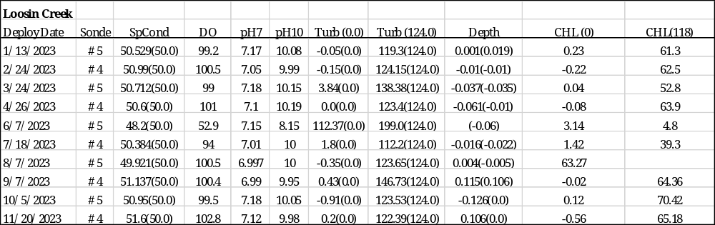

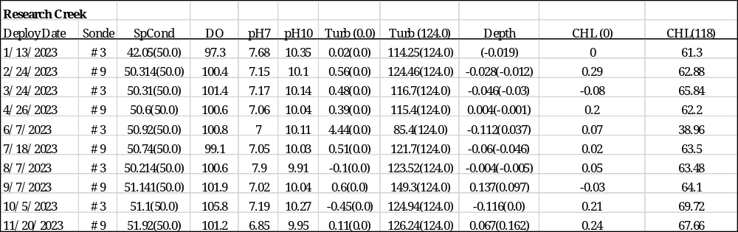

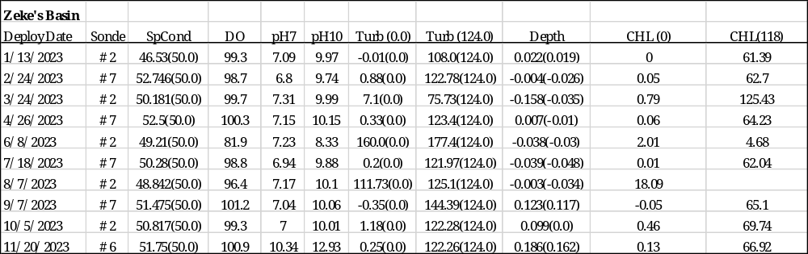

14) Other remarks/notes –
Data may be missing due to equipment or associated specific probes not being deployed, equipment failure, time of maintenance or calibration of equipment, or repair/replacement of a sampling station platform. Any NANs in the dataset stand for “not a number” and are the result of low power, disconnected wires, or out of range readings. If additional information on missing data is needed, contact the Research Coordinator at the reserve submitting the data.

For all data
New deployments were flagged as <0> (CND).

Temperature affected measurements (SpCond/Salinity, pH) were rejected anytime the temperature sensor was affected by out of water events (pronounced change in temp values during extreme low tide readings).

Data affected by low tide were coded (CLT). Lower SpCond/Salinity was addressed with <1> (CLT) due to the probability of fresher surface waters being measured as the water level decreased. Salinities approaching zero or less were addressed as <-3> [GOW] (CLT) and affected data were also rejected accordingly.

All depth data corresponding to rejected or suspect SpCond/Salinity data (due to low tide) were also rejected <-3> [SOW] (CLT) or flagged as suspect <1>[SOW](CLT). Depth sensor is located above Conductivity/Temperature (C/T) sensor and will be exposed when SpCond approaches 0.0. It is possible that some probes were still in the water during out of water events. The vertical orientation of the sondes means that shorter probes (pH, C/T) will be affected before longer probes (dissolved oxygen, turbidity).

All negative depth flagged and rejected unless affected by barometric pressure and coded as suspect <1> [SNV] (CAP).

Dissolved oxygen concentrations < 3 mg/L were coded <0> (CDA) along with corresponding values for DO% during hypoxic events.

Increased turbidity readings occurred throughout many deployments with unknown causes and were coded as such:
<-3> [STS] = rejected turbidity spike
<1> [STS] = Suspect turbidity spike

Small negative turbidity values < -2 NTU were flagged as suspect, <1> (CAF).

Negative chlorophyll values were flagged as <-3> [SNV].

Chlorophyll spikes were flagged as suspect <1> [SCS], or rejected <-3> [SCS].

East Cribbings
General
This station was converted to EXO2 sondes during 2015, beginning with the 09/15/2015 deployment. Vertical deployment in place for 12/04/12 – 08/03/2020.

The vertical deployment station was lost during hurricane Isaias on or around August 3 - 4, 2020. Shortly after the station was replaced with the earlier anchored cinder block style deployment.
The temporary anchored structure was utilized through 11/22/2021. The anchor line broke and due to strong currents, a temporary deployment structure was not replaced. Funds were allocated for replacement vertical deployment structures in 2023 and unfortunately the contract work was unable to be initiated. Sonde data has not been collected at this site since 2021.

Loosin Creek
General
Missing data due to instrument swap. Flagged <-2> [GMC]
06/07/2023 10:45

Missing data due to sonde malfunction 03/24/2023.

06/07/2023 deployment, wiper fell off sometime prior to 07/01/2023. Multiple parameters affected. Dissolved oxygen, turbidity and chlorophyll a were rejected through the end of the deployment 07/18/2023.

07/18/2023 deployment, programming error and no data collected.

On 12/19/2023 at 14:45 the sonde was out of the water for ISCO retrieval and data was rejected.

SpCond/Salinity
This site experiences out of water events and may sample a fresh water lens in advance or following this events.

Some low salinity events were flagged as suspect if the conditions seem abnormal for the site:
03/26/2023 19:45 and 4:00
03/29/2023 10:00
03/31/2023 17:45
04/07/2023 07:45, 8:00 and 11:00
04/11/2023 22:15
04/19/2023 05:15 and 05:30 and 16:30 – 17:15
04/22/2023 19:00
04/27/2023 17:00
06/15/2023 19:45
09/10/2023 20:00
10/06/2023 02:15

There was a rain event of approximately 2 inches on March 27, 2023 that may have resulted in fluctuating salinity levels during the 03/24/2023 deployment.

Elevated salinity was rejected on 11/04/2023 at 3:30.
Dissolved Oxygen
The following deployments did not pass post calibration with acceptable values with rejected or suspect data:
06/07/2023 wiper not present at retrieval. Data began showing signs of fouling around 06/26/2023 and was flagged as suspect. Data after 07/01/2023 was rejected.

Turbidity
Elevated turbidity readings were rejected or flagged as suspect.

Turbidity post calibration was not within acceptable range for zero following 03/24/2023 deployment. Data flagged as suspect, <1> [SPC] for beginning of deployment then rejected and flagged <-3> [SPC] from 04/06/2024 through the end of deployment as values seem elevated.

06/07/2023 deployment, wiper fell off sometime prior to 07/01/2023. Multiple parameters affected. Turbidity rejected through the end of the deployment 07/18/2023.

Turbidity post calibration was not within acceptable range following 09/07/2023 deployment. There may have been contamination of the standard as all sondes for this deployment were impacted. Data appears to fit conditions for the site.
Chlorophyll
Occasional chlorophyll spikes occurred and were flagged as suspect or rejected, cause unknown.
06/07/2023 deployment, wiper fell off sometime prior to 07/01/2023. Multiple parameters affected. Chlorophyll a data was rejected through the end of the deployment 07/18/2023.
Negative chlorophyll values <0.4 were rejected.

Research Creek
General
The vertical deployment station was lost following hurricane Isaias on or around August 3 - 4, 2020. Shortly after the station was replaced with the earlier anchored cinder block style deployment. Funds were allocated for replacement vertical deployment structures in 2023 and unfortunately the contract work was unable to be initiated.

SpCond sensor failed during the 12/13/2022 deployment. Data through the end of the deployment was rejected, including dissolved oxygen and depth data. <-3> [SCF] (CSM).

No data collected due to sonde swap on 01/13/2023 at 16:00.

4/26/2023 deployment wiper missing upon retrieval. Sensors subject to heavy biofouling. Affected data flagged as suspect or rejected due to biofouling as it becomes apparent.

06/08/2023 13:30 Data rejected due to sonde maintenance. Sonde raised to retrieve ISCO autosampler tubing.

11/20/2023 14:30 data record missed during sonde swap.

SpCond/Salinity
This site may experience out of water events and may sample a fresh water lens in advance or following this events.
01/13/2023 deployment specific conductivity may have been calibrated with a contaminated standard. Values for the entire deployment were flagged as suspect.

05/27/2023 00:00 Biofouling due to missing wiper. Data rejected through the end of deployment.
Dissolved Oxygen
SpCond sensor failed during the 12/13/2022 deployment. Dissolved oxygen data through the end of the deployment was rejected, as well as depth data. <-3> [SCF] (CSM).

The following deployments did not pass post calibration with acceptable values with rejected or suspect data:
01/13/2023
05/27/2023 00:00 Biofouling due to missing wiper. Data rejected through the end of deployment.
10/05/2023 post calibration was elevated, the last week of deployment may have been slightly elevated and was rejected.
pH
pH postcal was unacceptable for the following deployments causing data to be flagged as suspect or rejected.

01/13/2023 deployment data rejected. Sensor reconditioned before calibration and calibrated OK. Post calibration and viewing data indicates that the sensor was bad. pH data for the entire deployment rejected.

Turbidity
Elevated turbidity readings were rejected or flagged as suspect.
05/20/2023 00:00 Biofouling due to missing wiper. Data flagged suspect through the end of deployment.

06/07/2023 deployment, post calibration is low for turbidity. Data was flagged as suspect and rejected toward the end of deployment.

Turbidity post calibration was not within acceptable range following 09/07/2023 deployment. There may have been contamination of the standard as all sondes for this deployment were impacted. Data appears to fit conditions for the site.

At the end of 10/05/2023 deployment, there may have been some sensor drift with slightly elevated turbidity values. The 11/20/2023 deployment showed low values upon deployment. Turbidity was flagged as suspect beginning 11/09/2023.

Chlorophyll
Occasional chlorophyll spikes occurred and were flagged as suspect or rejected, cause unknown.
The site continues to experience frequent spikes in chlorophyll due to the temporary station deployment methods (cinderblock). It’s likely that sediment disturbances are resulting in suspended benthic chlorophyll. Spikes <400ug/L were not flagged.

Elevated chlorophyll values were flagged during the 12/13/2022 deployment which continued into 2023. Data was consistently elevated and rejected beginning 01/09/2023 through the end of deployment 01/13/2023.
05/13/2023 00:00 Biofouling due to missing wiper. Data rejected through the end of deployment.

06/07/2023 deployment, post calibration is low for chlorophyll. Data was flagged as suspect and rejected toward the end of deployment.
Negative chlorophyll values <0.4 were rejected.

Depth
Depth was dropped from collected data during 12/13/2022 deployment extending into 2023. Flagged as <-2> [SSM] (CSM).

Zekes Basin
General
An electronics short developed in the telemetry cable at this station during 2023 leading to the sonde memory chip failures and sporadic missing data.

06/08/2023 12:00 reading was missing data due to instrument swap. Flagged <-2> [GMC]

Missing data, instrument error unknown cause
08/06/2023 04:45, 10:30
09/12/2023 07:15, 07:30, 8:30
09/15/2023 07:30 – 10/05/2023 (TIME?)
SpCond sensor failed during the deployment. Data through the end of the deployment was rejected, including dissolved oxygen and depth data.

01/13/23 deployment failed post calibration. Data look good and seamless between deployments. Flagged as suspect.
Following the 08/07/23 deployment, the sonde was retrieved with fishing line tangled around the sensors and wiper and biofouling attached. Turbidity was flagged as suspect, did not pass post calibration within acceptable range from 08/30/23 through 09/02/23. Data from 09/02/23 – 09/07/23 was rejected for turbidity and chlorophyll.

SpCond/Salinity
This site experiences out of water events and may sample a fresh water lens in advance or following this events.
Dissolved Oxygen
The following deployments did not pass post calibration with acceptable values with rejected or suspect data:

08/07/2023 deployment, upon retrieval the sonde had fishing line wrapped around sensors and wiper with additional biofouling attached. Dissolved oxygen values were flagged as suspect from beginning of deployment due to post calibration values and data was rejected following a DO drop that began on 09/02/23 and lasted through the end of deployment on 09/07/23.
pH
pH postcal was unacceptable for the following deployments causing data to be flagged as suspect or rejected.
12/08/2023 00:15 pH sensor failure indicated. pH rejected through the end of the deployment. Post calibration unacceptable.

Turbidity
Elevated turbidity readings were rejected or flagged as suspect.

Following the 08/07/23 deployment, the sonde was retrieved with fishing line tangled around the sensors and wiper and biofouling attached. Turbidity was flagged as suspect, did not pass post calibration within acceptable range from 08/30/23 through 09/02/23. Data from 09/02/23 – 09/07/23 was rejected.

Turbidity post calibration was not within acceptable range following 09/07/2023 deployment. There may have been contamination of the standard as all sondes for this deployment were impacted.
Chlorophyll
Occasional chlorophyll spikes occurred and were flagged as suspect or rejected, cause unknown.
Following the 08/07/23 deployment, the sonde was retrieved with fishing line tangled around the sensors and wiper and biofouling attached. Turbidity was flagged as suspect, did not pass post calibration within acceptable range from 08/30/23 through 09/02/23. Data from 09/02/23 – 09/07/23 was rejected.
Negative chlorophyll values <0.4 were rejected.

