MAGLEV PID CONTROLLER
Kenneth Aaron Martinez Lazo
UPV/EHU
(Undergraduate)
Engineering school of Bilbao
Bilbao, Spain
kmartinez020@ikasle.ehu.eus

Abstract—This paper delves into the development of a PID (proportional, integral and derivative) controller with the aim on stabilizing a MAGLEV(magnetic levitation system) utilizing DIY tools and scientific data analysis applications.
Keywords—PID, MAGLEV

The Importance Of Control
Is widely known that there are many situations on which controlling a plant without the need of human intervention is key to automating a process, one such problem arises when dealing with magnetic levitation, the human reactions are not capable of maintaining a stable state. This is where we get the approach of a programmable, a fast reacting hardware is needed, as well as a proper setup and tools to measure, change and interact with said hardware.

General Description
The plant is a magnet of arbitrary shape and a specific mass that must be positioned at a user set distance from the sensor which will measure the magnetic field of said magnet and will return the information to the controller, the latter will send a processed signal to the switching circuit to control the force of the electromagnet that will oppose the force of gravity therefore archiving stability.

Functional Description
The mass of the plant is set by adding weight to increase the mass for gaining inertia which may result in slower rates of change in velocity, such plant is comprised of neodymium magnets characterized by their strength.
To know the position of the plant the use of a hall effect sensor is needed since it “proportionally responds to the changes in the magnetic field generated by the plant”, spaced away from the electromagnet to avoid interference, said sensor is the 49E, with parameters that will be analyzed further later on.
The used microcontroller is the ATMEGA328PU programmed through the Arduino IDE with a custom made shield that connects to the sensor and switching circuit.
Lastly, the electromagnet is a DIY coil with a ferromagnetic core with known parameters of 1mH inductance and 0.2ohm resistance.

The Characterization Of The Plant
The main problem we get is the characterization of a strongly non linear system, which means there must be a complex way to analyze it and then simplify it through tools like model fitting in matlab or mathematical linearizations around the operating point.
The mean physical concept would be the following:
$$F ≈\frac{i^{2}}{x^{2}}$$
Due to the need of controlling the current the use of a circuit that utilizes a PWM pulse to change the mean current through the coil was made. With this in mind the function may change:
$$F ≈\frac{{K_{pwm}*i}^{2}}{x^{2}}$$
Where Kpwm is the proportional rate at which the current changes given a pulse width. Later we can interprete the interactions of the model that should deliver a simpler system since the objective is countering the gravitational attraction:
$$ma=mg-K_{pwm}\frac{{*i}^{2}}{x^{2}}$$
Knowing this there can be a linearization of the system using a Taylor series:
$$ma=mg-K_{pwm}\frac{{*i}^{2}}{x^{2}} -K_{i}Δi+ K_{x}Δx$$
The approach is “ignoring” the complex part of the system with the squares because they will cancel each other if we know a stable point and the force or acceleration will be only the variations of current and distance:
$$a= \frac{-K_{i}Δi+ K_{x}Δx}{m}$$
Getting the laplace transform for the variation of position given the acceleration, mass and variations:
$$\left(ms^{2}- K_{x}\right)ΔX\left(s\right)=-K_{i}ΔI(s)$$
$$\frac{ΔX\left(s\right)}{ΔI(s)}=\frac{-K_{i} }{\left(ms^{2}- K_{x}\right)}$$
Since the formula explains its unstable and requires a PID to stabilize it must be taken into account the limitations of this analysis and real life mechanics of the MAGLEV, then, the system may include the stable clTF to be correctly shown.

Obtaining The stable system
As the plant is highly unstable the only practical way to obtain reliable data and gather the true dynamics is around getting the stable system using the knowledge gained while building the setup.

Fast Response

The velocity at which the system may react is not dependent on weight but rather on the slight variations of the current that are great, since the PWM signal has a frequency of 64kHz, the decision was to take samples every 40ms if necessary, meaning its archivable to adjust the proportional part as high as necessary to get constant oscillation. Thus archiving the first set of data, Kp = 75, this is rather large but understandable due to the fast change of the plant.

Oscilation Reduction
After getting further insight into the behavior the variations are large and given that the TF is at least second degree, it need to be damped, hence starting with low values until achieving stability at double Kd = 90;
This is particularly important since the stability of previous MAGLEV systems is commonly at Kd > Kp. [1]
Then it was required to acquire data on the “stable setup” and increment the sampling slowly to avoid changes in time due to the extraction of data.

Data Analysis
As the systems syable positions were stablished at 11.5mm and 12.5mm from the sensor then the step variations would be from D0 = 11.5mm and D1 = 12.5 and a pulse signal of varying dutty cycle changes the states and records the outputs on time, distance and pwm cycle as follows:
TIME (s) | PWM | DISTANCE (mm)
0,0478 | 50 | 7,44
0,095636 | 250 | 7,83
0,143476 | 250 | 9,66

Table 1. Snippet of gathered data
The table shown before can be interpreted and uploaded to the MATLAB system and use a fitting to get the clTF which as discussed contains at minimum two poles and then the oscilation and damping factors may introduce more poles and as such settled on the conditions np = 3; nz = 2.
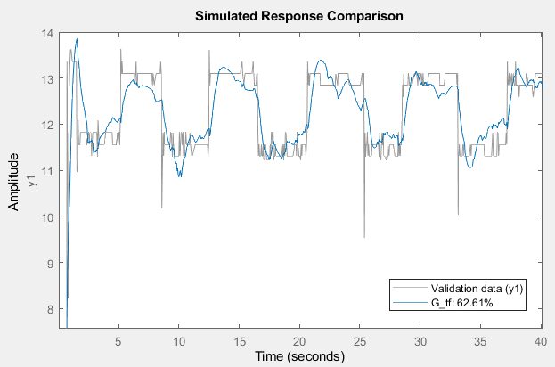
Fig 1. TF estimation

And obtained this transfer function that is both stable and concurs with the expected proportions of the PID control.
$$clTF =\frac{-0.1425s^{2}-0.0003072s- 0.05543}{s^{3} + 11.44 s^{2} + 0.5218 s + 5.969}$$
From this we can extract the poles:
-11.4402 + 0.0000i
-0.0000 + 0.7223i
-0.0000 - 0.7223i
Therefore concluding on the stability of said system.

Open Loop Extraction
Knowing the PID and Feedback values we can use simple calculations on MATLAB to get the olTF.
$$olTF=\frac{-0.001583s^{3} - 3.413e-06 s^{2}- 0.0006159 s}{ s^{5} + 12.13{ s}^{4} + 9.94 s^{3} + 6.386 s^{2} + 4.93 s + 0.01971}$$
$$olTF_ss=\frac{-0.0006159s}{ s^{2} + 0.5235}$$

Note that due to the complexity of getting the system out from the real data the final form is not exactly the physical analysis made in the beginning of the paper, however from the data and the result this is the best function that was obtained.

Conclusions
After analyzing solving and reaching a stable solution its possible to gather enough knowledge on the system even if this one is as complex as the one above, although the right procedure should have come from physical interpretation, then simulation of the system and implementation of the PID controller, it is possible to Heuristically fit the settings such that a stable or critically stable plant perfoms the tasks successfully.

References
- Robust-Proportional-Integral-Derivative Controller Design for Magnetic Levitation System Using Big Bang–Big Crunch Algorithm. Moayed Almobaied , Hassan S. Al-Nahhal , Khaled B.A. Issa Department of Electrical Engineering, Islamic University of Gaza, Gaza, Palestine.

- Optimized PID Controller for Magnetic Levitation System Shekhar Yadav, S. K. Verma, S. K. Nagar Department of Electrical Engineering, Indian Institute of Technology (BHU).

