BIKE RENTING

Aaron Rebello

11 february 2019

Contents

1 | Introduction |  |  | 3
 | 1.1 | Problem Statement . . . . . . . . . . . . . . . . . . . . . . . . . . . . . . . . . . . . . . . . . . |  | 3
 | 1.2 | Data . | . . . . . . . . . . . . . . . . . . . . . . . . . . . . . . . . . . . . . . . . . . . . . . . . . | 3
2 | Methodology |  |  | 5
 | 2.1 | Pre Processing . . . . . . . . . . . . . . . . . . . . . . . . . . . . . . . . . . . . . . . . . . . . |  | 5
 |  | 2.1.1 | Univariate and Bivariate analysis . . . . . . . . . . . . . . . . . . . . . . . . . . . . . . . . . | 5
 |  | 2.1.2 | Missing Value Analysis and Outlier Analysis . . . . . . . . . . . . . . . . . . . . . . . . . | 9
 |  | 2.1.3 | Feature Selection . . . . . . . . . . . . . . . . . . . . . . . . . . . . . . . . . . . . . . . | 12
 |  | 2.1.4 | Feature Scaling . . . . . . . . . . . . . . . . . . . . . . . . . . . . . . . . . . . . . . . . | 13
 | 2.2 | Modeling . . . . . . . . . . . . . . . . . . . . . . . . . . . . . . . . . . . . . . . . . . . . . . . |  | 14
 |  | 2.2.1 | Decision Tree. . . . . . . . . . . . . . . . . . . . . . . . . . . . . . . . . . . . . . . . | 14
 |  | 2.2.2 | Random Forest . . . . . . . . . . . . . . . . . . . . . . . . . . . . . . . . . | 14
 |  | 2.2.3 | Linear Regression . . . . . . . . . . . . . . . . . . . . . . . . . . . . . . . . . . . . . . . | 14
3 | Conclusion |  |  | 15
 | 3.1 | Model Evaluation . . . . . . . . . . . . . . . . . . . . . . . . . . . . . . . . . . . . . . . . . . . |  | 15
 | 3.2 | Model Selection . . . . . . . . . . . . . . . . . . . . . . . . . . . . . . . . . . . . . . . . . . . . |  | 15
Appendix A - R Code |  |  |  | 16

Chapter 1

Introduction

1.1 Problem Statement

In Bike rental, we have to forecast bike rental demand of Bike sharing program based on historical usage patterns in relation with weather, time and other data. Using these Bike Sharing systems, people rent a bike from one location and return it to a different or same place on need basis. People can rent a bike through membership (mostly regular users) or on demand basis (mostly casual users). This process is controlled by a network of automated kiosk across the city.

1.2 Data

The objective of this Case is to Predication of bike rental count on daily based on the environmental and seasonal settings.
The details of data attributes in the dataset are as follows –
instant: Record index
dteday: Date
season: Season (1:springer, 2:summer, 3:fall, 4:winter)
yr: Year (0: 2011, 1:2012)
mnth: Month (1 to 12)
hr: Hour (0 to 23)
holiday: weather day is holiday or not (extracted fromHoliday Schedule)
weekday: Day of the week
workingday: If day is neither weekend nor holiday is 1, otherwise is 0.
weathersit: (extracted fromFreemeteo)
1: Clear, Few clouds, Partly cloudy, Partly cloudy
2: Mist + Cloudy, Mist + Broken clouds, Mist + Few clouds, Mist
3: Light Snow, Light Rain + Thunderstorm + Scattered clouds, Light Rain + Scattered clouds
4: Heavy Rain + Ice Pallets + Thunderstorm + Mist, Snow + Fog
temp: Normalized temperature in Celsius. The values are derived via (t-t_min)/(t_max-t_min), t_min=-8, t_max=+39 (only in hourly scale)
atemp: Normalized feeling temperature in Celsius. The values are derived via (t-t_min)/(t_maxt_min), t_min=-16, t_max=+50 (only in hourly scale)
hum: Normalized humidity. The values are divided to 100 (max)
windspeed: Normalized wind speed. The values are divided to 67 (max)
casual: count of casual users
registered: count of registered users
cnt: count of total rental bikes including both casual and registered

Chapter 2

Methodology

2.1 Pre Processing

Any predictive modeling requires that we look at the data before we start modeling. However, in data mining terms looking at data refers to so much more than just looking. Looking at data refers to exploring the data, cleaning the data as well as visualizing the data through graphs and plots. This is often called as Exploratory Data Analysis, followed by pre processing.
Let us see what does the independent variables and dependent variables have to say about the count.

2.1.1 Univariate and Bivariate analysis:

- Let us see the distribution of target variable:-

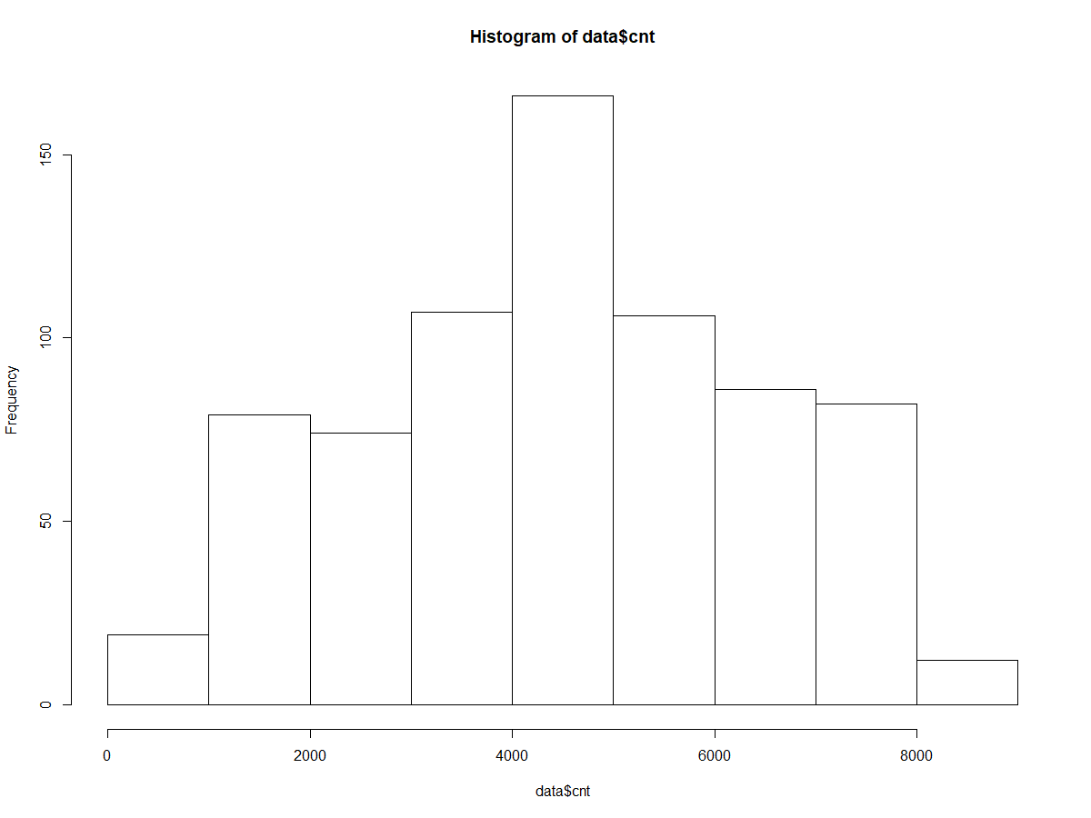

We see that the data is normally distributed.
2) let us see if the count in the rental bikes depends on the season:-
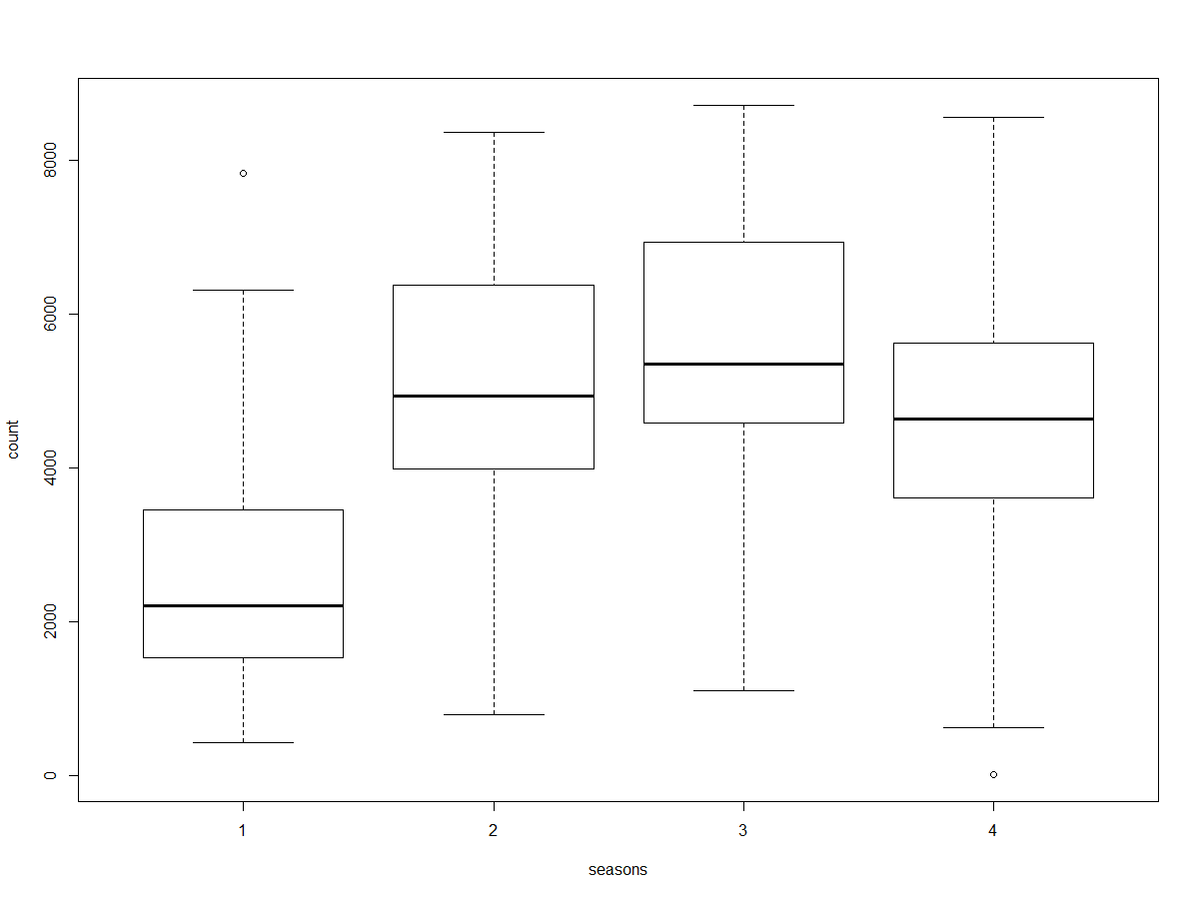
From the above box plot we see that, the bikes for rental are high in season3 (fall), followed by season2(summer),and season4 (winter), bike rentals are very less in season 1(spring)

3) Let us see which year had more bikes rented out of the both the years:-
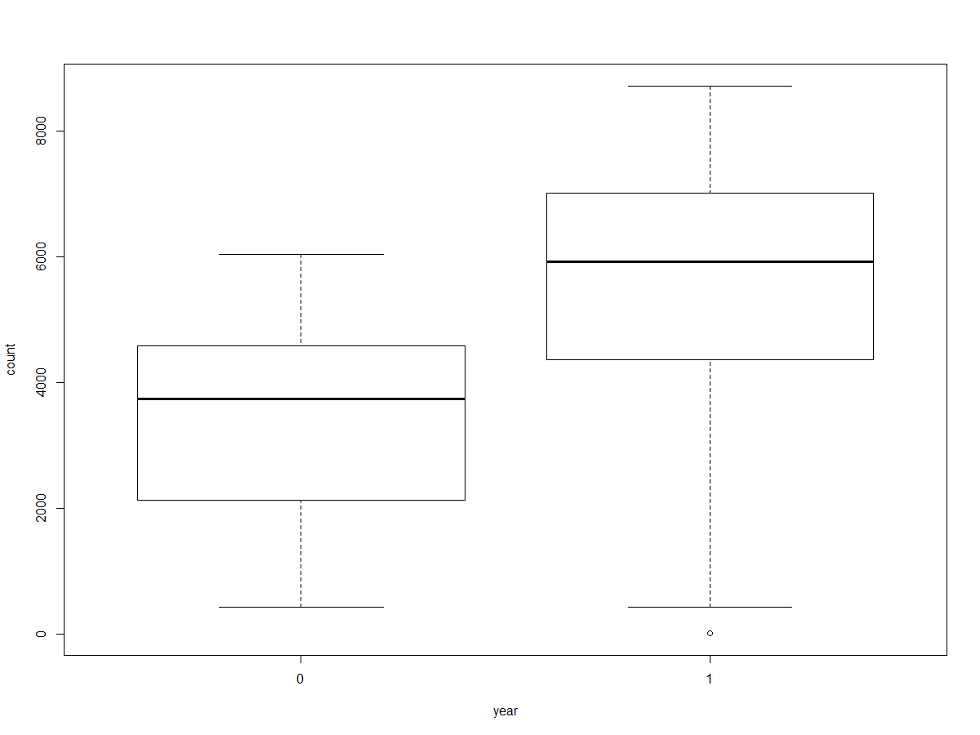
So, the box plot shows us that, compared to 2011, most of the bikes were rented in 2012. Which means that the count of the bikes are increasing as years pass.

4) We saw that the fall has large counts of bikes rented let us see which month in the fall has more counts.
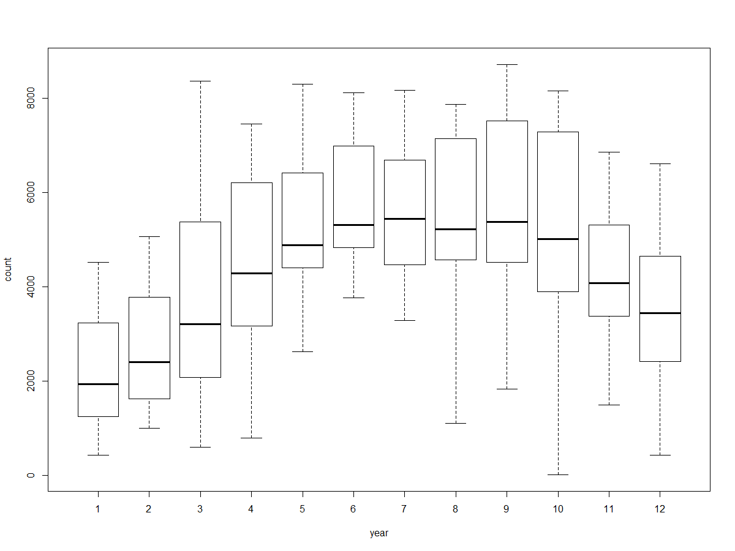

We see that, in fall, September month has large number of bikes rented.

5) Let us check which day in a week has more bikes rented.
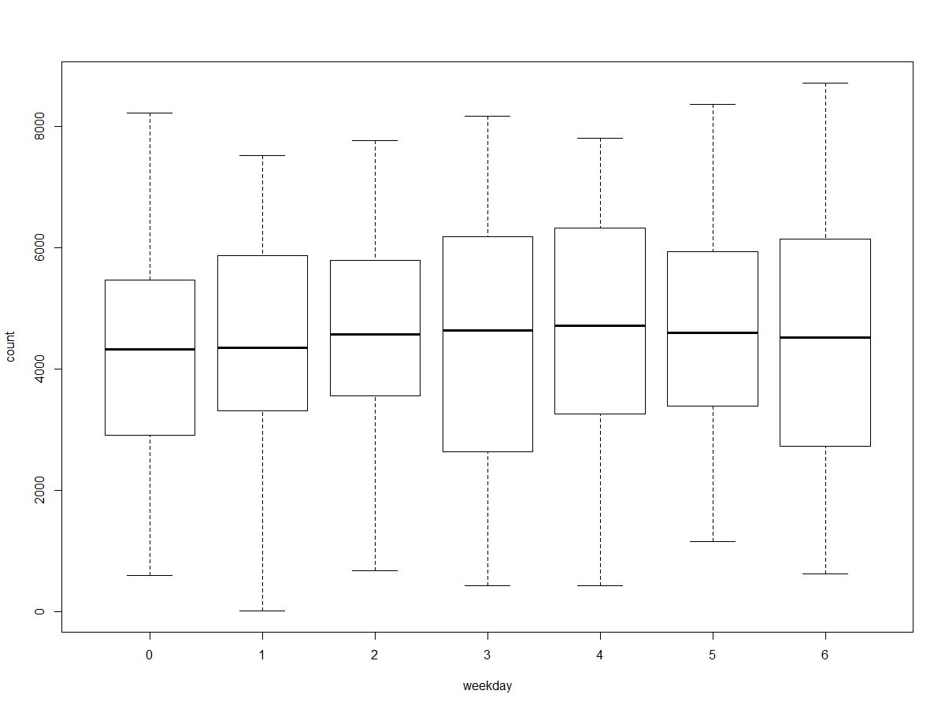
We see that the data cnt is uniformly distributed for days in a week. Let us see if it differs in casual and registered users.
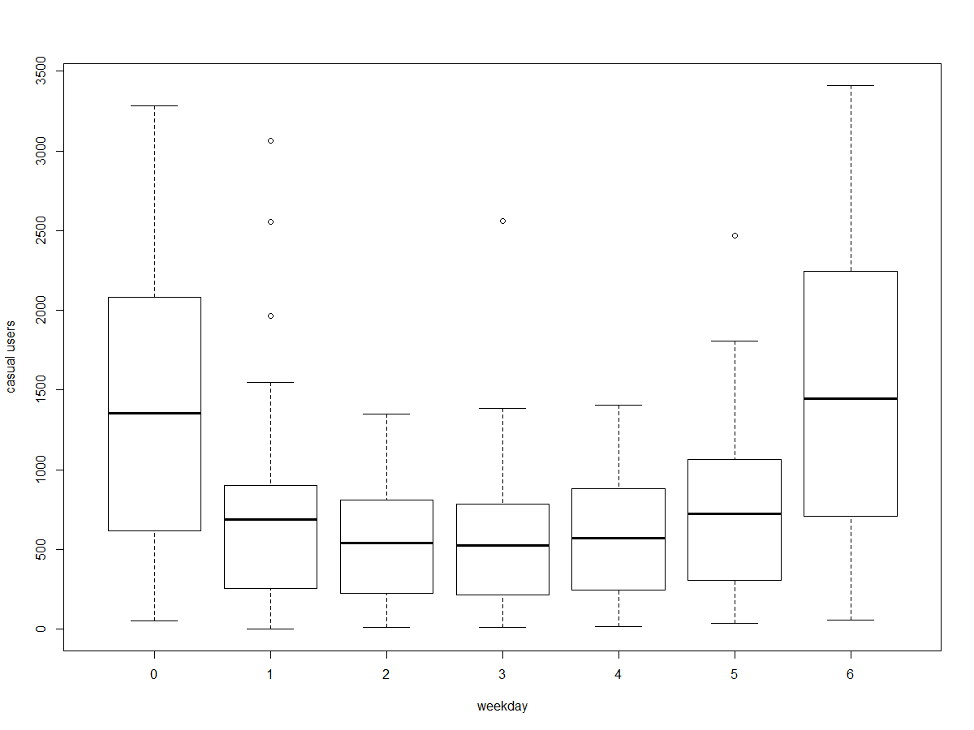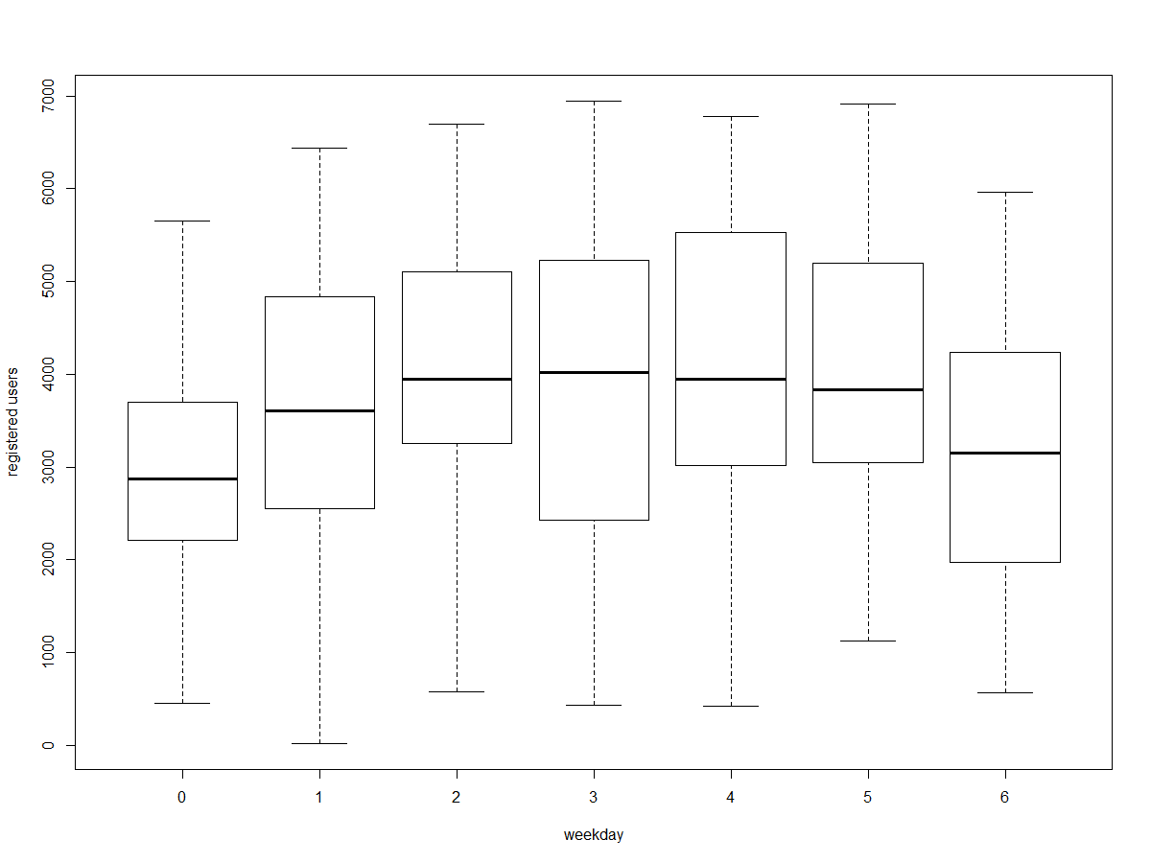

Hence this shows that, out of the total users, the casual users rent more bikes during weekend. While, the registered users rent most of it during the week days.

6) let us see how does the number of bike rental users depends on the weather condition
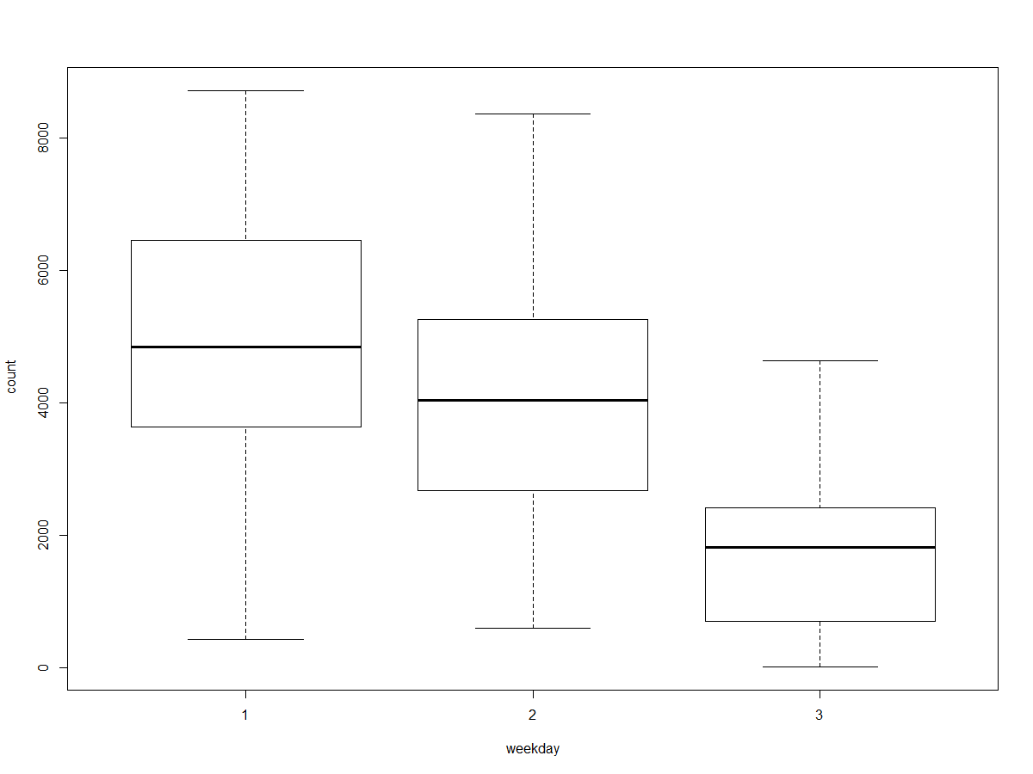
Hence, we see that the most of the users rent bikes during clean whether and less users during rainy weather and when the weather is bad there is 0 instance of users.

7) let us see if the temperature affects the count of users renting bike
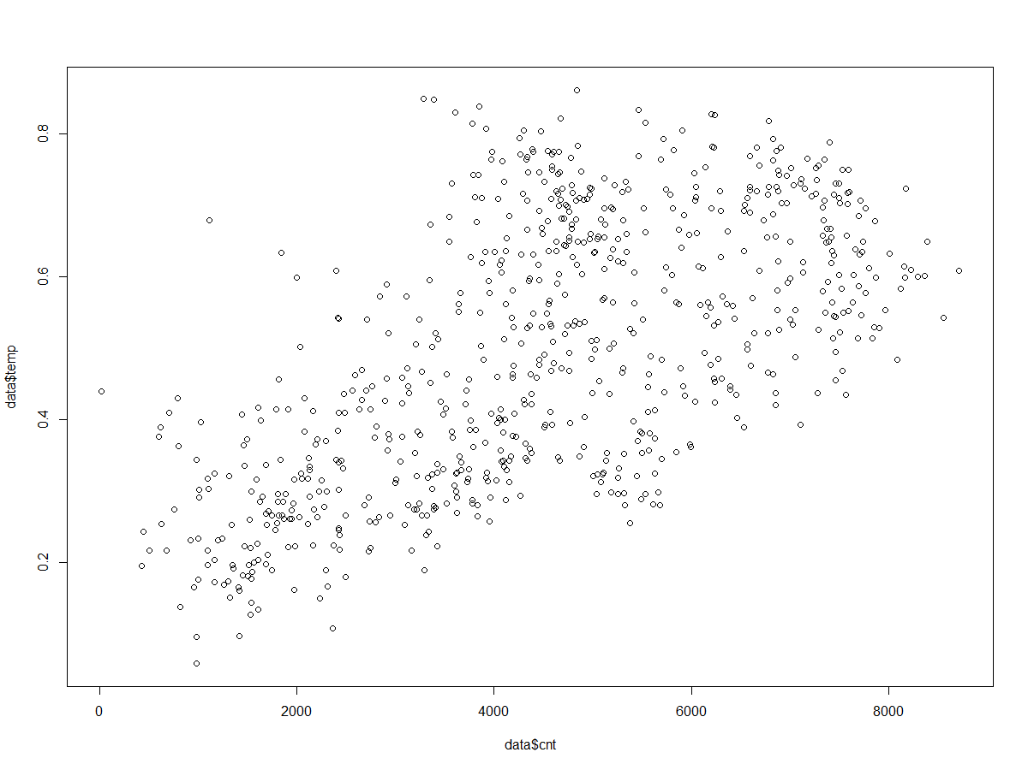
This scatter plot shows that the count of bikes rented increases with the count.

2.1.2 Missing value Analysis and Outlier Analysis

Missing values occur when no data value is stored for the variable in an observation. A missing value can signify a number of different things in your data. Perhaps the data was not available or not applicable or the event did not happen. It could be that the person who entered the data did not know the right value, or missed filling in. Missing values are a common occurrence, and you need to have a strategy for treating them. Typically, ignore the missing values, or exclude any records containing missing values, or replace missing values with the mean, or infer missing values from existing values. We check for missing values in our data. We saw that the target variable has most number of missing value which seems to be less than 30% of the total data. And since it the target data we need to impute data. Here, we use KNN imputation and impute the data
apply(data,2,function(x){sum(is.na(x))})
instant dteday season yr mnth holiday weekday workingday weathersit temp atemp
0 0 0 0 0 0 0 0 0 0 0
hum windspeed casual registered cnt
0 0 0 0 0
In this data there are no missing values present, so we move on with the outlier analysis.

Now, we plotted box plot to see if there are any outliers in the data. An outlier is an observation that lies an abnormal distance from other values in a random sample from a population. There are numerous impacts of outliers in the data set. It increases the error variance and reduces the power of statistical tests. If the outliers are non-randomly distributed, they can decrease normality. They can also impact the basic assumption of Regression, ANOVA and other statistical model assumptions. After plotting box plot, we got the figures as below:-

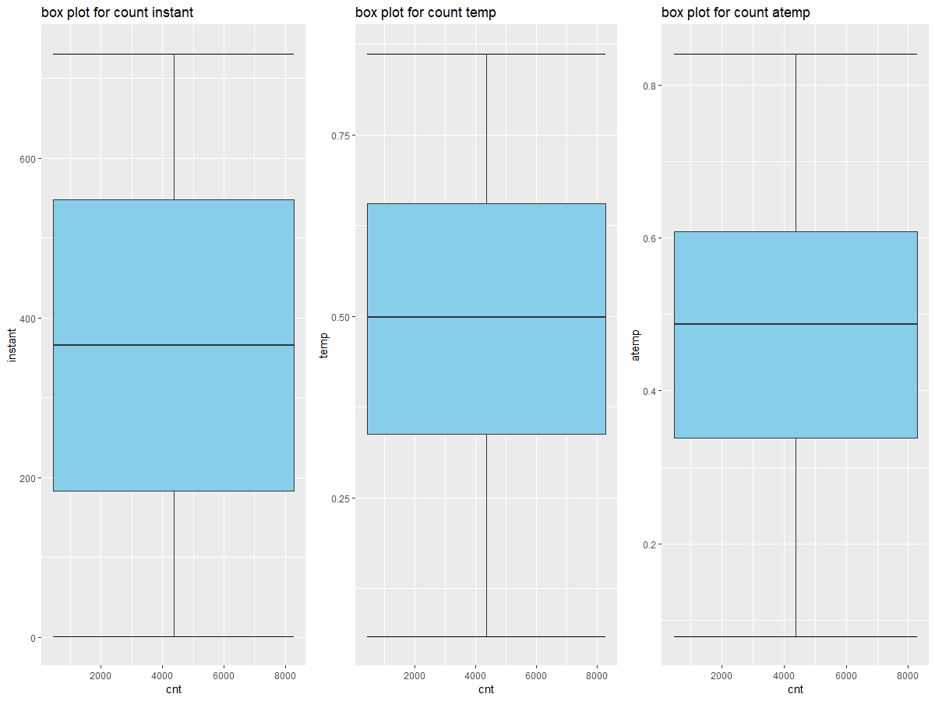
Fig 1

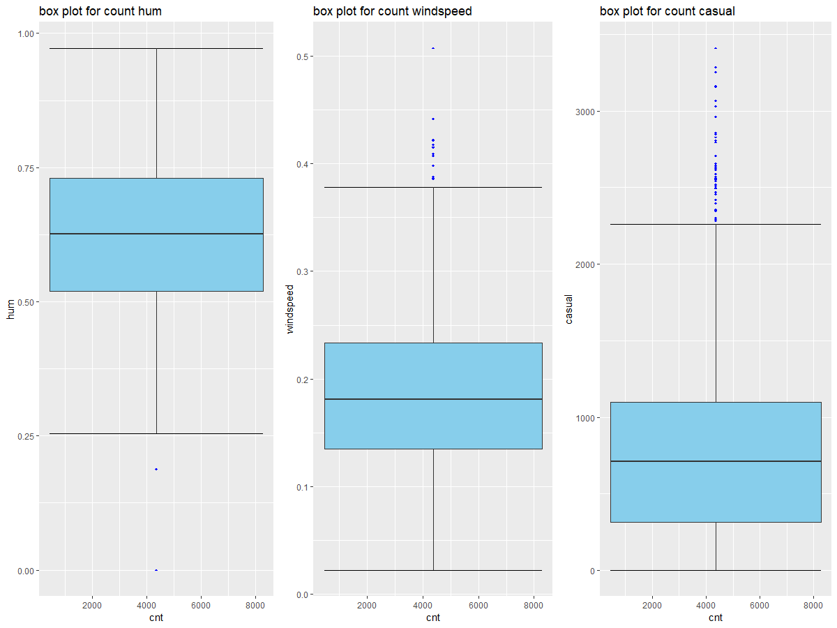
Fig 2
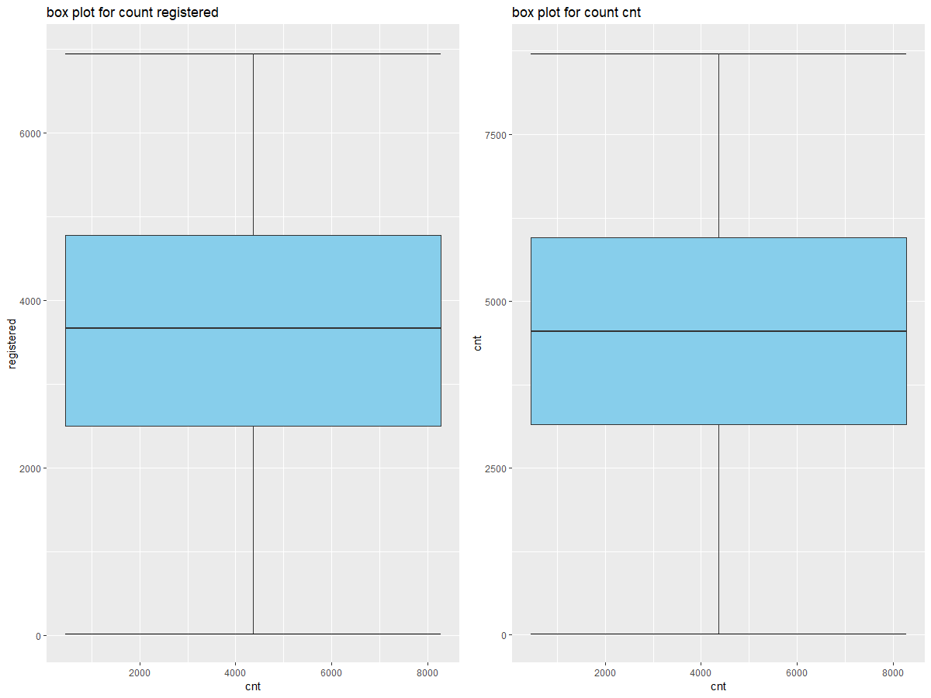

Fig 3

From the figure 1,2,3 we can see that the humidity, windspeed and casual users, in fig2 have outliers present in their data. So we remove the outliers from the data using knn.
We remove the outliers from the hum and windspeed variable because we are going to remove the causal users variable future as it sums up with the registered users to give the target variable.
Let us see the box plot after the outliers have been removed:-

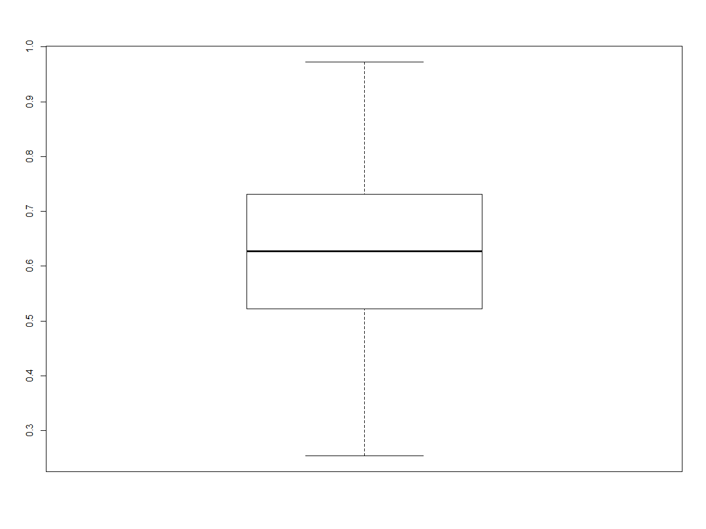

The outliers from the humidity has been removed

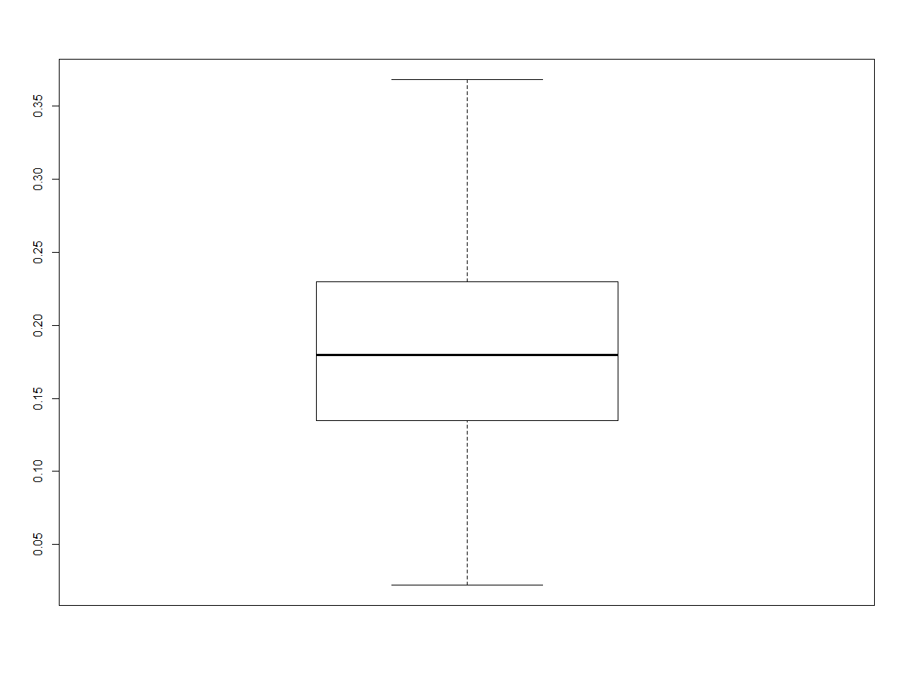
The outliers from the windspeed has been removed

2.1.3 Feature Selection

Before performing any type of modeling we need to assess the importance of each predictor variable in our analysis. There is a possibility that many variables in our analysis are not important at all to the problem of class prediction. There are several methods of doing that. We are using correlation matrix to identify most correlated numeric variables and anova test for categorical variables.

2.1.3.1 Correlation Matrix
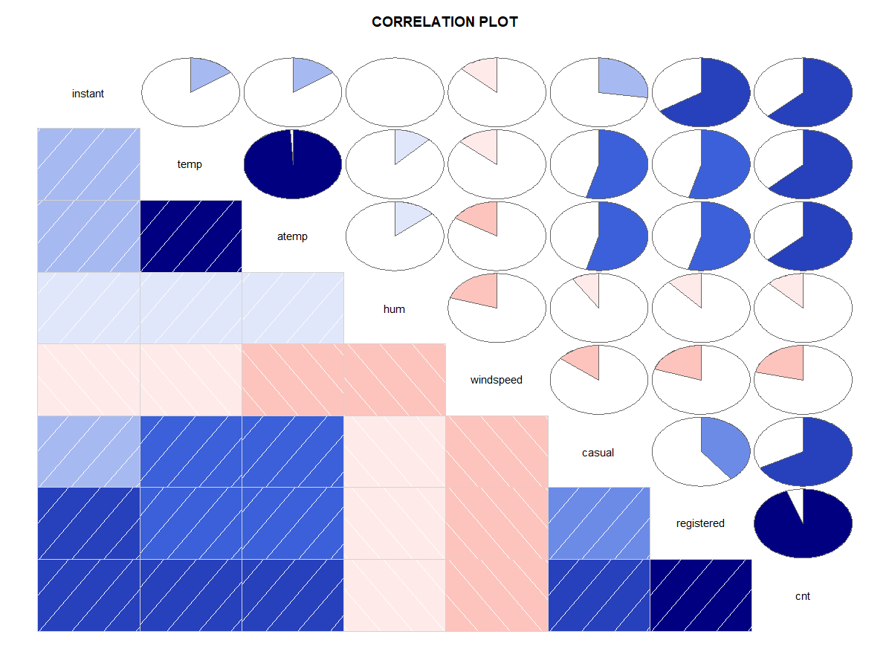
From the above figure we can see that the temp is highly correlated to atemp

2.1.3.2 Anova Test

summary(anova_test)
Df Sum Sq Mean Sq F value Pr(>F)
season 3 950595868 316865289 436.234 < 2e-16 ***
yr 1 884008263 884008263 1217.030 < 2e-16 ***
mnth 11 187311622 17028329 23.443 < 2e-16 ***
holiday 1 3306975 3306975 4.553 0.03321 *
weekday 6 15839061 2639843 3.634 0.00147 **
weathersit 2 185659616 92829808 127.800 < 2e-16 ***
Residuals 706 512813988 726365
---
Signif. codes: 0 ‘***’ 0.001 ‘**’ 0.01 ‘*’ 0.05 ‘.’ 0.1 ‘ ’ 1

After performing anova test, we see that every variable is important. So let us keep all the categorical variables .
we will remove instant and date variable as they are unique and dont explain much about the target variable
Also, we will remove casual and registered variable as they sum up to give the target variable total count of bikes
as temp is highly correlated to atemp we will remove atemp.
After removing all this variables our data is ready to be feed to the model.

2.1.4 Feature Scaling

After looking at the data, we see that the data is already kind of normalized, so there is no need for feature scaling.
So we move on with our machine learning models.

2.2 Modeling

As we know that our model is regression model, we first divide the data into train and test and then apply the train data on the following models, which gives us the metrics.

    - Decision tree
Decision tree builds regression or classification models in the form of a tree structure. It breaks down a dataset into smaller and smaller subsets while at the same time an associated decision tree is incrementally developed. The final result is a tree with decision nodes and leaf nodes. A decision node (e.g., Outlook) has two or more branches (e.g., Sunny, Overcast and Rainy), each representing values for the attribute tested. Leaf node (e.g., Hours Played) represents a decision on the numerical target. The topmost decision node in a tree which corresponds to the best predictor called root node. Decision trees can handle both categorical and numerical data.

    - Random Forest

The Random Forest is one of the most effective machine learning models for predictive analytics, making it an industrial workhorse for machine learning.

    - Linear Regression
In statistics, linear regression is a linear approach to modelling the relationship between a scalar response (or dependent variable) and one or more explanatory variables (or independent variables). The case of one explanatory variable is called simple linear regression.

The code for models is in the appendix .

Chapter 3

Conclusion

3.1 Model Evaluation

Now that we have a few models for predicting the target variable, we need to decide which one to choose. There are several criteria that exist for evaluating and comparing models. We can compare the models using RMSE value

RMSE: Root Mean Square Error is the standard deviation of the residuals (prediction errors). Residuals are a measure of how far from the regression line data points are; RMSE is a measure of how spread out these residuals are. In other words, it tells you how concentrated the data is around the line of best fit Lower the value of RMSE the better the model.

- Decision tree
After implementing the model we get the rmse value as #RMSE=965.9852495

- Random Forest
After implementing random forest model we get the value as #RMSE=694.3410299

- Linear Regression
After implementing linear regression model we get the value as #RMSE=807.3537860
.18
3.2 Model Selection

We can see that Random Forest has the lowest value of RMSE i.e. 694.34.
So, we select the random forest as our final model.

Appendix A – R code

rm(list=ls())

setwd("C:/Users/ARON/Desktop/edwisor projects/bike rental")
getwd()

Load Libraries
# x = c("ggplot2", "corrgram", "DMwR", "caret", "randomForest", "unbalanced", "C50", "dummies", "e1071", "Information",
# "MASS", "rpart", "gbm", "ROSE", 'sampling', 'DataCombine', 'inTrees')
#
# install.packages(x)
# lapply(x, require, character.only = TRUE)
# rm(x)

library(xlsx)
library(rlang)
library(ggplot2)

data_original=read.csv("day.csv")
data=data_original

########analysing dataset################################################

#let us sse the structure

View(data)

str(data)

colnames(data)
dim(data)

class(data$dteday)

#no of unique values in each variables
apply(data, 2,function(x) length(table(x)))

unique(data$weekday)
unique(data$mnth)

# we can see that season,year,month,holiday,weekday,workingday,weathersit are to converted into factor for proper analysis .

###########################EDA###########################################

#let us convert the required dtype into factor

fact_names=c('season','yr','mnth','holiday','weekday','workingday','weathersit')

for (i in fact_names){
print(i)
data[,i]=as.factor(data[,i])
}
str(data)

#let us convert the integer into numeric dtype
data$instant=as.numeric(data$instant)
data$casual=as.numeric(data$casual)
data$registered=as.numeric(data$registered)
data$cnt=as.numeric(data$cnt)

#let us convert date into date dtype
#data$dteday=as.Date(data$dteday)

str(data)

#getting all numeric varaibles together
num_index = sapply(data, is.numeric)
num_data = data[,num_index]
num_col = colnames(num_data) #storing all the column name

#getting all categorical variables together

cat_ind=sapply(data, is.factor)
cat_data=data[,cat_ind]
cat_col= colnames(cat_data)

str(data)

num_col
cat_col

# #####analysing data (univariate)##########################

#let us see the distribution of target variable
hist(data$cnt)
#we see that, the target variable is normally distributed

hist(data$temp)
hist(data$atemp)
hist(data$windspeed)
#most of the data is normally distributed

###############analysing data (bivariate)##########################

names(data)

#let us see if the count in the rental bikes depends on the season

boxplot(data$cnt~data$season,xlab="seasons",ylab="count",mail="")
#we see that the bikes for rental are high in season3 (fall), followed by season2(summer),and season4 (winter), bike rentals are very less in season 1(spring)

#let us see which year had more bikes rented

boxplot(data$cnt~data$yr,xlab="year",ylab="count",mail="")
#compared to 2011, most of the bikes were rented in 2012

#let us see which month has the more bikes rented
boxplot(data$cnt~data$mnth,xlab="year",ylab="count",mail="")
#september had more number of bikes rented, which relates to our hypothesis by analysing season

#let us see whethere the bikes are rented more in working days or holidays
boxplot(data$cnt~data$workingday,xlab="workingday",ylab="count",mail="")
#there is almost similar bike renting at both the days

#let us see on which day in a week the bikes are rented the most
boxplot(data$cnt~data$weekday,xlab="weekday",ylab="count",mail="")
#the data distribution is almost similar on all days, let us check the casual and registered users

boxplot(data$casual~data$weekday,xlab="weekday",ylab="casual users",mail="")
#we see that the most of the bikes are rented by the casual users during the weekend (i.e. saturday, sunday followed by friday)
boxplot(data$registered~data$weekday,xlab="weekday",ylab="registered users",mail="")
#registered users data is almost uniform

#let us see how does the number of bike rental users depends on the weather condition
boxplot(data$cnt~data$weathersit,xlab="weather",ylab=" count",mail="")
#we see that the most of the users rent bikes during clean whether and less users during rainy weather and when the weather is bad there is 0 instance of users

#let us see if the temperature affects the count of users renting bike
plot(data$cnt,data$temp)
#the scatter plot shows that,as the temperature increases, the count increase
plot(data$cnt,data$atemp)
#the scatter plot shows that,as the feeling temperature increases, the count increase

#let us see if humidity affects the count of bikes
plot(data$cnt,data$hum)
#humidity doesnt affect the count

####### missing value analysis and outlier analysis##############

#checking missing value
apply(data,2,function(x){sum(is.na(x))})

#From missing value analysis we see that there are no missing values in the data

library(DMwR)
library(lattice)
library(grid)

#let us first check outliers

library(ggplot2)

for (i in 1:length(num_col))
{
assign(paste0("gn",i),
ggplot(aes_string(y = (num_col[i]), x = 'cnt'),data = data) +
stat_boxplot(geom = "errorbar", width = 0.5) +
geom_boxplot(outlier.colour="blue", fill = "skyblue",
outlier.shape=18,outlier.size=1, notch=FALSE) +
labs(y=num_col[i],x="cnt")+
ggtitle(paste("box plot for count",num_col[i])))
}

## Plotting plots together

gridExtra::grid.arrange(gn1,gn2,gn3,ncol=3)
gridExtra::grid.arrange(gn4,gn5,gn6,ncol=3)
gridExtra::grid.arrange(gn7,gn8,ncol=2)

#we see that the humidity,windspeed casual variable has outliers, out of which we are removing casual in future as the casual and registered variables sums up to explain the target variable.
#there are two variables in humidity, let us see the two variables
boxplot.stats(data$hum,coef=1.5)
#outliers are 0.187917 and 0, so let us remove them
data$hum[data$hum %in% boxplot.stats(data$hum)$out] = NA

boxplot.stats(data$windspeed,coef=1.5)
#there are 13 variables in windspeed, so let us remove them
data$windspeed[data$windspeed %in% boxplot.stats(data$windspeed)$out]=NA

# #checking all the missing values
library(DMwR)
sum(is.na(data))
data = knnImputation(data, k=3)

# let us check missing values left
apply(data,2,function(x){sum(is.na(x))})
dim(data)

#let us check if the outliers have been removed or not
boxplot(data$hum)
boxplot(data$windspeed)

#so, the outlier has been removed

#######feature selection###########################

library(corrgram)

corrgram(data[,num_index],
order = F, #we don't want to reorder
upper.panel=panel.pie,
lower.panel=panel.shade,
text.panel=panel.txt,
main = 'CORRELATION PLOT')
#We can see var the highly corr related var in plot marked dark blue.
#Dark blue color means highly positive correlated
#we see that that the temp is highly correlated to atemp, so let us remove temp

##---------anova ----------------------------------
names(data)
colnames(cat_data)

#Anova test
library("lsr")
anova_test=aov(cnt~season+yr+mnth+holiday+weekday+
workingday+weathersit,data = data)

summary(anova_test)

####################Removing Highly Corelated and Independent var##################
#we will remove instant and date variable as they are unique and dont exolain much about the target variable
#Also, we will remove casual and registered variable as they sum up to give the target variable total count of bikes
#as temp is highly correlated to atemp we will remove atemp

data= subset(data,select= -c(instant,dteday,atemp,casual,registered))

colnames(data)
str(data)
da
#####feature scaling######################

View(data)
#we see that the data is already normalized, so the data is ready to be fitted in the model for development

############model development##########################

####decision tree########

library(MASS)
library(rpart)

train_index= sample(1:nrow(data),0.8*nrow(data))
train= data[train_index,]
test= data[-train_index,]

DT_regression=rpart(cnt ~.,data=train,method="anova")

summary(DT_regression)

DT_predict=predict(DT_regression,test[,-11])

#evaluate
View(test[,11])

#install.packages("DMwR")

library(DMwR)
regr.eval(test[,11],DT_predict,stats = c("mae","mape","rmse"))

#mae mape rmse
#670.8904240 0.2206328 965.9852495

####random forest######

library(randomForest)

rf_model= randomForest(cnt~.,train,importance=TRUE,ntree=100)

summary(rf_model)

rf_predict=predict(rf_model,test[,-11])

regr.eval(test[,11],rf_predict,stats = c("mae","mape","rmse"))

#mae mape rmse
#496.1101195 0.1649831 694.3410299

####linear regression#######

library(usdm)

lm_model= lm(cnt~.,data=train)

summary(lm_model)

lm_predict=predict(lm_model,test[,-11])

regr.eval(test[,11],lm_predict,stats = c("mae","mape","rmse"))

#mae mape rmse
#598.3067621 0.1812669 807.3537860

