Do you need a way to easily access different tools most commonly used in a classroom?

We know you do so we have your back.

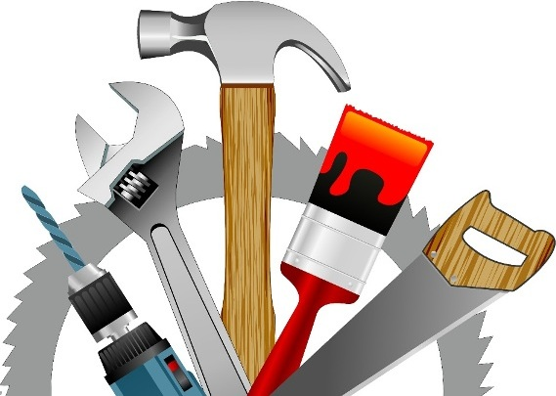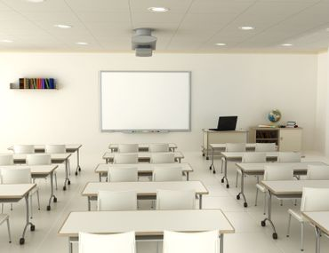

These are just a few of the features it has:

* A timer which counts both up and down
* A reward point tracker
* A student picker
* Even an exam timer