UniBoard Mini Project Report
  - Digital Campus Notice Board
Module EC4307 Web Application Development
Student name ___________________________________
Student index EG/2023/5753
GitHub repository ________________________________
Date 30 October 2026

Project purpose
UniBoard is a campus notice board that stores university announcements in MongoDB. Administrators publish notices with optional poster images and PDF documents. Students read notices relevant to their academic batch. Notice is the main entity and supports create, read, update and delete operations through the application.
The first page after a successful student or administrator login is the notice feed. This gives users direct access to announcements instead of sending them to a statistics screen. The activity overview remains available from the menu.

Problem and objectives
Announcements shared through separate messages or physical boards can be difficult to find again. UniBoard provides a single place to view current notices and search older updates. A student can open a full notice, read its poster, save it and ask a question in the comments.
- Keep announcements in a persistent database and provide working notice CRUD.
- Allow administrators to manage notices while students receive only permitted content.
- Make posters readable on phones and provide clear search, filter and sort controls.

User roles
Role | Access
Student | Register, sign in, browse permitted notices, comment, save notices and mark them as read.
Administrator | Sign in through Admin Login, publish and manage notices, and inspect read receipts.

Application structure and notice CRUD
The frontend uses Vue 3, Vite and Tailwind CSS. Vue views call shared service modules, which send HTTP requests to the Express API. Controllers validate permissions and work with Mongoose models. MongoDB keeps accounts, notices and related records after a browser or application restart.
Layer | Main files | Purpose
Frontend | frontend/src/views and components | Forms, notice feed, image and PDF viewers.
API services | frontend/src/services | Shared requests, login state and attachment retrieval.
Backend | backend/routes and controllers | HTTP routes, role checks and notice operations.
Database | backend/models | Mongoose schemas, references and indexes.

Notice operations
Operation | Route | Result
Create | POST /api/notices | An administrator submits a notice with an optional image and PDF. It is saved in MongoDB.
Read | GET /api/notices and /api/notices/:id | The feed lists permitted notices. The details page displays one complete notice.
Update | PUT /api/notices/:id | An administrator edits the content, audience, event details or attachments.
Delete | DELETE /api/notices/:id | After confirmation, the notice, attachments and related records are removed.

Login and access control
Student registration creates a student account and then returns to Student Login. It does not issue a login token. Administrator accounts are created through the backend setup command; there is no public administrator registration form or API.
The two login handlers check the role stored in MongoDB. Protected routes verify the JWT and load the current account from the database. The client also verifies its session before displaying a protected page. Editing a stored browser role cannot grant administrator access.
The active tab stores its session in sessionStorage. Refreshing a protected page keeps a valid session, while opening the website root or a login page starts a new sign-in flow. Logout clears the current session.

Database design
The database uses five collections. Every document has an ObjectId identity. Reference fields connect users and notices to comments, saved notices and read records. The diagram shows these logical relationships.
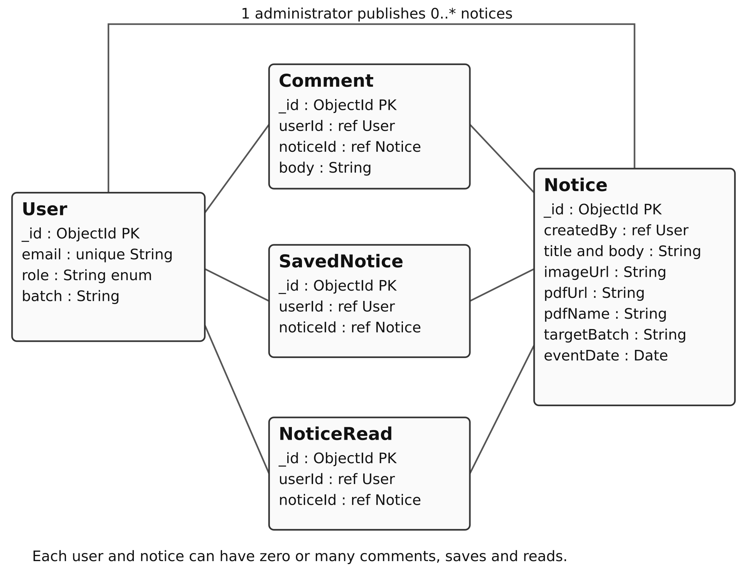
Figure 1 Main collections and their relationships
Collection | Important design rule
User | Email has a unique index. Passwords are stored as bcrypt hashes.
Notice | createdBy references User. Category and target batch use allowed values.
Comment | userId and noticeId reference the author and parent notice.
SavedNotice | A unique compound index prevents duplicate user and notice pairs.
NoticeRead | A unique compound index prevents duplicate read records for the same user and notice.

Mongoose references are application relationships, not SQL foreign keys. Deleting a notice also removes its comments, saves and read records. Images are stored in backend/uploads and PDFs in the private backend/documents folder. The notice stores paths and a PDF filename; MongoDB does not store file bytes.

Creating and updating announcements
An administrator opens Create announcement from the feed or Admin Panel from the menu. The form collects a title, content, category and audience. Events also require a date, time and location. One image and one PDF are independently optional, with previews before publishing.
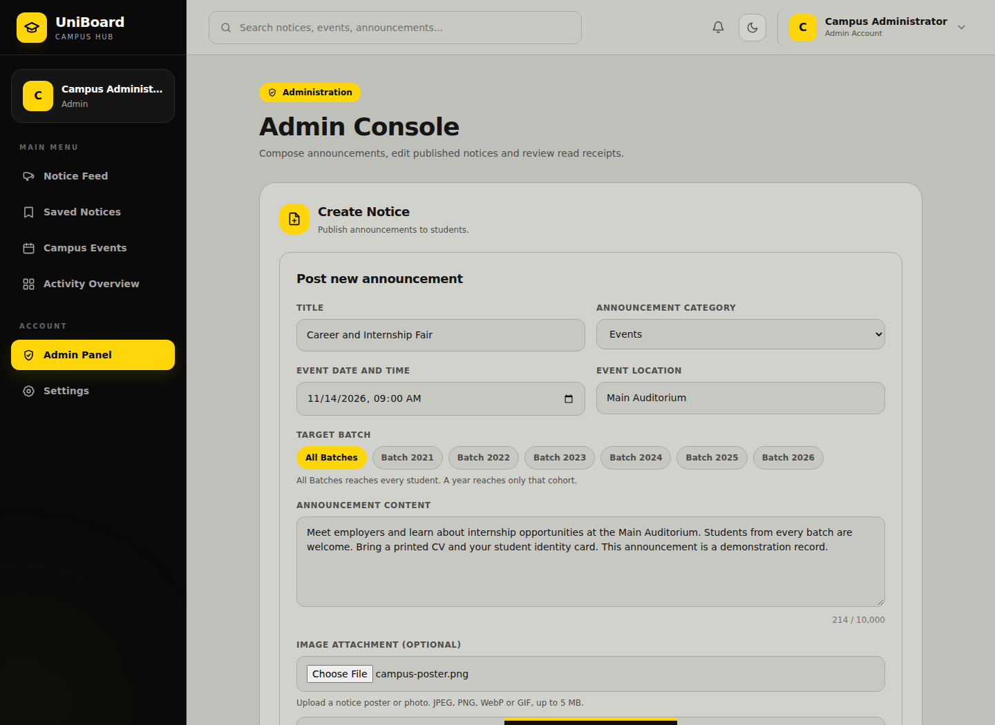
Figure 2 Administrator form with event details and a selected poster
The same form is reused for updates. Edit loads existing values. Images and PDFs can be kept, replaced or removed independently. Keep PDF undoes a removal before saving. Changes are applied only after Save Changes succeeds; validation errors preserve the form for correction.
The title limit is 150 characters, content 10,000 and venue 160. JPEG, PNG, WebP, GIF and PDF attachments have a 5 MB limit per file. The API also checks PDF headers and end markers. The submit button is disabled while saving or when the selected attachment is invalid.

Reading notices and viewing attachments
Notice cards display titles, audiences, dates and attachments. Posters use object-contain and support zoom. View PDF renders pages with navigation, zoom and download controls. Open notice shows complete content and discussion. PDF retrieval requires login and checks the notice audience on the server.
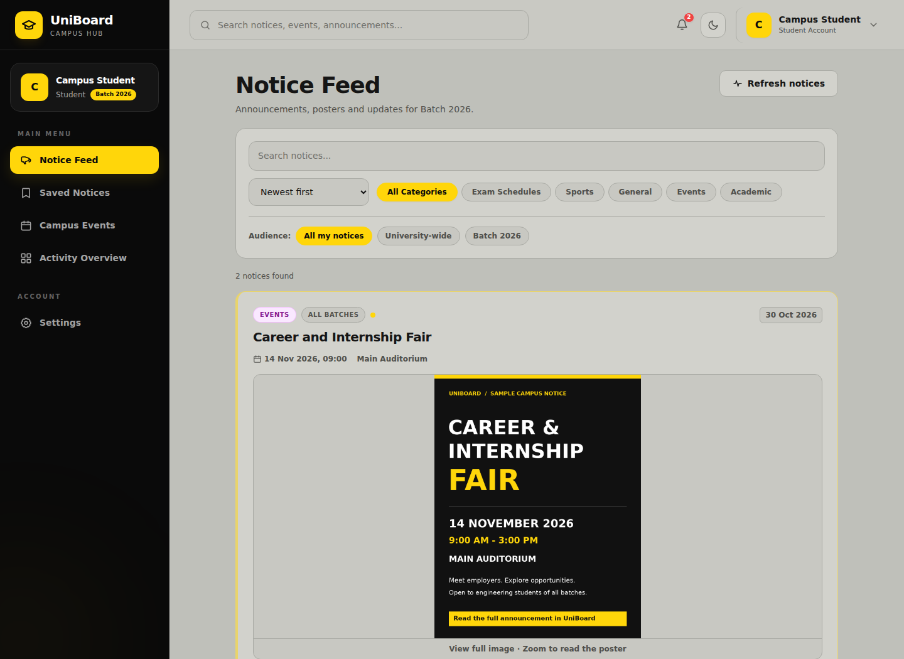
Figure 3 Notice feed showing a complete sample event poster
Search checks notice titles and content. Categories and batch filters narrow the results. Users can sort by newest, oldest, title A to Z or title Z to A. The API applies a fixed list of allowed sort options and keeps audience restrictions active when search and sorting are used together.
On a phone, extra filters collapse behind Filters. PDF.js displays document pages without a browser PDF plugin. The viewer also offers open and download links. Missing files produce readable errors while notice text remains available. Notices with only a PDF are supported.

Student interaction and safe removal
Students can save a notice to their personal collection, mark it as read and comment on it. Saving or marking the same notice twice does not create duplicate records. A comment can be deleted by its author or an administrator. All these actions check the notice audience on the server.
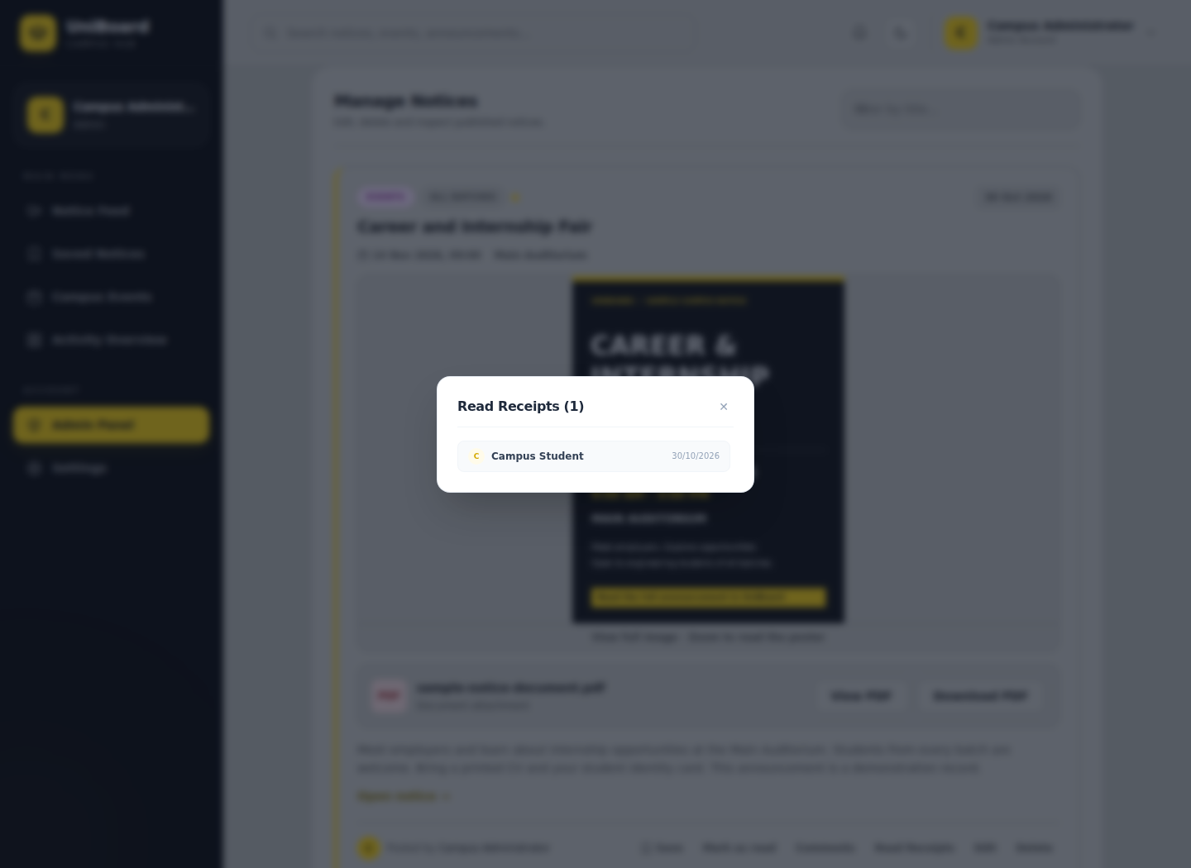
Figure 4 Administrator read receipts for the sample announcement
The unread count changes after Mark as read succeeds. Administrators can inspect the readers for a notice. Opening the feed does not automatically mark every displayed notice as read.
Delete asks for confirmation. Cancelling keeps the notice. Confirming removes it, its attachments, comments, bookmarks and read records. Replaced or removed images and PDFs are cleaned up, as are uploads rejected by validation. Students cannot publish, edit or delete notices.

Testing and evaluation
Nine automated backend tests passed against temporary MongoDB instances, without using the application database. A persistence check reconnects Mongoose before reading the same notice.
Test group | Result
API health, authentication, schema checks and admin registration rejection | 4 passed
Login portals, database roles and expired tokens | 1 passed
Administrator setup and explicit account promotion | 1 passed
Notice CRUD, audience checks, comments, saves and read receipts | 1 passed
Search, sorting, reconnect persistence and image cleanup | 1 passed
PDF upload, private access, validation, replacement, removal and cleanup | 1 passed

The frontend build passed. Browser checks covered login, registration, the feed, search, filters, sort, details, images, comments, saves, receipts and CRUD. PDF rendering, page navigation, zoom, downloads and editing worked. Both viewers fitted a 390 pixel phone screen. No JavaScript runtime errors were detected.

Validation examples
Input or action | Expected and observed behavior
Empty notice title | API rejects the request with a validation message.
Invalid type, broken PDF or file over 5 MB | The form or API rejects the upload.
Notice for another batch | The student cannot read it or retrieve its PDF.
Invalid or expired token | Protected requests require sign-in again.
Delete cancelled | The notice remains available.

Current limitations
Password reset has no production email delivery. Attachments use local disk and must be preserved when moving the app. PDF signature checks are not a full parser or malware scan. Notice deletion is not a multi-document transaction. The prototype has not been load-tested for a large university deployment.

Setup and demonstration
Use Node.js 22.13 or later. Install dependencies with npm ci in backend and frontend. Configure MONGODB_URI and a unique JWT_SECRET in backend/.env. Run npm run dev in each folder. The frontend development proxy forwards API and upload requests to the backend.
Run npm run setup-admin in the backend terminal to provision an administrator. The command asks for a name, email and a confirmed password with at least 12 characters. Existing administrator passwords are preserved. Use Admin Login for the administrator and Student Login for registered students.
For a compiled local build, run npm run build in frontend and npm start in backend. Express then serves both the frontend and API. To run the backend checks, use npm test from backend.

Demonstration sequence
Time | Action
0:00 to 0:25 | Introduce the project, its users and the technology stack.
0:25 to 1:20 | Show the two login portals. Publish a notice with a poster and PDF.
1:20 to 2:15 | Sign in as a student and show the feed, search, filter and sort.
2:15 to 3:05 | Open details, view the attachments, save, comment and mark as read.
3:05 to 4:05 | Edit the notice as admin, inspect readers and demonstrate delete confirmation.
4:05 to 4:40 | Show database persistence, explain the collections and close the demonstration.

The recording must include the student presenter with the camera on and remain within five minutes. The GitHub repository URL must be submitted through the lecturer's sheet. The report and video filenames should contain the student index number.

References
EC4307 Web Application Development Mini Project Evaluation Rubrics, lecturer handout dated 14 October 2026, page 1.
UniBoard source code and local documentation: README.md, backend/models, backend/controllers, backend/tests and frontend/src. The screenshots in this report use sample notices and test accounts from the local demonstration.

