**biteSizedVisuals Series: Tackling Air Pollution One Plot at a Time!**

Welcome to the biteSizedVisuals Series: Tackling Air Pollution One Plot at a Time!

In this series, I’ll break down air quality and pollution data into easily digestible compelling visualizations. Each post will highlight a key aspect of air pollution, using simple yet powerful plots to uncover insights and trends. Whether you’re a data enthusiast, policy maker, or environmental advocate, these bite-sized visuals will help you grasp important air quality issues without the complexity.

Moreover, you are free to share this on social media, as all content under biteSizedAQ is provided under Creative Commons Attribution 4.0 International (CC BY 4.0) license. If you do, the only request is to please link back to the original post.

Let’s dive into the data—one plot at a time!

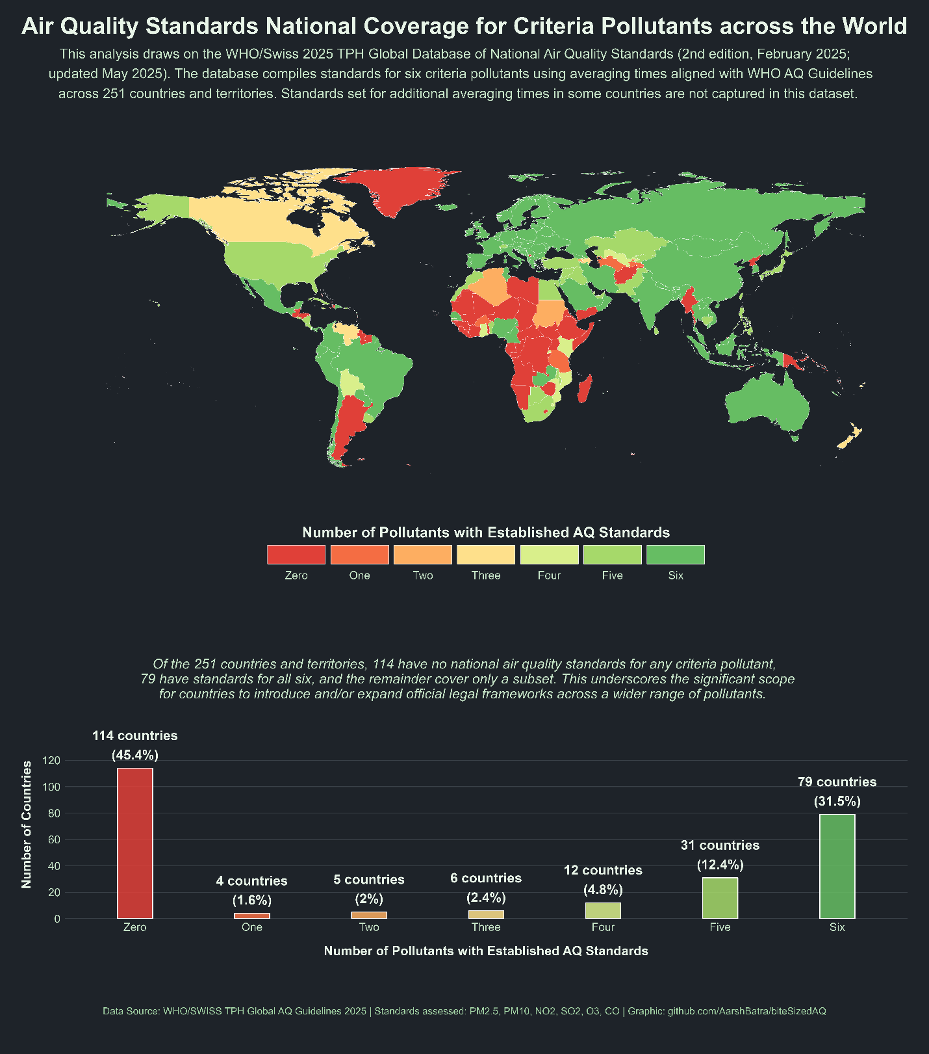

Air pollution is a major environmental health risk, contributing to millions of premature deaths each year. A primary tool for combating this crisis is the use of **national air quality standards**, limits on air pollution set by countries to protect their citizens. This report, based on a database ([Link to Source](https://www.who.int/tools/air-quality-standards)) compiled by the World Health Organization (WHO) and the Swiss Tropical and Public Health Institute (Swiss TPH), provides an overview of the regulatory landscape.

The analysis processes the raw data and focuses on a simple count: for each of the **251 countries and territories** included, it tallies the number of the six key pollutants for which national standards have been set in each country, specifically those that use averaging times aligned with the WHO’s own data compilation (1 yr, 24 hrs, 8 hrs, 1 hr, 15 minutes, 10 minutes). Standards set for additional averaging times not in line with the WHO are not compiled by WHO in this database. Please refer additional sources for that information and interpret accordingly. It’s important to note that this short analysis largely focuses on the **existence** of a standard for a specific pollutant, rather than on the stringency of the concentration levels.

***For e.g. If India’s count is 6, it indicates that national standards exist for all six criteria pollutants, with averaging times aligned to WHO guidance. In this analysis, a country is considered to have a standard for a pollutant even if it specifies only a single averaging time (e.g., 24 hours); multiple averaging times are beneficial but not required for a country to qualify as having a standard for that pollutant.***

**Key Air Pollutants**

Here is a closer look at the six criteria pollutants examined in the report:

* **Particulate Matter** (PM2.5​ and PM10​): These microscopic particles are a primary component of urban smog and haze, often originating from sources like vehicle exhaust and industrial emissions. They are so small they can bypass the body’s defenses and enter the bloodstream, causing serious cardiovascular, respiratory, and even neurological diseases. The smaller the particle, the more harmful it is. E.g. PM2.5 is smaller than PM10 and as a results leads to much more harm for the same amount of exposure.
* **Nitrogen Dioxide** (NO2​): A toxic, reddish-brown gas primarily from vehicle exhaust, power plants, and industrial boilers. NO2​ can inflame airways, making people more susceptible to respiratory infections and reducing lung function, particularly in children and individuals with asthma.
* **Sulfur Dioxide** (SO2​): A pungent gas released from burning fossil fuels like coal and oil. SO2​ is a major contributor to acid rain and can cause immediate breathing difficulties, especially for people with asthma, by constricting airways.
* **Ozone** (O3​): Unlike the protective layer in the upper atmosphere, ground-level ozone is a harmful pollutant formed by chemical reactions between other pollutants in sunlight. It is a key ingredient of smog that can trigger asthma attacks, reduce lung function, and cause chest pain.
* **Carbon Monoxide** (CO): An odorless, colorless gas that can be deadly at high concentrations. It is mainly produced by the incomplete combustion of fuels in vehicles and furnaces. CO prevents oxygen from being transported in the blood, leading to dizziness, confusion, and, in severe cases, death.

**The Findings**

The analysis reveals a notable divide in the global adoption of comprehensive air quality standards.

A total of **79 countries**, representing just under a third of the sample (31.5%), have established national standards for all six of the WHO-comparable pollutants. This group includes a diverse range of nations that have made regulatory air quality a priority.

On the other end of the spectrum, a striking **114 countries and territories**—more than 45% of the sample—have not established a single standard for any of the six pollutants that is included in this particular database. This highlights a critical regulatory gap that leaves a large portion of the world’s population unprotected. Most of these countries lie in Africa.

The remaining **58 countries** fall in the middle, having established standards for at least one but not all six of the pollutants. Many nations have extensive regulatory systems that may use different averaging times or approaches not captured in this specific dataset. For example, the U.S. has a SO2​ standard which is calculated as a 3-year average of the 99th percentile of the yearly distribution of 1-hour daily maximum concentrations. But this analysis is based on the WHO compiled dataset whose focus is on more standard averaging times, so the U.S.’s total count in this analysis is 5, instead of 6.

**WHO Guidelines vs. National Standards: A Deeper Look**

It’s crucial to understand the fundamental difference between WHO guidelines and national air quality standards. WHO guidelines are evidence-based recommendations for pollutant concentrations below which adverse health effects are unlikely to occur (as per current research). They are a scientific benchmark, but they are **not legally binding** and are purely advisory, meant to guide countries in setting their own national standards.

Countries set and enforce these standards based on a variety of factors, including public health goals, economic capacity, and political will. This is why a nation’s standard do not always align with the WHO’s guidelines. The process of establishing a legally enforceable standard involves complex negotiations and considerations of implementation, infrastructure, and legal frameworks.

The divergence between WHO guidelines and a country’s standards is evident when we compare countries and their standards for the same pollutants under same averaging times. For example, while Norway and Israel have set their national annual average standard for PM2.5​ at 5 micrograms per cubic meter (5 µg/m3), which aligns with the WHO guideline, Algeria’s national standard for the same pollutant is set at 80 µg/m3. Countries in the middle also show wide variation: the United States has an annual average PM2.5​ standard of 9 µg/m3, while India’s is 40 µg/m3. Similar divergence is observed when we analyze other pollutants in the compiled database.

These wide differences in stringency demonstrate that while setting a standard is a critical first step, a nation’s true commitment to mitigating air pollution as a major health threat is reflected in how closely its legally binding standards align with WHO’s health-based recommendations.

But, there is more. Setting a national standard is not equal to automatic legally binding enforcement of that standard. Although, national standards are generally regarded as legally binding regulations, however, the strength of their enforcement and practical implementation varies widely across the world.

* **United States:** The U.S. sets legally binding National Ambient Air Quality Standards (NAAQS) under the Clean Air Act for pollutants such as PM2.5​, PM10​, SO2​, NO2​, CO, O3​, and lead (Pb). States are required to create implementation plans, and failure to comply can lead to federal intervention.
* **European Union:** The EU has Air Quality Directives that set legally binding limit values for pollutants. Member states are obligated to meet these limits, and the European Court of Justice can enforce compliance, making them similar to NAAQS in their legal authority.
* **China:** China has legally binding national air quality standards (GB 3095-2012, updated in 2018). Cities are required to meet them, and officials can face political consequences for non-compliance, indicating a strong enforcement mechanism.
* **India:** India’s National Ambient Air Quality Standards (NAAQS), issued by the Central Pollution Control Board (CPCB), are technically legally notified standards. However, enforcement is often weak, and systematic compliance mechanisms like mandatory plans or strict penalties are less developed than in the U.S. or EU. In practice, they often operate closer to guidelines.
* **Other countries:** In many low- and middle-income countries, standards may be formally legal but function more like guidelines due to a lack of robust enforcement mechanisms, monitoring infrastructure, and legal capacity.

In summary, while national standards are typically legally binding on paper, their true impact on air quality and public health depends heavily on the strength of enforcement, which differs significantly from country to country.

**Conclusion**

This simple analysis of global air quality standards reveals a profound and concerning divide in the world’s approach to this critical public health issue. While it is encouraging that 79 countries have established comprehensive, WHO-aligned regulatory frameworks, a staggering 114 countries have yet to set a single comparable standard. This fundamental gap in regulation leaves billions of people without the foundational legal protections needed to address air pollution.

Furthermore, even among nations that have set standards, there is a wide disparity in how closely they align with health-based WHO guidelines and how rigorously they are enforced. As shown by the examples of India and the United States, and the stark contrast with countries like Norway and Israel, a national standard’s existence on paper does not guarantee its effectiveness in practice. Ultimately, closing these gaps—in both the presence and stringency of air quality standards—is the next critical step toward securing a healthier future for all.

**Takeaways: A Shared Responsibility**

Air pollution knows no borders. While the burden of action falls heavily on governments and funders, each of us has a very important role to play in advocating for cleaner air. Whether it’s supporting organizations, raising awareness in your community, or calling on leaders to prioritize air quality, the time to act is now.

Clean air should not be a luxury; it’s a human right. Let’s ensure that every breath we take moves us closer to a world where that right is realized for all.

**Analysis Code for this blog**

This analysis does some basic cleaning of the raw WHO dataset to produce the above visualization. All cleaning and analysis was done using the R programming language. Code can be found in the corresponding Rmd file. Here is a [quick link](https://github.com/AarshBatra/biteSizedAQ/blob/main/18.bite.sized.vis.4.who.nat.aq.st.database.2025.Rmd) to access it.

**Support This Work: Give It a Star**

Thank you for reading! If you found this project helpful or interesting, please consider starring it on GitHub. Your stars help others discover and benefit from this fully open and free repository. Click [here to star the repository](https://github.com/AarshBatra/biteSizedAQ/stargazers) and join the growing community of folks who follow biteSizedAQ.

**Get in touch**

Get in touch about related topics/report any errors. Reach out to me at [aarshbatra.in@gmail.com](mailto:aarshbatra.in@gmail.com).

**License and Reuse**

The dataset used in this visualization is provided by WHO under specific terms of use. It may not be used for commercial, promotional, or political purposes, nor in any way that suggests endorsement by WHO of any product, service, or organization. Reuse must respect the rights of WHO and attributed data owners, comply with WHO’s policies and principles, and not involve illegal activities. This visualization is shared for informational and educational purposes only, in accordance with those conditions. While every effort has been made to follow the applicable licensing guidelines, any unintended misuse or misinterpretation is unintentional, and corrections will be made if notified.