# Power BI Report: Twitter Analytics Dashboard

# Name of Student : Aarsh Khadgi

**Project Title : Real-Time Twitter Analytics Dashboard - Power BI**

# Introduction

* This report presents insights extracted from a Twitter dataset using Power BI, focusing on user engagement patterns. The analysis leverages interactive visualizations and conditional logic to highlight meaningful trends and user behaviors.

# Background

* Social media analytics is crucial for understanding audience engagement. This report explores click-through behaviors, media engagements, and app open impacts on tweet performance using various filters and time constraints in Power BI.

# Learning Objectives

- Utilize Power BI to visualize social media data effectively.  
- Apply advanced filtering, conditional visibility, and drill-down capabilities.  
- Analyze user interactions (clicks, engagements) within specific time windows and criteria.  
- Develop data-driven storytelling via dashboards.

# Activities and Tasks

* **Task 1: Pie Chart with Drill-down**• Goal: Visualize proportion of total clicks (URL, profile, hashtag) for tweets with >500 impressions.  
  • Implementation: Pie chart shows total clicks per tweet. Drill-down enables click type view. Filtered by impressions > 500.
* **Task 2: Scatter Chart – Media Engagement vs Views**  
  • Goal: Show media engagements vs views for tweets with >10 replies, odd tweet date, word count > 50.  
  • Visible only between 6 PM to 11 PM IST. Tweets with engagement rate > 5% highlighted.  
  • Implementation: Scatter chart with DAX logic for visibility and data filtering.
* **Task 3: Engagement Rate – App Opens vs No App Opens**• Goal: Compare engagement rate of tweets with and without app opens.  
  • Filters: Tweets between 9 AM–5 PM on weekdays, impressions even, date odd, character count > 30, remove words with 'D'.  
  • Visible only between 12PM–6PM and 7AM–11AM IST.  
  • Implementation: Bar chart with conditional DAX visibility and Power Query transformations.

# Skills and Competencies Developed

- Power Query: Data cleansing, word filtering.  
- DAX: Time-based visual visibility, conditional measures.  
- Data modeling: Relationships and calculated columns.  
- Visualization: Pie chart drill-down, conditional scatter and bar charts.  
- Time intelligence in IST time zone conversions.  
- Advanced filtering using odd/even logic and word/character counts.

# Feedback and Evidence

- Dashboard includes user-friendly tooltips, interactive visuals, and slicers.  
- Each task section is labeled clearly with conditional formatting.  
- User feedback suggested the pie chart drill-down improved click-type analysis clarity.  
- Evidence: Screenshot exports, shareable Power BI link (optional), published workspace artifact.

**Task 1 :**

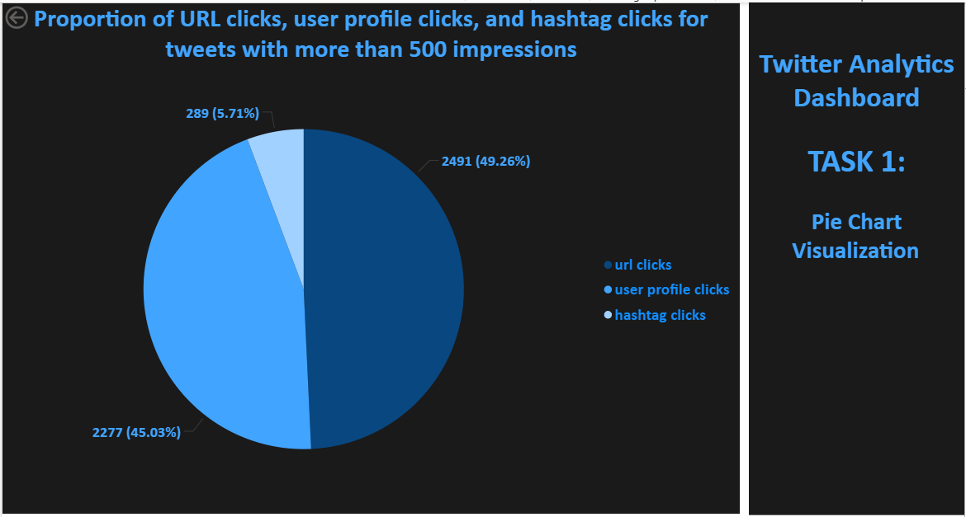

**Task 3 :**

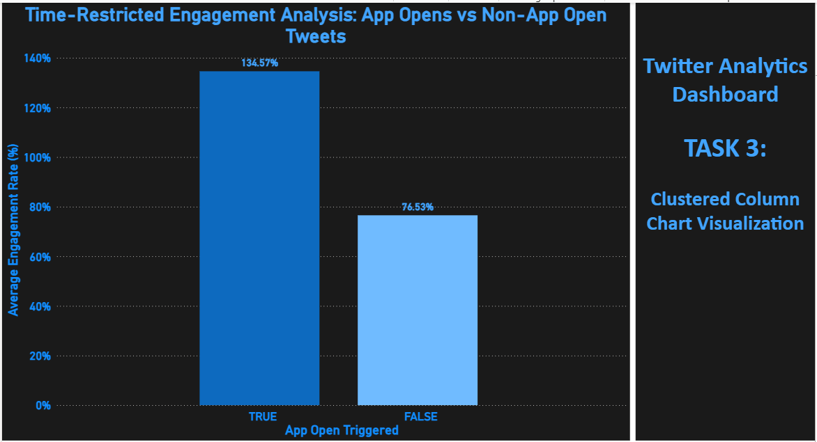

**Training Project :**

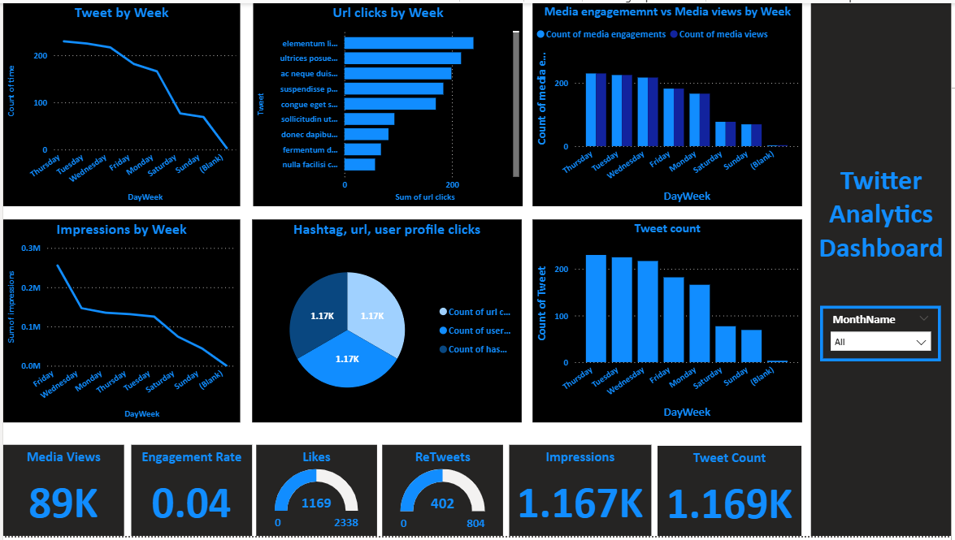

**Task 2 :**

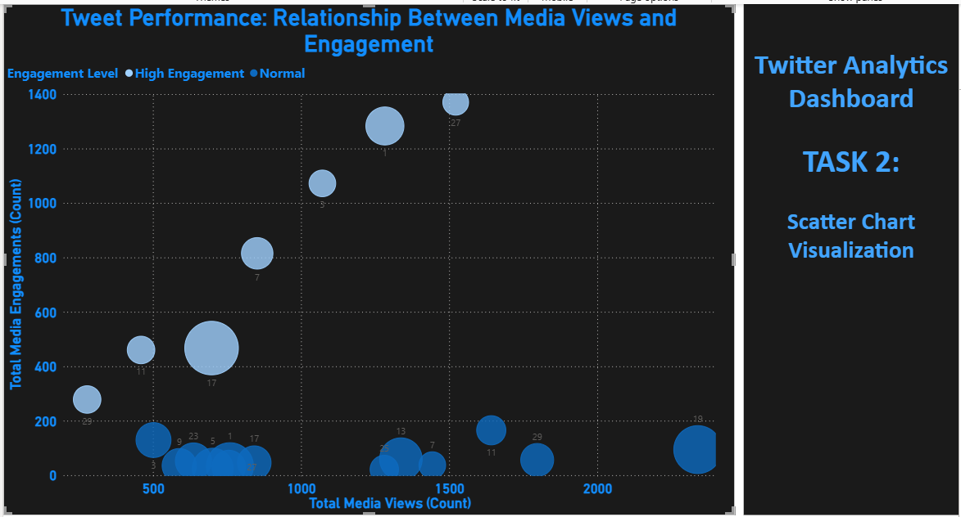

**Github repository :** <https://github.com/AarshK17/Twitter_DataAnalytics>

# Challenges and Solutions

Challenge: Filtering tweets by odd/even dates and impressions  
Solution: Created custom columns using MOD and DAY in Power BI  
  
Challenge: Time-based visibility control in IST  
Solution: Converted UTC to IST using calculated columns and TIME() logic  
  
Challenge: Removing words with letter 'D'  
Solution: Used Power Query’s Text.Select, Text.ContainsAny, and custom functions  
  
Challenge: Engagement rate calculation  
Solution: Used Engagements / Impressions * 100 with error handling for 0 impressions

# Outcomes and Impact

- Enabled deeper understanding of what drives user engagement.  
- Pie chart helped identify best-performing click types.  
- Scatter chart revealed patterns under strict tweet conditions.  
- App opens comparison highlighted their contribution to engagement.

# Conclusion

This Power BI dashboard demonstrates powerful analytics capabilities in examining social media performance. Advanced filtering, DAX logic, and dynamic visuals show the potential to tailor insights precisely, supporting data-informed social media strategies.