

A/B Neuromarketing Test
Recommendations Report

Generated September 22, 2026
26 products analyzed · 31 attribute tests · 0 ready to adopt now

Table of Contents
Right-click and choose 'Update Field' to populate the table of contents.

Executive Summary
Of 31 attribute tests across 26 products, 0 are backed by strong enough evidence to adopt immediately, 1 show a promising signal worth validating further, and 30 still need more participant data before any conclusion can be drawn. A change is only marked ADOPT once at least two of the three response metrics (engagement, emotion, attention time) show a statistically significant difference (p < 0.05).

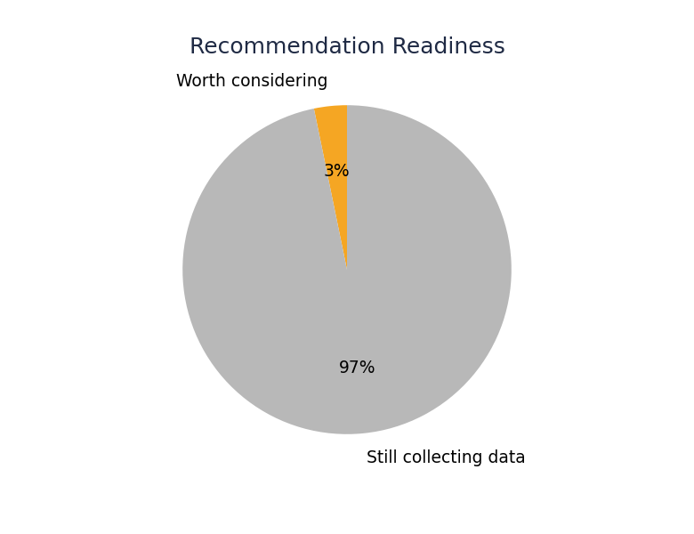
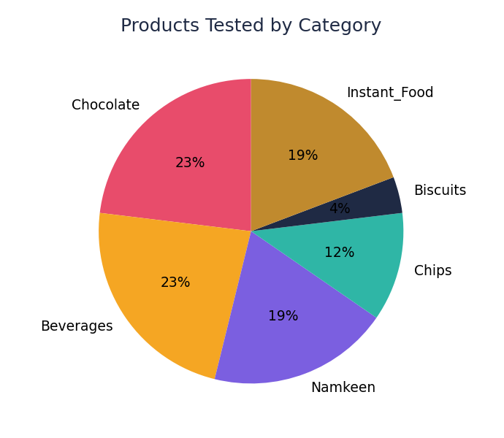

Data Collection Status
1 of 31 attribute tests have enough data to support a recommendation so far. The remainder need more participant sessions — each test needs roughly 20 responses per variant for a reliable read.

All Products — Summary Table
Product | Category | High-confidence | Consider | Collecting data
Milk Chocolate | Chocolate | 0 | 1 | 0
100% Pure Orange Juice (32oz) | Beverages | 0 | 0 | 1
Aloo Bhujia | Namkeen | 0 | 0 | 1
Apple Juice | Beverages | 0 | 0 | 1
Butter Chakli | Namkeen | 0 | 0 | 1
Cacao Symphony | Chocolate | 0 | 0 | 1
Choco Candy | Chocolate | 0 | 0 | 1
Choco Lyra | Chocolate | 0 | 0 | 1
Cocoa Bliss | Chocolate | 0 | 0 | 2
Dark Choco | Chocolate | 0 | 0 | 1
FreshVibe Peach | Beverages | 0 | 0 | 1
Golden Crisp Chips | Chips | 0 | 0 | 1
Lemon Bhujia | Namkeen | 0 | 0 | 1
Mango Juice | Beverages | 0 | 0 | 1
Masala Wafer | Chips | 0 | 0 | 1
NeuBisc Biscuits | Biscuits | 0 | 0 | 5
Neuinsta Geki Spicy Chicken Ramen | Instant_Food | 0 | 0 | 1
Neuinsta Minute Khana Dal Makhani | Instant_Food | 0 | 0 | 1
Neuinsta Poha (3 Minute Breakfast) | Instant_Food | 0 | 0 | 1
Neuinsta Schezwan Instant Noodles | Instant_Food | 0 | 0 | 1
Neuinsta Vegetable Upma (3 Minute Breakfast) | Instant_Food | 0 | 0 | 1
Orange Juice (Generic) | Beverages | 0 | 0 | 1
Sliced Chips | Chips | 0 | 0 | 1
Tomato Treat | Namkeen | 0 | 0 | 1
VitaFresh Orange | Beverages | 0 | 0 | 1
Zigzag Snacks | Namkeen | 0 | 0 | 1

Per-Product Recommendations
Milk Chocolate · Chocolate
Milk Chocolate — 1 attribute tested, 0 high-confidence changes recommended, 1 worth considering with more data, 0 still collecting data.
🟡 CONSIDER — medium confidence, worth more data
- Packaging Transparency: Use packaging with: Transparent Product Window.
Support: emotion score p=0.024

100% Pure Orange Juice (32oz) · Beverages
100% Pure Orange Juice (32oz) — 1 attribute tested, 0 high-confidence changes recommended, 0 worth considering with more data, 1 still collecting data.
⚪ STILL COLLECTING DATA — directional only, not yet actionable
- Price Discount: Price Discount: trending toward 'Rs60 Struck-through Discounted to Rs45' (n_a=2, n_b=1) — not yet statistically significant, do not act on this yet. Collect ~19 more participants for a reliable read.

Aloo Bhujia · Namkeen
Aloo Bhujia — 1 attribute tested, 0 high-confidence changes recommended, 0 worth considering with more data, 1 still collecting data.
⚪ STILL COLLECTING DATA — directional only, not yet actionable
- Packaging Format: Packaging Format: no data or no directional signal yet (n_a=0, n_b=0).

Apple Juice · Beverages
Apple Juice — 1 attribute tested, 0 high-confidence changes recommended, 0 worth considering with more data, 1 still collecting data.
⚪ STILL COLLECTING DATA — directional only, not yet actionable
- Overall Packaging Redesign: Overall Packaging Redesign: trending toward 'Nature's Goodness - Plastic Bottle 500ml From Concentrate' (n_a=2, n_b=1) — not yet statistically significant, do not act on this yet. Collect ~19 more participants for a reliable read.

Butter Chakli · Namkeen
Butter Chakli — 1 attribute tested, 0 high-confidence changes recommended, 0 worth considering with more data, 1 still collecting data.
⚪ STILL COLLECTING DATA — directional only, not yet actionable
- Packaging Material: Packaging Material: no data or no directional signal yet (n_a=0, n_b=0).

Cacao Symphony · Chocolate
Cacao Symphony — 1 attribute tested, 0 high-confidence changes recommended, 0 worth considering with more data, 1 still collecting data.
⚪ STILL COLLECTING DATA — directional only, not yet actionable
- Health Claims Badges: Health Claims Badges: trending toward 'With Claims (Less Sugar No Artificial Colors Cocoa Rich)' (n_a=1, n_b=1) — not yet statistically significant, do not act on this yet. Collect ~19 more participants for a reliable read.

Choco Candy · Chocolate
Choco Candy — 1 attribute tested, 0 high-confidence changes recommended, 0 worth considering with more data, 1 still collecting data.
⚪ STILL COLLECTING DATA — directional only, not yet actionable
- Price Discount: Price Discount: trending toward 'Rs59 Discounted Price' (n_a=1, n_b=2) — not yet statistically significant, do not act on this yet. Collect ~19 more participants for a reliable read.

Choco Lyra · Chocolate
Choco Lyra — 1 attribute tested, 0 high-confidence changes recommended, 0 worth considering with more data, 1 still collecting data.
⚪ STILL COLLECTING DATA — directional only, not yet actionable
- Packaging Format: Packaging Format: trending toward 'Bar Format' (n_a=2, n_b=2) — not yet statistically significant, do not act on this yet. Collect ~18 more participants for a reliable read.

Cocoa Bliss · Chocolate
Cocoa Bliss — 2 attributes tested, 0 high-confidence changes recommended, 0 worth considering with more data, 2 still collecting data.
⚪ STILL COLLECTING DATA — directional only, not yet actionable
- Pack Format: Pack Format: trending toward 'Six Individually Wrapped Bars' (n_a=2, n_b=1) — not yet statistically significant, do not act on this yet. Collect ~19 more participants for a reliable read.
- Packaging Finish: Packaging Finish: trending toward 'Matte Finish' (n_a=1, n_b=1) — not yet statistically significant, do not act on this yet. Collect ~19 more participants for a reliable read.

Dark Choco · Chocolate
Dark Choco — 1 attribute tested, 0 high-confidence changes recommended, 0 worth considering with more data, 1 still collecting data.
⚪ STILL COLLECTING DATA — directional only, not yet actionable
- Background Theme: Background Theme: trending toward 'Natural Rustic Theme (Beige)' (n_a=1, n_b=1) — not yet statistically significant, do not act on this yet. Collect ~19 more participants for a reliable read.

FreshVibe Peach · Beverages
FreshVibe Peach — 1 attribute tested, 0 high-confidence changes recommended, 0 worth considering with more data, 1 still collecting data.
⚪ STILL COLLECTING DATA — directional only, not yet actionable
- Naming And Size: Naming And Size: trending toward 'Peach Delight, 500ml' (n_a=2, n_b=1) — not yet statistically significant, do not act on this yet. Collect ~19 more participants for a reliable read.

Golden Crisp Chips · Chips
Golden Crisp Chips — 1 attribute tested, 0 high-confidence changes recommended, 0 worth considering with more data, 1 still collecting data.
⚪ STILL COLLECTING DATA — directional only, not yet actionable
- Branding Design: Branding Design: trending toward 'Basic Salted Chips (No Branding)' (n_a=1, n_b=1) — not yet statistically significant, do not act on this yet. Collect ~19 more participants for a reliable read.

Lemon Bhujia · Namkeen
Lemon Bhujia — 1 attribute tested, 0 high-confidence changes recommended, 0 worth considering with more data, 1 still collecting data.
⚪ STILL COLLECTING DATA — directional only, not yet actionable
- Packaging Format: Packaging Format: trending toward 'Lemon Bhujia Pouch' (n_a=1, n_b=1) — not yet statistically significant, do not act on this yet. Collect ~19 more participants for a reliable read.

Mango Juice · Beverages
Mango Juice — 1 attribute tested, 0 high-confidence changes recommended, 0 worth considering with more data, 1 still collecting data.
⚪ STILL COLLECTING DATA — directional only, not yet actionable
- Overall Packaging Redesign: Overall Packaging Redesign: no data or no directional signal yet (n_a=0, n_b=0).

Masala Wafer · Chips
Masala Wafer — 1 attribute tested, 0 high-confidence changes recommended, 0 worth considering with more data, 1 still collecting data.
⚪ STILL COLLECTING DATA — directional only, not yet actionable
- Color: Color: no data or no directional signal yet (n_a=0, n_b=0).

NeuBisc Biscuits · Biscuits
NeuBisc Biscuits — 5 attributes tested, 0 high-confidence changes recommended, 0 worth considering with more data, 5 still collecting data.
⚪ STILL COLLECTING DATA — directional only, not yet actionable
- Color: Color: trending toward 'Orange Packaging' (n_a=5, n_b=3) — not yet statistically significant, do not act on this yet. Collect ~17 more participants for a reliable read.
- Packaging Format: Packaging Format: trending toward 'Choco Chip Cookies Pack' (n_a=4, n_b=1) — not yet statistically significant, do not act on this yet. Collect ~19 more participants for a reliable read.
- Product Flavor: Product Flavor: trending toward 'NeuBisc Chocolate Cookies' (n_a=3, n_b=2) — not yet statistically significant, do not act on this yet. Collect ~18 more participants for a reliable read.
- Product Imagery Vs Info: Product Imagery Vs Info: trending toward 'With Net Weight 200g Shown (No Photos)' (n_a=4, n_b=2) — not yet statistically significant, do not act on this yet. Collect ~18 more participants for a reliable read.
- Promotional Badge: Promotional Badge: trending toward 'Without Extra Offer' (n_a=5, n_b=4) — not yet statistically significant, do not act on this yet. Collect ~16 more participants for a reliable read.

Neuinsta Geki Spicy Chicken Ramen · Instant_Food
Neuinsta Geki Spicy Chicken Ramen — 1 attribute tested, 0 high-confidence changes recommended, 0 worth considering with more data, 1 still collecting data.
⚪ STILL COLLECTING DATA — directional only, not yet actionable
- Color: Color: trending toward 'Black/Orange Packaging' (n_a=1, n_b=1) — not yet statistically significant, do not act on this yet. Collect ~19 more participants for a reliable read.

Neuinsta Minute Khana Dal Makhani · Instant_Food
Neuinsta Minute Khana Dal Makhani — 1 attribute tested, 0 high-confidence changes recommended, 0 worth considering with more data, 1 still collecting data.
⚪ STILL COLLECTING DATA — directional only, not yet actionable
- Product Imagery Layout: Product Imagery Layout: trending toward 'Large Bowl Image with Spoon (Left Side)' (n_a=1, n_b=2) — not yet statistically significant, do not act on this yet. Collect ~19 more participants for a reliable read.

Neuinsta Poha (3 Minute Breakfast) · Instant_Food
Neuinsta Poha (3 Minute Breakfast) — 1 attribute tested, 0 high-confidence changes recommended, 0 worth considering with more data, 1 still collecting data.
⚪ STILL COLLECTING DATA — directional only, not yet actionable
- Packaging Format: Packaging Format: no data or no directional signal yet (n_a=0, n_b=0).

Neuinsta Schezwan Instant Noodles · Instant_Food
Neuinsta Schezwan Instant Noodles — 1 attribute tested, 0 high-confidence changes recommended, 0 worth considering with more data, 1 still collecting data.
⚪ STILL COLLECTING DATA — directional only, not yet actionable
- Branding Design: Branding Design: trending toward 'Bold Shadowed Logo Text' (n_a=1, n_b=1) — not yet statistically significant, do not act on this yet. Collect ~19 more participants for a reliable read.

Neuinsta Vegetable Upma (3 Minute Breakfast) · Instant_Food
Neuinsta Vegetable Upma (3 Minute Breakfast) — 1 attribute tested, 0 high-confidence changes recommended, 0 worth considering with more data, 1 still collecting data.
⚪ STILL COLLECTING DATA — directional only, not yet actionable
- Product Tagline: Product Tagline: trending toward 'Fast Breakfast' (n_a=1, n_b=2) — not yet statistically significant, do not act on this yet. Collect ~19 more participants for a reliable read.

Orange Juice (Generic) · Beverages
Orange Juice (Generic) — 1 attribute tested, 0 high-confidence changes recommended, 0 worth considering with more data, 1 still collecting data.
⚪ STILL COLLECTING DATA — directional only, not yet actionable
- Price Display: Price Display: trending toward 'No Price Shown on Pack' (n_a=1, n_b=1) — not yet statistically significant, do not act on this yet. Collect ~19 more participants for a reliable read.

Sliced Chips · Chips
Sliced Chips — 1 attribute tested, 0 high-confidence changes recommended, 0 worth considering with more data, 1 still collecting data.
⚪ STILL COLLECTING DATA — directional only, not yet actionable
- Color And Branding: Color And Branding: no data or no directional signal yet (n_a=0, n_b=0).

Tomato Treat · Namkeen
Tomato Treat — 1 attribute tested, 0 high-confidence changes recommended, 0 worth considering with more data, 1 still collecting data.
⚪ STILL COLLECTING DATA — directional only, not yet actionable
- Packaging Claims: Packaging Claims: trending toward 'Simple Design' (n_a=1, n_b=1) — not yet statistically significant, do not act on this yet. Collect ~19 more participants for a reliable read.

VitaFresh Orange · Beverages
VitaFresh Orange — 1 attribute tested, 0 high-confidence changes recommended, 0 worth considering with more data, 1 still collecting data.
⚪ STILL COLLECTING DATA — directional only, not yet actionable
- Packaging Transparency: Packaging Transparency: trending toward 'Opaque Bottle (Product Not Visible)' (n_a=3, n_b=1) — not yet statistically significant, do not act on this yet. Collect ~19 more participants for a reliable read.

Zigzag Snacks · Namkeen
Zigzag Snacks — 1 attribute tested, 0 high-confidence changes recommended, 0 worth considering with more data, 1 still collecting data.
⚪ STILL COLLECTING DATA — directional only, not yet actionable
- Packaging Format: Packaging Format: no data or no directional signal yet (n_a=0, n_b=0).

