Neuromarketing Study — Product Packaging Test
Neuromarketing Analysis Report

Prepared for: Client Stakeholders
Report generated: August 13, 2026 at 12:07
Revision 3 of 3 · Based on 1064 trials across 647 participants

Table of Contents
Right-click and choose 'Update Field' to populate the table of contents.

Document Control & Revision History
This report is automatically regenerated after every analysis run against the live dataset. It is cumulative: nothing from a prior run is lost — the table below lists every analysis run recorded to date, and the Appendix contains the full narrative history.
Rev # | Date / Time | Total Trials | Participants | Avg Engagement
1 | 2026-07-23 06:09 | 1052 | 645 | 3.59
2 | 2026-07-23 06:49 | 1052 | 645 | 3.59
3 | 2026-08-13 12:05 | 1064 | 647 | 3.66

1. Executive Summary
12 new row(s) added, from 4 participant(s). Among just the new data, the dominant emotion was neutral and average engagement score was 9.14. Overall average engagement score moved up from 3.59 to 3.66 (+1.7%) across the whole dataset. C (Neutral) currently leads in engagement (6.62) vs B (Right) (5.02). Most frequent emotion overall: surprise (21.2%). Significant A/B findings: emotion score: A (Left) (p=0.027); emotion score: A (Left) (p=0.0383).

This section is regenerated automatically after every analysis and always reflects the most recently collected data. See Section 8 (Appendix) for the complete run-by-run history of how these findings have evolved.

2. Objectives & Scope
This study evaluates customer response to a single product's design variants using non-intrusive eye-tracking (gaze and fixation analysis) and facial emotion recognition. The objective is to identify which visual design (stimulus variant) drives the strongest attention and the most positive emotional engagement, in order to inform the final packaging and design decision with quantitative, behavioral evidence rather than opinion alone.
The scope covers all participant sessions recorded to date in the underlying dataset, and is updated automatically as new sessions are added — this report always reflects the complete, current body of evidence.

3. Methodology
Data was collected and analyzed using the following pipeline:
- Eye tracking: gaze position (x/y) and fixation duration captured via OpenCV + MediaPipe face/eye landmark detection.
- Facial emotion recognition: frame-level emotion classification via DeepFace, producing one of five categories per trial — happy, sad, angry, surprise, or neutral.
- Engagement score: a composite metric combining attention time and emotion valence, capturing both how long and how positively a participant engaged with the stimulus.
- A/B(/C) testing: independent two-sample t-tests (Welch's) comparing engagement, emotion, and attention-time means across stimulus variants (A, B, C).
- Segmentation: K-means clustering (k=3) of all participants based on emotion score, attention time, and engagement score, to identify distinct behavioral profiles.
All figures in this report are computed directly from the underlying dataset at generation time — no manual data entry is involved.

4. Key Metrics Snapshot (Current)
Metric | Value
Total Trials | 1,064
Total Participants | 647
Avg Engagement Score | 3.66
Avg Attention Time (s) | 3.11
Analysis Runs Logged | 3

Trend Across Analysis Runs
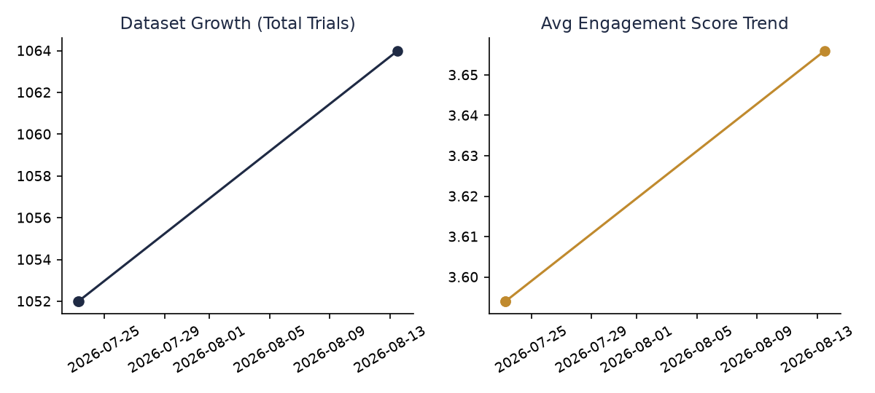

5. Findings

5.1 Emotion Distribution
Across all recorded trials, Surprise was the most frequently detected emotion, accounting for 21.2% of reactions.
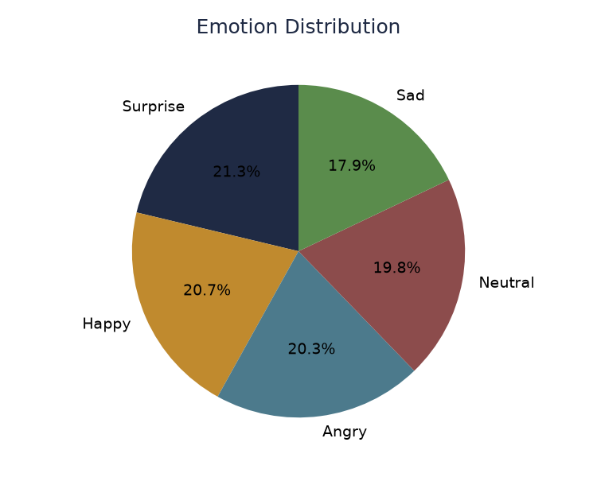
Emotion | Share of Trials
Surprise | 21.2%
Happy | 20.7%
Angry | 20.3%
Neutral | 19.8%
Sad | 17.9%

5.2 Engagement & Attention by Stimulus
C (Neutral) currently leads in average engagement (6.62), while B (Right) trails (5.02). This comparison is based on the subset of trials where a stimulus variant was explicitly assigned.
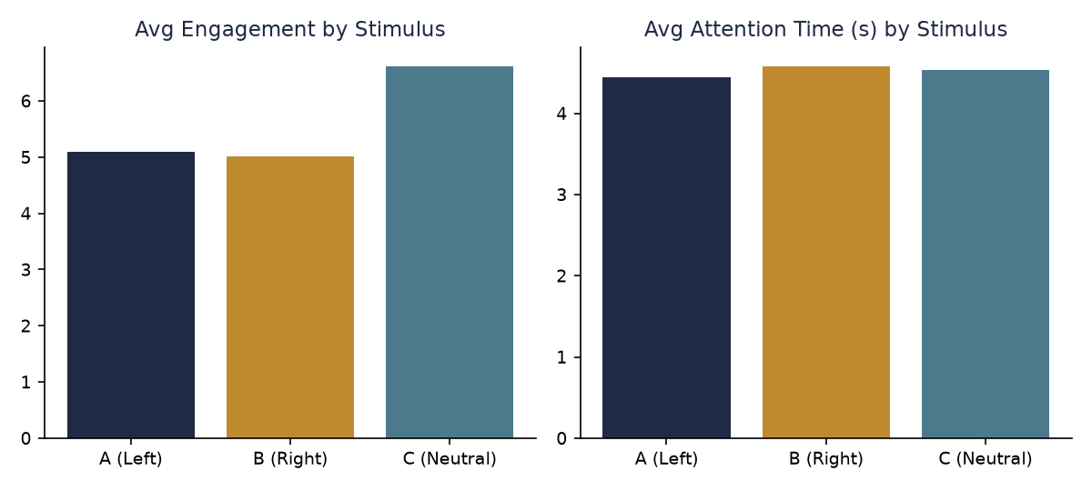
Stimulus | Avg Engagement | Avg Attention Time (s)
A (Left) | 5.09 | 4.45
B (Right) | 5.02 | 4.58
C (Neutral) | 6.62 | 4.54

5.3 Participant Segmentation
Three behavioral segments were identified via clustering. Segment 1 shows the highest engagement (4.75) and represents 46% of all trials — the strongest-responding audience profile. Segment 0 shows the lowest engagement (2.25) and may warrant a different creative or messaging approach.
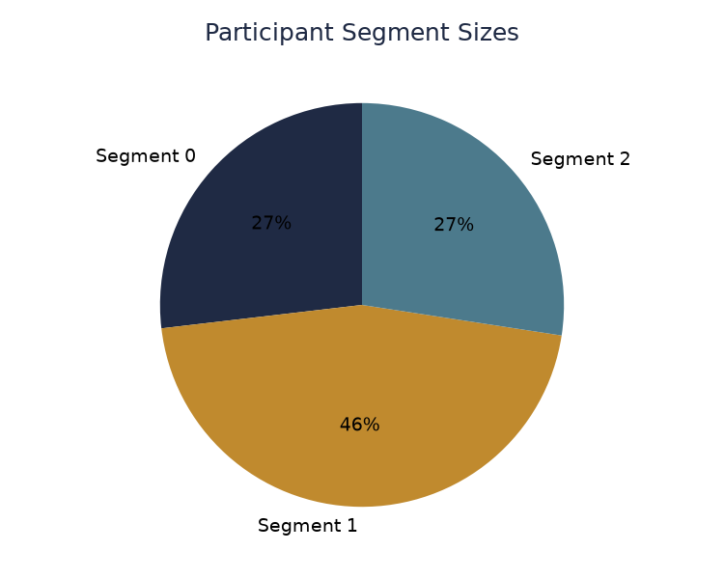
Segment | Size | Avg Emotion | Avg Attention | Avg Engagement
0 | 283 | 0.15 | 2.10 | 2.25
1 | 482 | 0.54 | 4.20 | 4.75
2 | 289 | 0.81 | 2.20 | 3.01

6. A/B Test Results
Each stimulus pair was compared using an independent two-sample t-test. A result is marked significant only when p < 0.05; comparisons with fewer than 3 samples per variant are marked as not tested rather than "no difference", since significance cannot be meaningfully assessed on that little data.

Engagement Score
Variant A | Variant B | Mean A | Mean B | p-value | Sig.? | Result / Note
A (Left) | B (Right) | 5.095 | 5.02 | 0.7907 | No | no significant difference
A (Left) | C (Neutral) | 5.095 | 6.617 | 0.1758 | No | no significant difference
B (Right) | C (Neutral) | 5.02 | 6.617 | 0.1614 | No | no significant difference

Emotion Score
Variant A | Variant B | Mean A | Mean B | p-value | Sig.? | Result / Note
A (Left) | B (Right) | 0.65 | 0.441 | 0.027 | Yes | A (Left)
A (Left) | C (Neutral) | 0.65 | 0.5 | 0.0383 | Yes | A (Left)
B (Right) | C (Neutral) | 0.441 | 0.5 | 0.3432 | No | no significant difference

Attention Time
Variant A | Variant B | Mean A | Mean B | p-value | Sig.? | Result / Note
A (Left) | B (Right) | 4.445 | 4.579 | 0.6404 | No | no significant difference
A (Left) | C (Neutral) | 4.445 | 4.537 | 0.8457 | No | no significant difference
B (Right) | C (Neutral) | 4.579 | 4.537 | 0.9288 | No | no significant difference

Confidence & Limitations
- Several stimulus comparisons currently have small sample sizes (A (Left) vs B (Right) (n=22 / n=19); A (Left) vs C (Neutral) (n=22 / n=3); B (Right) vs C (Neutral) (n=19 / n=3)). Findings from these comparisons should be treated as directional, not conclusive, until more participants are tested.
- Statistical significance is assessed at the standard p < 0.05 threshold using independent two-sample t-tests (Welch's, unequal variance assumed).

7. Recommendations
Based on the current data, the following actions are recommended:
- Prioritize C (Neutral) — it currently shows the highest engagement score (6.62), outperforming B (Right) (5.02).
- Act on statistically confirmed results: emotion score: A (Left) (p=0.027); emotion score: A (Left) (p=0.0383).
- Tailor messaging toward Segment 1 — it shows the highest average engagement (4.75) of all identified participant clusters.

8. Appendix: Full Analysis Change Log
Every analysis run ever recorded is listed below, oldest first, so the evolution of findings over time remains fully auditable.

Run 1 — 2026-07-23 06:09 (1052 trials)
First recorded analysis: 1052 total trials across 645 participants. C (Neutral) currently leads in engagement (5.50) vs B (Right) (5.02). Most frequent emotion overall: surprise (21.3%). Significant A/B findings: emotion score: A (Left) (p=0.027).

Run 2 — 2026-07-23 06:49 (1052 trials)
No new rows since the last analysis — dataset size unchanged. Overall average engagement score moved unchanged from 3.59 to 3.59 (+0.0%) across the whole dataset. C (Neutral) currently leads in engagement (5.50) vs B (Right) (5.02). Most frequent emotion overall: surprise (21.3%). Significant A/B findings: emotion score: A (Left) (p=0.027).

Run 3 — 2026-08-13 12:05 (1064 trials)
12 new row(s) added, from 4 participant(s). Among just the new data, the dominant emotion was neutral and average engagement score was 9.14. Overall average engagement score moved up from 3.59 to 3.66 (+1.7%) across the whole dataset. C (Neutral) currently leads in engagement (6.62) vs B (Right) (5.02). Most frequent emotion overall: surprise (21.2%). Significant A/B findings: emotion score: A (Left) (p=0.027); emotion score: A (Left) (p=0.0383).

