**Coding Challenge SQL Aarthi P**

**Crime Management Shema DDL and DML 19/06/2025**

**-- Create tables**

CREATE TABLE Crime (

CrimeID INT PRIMARY KEY,

IncidentType VARCHAR(255), IncidentDate DATE,

Location VARCHAR(255), Description TEXT,

Status VARCHAR(20) );

CREATE TABLE Victim (

VictimID INT PRIMARY KEY, CrimeID INT,

Name VARCHAR(255),

ContactInfo VARCHAR(255), Injuries VARCHAR(255),

FOREIGN KEY (CrimeID) REFERENCES Crime(CrimeID) );

CREATE TABLE Suspect (

SuspectID INT PRIMARY KEY, CrimeID INT,

Name VARCHAR(255), Description TEXT,

CriminalHistory TEXT,

FOREIGN KEY (CrimeID) REFERENCES Crime(CrimeID) );

**-- Insert sample data**

INSERT INTO Crime (CrimeID, IncidentType, IncidentDate, Location, Description, Status) VALUES

(1, 'Robbery', '2023-09-15', '123 Main St, Cityville', 'Armed robbery at a convenience store','Open'),

(2, 'Homicide', '2023-09-20', '456 Elm St, Townsville', 'Investigation into a murder case', 'Under Investigation'),

(3, 'Theft', '2023-09-10', '789 Oak St, Villagetown', 'Shoplifting incident at a mall', 'Closed');

INSERT INTO Victim (VictimID, CrimeID, Name, ContactInfo, Injuries) VALUES(1, 1, 'John Doe','johndoe@example.com', 'Minor injuries'), (2, 2, 'Jane Smith', 'janesmith@example.com', 'Deceased'),(3, 3, 'Alice Johnson', 'alicejohnson@example.com', 'None');

INSERT INTO Suspect (SuspectID, CrimeID, Name, Description, CriminalHistory) VALUES(1, 1, 'Robber 1', 'Armed and masked robber', 'Previous robbery convictions'), (2, 2, 'Unknown', 'Investigation ongoing', NULL),(3, 3, 'Suspect 1', 'Shoplifting suspect', 'Prior shoplifting arrests');

**Solve the below queries**:

1. Select all open incidents.

**select * from Crime**

**where Status = "Open";**

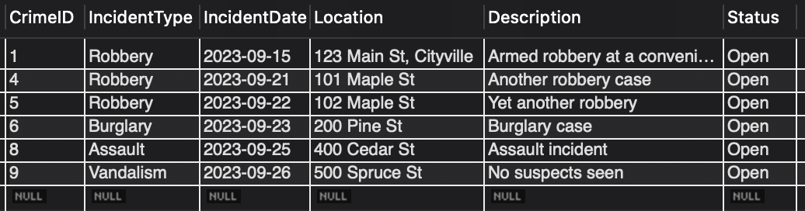

1. Find the total number of incidents.

**select count(CrimeID) as total_numer_of_incidents from Crime;**

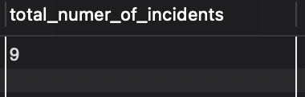

1. List all unique incident types.

**select distinct IncidentType as Unique_Incident_Types from Crime;**

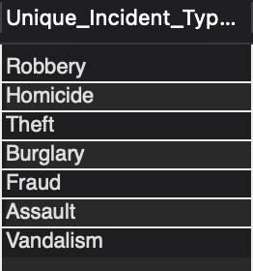

1. Retrieve incidents that occurred between '2023-09-01' and '2023-09-10'.

**select * from Crime**

**where IncidentDate Between '2023-09-01' and '2023-09-10';**

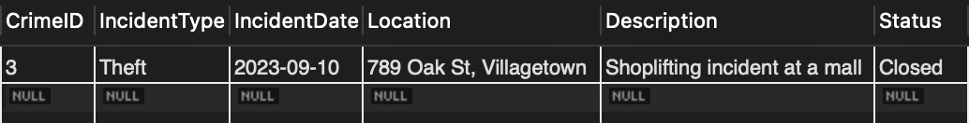

1. List persons involved in incidents in descending order of age.

insert into Crime (CrimeID, IncidentType, IncidentDate, Location, Description, Status) values

(4, 'Robbery', '2023-09-21', '101 Maple St', 'Another robbery case', 'Open'),

(5, 'Robbery', '2023-09-22', '102 Maple St', 'Yet another robbery', 'Open');

insert into Crime (CrimeID, IncidentType, IncidentDate, Location, Description, Status) values

(6, 'Burglary', '2023-09-23', '200 Pine St', 'Burglary case', 'Open'),

(7, 'Fraud', '2023-09-24', '300 Birch St', 'Fraud case', 'Closed');

insert into Victim (VictimID, CrimeID, Name, ContactInfo, Injuries) values

(4, 6, 'Alex King', 'alexking@example.com', 'None');

insert into Suspect (SuspectID, CrimeID, Name, Description, CriminalHistory) values

(4, 7, 'Alex King', 'Fraud suspect', 'None');

insert into Crime (CrimeID, IncidentType, IncidentDate, Location, Description, Status) values

(8, 'Assault', '2023-09-25', '400 Cedar St', 'Assault incident', 'Open');

insert into Suspect (SuspectID, CrimeID, Name, Description, CriminalHistory) values

(5, 1, 'John Criminal', 'Repeat offender', 'Robbery'),

(6, 8, 'John Criminal', 'Repeat offender', 'Assault');

insert into Crime (CrimeID, IncidentType, IncidentDate, Location, Description, Status) values

(9, 'Vandalism', '2023-09-26', '500 Spruce St', 'No suspects seen', 'Open');

alter table Victim add column Age int;

Update Victim set Age=25 where VictimID=1;

Update Victim set Age=35 where VictimID=2;

Update Victim set Age=40 where VictimID=3;

Update Victim set Age=30 where VictimID=4;

alter table Suspect add column Age int;

Update Suspect set Age=30 where SuspectID=1;

Update Suspect set Age=Null where SuspectID=2;

Update Suspect set Age=35 where SuspectID=3;

Update Suspect set Age=40 where SuspectID=4;

Update Suspect set Age=25 where SuspectID=5;

Update Suspect set Age=45 where SuspectID=6;

**Select Name,Age,'Victim' From Victim**

**union**

**select name, Age,'Suspect' from Suspect**

**order by age desc;**

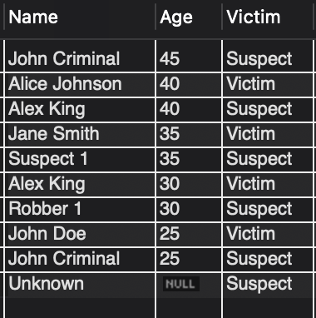

1. Find the average age of persons involved in incidents.

**select avg(Age) as AvgAge**

**from (Select Age From Victim**

**union all**

**select Age from Suspect) as pplAge;**

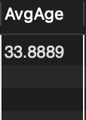

1. List incident types and their counts, only for open cases.

**select distinct IncidentType, count(*) as Count from Crime**

**where status="Open"**

**group by IncidentType;**

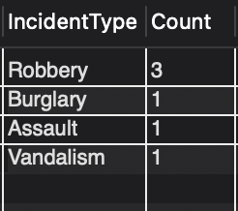

1. Find persons with names containing 'Doe'.

**select Name from Victim**

**where Name like "%Doe%"**

**union**

**select Name from Suspect**

**where Name like "%Doe%";**

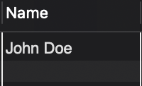

1. Retrieve the names of persons involved in open cases and closed cases.

**select Name, "Victim" as people from Victim v**

**join Crime c on v.CrimeID = c.CrimeID**

**where c.Status = "Open"**

**union**

**select Name, "Suspect" as people from Suspect s**

**join Crime c on s.CrimeID = c.CrimeID**

**where c.Status = "Open";**

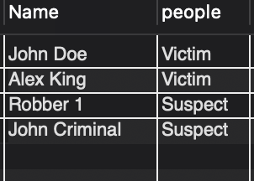

1. List incident types where there are persons aged 30 or 35 involved.

**select IncidentType from Crime c**

**join Victim v on v.CrimeID = c.CrimeID**

**where v.age = 30 or v.age = 35**

**union**

**select IncidentType from Crime c**

**join Suspect s on s.CrimeID = c.CrimeID**

**where s.age = 30 or s.age = 35;**

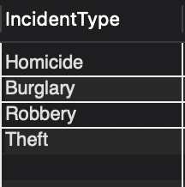

1. Find persons involved in incidents of the same type as 'Robbery'.

**select Name, "Victim" as people from Victim v**

**join Crime c on v.CrimeID = c.CrimeID**

**where c.IncidentType = "Robbery"**

**union**

**select Name, "Suspect" as people from Suspect s**

**join Crime c on s.CrimeID = c.CrimeID**

**where c.IncidentType = "Robbery";**

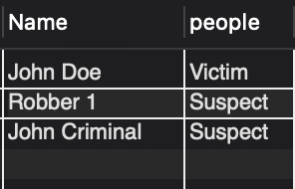

1. List incident types with more than one open case.

**select IncidentType from Crime**

**where Status="Open"**

**group by IncidentType**

**having count(*)>1;**

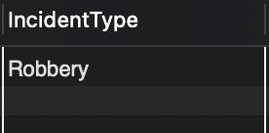

1. List all incidents with suspects whose names also appear as victims in other incidents.

**select distinct c.* from Crime c**

**join Suspect s on s.CrimeID = c.CrimeID**

**where s.Name in(select distinct Name from Victim v);**

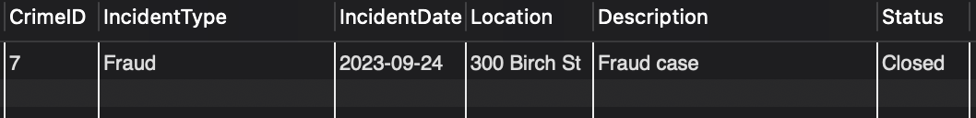

1. Retrieve all incidents along with victim and suspect details.

**select c.*,v.*,s.* from Crime c**

**join Victim v on v.CrimeID = c.CrimeID**

**join Suspect s on s.CrimeID = c.CrimeID;**



1. Find incidents where the suspect is older than any victim.

**select c.* from Crime c**

**join Suspect s on s.CrimeID = c.CrimeID**

**where s.Age > any(select Age from Victim);**

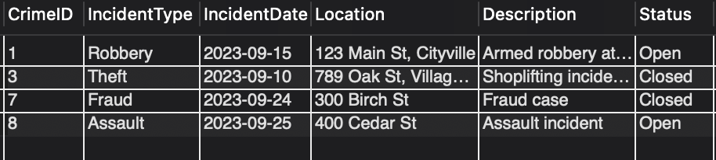

1. Find suspects involved in multiple incidents:

**select Name from Suspect**

**group by Name**

**having count(*)>1;**

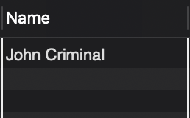

1. List incidents with no suspects involved.

**select * from Crime**

**where CrimeID not in (select CrimeID from Suspect);**

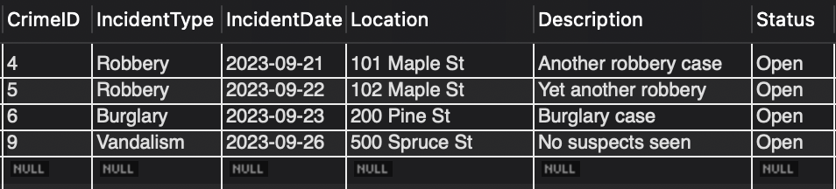

1. List all cases where at least one incident is of type 'Homicide'and all other incidents are of type 'Robbery'.

**select * from Crime**

**where exists (select 1 from Crime where IncidentType = 'Homicide')**

**and not exists (select 1 from Crime where IncidentType not in ('Homicide', 'Robbery'));**

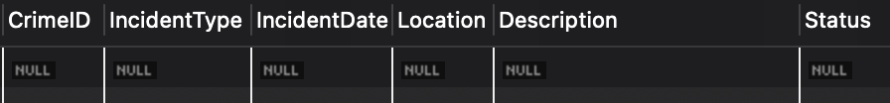

*The table turned out to be null ‘coz there are no cases where at least one incident is of type 'Homicide'and all other incidents are of type 'Robbery'.*

1. Retrieve a list of all incidents and the associated suspects, showing suspects for each incident, or 'No Suspect'if there are none.

**select c.*, coalesce(s.Name, "No Suspect") as SuspectName from Crime c**

**join Suspect s on s.CrimeID = c.CrimeID;**

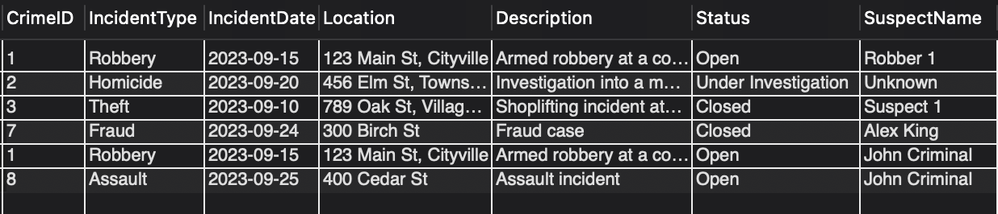

1. List all suspects who have been involved in incidents with incident types 'Robbery' or 'Assault'

**select s.Name from Suspect s**

**join Crime c on s.CrimeID = c.CrimeID**

**where c.IncidentType = 'Robbery' or c.IncidentType = 'Assualt';**

