AARTHI.M

**Final Project**

1

3/21/2024 **Annual Review**

PROJECT TITLE

STOCK PREDICTION USING RANDOM FOREST ALGORITHM

2 2

3/21/2024 **Annual Review**



3/21/2024 **Annual Review**



# AGENDA

# 1.PROBLEM STATEMENT

# 2.PROJECT OVERVIEW

# 3.WHO ARE THE END USERS

# 4.SOLUTION AND ITS VAKUE PROPOSITION

# 5.THE WOW IN THE SOLUTION

# 6.MODELLING

# 7.RESULT



3

PROBLEM STATEMENT

* The objective of this project is to develop a predictive model using the Random Forest algorithm to forecast stock prices accurately.
* The model will utilize historical stock price data along with other relevant features to predict future price movements.
* The goal is to build a robust and reliable prediction system that can assist stakeholders in making informed decisions regarding stock investments.



3/21/2024 **Annual Review** 4

PROJECT OVERVIEW

* This project aims to develop a model to predict the stock price using the algorithm called as Random Forest Algorithm.
* The stock price is predicted using the prices of the past dataset.
* The output displays the actual and the predicted value of the stock .



5

**WHO ARE THE END USERS?**

* **Traders**
* **Investors**
* **Financial Analysts**
* **Financial Software Developers**
* **Quantitative Analysts**

6

3/21/2024 **Annual Review**



3/21/2024 **Annual Review**

**SOLUTION AND ITS VALUE PROPOSITION**

Developing a stock prediction solution using the Random Forest algorithm involves collecting historical stock price data and relevant features, preprocessing the data, and engineering new features if necessary.

Then, a Random Forest regression model is designed and trained, with hyper parameters optimized through techniques like cross-validation.

The trained model is evaluated using testing data, assessing its performance with metrics such as MAE, MSE, and RMSE.

Once validated, the model is deployed for real-time prediction or integration into existing systems, with ongoing monitoring and maintenance to ensure accuracy and adaptability to market changes.

7



THE WOW IN YOUR SOLUTION

The solution will be more accurate.

The model is more adaptable for any kind of data.

The model is more efficient for the user.

8

3/21/2024 **Annual Review**

# MODELLING

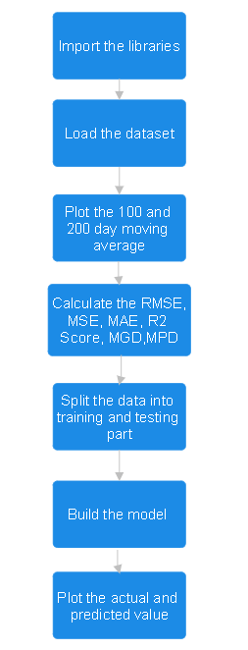

 9

3/21/2024 **Annual Review**

# RESULTS

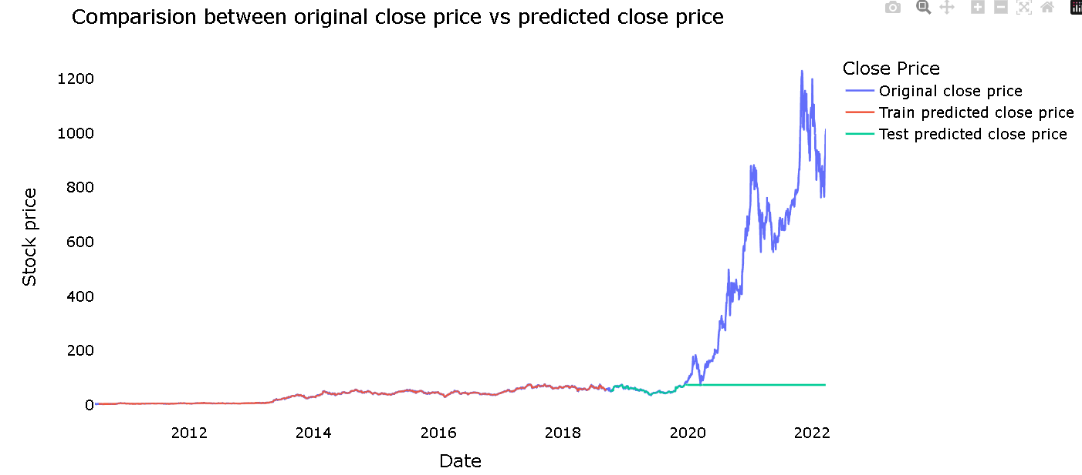

Demo Link

 10

3/21/2024 **Annual Review**