Bloomsbury operates under consumer and non-consumer divisions. (Figure 1) The company’s sales growth was 0.06% in 2018 while it soared to 24.29% in 2021(Figure 2) due to the increase in the sales of academic and professional books by 34% (Figure 3)

Figure 1: Consumer and non-consumer divisions (Bloomsbury Annual Report, 2020)

Figure 2: Annual revenue growth from 2019 to 2022

Figure 3: annual revenue growth of non-consumer division

Bloomsbury owns the largest market share for children’s books sector (Figure 5) owing to the publication. Harry Potter and the books series by Sarah J Maas have been the largest contributors to the segment sales. When one of Sarah’s books dropped in sales, the section itself faced a loss of 1.79% revenue in 2020. (Bloomsbury Annual Report, 2020, p. 19) Following the decline, the sales bounced back in 2020 and grew up to 24.72% in 2021 due to the sales growth in same titles. (Figure 4)

Figure 4: Annual revenue growth of consumer division

Figure 5: Market share of UK Publishers in children's trade (IBISWorld, n.d.)

During 2021-2022, revenue growth of Bloomsbury declined from 24.29% to 14.77% which matches the macroeconomic conditions of the UK economy in publishing industry, whose revenue growth of dropped by 2.75% (Figure 7). Its operating margin also remained consistent except during the pandemic when it slightly increased due to drop in administrative expenses by 3% (Figure 6)

Figure 6: Operating Profit Margin trends

Figure 7: Comparison of Bloomsbury's revenue with publishing industry (IBISWorld, 2023)

Bloomsbury operates through three major products-print, digital and rights and services. Digitalisation of publishing services and selling to businesses and libraries began even before the pandemic. This offered a first-mover advantage to Bloomsbury in building its digital repositories stronger when compared to its immediate competitors in the industry. Thereby, the Bloomsbury Digital Resources pronounced huge growth in its year-on-year revenue. (Figure 8)

Figure 8: BDR Revenue Growth (Bloomsbury Investor Relations, June 2023)

As an independent publisher not owned by a conglomerate, Bloomsbury has become the fifth largest publication in the UK (IBISWorld, 2023) by acquisitions and gaining huge capital investments through shares. The company’s progressive dividends policy payment accounted for almost 14% or more of the opening balance every year. Bloomsbury raised £8 million In 2020 by issuing shares and successfully acquired new digital businesses to expand its market presence in 2021 (Figure 9) Bloomsbury shares continue to out-perform the FTSE 100, going into 2024. (Figure 10)



Figure 9:Consolidated Cash Waterfall over five years

Figure 10: Stock performance over past five years (FT, 2024)

The surge in number of readers benefitted the overall revenue growth of publishing industry and Bloomsbury during the pandemic. However, after 2022, the sales growth of Bloomsbury seems to have slowed down across its various divisions. (Figure 11)

Figure 11: Sales growth across sub-divisions (Bloomsbury interim reports, 2022, 2023)

In summary, Bloomsbury’s strategy of multiple acquisitions has benefitted in increasing revenue while it has also led to an increase in inventory and current assets when compared to its competitors in the industry, as indicated by the high current ratio. This operational weakness indicates potentially underemployed capital. (Figure 12)

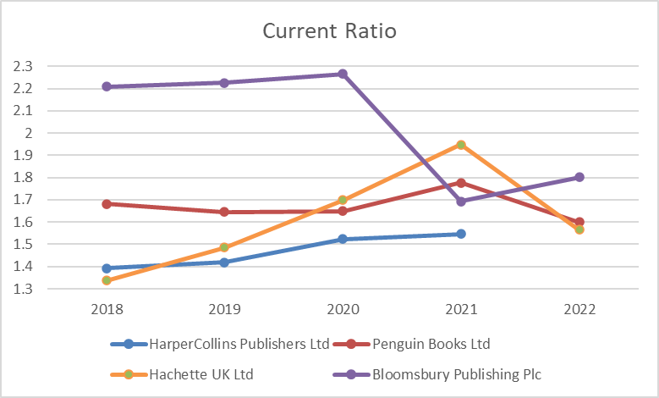

Figure 12: Current ratio trends with competitors (Orbis, 2022)

Bloomsbury’s growth strategy and long-term focus is to invest in high-value intellectual property and digital channels, publish works of excellence and originality, and grow their diversified portfolio of content and services across our Consumer and Non-Consumer Divisions to build quality revenues and increase earnings. (Figure 13)

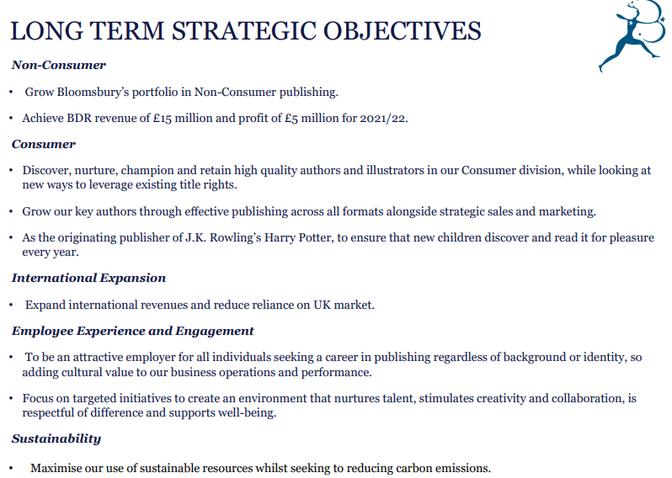

Figure 13: Strategic objectives (Bloomsbury Prelim Report, February 2020)

Following the enormous success of Harry Potter books, the founder and CEO, Nigel Newton, wanted to extend the strategic focus to non-consumer publishing by promoting sales in academic and professional book publishing. The company expanded its academic digital resources and delivered online software services to libraries, ICAEW with Bloomsbury Professional tax Online and launched the Drama Online platform, a high-quality online research tool for drama and literature students, professors, and lecturers (Drama Online - Bloomsbury, 2023). Association with Spotify to launch audiobooks as podcasts increased the rights and services revenue by 60% in 2018 (Bloomsbury, August 2018, p. 17) As the academia started shifting towards digital libraries, Bloomsbury made use of the opportunity to expand its academic resources library through acquisitions and strategic partnerships. Bloomsbury’s strategy of utilising its resources can be explained using the VRIO framework (Figure 14)



Figure 14: VRIO Framework explaining resources and capabilities of Bloomsbury

Following the estimated growth of audio books in the US and the UK markets, Bloomsbury audio was launched in-house and distributed through Audible. However, the market share of audio books dropped during the pandemic and the revenue growth slowed down. (Bloomsbury Interim Report, August 2020, p. 6) During the pandemic, as institutions switched to online teaching, Bloomsbury’s subscriptions revenue rose to 36% of the section revenue. It continued to grow through partnering with institutional press and with companies with specialised digital resources. To increase the number of subscribers, Bloomsbury offered trial versions to universities and introduced definite market verticals for its digital resources (BDR) (Figure 15)

Figure 15: Key market leading verticals of BDR (Bloomsbury Prelim Report, Feb 2021)

Strategic acquisitions during the pandemic targeted the academic and non-consumer divisions such as Red Globe Press and ABC-CLIO. To proceed with the acquisitions, Bloomsbury issued shares in February 2020 and raised capital. Following that, it spent £26.6 million in acquisitions in 2021 (Bloomsbury Interim Report, February 2022, p. 10).

In comparison with its competitors in academic publishing, Oxford University Press, John Wiley and Sons and Cambridge University Press, all of them had a huge growth in their digital revenue, indicating an industry trend of revenue growth.

Figure 16: Digital Publishing revenue share during the pandemic

In consumer division, Bloomsbury has had a long-standing success because of the launch of children’s books such as Harry Potter, book series by Sarah J Mass and Neil Gaiman and adult books by Khaled Hosseini. The long-term strategy is to promote the sales of backlist titles and acquire new front list publishers. Even though the non-consumer division included digital resources, consumer division was highly reliant on print books and e-books were only a minimal part of the division in 2019. Bloomsbury promoted the sales of backlist titles by publishing illustrated versions and innovative marketing strategies. During the pandemic, to offset the losses caused by lack of printing materials available and to reduce its inventory, Bloomsbury built its own sales website to promote direct-to-consumer sales of children’s and adults’ books. This encouraged audiences to purchase books directly from the publisher and eliminated commissions to online selling platforms. Various other activities were also carried out through Bloomsbury’s websites to increase the company’s revenues during the pandemic (Figure 17). As a result of various campaigns and home delivery service (Figure 18), website revenue went up by 134% in 2019.

Figure 17: Steps to promote consumer division sales (Bloomsbury Prelim Report, Feb 2020)

Figure 18: Marketing Strategies during pandemic (Bloomsbury Prelim Report, Feb 2020)

As a way of acquiring latest content in consumer division, Bloomsbury invested large shares of its working capital to royalty payments and advance payments to its authors. In 2020, it paid £11 million as advances and £19.5 million as royalty payments to support the authors all the while building a backlog of high-quality content. (Bloomsbury Prelim Report, Feb 2021) This has resulted in Bloomsbury consistently staying on top of the children’s publishing market for over five years (Figure 19)

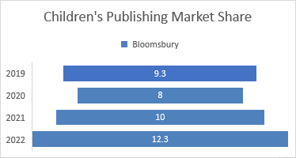

Figure 19: Market share from 2019 to 2022 (IBISWorld, n.d.)

Thirdly, Bloomsbury’s strategy was to focus on international expansion to reduce the over-dependence on the UK market. As a result, it opened headquarters in the US, India and Australia and partnered with companies in China as joint interventions. Owing to the company’s focus on academic division, it utilised the largest academic market in the US (Bloomsbury Annual Report, 2020) and targeted higher education institutes to expand its market presence.

During the pandemic, there was a huge drop in sales in India (Figure 20) while sales in the US grew by 34%. As the number of readers surged in other countries, it was an opposite trend in India (Bhowal, 2022) and both online and offline sales dopped to an all-time low that year. The Indian publishing industry faced with many struggles due to piracy and the disruption of distributing channels. However, Bloomsbury bounced back quickly to regain its revenues by an increase of 58% the next year by strategically shifting towards publishing books in regional languages and through translations. (Parakala, 2022)

Figure 20: Sales growth by regions of publication

Finally, during the pandemic, Bloomsbury also contributed to society by formulating sustainability and employee well-being goals and achieving them through partnering with non-profit organisations and trusts like the Woodland Trust and Reforest Action (Figure 21)

Figure 21: Bloomsbury Initiatives ( (Bloomsbury Interim Report, February 2021)

After the pandemic, the company continued its strategic focus by classifying its long-term goals into three categories. Each category incorporated various goals and collectively benefitted the company to achieve £230 million in revenue in 2022, thereby extending the benefits of the pandemic boom of the publishing industry.

Figure 22: Three strategic divisions under focus

Having established a strong digital presence in the UK and international markets, Bloomsbury began cross selling its products and services through its acquisitions. It also ensured the generation of latest content by paying £14.8 million advances to the authors even before the publication of books and continued the organic growth strategy through acquisitions (Bloomsbury prelim report, February 2023, p. 11) Launching the content as e-book, print and audio books have provided complementary customer access, allowing diverse people to access the reading materials. In early 2023, Bloomsbury also reached 27700 academic customers, halfway towards its target of 5000 customers, resulting in a revenue growth of 28% (Bloomsbury prelim report, February 2023, p. 13). To boost the number of audiences, Bloomsbury also follows speeding to the market and digital first strategies. (Figure 24) This eliminates accumulation of inventory and provides first mover advantage. As a result of the international expansion strategies, Bloomsbury has successfully increased to acquire 48% of its global revenue from the US. Bloomsbury’s ability to stick to the long-term goals has resulted in a flywheel strategy where investment in strong content delivers better operations and generating cash to fund further investment. Further, the five digital verticals have increased multi-fold after the pandemic.

Figure 23: Key verticals in BDR (Bloomsbury prelim report, February 2023)

Figure 24: Content strategy for academic books (Competition Markets Authority, 2020)

Finally, Bloomsbury has grown beyond being the publisher of Harry Potter to establish strong markets in academic publishing and digital services provider. Based on the industry analysis by Deloitte (AOP and Deloitte, October 2023), the digital subscription revenues have been on a constant rise, adding more value to Bloomsbury’s plan of expanding its subscription-based digital services platform. The company also tries to maintain its strong presence in the consumer division through supporting new talent. However, the strategy makes the company vulnerable to multiple competitions and as explained by the industry life cycle (Figure 27), it might result in a shake-out. Paying out higher dividends each year (Figure 25) has decreased its cash strength in August 2023 by 11% (Figure 26)

Figure 25: Dividend per share till August 2023 (Bloomsbury Interim Report, August 2023)

Figure 26: Cash waterfall for 2023 H1 (Bloomsbury Interim Report, August 2023)

Figure 27: Porter's five forces and the Industry cycle (Whittington, 2019, p. 77)

Bloomsbury tries to compete against different competitors in the two divisions. In academic division, Oxford and Cambridge University Press have expanded their digital sections to include multiple sectors and have wider global audience while Bloomsbury has a niche focus on humanities and social sciences. In the consumer division, HarperCollins, Penguin Random House, and Hachette are part of bigger conglomerates with more market share. (Figure 28) Moving into 2024, Bloomsbury’s strategies to tackle competition from different ends still seem unclear.

Figure 28: Market share of publishing companies in the UK (IBISWorld, 2023)

In the past decade, the world has transitioned heavily towards the creative economy and various international organisations and national economies are going above and beyond to support the creative industries, particularly after the pandemic that caused heavy damage to employment and resources in the industry. The definition of creative economy is constantly evolving, and various frameworks have been introduced to explain its constituents (UN Conference of Trade and Development, 2022) One of the most prominent sectors of the industry is publishing. Since its founding in 1986, Bloomsbury has established a firm place in the UK market (Figure 20) and has been listed in LSE since 1995. Its operational strategies are aligned with the UK economy. The UK Government signed a creative industries sector deal that acknowledges the cultural heritage values upheld by the industry and the benefits that can be reaped at an inter (national scale by the collaboration between the industry federations and the Government. (Industrial Strategy, 2017, p. 2) ) This marked a significant shift in towards the knowledge economy and the Creative Industries Council plays a huge role in supporting the various sectors in the industry. Despite the extended financial support to the industry, digitalization of content and services was prioritized (Figure 29) rather than supporting the publishing sector that contributed to 12.6% of the GVA of creative industries. (Industrial Strategy, 2017, p. 6)

Figure 29: Reduced spending on publishing industry (Industrial Strategy, 2017)

Following the lack of government support to increase the global demand and copyright protection for the UK authors, the Publisher’s Association demanded various steps to be taken by the government to enhance its support to the publishing sector including zero VAT on e-books and digital publications and improve copyright framework. Following the discussion, the UK government launched a new copyright protection guidance in 2020 (Intellectual Property Office, January 2020) that eliminated the post Brexit confusion on trade between UK and EU and both regions continued the tax relaxation on import and export of print books. This eased the various publishers in the UK including Bloomsbury to flourish in books sales in the Europe region. (Figure 30). Also, VAT for book publishing was extended to e-books (HM Revenue and Customs, April 2020) and the decision was fast-forwarded by seven months to encourage customer reading during the pandemic. Since 2020, the digital publishing sector of the industry has earned revenue more than £3000 million (Figure 31)

Figure 30: Continental Europe sale increase (Bloomsbury Interim Report, August 2020)

Figure 31: Digital: e-books, e-magazines, and e-newspapers. (Statista, October 2023)

Following BREXIT, the UK government tried to modify the IP rights exhaustion regime that eliminated authors’ copyrights over the content after it is published. This would have heavily affected the royalty rights of authors’ works and decreased the export trade of publishers. However, followed by the ‘save our books’ campaign, launched by the collective efforts of the publishing industry, the government withdrew its efforts to change the regime. (Publishers' Association, January 2022). Online selling platforms like Amazon has long monopolized the e-books and audio books industry, gaining unfair advantage in the sector and the power of manipulating the authors and publishers to agree to its rules and conditions. (Publishers' Association, 2020) To understand the issue, the UK government and the Competitions Market Authority established the taskforce (Competition Markets Authority, 2020) to collect information about the anti-competitive actions in digital markets. Upon the overwhelming response from publishers and other affected bodies, in 2022, the government has set up a digital markets unit within the CMA to monitor and file lawsuits against the unfair competition. (Secretary of State, 2022) However, the outcomes of this regime are yet to be evident and its impact on the digital publishing industry is not clear. When the pandemic hit, the UK government undertook various schemes and policies to develop the trade and sustainability of creative industries. The paycheck protection scheme and furlough scheme launched in 2020 (Bloomsbury Annual Report, 2021, p. 108) supported Bloomsbury financially to retain its employees and survive through the pandemic without significant human labour losses. 16 staff members were furloughed, and the cash reserves were increased by £1.3 million due to the support from the schemes. The furlough scheme supported various other small-scale publishers to survive the pandemic as well. However, post-pandemic, governmental schemes to support the book publishing industry remain sub-par and unclear even though it continues to contribute more than 9% to the country’s GVA every year. (Figure 32)

Figure 32: GVA Margin of publishing industry to the Creative industries (DCMS, UK, 2022)

2023 witnessed the world moving from creative economy to the innovation economy by the advent of general-purpose technologies and the publishing industry being one of the most exposed to infringement and copyright tampering. Even though tech companies argue that copyrighted works can be officially used for training Large Language Models, the outcomes are devastating and can hugely impact the authors future works and books sales. As a measure to address the inevitable growth of AI in various industries the UK Government hosted AI Safety Summit in November 2023. Before the summit, it was requested by the various publishing associations to address the issue of AI models reading various authors’ years’ worth of work and using the information to train their LLMs (Publishers Association, October 2023). This new technology will also impact Bloomsbury in several ways, says Nigel Newton (Thomas, October 2023) Following that, the summit has convened to collaborate internationally to set legal frameworks on the usage and deployment of AI in various industries.

In conclusion, most of the governmental initiatives are outcomes of industry demand through federations and associations. As the world explores yet another modern technology, the same has happened in the publishing industry when Amazon launched Kindle and eBooks were considered the future. However, the industry has long sustained the initial hype of e-books as customers keep returning to physical books and their sales keep booming year after year (Lex Populi, 2023) While the industry awaits governmental regulations to come into place to monitor generative AI, there are high hopes that people will return to the magical feeling of holding books in their hands.

**BIBLIOGRAPHY**

1. AOP and Deloitte, October 2023. Association of Online Publishers DPRI. [Online] Available at: <https://www.ukaop.org/research/q2-2023-sees-revenue-growth-for-digital-publishers-with-notable-surge-in-subscriptions-reports-aop-and-deloitte>
2. Bhowal, T., 2022. India Today. [Online] Available at: <https://www.indiatoday.in/lifestyle/what-s-hot/story/reading-culture-is-not-declining-says-bloomsbury-asia-pacific-md-vafa-payman-2002984-2022-09-21>
3. Bloomsbury Annual Report, 2020. Annual Report 2020. [Online] Available at: <https://www.bloomsbury-ir.co.uk/docs/librariesprovider16/archives/annual_reports/2020ar.pdf>
4. Bloomsbury Annual Report, 2021. Bloomsbury Annual Report. [Online] Available at: <https://www.bloomsbury-ir.co.uk/docs/librariesprovider16/archives/annual_reports/annual-report-and-accounts-2021.pdf>
5. Bloomsbury Interim Report, August 2020. Bloomsbury Interim Report. [Online] Available at: <https://www.bloomsbury-ir.co.uk/docs/librariesprovider16/archives/i_presentations/interim-presentation2020v2.pdf>
6. Bloomsbury Interim Report, August 2023. Bloomsbury Interim Report. [Online] Available at: <https://www.bloomsbury-ir.co.uk/docs/librariesprovider16/archives/i_presentations/interim-results-presentation-hy24.pdf>
7. Bloomsbury Interim Report, February 2021. Bloomsbury Interim Report. [Online] Available at: <https://www.bloomsbury-ir.co.uk/docs/librariesprovider16/archives/bloomsbury-interim-results-presentation-hy22.pdf>
8. Bloomsbury Interim Report, February 2022. Bloomsbury Interim Report. [Online] Available at: <https://www.bloomsbury-ir.co.uk/docs/librariesprovider16/archives/i_presentations/preliminary-resutls-presentation-fy22.pdf>
9. Bloomsbury Investor Relations, June 2023. Capital Markets Event Presentation. [Online] Available at: <https://www.bloomsbury-ir.co.uk/docs/librariesprovider16/archives/i_presentations/bloomsbury-cmd-presentation-2023.pdf>
10. Bloomsbury Prelim Report, Feb 2020. Bloomsbury Prelim Report. [Online] Available at: <https://www.bloomsbury-ir.co.uk/docs/librariesprovider16/archives/annual_reports/prelim-presentation2020.pdf>
11. Bloomsbury Prelim Report, Feb 2021. Bloomsbury Prelim Report. [Online] Available at: <https://www.bloomsbury-ir.co.uk/docs/librariesprovider16/archives/i_presentations/preliminary-results-presentation-fy21.pdf>
12. Bloomsbury Prelim Report, February 2020. Bloomsbury Prelim Report. [Online] Available at: <https://www.bloomsbury-ir.co.uk/docs/librariesprovider16/archives/annual_reports/prelim-presentation2020.pdf>
13. Bloomsbury prelim report, February 2023. Bloomsbury prelim report. [Online] Available at: <https://www.bloomsbury-ir.co.uk/docs/librariesprovider16/archives/i_presentations/bloomsbury-prelim-results-presentation-fy2023.pdf>
14. Bloomsbury, August 2018. Interim report. [Online] Available at: <https://www.bloomsbury-ir.co.uk/docs/librariesprovider16/archives/annual_reports/interim-presentation2018.pdf>
15. Competition Markets Authority, 2020. Digital Markets Taskforce. [Online] Available at: <https://assets.publishing.service.gov.uk/media/5efc5e433a6f4023c77a135c/Call_for_information_July2020.pdf>
16. DCMS, UK, 2022. DCMS Sectors Economic Estimates: Monthly GVA (to September 2022). [Online] Available at: <https://www.gov.uk/government/statistics/dcms-sectors-economic-estimates-monthly-gva-to-september-2022>
17. Drama Online - Bloomsbury, 2023. Drama Online - Bloomsbury. [Online] Available at: <https://www.bloomsbury.com/uk/discover/bloomsbury-digital-resources/products/drama-online/>
18. FT, 2024. Markets Data Chart in comparison to FTSE 100. [Online] Available at: <https://markets.ft.com/data/equities/tearsheet/charts?s=BMY:LSE&chartParams=%7B%22backfill%22%3Atrue%2C%22apiPath%22%3A%22%2F%2Fmarkets.ft.com%2Fdata%2F%22%2C%22apiSeries%22%3A%22chartapi%2Fseries%22%2C%22realtime%22%3Afalse%2C%22useProxyAction%22%3Afalse>
19. HM Revenue and Customs, April 2020. UK Government Guidance. [Online] Available at: <https://www.gov.uk/guidance/zero-rate-of-vat-for-electronic-publications>
20. IBISWorld, 2023. Book Publishing in the UK. [Online] Available at: <https://0-my-ibisworld-com.pugwash.lib.warwick.ac.uk/uk/en/industry/j58.110/at-a-glance>
21. IBISWorld, n.d. Children's Book Publishing in the UK. [Online] Available at: <https://0-my-ibisworld-com.pugwash.lib.warwick.ac.uk/uk/en/industry-specialized/sp0.208/companies>
22. Industrial Strategy, 2017. Creative Industries Sector Deal. [Online] Available at: <https://assets.publishing.service.gov.uk/media/5aba68f040f0b67d64e21976/creative-industries-sector-deal-print.pdf>
23. Intellectual Property Office, January 2020. UK Government guidance. [Online] Available at: <https://www.gov.uk/guidance/protecting-copyright-in-the-uk-and-eu>
24. Lex Populi, 2023. Financial Times. [Online] Available at: <https://www.ft.com/content/2e0d5266-0815-4c37-8b40-896692422828>
25. Orbis, 2022. Orbis. [Online] Available at: <https://orbis-r1.bvdinfo.com/version-20231204-2-0/Orbis/1/Companies/Search>
26. Parakala, V., 2022. Mint Lounge. [Online] Available at: <https://lifestyle.livemint.com/news/big-story/in-its-10th-year-in-india-bloomsbury-turns-to-translations-111664889022587.html>
27. Publishers Association, October 2023. Trade Bodies issue joint statement on Artificial Intelligence. [Online] Available at: <https://www.publishers.org.uk/trade-bodies-issue-joint-statement-on-artificial-intelligence/>
28. Publishers' Association, 2020. PA Responce to Digital Markets Taaskforce. [Online] Available at: <https://assets.publishing.service.gov.uk/media/5fce1348e90e07562aba0dd2/Publishers_Association_response_to_CMA_DMT_call_for_evidence_FINAL_for_publication-.pdf>
29. Publishers' Association, January 2022. Save Our Books. [Online] Available at: <https://www.saveourbooks.org.uk/news>
30. Secretary of State, 2022. Consultation Outcome. [Online] Available at: <https://www.gov.uk/government/consultations/a-new-pro-competition-regime-for-digital-markets/outcome/a-new-pro-competition-regime-for-digital-markets-government-response-to-consultation#executive-summary>
31. Statista, October 2023. e-Books in the UK. [Online] Available at: <https://0-www-statista-com.pugwash.lib.warwick.ac.uk/study/24380/e-books-in-the-united-kingdom-statista-dossier/>
32. Thomas, D., October 2023. Financial Times. [Online] Available at: <https://www.ft.com/content/66c76cbb-a42c-4d4f-bfbf-4ab90f020c78>
33. UN Conference of Trade and Development, 2022. UNCTAD Creative Economy Outlook. [Online] Available at: <https://unctad.org/system/files/official-document/ditctsce2022d1_en.pdf>
34. Whittington, R. et al., 2019. Exploring Strategy, Text and Cases. 10th ed.,Pearson Higher Education & Professional Group.