WHATSNEXT VISION MOTORS
VEHICLE ORDER MANAGEMENT SYSTEM
PROJECT DOCUMENTATION

Submitted By: AARTHI N 24CSR001
Department: Computer Science and Engineering

Project Overview
WhatsNext Vision Motors is an automotive company that wants to improve the customer experience and simplify its operations with a Salesforce CRM. The CRM stores vehicle, dealer, customer, order, test drive and service request records in one place and connects them through lookup relationships.
The key features are:
- Automatic assignment of each new order to a dealer based on the customer's location.
- A stock check that prevents customers from placing orders for vehicles that are out of stock.
- A scheduled batch job that moves Pending orders to Confirmed once stock is available.
- Automated email reminders sent to customers before their scheduled test drives.
- A Lightning app with tabs for every object, so staff work from a single workspace.
These features address the main business needs of the company: accurate stock-based ordering, less manual effort for staff, and clear, timely communication with customers.

Objectives
The main objective of the CRM system is to provide WhatsNext Vision Motors with a reliable and automated vehicle ordering process. By maintaining customer and vehicle information in Salesforce and automating dealer assignment, stock validation, order confirmation, and reminders, the system helps reduce errors and waiting time for customers. It also reduces employees’ manual workload, allowing them to focus on tasks that require human judgment. Overall, the CRM aims to improve customer satisfaction, build customer loyalty, and help the business respond more efficiently to customer demands.
- Centralizing customer, vehicle, dealer, order, test-drive, and service-request records.
- Automating the ordering process and dealer assignment.
- Validating vehicle stock availability.
- Updating order statuses when stock becomes available.
- Sending test-drive reminders and customer updates.
- Reducing repetitive manual work through Salesforce automation.

1. Requirement Analysis and Planning

1.1 Understanding Business Requirements
Automotive companies commonly face three problems: customers ordering vehicles that are not in stock, staff spending time assigning dealers and updating order statuses by hand, and customers forgetting appointments such as test drives. The CRM is designed to remove these problems. The user needs behind the project are:
- Customers want a quick ordering process, a nearby dealer, and a reminder before their test drive.
- Sales staff want orders to be assigned and confirmed without manual work.
- Managers want accurate stock information and orders that reflect real availability.
- Administrators want business rules that are modular, maintainable and secure.

1.2 Project Scope
The scope of the project is limited to the ordering, stock, test drive and service request processes of WhatsNext Vision Motors.
The functional requirements are listed below.
1. Vehicle Management: Stores and manages vehicle details, stock quantity, and availability status using the Vehicle object.
2. Dealer Management: Stores authorized dealer information using the Vehicle Dealer object.
3. Customer Management: Stores customer details, including email, phone number, and address, using the Vehicle Customer object.
4. Order Management: Tracks customer orders, including order date and status, using the Vehicle Order object.
5. Test Drive and Service Management: Tracks test-drive bookings and service requests using the Test Drive and Service Request objects.
6. Automatic Dealer Assignment: Assigns new orders to dealers based on customer location using the Auto Assign Dealer Flow.
7. Stock Validation: Prevents order placement when the selected vehicle is out of stock using an Apex trigger and handler.
8. Automatic Order Confirmation: Updates pending orders to Confirmed when stock becomes available using Batch Apex and a scheduled job.
9. Test Drive Reminders: Sends email reminders for scheduled test drives using a Test Drive Reminder Flow.

1.3 Data Model
Six custom objects form the data model. Vehicle Order, Test Drive and Service Request each link to a Vehicle Customer and a Vehicle, and each Vehicle links to a Vehicle Dealer.

OBJECT | PURPOSE | REALAIONSHIP
Vehicle__c | Stores vehicle details | Lookup to Vehicle Dealer; related to orders
Vehicle_Dealer__c | Stores authorized dealer information | Related to vehicles and orders
Vehicle_Customer__c | Stores customer details | Related to orders and test drives
Vehicle_Order__c | Tracks vehicle purchases | Lookups to Customer and Vehicle
Vehicle_Test_Drive__c | Tracks test drive bookings | Lookups to Customer and Vehicle
Vehicle_Service_Request__c | Tracks servicing requests | Lookups to Customer and Vehicle
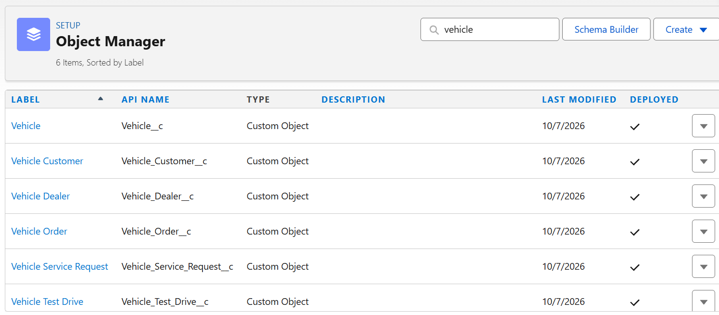

2. Salesforce Development, Backend and Configurations

2.1 Environment Setup and DevOps Workflow
Development was carried out in a Salesforce Developer Edition org using Setup for declarative configuration and the Developer Console for Apex. Work followed the order objects, tabs, app, flows, Apex and scheduling, with each component tested before the next was added.

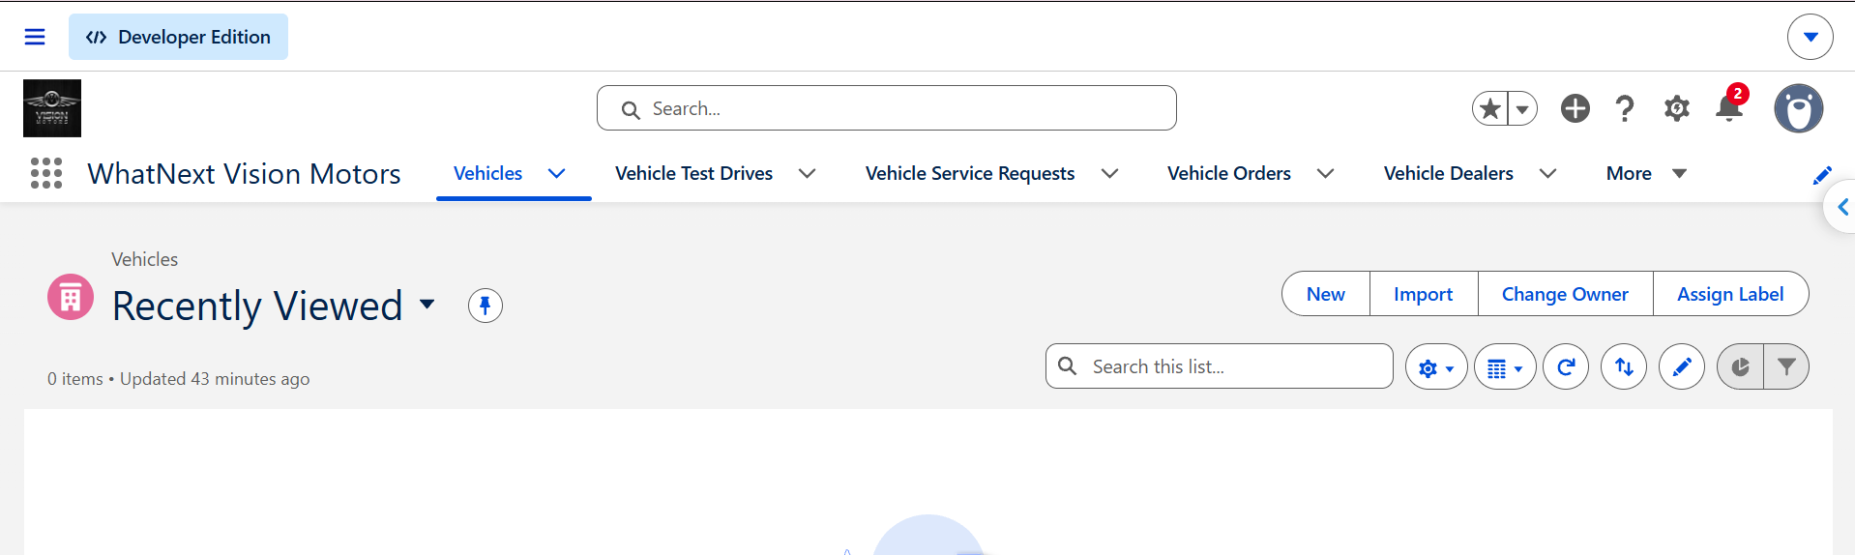

2.2 Objects and Fields
Each object was created with the fields below.
1.Vehicle Object
The Vehicle object stores information about the vehicles available at WhatsNext Vision Motors. It maintains details such as vehicle name, model, price, stock quantity, and availability status. This object helps the company manage vehicle inventory and verify stock availability before processing customer orders.
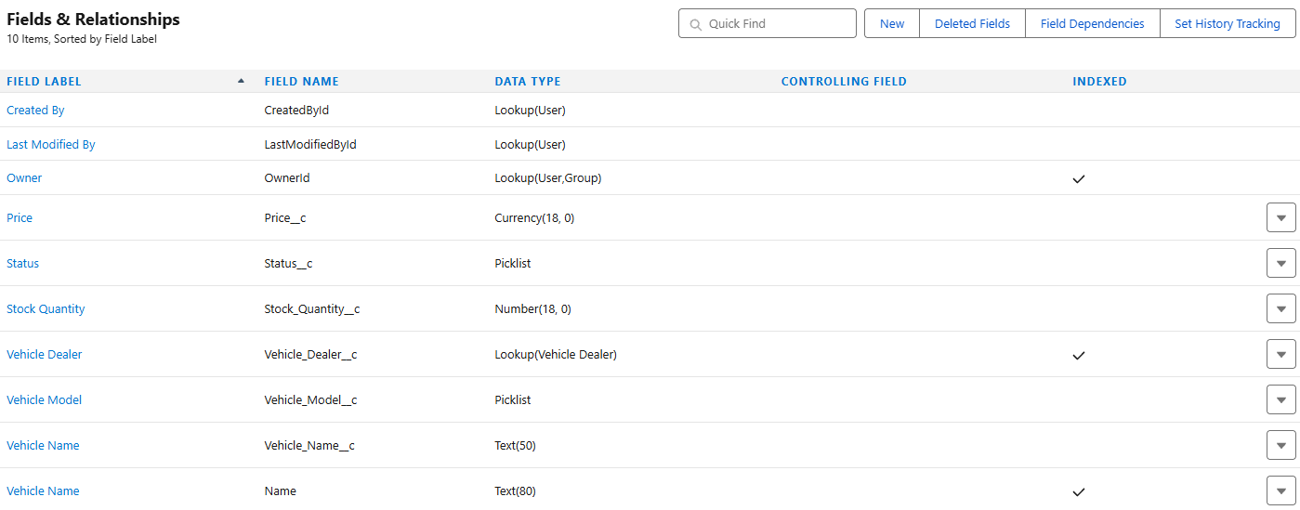

Figure 2.1 Vehicle object fields and relationships.
2. Vehicle Dealer Object
The Vehicle Dealer object stores information about authorized dealers, including dealer name, contact details, address, and location. It helps the system identify suitable dealers and assign customer orders based on the customer's location.
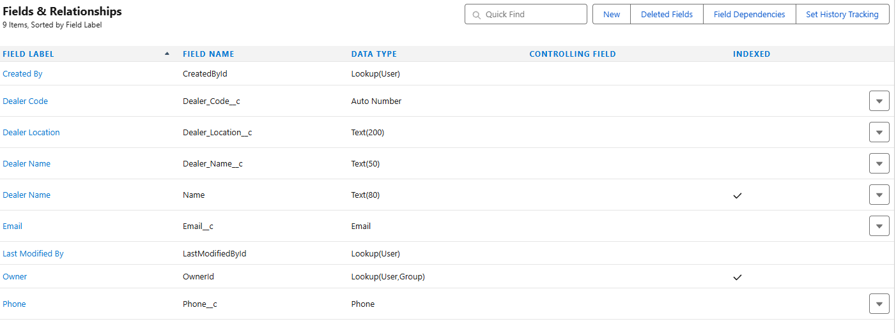

Figure 2.2 Vehicle Dealer object fields.

3. Vehicle Customer Object
The Vehicle Customer object maintains customer information, such as name, email address, phone number, and residential address. It provides a centralized record of customer details, making it easier to manage orders, test-drive bookings, and service requests.
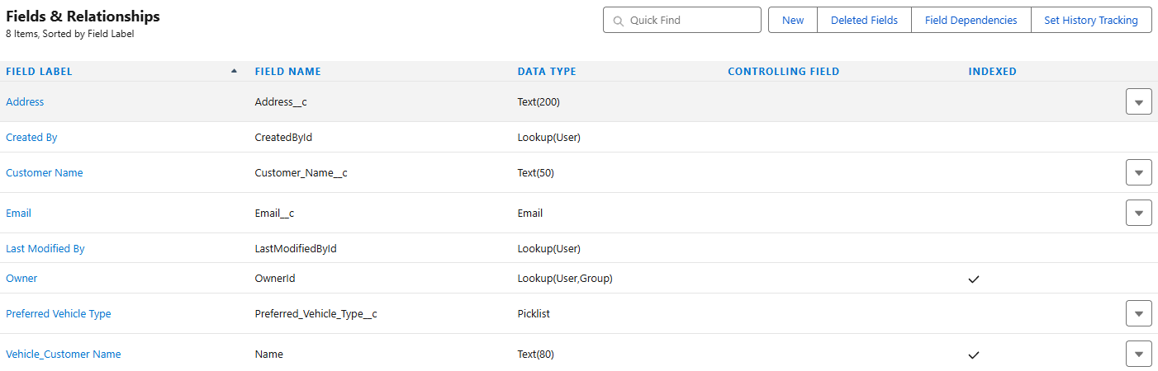

Figure 2.3 Vehicle Customer object fields.

4. Vehicle Order Object
The Vehicle Order object records customer vehicle orders, including the selected vehicle, customer details, assigned dealer, order date, and order status. It helps track the order lifecycle, from placement to confirmation, and supports automated stock validation and order status updates.
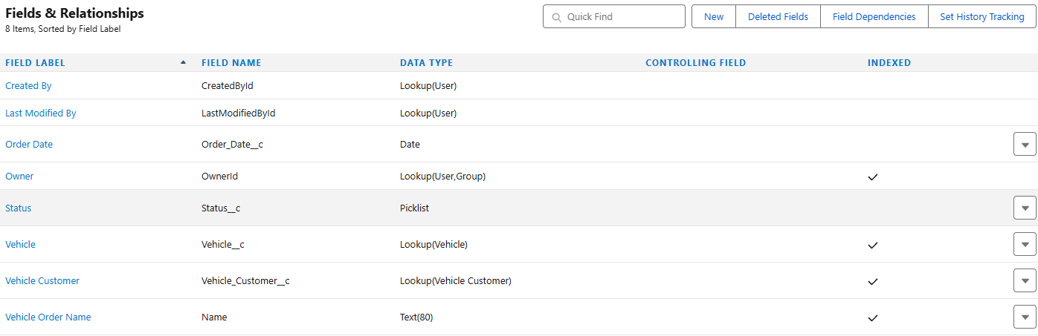

Figure 2.4 Vehicle Order object fields.

5. Test Drive Object
The Test Drive object manages customer test-drive bookings. It stores details such as the customer, selected vehicle, scheduled date and time, and booking status. It also supports automated email reminders to help customers remember their scheduled appointments.
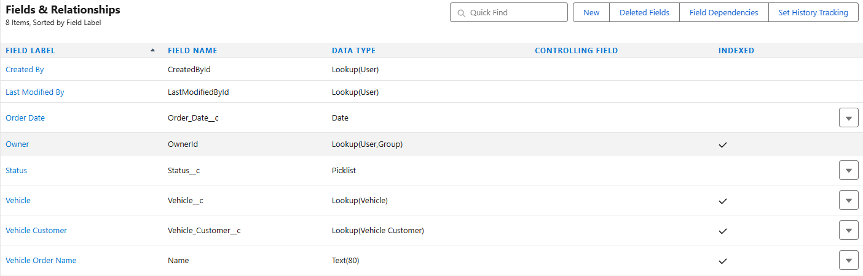

Figure 2.5 Vehicle Test Drive object fields.

6. Vehicle Service Request Object
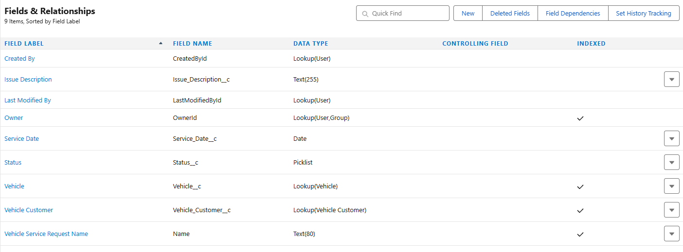
The Service Request object records customer requests related to vehicle servicing and support. It maintains relevant details such as the customer, vehicle, request description, submission date, and service status. This object helps the company organize and track service requests efficiently.

Figure 2.6 Vehicle Service Request object fields.

2.3 Tabs and App Manager
Custom tabs and the Salesforce application configuration provide navigation to the records used by the project. Include only the tabs and application components that have actually been configured.
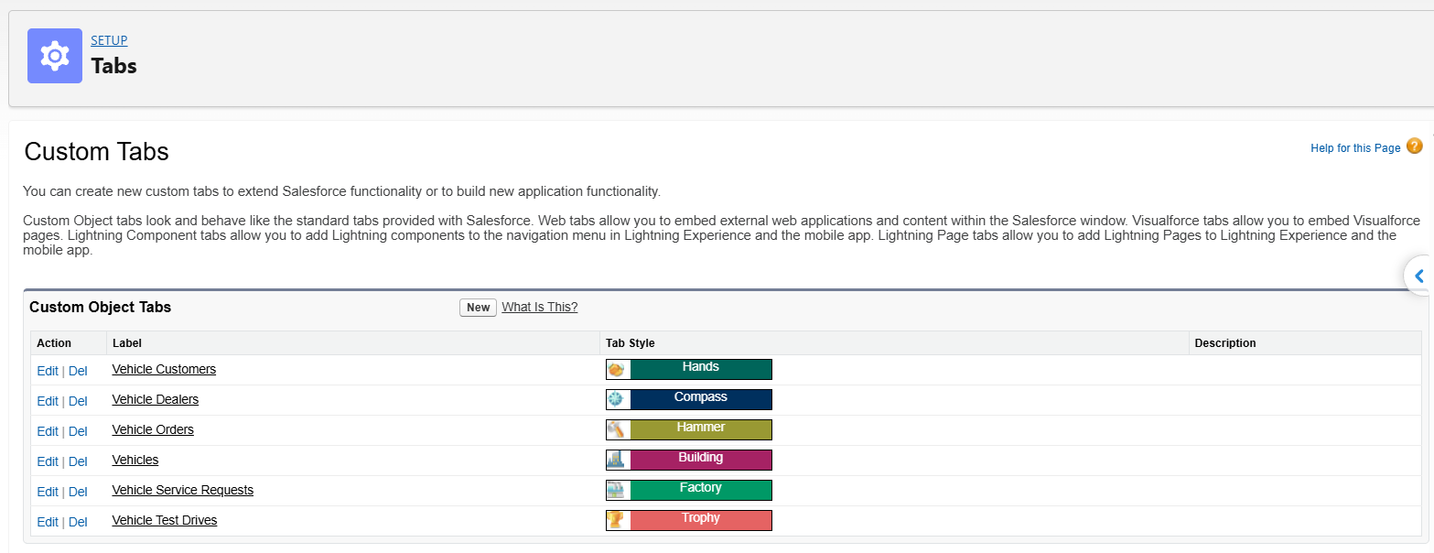

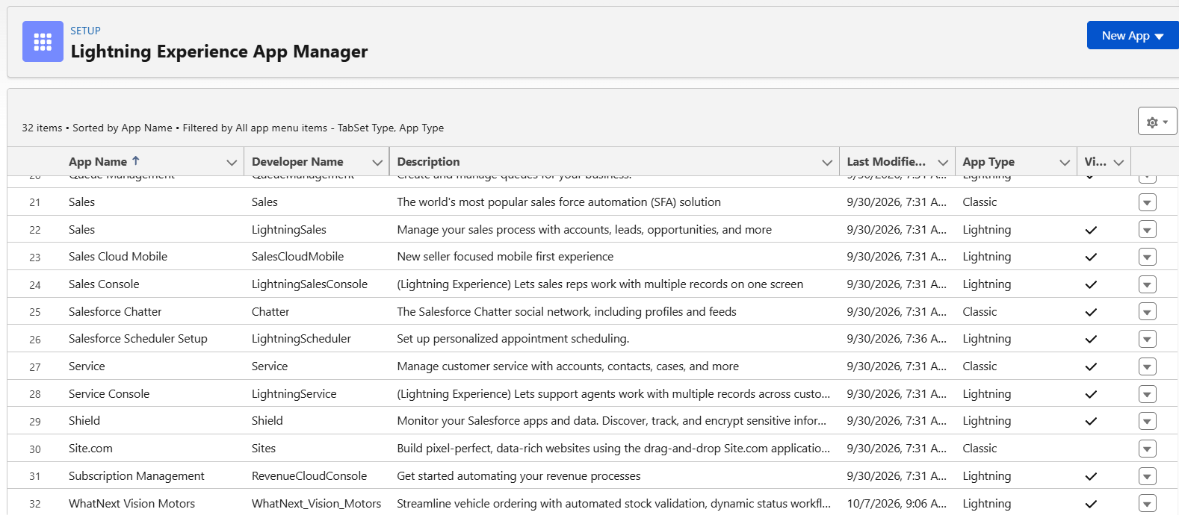

3. AUTOMATION AND APEX DEVELOPMENT

Two record-triggered flows were created. Both are active.
3.1 Auto Assign Dealer Flow
- The Flow is triggered when a Vehicle Order record is created.
- The entry condition checks whether the order status is Pending.
- Get Customer Information retrieves the customer linked to the order.
- Get Nearest Dealer searches for a dealer whose location matches the customer's address.
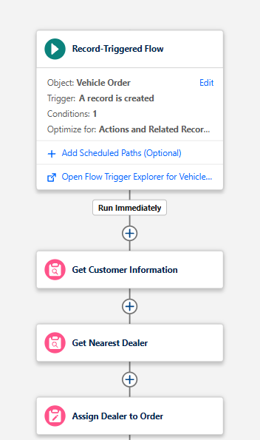
- Assign Dealer to Order updates the matched dealer information.

Figure 3.1 Auto Assign Dealer flow
3.2 Test Drive Reminder Flow
- The Flow runs when a Vehicle Test Drive record is created or updated.
- The entry condition checks whether the test-drive status is Scheduled.
- A scheduled path is configured to run one day before the test-drive date.
- Get Customer Information retrieves the associated customer's details.
- Send Test Drive Reminder sends an email with the subject “Reminder: Your Test Drive is Tomorrow!”
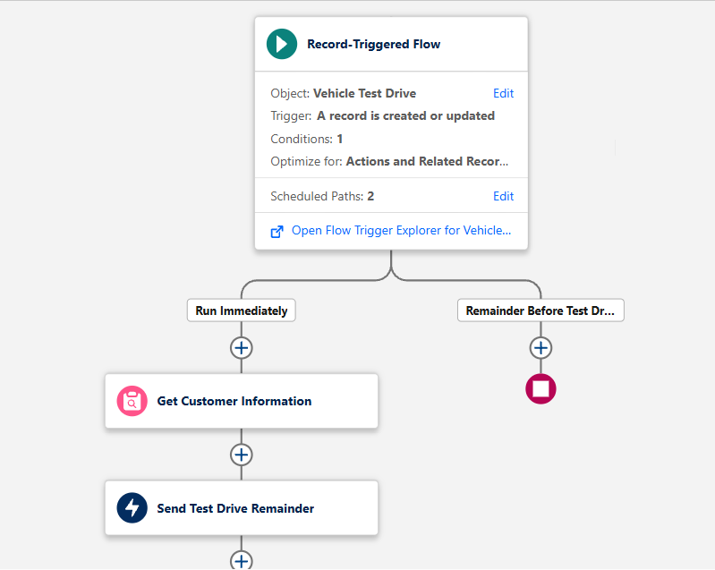

Figure 3.2 Test Drive Reminder flow canvas.

3.3 Apex Classes, Triggers and Asynchronous Apex
Apex is used where stock rules need transactional control and where orders must be processed in bulk. Full source code is in Appendix A.
1. VehicleOrderTrigger
The VehicleOrderTrigger is responsible for handling changes to Vehicle Order records. It executes during before-insert, before-update, after-insert, and after-update events. It calls the VehicleOrderTriggerHandler class to perform stock validation and stock management operations.

2. VehicleOrderTriggerHandler
The VehicleOrderTriggerHandler contains the main business logic for vehicle order processing. It checks the associated vehicle's stock quantity and prevents an order when the stock is zero or less. It also updates the vehicle's stock quantity when an order reaches the Confirmed status, according to the implemented logic.
3. VehicleOrderBatch
The VehicleOrderBatch class uses Batch Apex to process multiple vehicle orders asynchronously. It retrieves Pending orders, checks the stock availability of their associated vehicles, and confirms eligible orders when stock is available. This helps automate order processing for multiple records.
4. VehicleOrderBatchScheduler
The VehicleOrderBatchScheduler class implements Salesforce's Schedulable interface to execute the batch process automatically. It invokes the VehicleOrderBatch class with a batch size of 50, allowing vehicle orders to be processed in manageable groups.
5. Daily Vehicle Order Processing
The Daily Vehicle Order Processing scheduled job is configured to run the batch process daily at midnight using a cron expression. It helps automate the processing of pending vehicle orders without requiring manual execution, provided the job has been scheduled successfully.
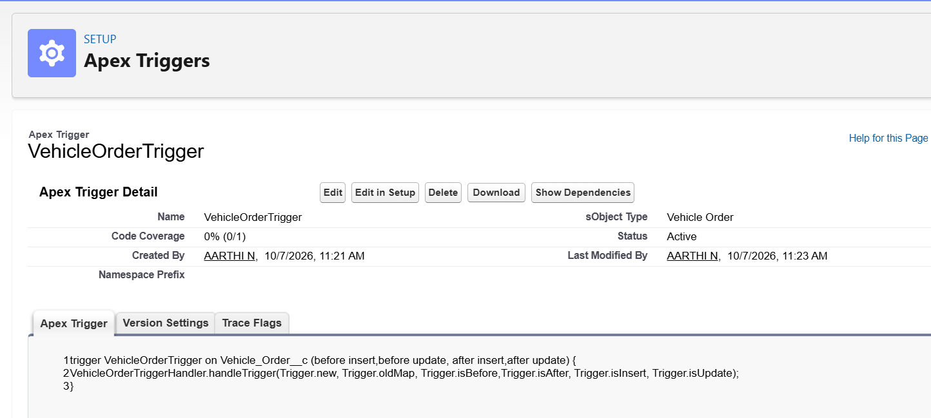

SOURCE CODE:
- VehicleOrderTriggerHandler
public class VehicleOrderTriggerHandler {
public static void handleTrigger(List<Vehicle_Order__c> newOrders,
Map<Id, Vehicle_Order__c> oldOrders,
Boolean isBefore, Boolean isAfter, Boolean isInsert, Boolean isUpdate) {
if (isBefore) {
if (isInsert || isUpdate) {
preventOrderIfOutOfStock(newOrders);
}
if (isAfter) {
if (isInsert || isUpdate) {
updateStockOnOrderPlacement(newOrders);
}
}
}

// Prevent orders when the vehicle is out of stock
private static void preventOrderIfOutOfStock(List<Vehicle_Order__c> orders) {
Set<Id> vehicleIds = new Set<Id>();
for (Vehicle_Order__c order : orders) {
if (order.Vehicle__c != null) {
vehicleIds.add(order.Vehicle__c);
}
}
if (!vehicleIds.isEmpty()) {
Map<Id, Vehicle__c> vehicleStockMap = new Map<Id, Vehicle__c>();
for (Vehicle__c vehicle : [SELECT Id, Stock_Quantity__c FROM Vehicle__c WHERE Id IN :vehicleIds]) {
vehicleStockMap.put(vehicle.Id, vehicle);
}
for (Vehicle_Order__c order : orders) {
if (vehicleStockMap.containsKey(order.Vehicle__c)) {
Vehicle__c vehicle = vehicleStockMap.get(order.Vehicle__c);
if (vehicle.Stock_Quantity__c <= 0) {
order.addError('This vehicle is out of stock. Order cannot be placed.');
}
}
}
}
}

// Update vehicle stock when an order is placed
private static void updateStockOnOrderPlacement(List<Vehicle_Order__c> orders) {
Set<Id> vehicleIds = new Set<Id>();
for (Vehicle_Order__c order : orders) {
if (order.Vehicle__c != null && order.Status__c == 'Confirmed') {
vehicleIds.add(order.Vehicle__c);
}
}
if (!vehicleIds.isEmpty()) {
Map<Id, Vehicle__c> vehicleStockMap = new Map<Id, Vehicle__c>();
for (Vehicle__c vehicle : [SELECT Id, Stock_Quantity__c FROM Vehicle__c WHERE Id IN :vehicleIds]) {
vehicleStockMap.put(vehicle.Id, vehicle);
}
List<Vehicle__c> vehiclesToUpdate = new List<Vehicle__c>();
for (Vehicle_Order__c order : orders) {
if (vehicleStockMap.containsKey(order.Vehicle__c)) {
Vehicle__c vehicle = vehicleStockMap.get(order.Vehicle__c);
if (vehicle.Stock_Quantity__c > 0) {
vehicle.Stock_Quantity__c -= 1;
vehiclesToUpdate.add(vehicle);
}
}
}
if (!vehiclesToUpdate.isEmpty()) {
update vehiclesToUpdate;
}
}
}
}

2. VehicleOrderTrigger
trigger VehicleOrderTrigger on Vehicle_Order__c (before insert, before update, after insert, after update) {
VehicleOrderTriggerHandler.handleTrigger(Trigger.new, Trigger.oldMap, Trigger.isBefore,
Trigger.isAfter, Trigger.isInsert, Trigger.isUpdate);
}

3. VehicleOrderBatch
global class VehicleOrderBatch implements Database.Batchable<sObject> {

global Database.QueryLocator start(Database.BatchableContext bc) {
return Database.getQueryLocator([
SELECT Id, Status__c, Vehicle__c
FROM Vehicle_Order__c
WHERE Status__c = 'Pending'
]);
}

global void execute(Database.BatchableContext bc, List<Vehicle_Order__c> orderList) {
Set<Id> vehicleIds = new Set<Id>();
for (Vehicle_Order__c order : orderList) {
if (order.Vehicle__c != null) {
vehicleIds.add(order.Vehicle__c);
}
}

if (!vehicleIds.isEmpty()) {
Map<Id, Vehicle__c> vehicleStockMap = new Map<Id, Vehicle__c>();
for (Vehicle__c vehicle : [SELECT Id, Stock_Quantity__c FROM Vehicle__c WHERE Id IN :vehicleIds]) {
vehicleStockMap.put(vehicle.Id, vehicle);

List<Vehicle_Order__c> ordersToUpdate = new List<Vehicle_Order__c>();
List<Vehicle__c> vehiclesToUpdate = new List<Vehicle__c>();

for (Vehicle_Order__c order : orderList) {
if (vehicleStockMap.containsKey(order.Vehicle__c)) {
Vehicle__c vehicle = vehicleStockMap.get(order.Vehicle__c);
if (vehicle.Stock_Quantity__c > 0) {
order.Status__c = 'Confirmed';
vehicle.Stock_Quantity__c -= 1;
ordersToUpdate.add(order);
vehiclesToUpdate.add(vehicle);
}
}
}

if (!ordersToUpdate.isEmpty()) {
update ordersToUpdate;
}
if (!vehiclesToUpdate.isEmpty()) {
update vehiclesToUpdate;
}
}
}

global void finish(Database.BatchableContext bc) {
System.debug('Vehicle order batch job completed.');
}
}
4. VehicleOrderBatchScheduler
global class VehicleOrderBatchScheduler implements Schedulable {
global void execute(SchedulableContext sc) {
VehicleOrderBatch batchJob = new VehicleOrderBatch();
Database.executeBatch(batchJob, 50); // 50 is the batch size
}
}

5. Scheduling the batch job (Execute Anonymous)
String cronExp = '0 0 0 * * ?'; // Runs daily at 12:00 AM (midnight)
System.schedule('Daily Vehicle Order Processing', cronExp, new VehicleOrderBatchScheduler());

4. TESTING AND VALIDATION

4.1 Testing Overview
- Testing verifies the functionality of Flows, Apex triggers, and batch processing.
- Vehicle order scenarios are used to validate stock management.
- Dealer assignment is tested using customer and dealer location information.
- Test-drive reminders are checked using scheduled test-drive records.
- Actual outcomes are documented after executing each test.

Test Case | Input / Action | Expected Result
Valid Vehicle Order | Create an order for a vehicle with available stock. | The order is accepted and stock is updated according to the trigger logic.
Out-of-Stock Vehicle | Create an order for a vehicle with zero stock. | The order is rejected with an error message.
Order Update | Update an existing vehicle order. | The configured trigger logic executes.
Dealer Assignment | Create a Pending order with customer location details. | The matching dealer is assigned if the Flow is configured correctly.
Test Drive Reminder | Create or update a Scheduled test drive with a future date. | The reminder email is sent when the scheduled path executes
Batch Processing | Execute the batch with eligible vehicle orders. | Orders are processed according to the batch logic.
Scheduled Execution | Run or wait for the scheduled Apex job. | The scheduler invokes the batch process successfully

Conclusion
The WhatsNext Vision Motors CRM meets the goals set at the start of the project. It stores vehicle, dealer, customer, order, test drive and service request data in a connected model, and presents it through a Lightning app. Dealer assignment and test drive reminders are automated with flows, orders for out-of-stock vehicles are blocked by an Apex trigger, and Pending orders are confirmed by a scheduled batch job when stock returns. Together these features give customers a faster and more transparent ordering experience and reduce manual work for staff. The project also gave practical experience in data modelling, Flow Builder, Apex triggers, batch Apex and scheduled Apex.

Future Enhancements
- Chatbot integration so customers can book test drives and check order status in conversation.
- AI suggestions, for example Einstein recommendations for vehicles based on a customer's preferred type.
- Map-based nearest dealer search using a Geolocation field or distance calculation, in place of exact text matching.
- Reduce stock only when an order's status changes to Confirmed, by comparing with the previous value, to avoid repeated deductions when a confirmed order is edited.
- Avoid duplicate vehicle records in the batch job's update list by using a map keyed by record Id.
- Email notifications for stock replenishment and order processing from the batch job.
- Lightning Web Components for a customer-facing order and test drive booking page.
- Dashboards for orders by status, stock by dealer and service request volume.

