**WEB TECHNOLOGY AND MOBILE APPLICATIONS**

**ASSIGNMENT 3**

**AIM :**

To create a **web page** that displays **"Hello, World!"** inside a **decorative box** centered on the screen using **HTML & CSS**.

# ALGORITHM :

## Start

1. Open NetBeansand create a new web project.
2. In the Web Pagesfolder, create or edit the index.html file.
3. Add HTML structurewith a heading inside a <div> box.
4. Apply CSS stylesto:
   * Center the box on the page.
   * Add a background gradient.
   * Style the box with border, shadow, and animation.
5. Save the file.
6. Run the project in NetBeans.
7. Open a browser and visit
8. The page should display "Hello, World!"in a stylish box.

## End CODE:

<!DOCTYPE html>

<html>

<head>

<title>Hello World</title>

<meta charset="UTF-8">

<meta name="viewport" content="width=device-width, initial-scale=1.0">

<style>

/* Full-page styling */ body {

display: flex;

justify-content: center; align-items: center;

height: 100vh;

background: linear-gradient(135deg, #ff9a9e, #fad0c4); margin: 0;

font-family: Arial, sans-serif;

}

/* Stylish box */

.box {

background: white; padding: 30px 50px; border-radius: 15px;

box-shadow: 0px 10px 20px rgba(0, 0, 0, 0.2); text-align: center;

font-size: 28px; font-weight: bold; color: #333;

border: 5px solid #ff6b81; position: relative;

animation: fadeIn 1.5s ease-in-out;

}

/* Glowing Effect */

.box:hover {

box-shadow: 0px 0px 20px rgba(255, 107, 129, 0.8); transition: 0.3s;

}

/* Animation */ @keyframes fadeIn {

from {

opacity: 0;

transform: translateY(-20px);

}

to {

opacity: 1;

transform: translateY(0);

}

}

</style>

</head>

<body>

<div class="box">✨ Hello, World! ✨</div>

</body>

</html>

# OUTPUT :

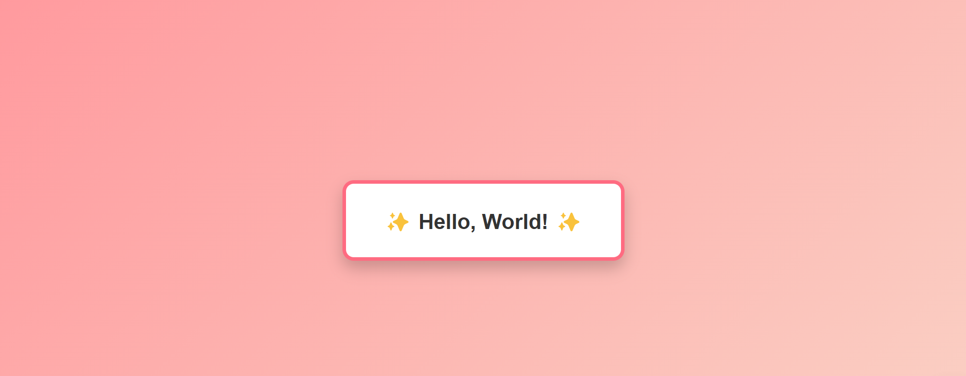

**RESULT :**

Thus, Servlet program to execute “Hello World” ­­­­­­­­­­­­­­­­­­­­­­­­was completed successfully.