**Latches**

There are two types of memory elements based on the type of triggering that is suitable to operate it.

* Latches
* Flip-flops

Latches operate with enable signal, which is **level sensitive**. Whereas, flip-flops are edge sensitive. We will discuss about flip-flops in next chapter. Now, let us discuss about SR Latch & D Latch one by one.

## SR Latch

SR Latch is also called as **Set Reset Latch**. This latch affects the outputs as long as the enable, E is maintained at ‘1’. The **circuit diagram** of SR Latch is shown in the following figure.

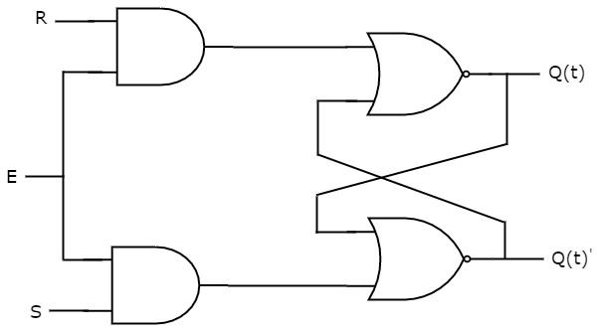

This circuit has two inputs S & R and two outputs Q(t) & Q(t)’. The **upper NOR gate** has two inputs R & complement of present state, Q(t)’ and produces next state, Q(t+1) when enable, E is ‘1’.

Similarly, the **lower NOR gate** has two inputs S & present state, Q(t) and produces complement of next state, Q(t+1)’ when enable, E is ‘1’.

We know that a **2-input NOR gate** produces an output, which is the complement of another input when one of the input is ‘0’. Similarly, it produces ‘0’ output, when one of the input is ‘1’.

* If S=1, then next state Q(t+1) will be equal to ‘1’ irrespective of present state, Q(t) values.
* If R=1, then next state Q(t+1) will be equal to ‘0’ irrespective of present state, Q(t) values.

At any time, only of those two inputs should be ‘1’. If both inputs are ‘1’, then the next state Q(t+1) value is undefined.

The following table shows the **state table** of SR latch.

|  |  |  |
| --- | --- | --- |
| **S** | **R** | **Q(t+1)** |
| 0 | 0 | Q(t) |
| 0 | 1 | 0 |
| 1 | 0 | 1 |
| 1 | 1 | - |

Therefore, SR Latch performs three types of functions such as Hold, Set & Reset based on the input conditions.

## D Latch

There is one drawback of SR Latch. Tha t is the next state value can’t be predicted when both the inputs S & R are one. So, we can bovercome this difficulty by D Latch. It is also called as Data Latch. The **circuit diagram** of D Latch is shown in the following figure.

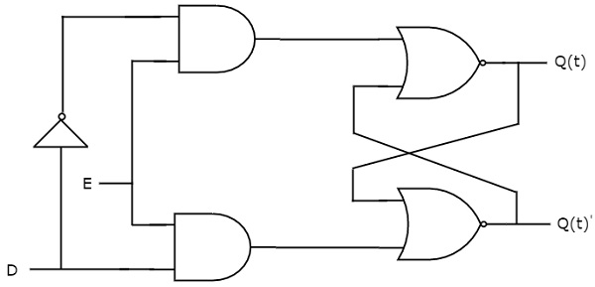

This circuit has single input D and two outputs Q(t) & Q(t)’. D Latch is obtained from SR Latch by placing an inverter between S amp;& R inputs and connect D input to S. That means we eliminated the combinations of S & R are of same value.

* If D=0 → S=0 & R=1, then next state Q(t+1) will be equal to ‘0’ irrespective of present state, Q(t) values. This is corresponding to the second row of SR Latch state table.
* If D=1 → S=1 & R=0, then next state Q(t+1) will be equal to ‘1’ irrespective of present state, Q(t) values. This is corresponding to the third row of SR Latch state table.

The following table shows the **state table** of D latch.

|  |  |
| --- | --- |
| **D** | **Q(t+1)** |
| 0 | 0 |
| 1 | 1 |

Therefore, D Latch Hold the information that is available on data input, D. That means the output of D Latch is sensitive to the changes in the input, D as long as the enable is High.

**Flip-Flops**

We can implement flip-flops in two methods.

In first method, **cascade two latches** in such a way that the first latch is enabled for every positive clock pulse and second latch is enabled for every negative clock pulse. So that the combination of these two latches become a flip-flop.

In second method, we can directly implement the flip-flop, which is edge sensitive. In this chapter, let us discuss the following **flip-flops** using second method.

* SR Flip-Flop
* D Flip-Flop
* JK Flip-Flop
* T Flip-Flop

## SR Flip-Flop

SR flip-flop operates with only positive clock transitions or negative clock transitions. Whereas, SR latch operates with enable signal. The **circuit diagram** of SR flip-flop is shown in the following figure.

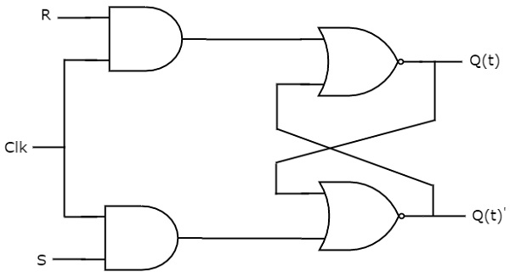

This circuit has two inputs S & R and two outputs Q(t) & Q(t)’. The operation of SR flipflop is similar to SR Latch. But, this flip-flop affects the outputs only when positive transition of the clock signal is applied instead of active enable.

The following table shows the **state table** of SR flip-flop.

|  |  |  |
| --- | --- | --- |
| **S** | **R** | **Q(t+1)** |
| 0 | 0 | Q(t+1) |
| 0 | 1 | 0 |
| 1 | 0 | 1 |
| 1 | 1 | - |

Here, Q(t) & Q(t+1) are present state & next state respectively. So, SR flip-flop can be used for one of these three functions such as Hold, Reset & Set based on the input conditions, when positive transition of clock signal is applied. The following table shows the **characteristic table** of SR flip-flop.

|  |  |  |  |
| --- | --- | --- | --- |
| **Present Inputs** | | **Present State** | **Next State** |
| **S** | **R** | **Q(t)** | **Q(t+1)** |
| 0 | 0 | 0 | 0 |
| 0 | 0 | 1 | 1 |
| 0 | 1 | 0 | 0 |
| 0 | 1 | 1 | 0 |
| 1 | 0 | 0 | 1 |
| 1 | 0 | 1 | 1 |
| 1 | 1 | 0 | x |
| 1 | 1 | 1 | x |

By using three variable K-Map, we can get the simplified expression for next state, Q(t+1). The **three variable K-Map** for next state, Q(t+1) is shown in the following figure.

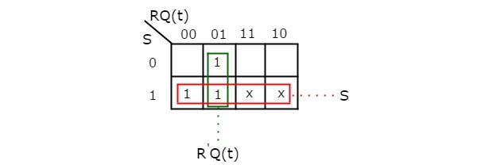

The maximum possible groupings of adjacent ones are already shown in the figure. Therefore, the **simplified expression** for next state Q(t+1) is

Q(t+1)=S+R′Q(t)Q(t+1)=S+R′Q(t)

## D Flip-Flop

D flip-flop operates with only positive clock transitions or negative clock transitions. Whereas, D latch operates with enable signal. That means, the output of D flip-flop is insensitive to the changes in the input, D except for active transition of the clock signal. The **circuit diagram** of D flip-flop is shown in the following figure.

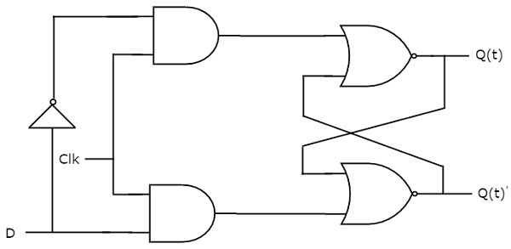

This circuit has single input D and two outputs Q(t) & Q(t)’. The operation of D flip-flop is similar to D Latch. But, this flip-flop affects the outputs only when positive transition of the clock signal is applied instead of active enable.

The following table shows the **state table** of D flip-flop.

|  |  |
| --- | --- |
| **D** | **Q(t+1)** |
| 0 | 0 |
| 0 | 1 |

Therefore, D flip-flop always Hold the information, which is available on data input, D of earlier positive transition of clock signal. From the above state table, we can directly write the next state equation as

Q(t+1)=D

Next state of D flip-flop is always equal to data input, D for every positive transition of the clock signal. Hence, D flip-flops can be used in registers, **shift registers** and some of the counters.

## JK Flip-Flop

JK flip-flop is the modified version of SR flip-flop. It operates with only positive clock transitions or negative clock transitions. The **circuit diagram** of JK flip-flop is shown in the following figure.

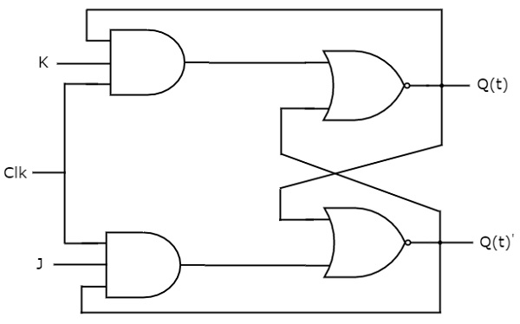

This circuit has two inputs J & K and two outputs Q(t) & Q(t)’. The operation of JK flip-flop is similar to SR flip-flop. Here, we considered the inputs of SR flip-flop as **S=J Q(t)’** and **R=KQ(t)** in order to utilize the modified SR flip-flop for 4 combinations of inputs.

The following table shows the **state table** of JK flip-flop.

|  |  |  |
| --- | --- | --- |
| **J** | **K** | **Q(t+1)** |
| 0 | 0 | Q(t) |
| 0 | 1 | 0 |
| 1 | 0 | 1 |
| 1 | 1 | Q(t)' |

Here, Q(t) & Q(t+1) are present state & next state respectively. So, JK flip-flop can be used for one of these four functions such as Hold, Reset, Set & Complement of present state based on the input conditions, when positive transition of clock signal is applied. The following table shows the **characteristic table** of JK flip-flop.

|  |  |  |  |
| --- | --- | --- | --- |
| **Present Inputs** | | **Present State** | **Next State** |
| **J** | **K** | **Q(t)** | **Q(t+1)** |
| 0 | 0 | 0 | 0 |
| 0 | 0 | 1 | 1 |
| 0 | 1 | 0 | 0 |
| 0 | 1 | 1 | 0 |
| 1 | 0 | 0 | 1 |
| 1 | 0 | 1 | 1 |
| 1 | 1 | 0 | 1 |
| 1 | 1 | 1 | 0 |

By using three variable K-Map, we can get the simplified expression for next state, Q(t+1). **Three variable K-Map** for next state, Q(t+1) is shown in the following figure.

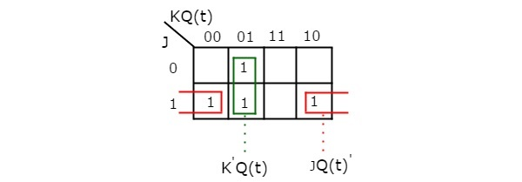

The maximum possible groupings of adjacent ones are already shown in the figure. Therefore, the **simplified expression** for next state Q(t+1) is

Q(t+1)=JQ(t)′+K′Q(t)Q(t+1)=JQ(t)′+K′Q(t)

## T Flip-Flop

T flip-flop is the simplified version of JK flip-flop. It is obtained by connecting the same input ‘T’ to both inputs of JK flip-flop. It operates with only positive clock transitions or negative clock transitions. The **circuit diagram** of T flip-flop is shown in the following figure.

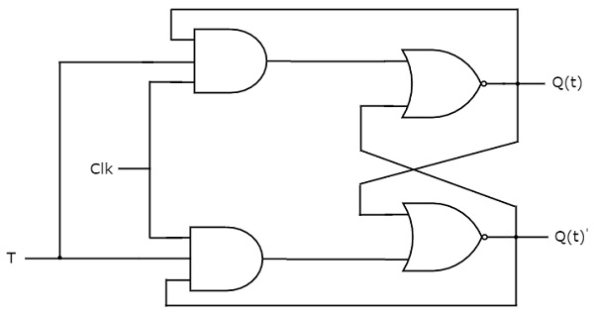

This circuit has single input T and two outputs Q(t) & Q(t)’. The operation of T flip-flop is same as that of JK flip-flop. Here, we considered the inputs of JK flip-flop as **J=T** and **K=T** in order to utilize the modified JK flip-flop for 2 combinations of inputs. So, we eliminated the other two combinations of J & K, for which those two values are complement to each other in T flip-flop.

The following table shows the **state table** of T flip-flop.

|  |  |
| --- | --- |
| **D** | **Q(t+1)** |
| 0 | Q(t) |
| 1 | Q(t)’ |

Here, Q(t) & Q(t+1) are present state & next state respectively. So, T flip-flop can be used for one of these two functions such as Hold, & Complement of present state based on the input conditions, when positive transition of clock signal is applied. The following table shows the **characteristic table** of T flip-flop.

|  |  |  |
| --- | --- | --- |
| **Inputs** | **Present State** | **Next State** |
| **T** | **Q(t)** | **Q(t+1)** |
| 0 | 0 | 0 |
| 0 | 1 | 1 |
| 1 | 0 | 1 |
| 1 | 1 | 0 |

From the above characteristic table, we can directly write the **next state equation** as

Q(t+1)=T′Q(t)+TQ(t)′Q(t+1)=T′Q(t)+TQ(t)′

⇒Q(t+1)=T⊕Q(t)⇒Q(t+1)=T⊕Q(t)

The output of T flip-flop always toggles for every positive transition of the clock signal, when input T remains at logic High (1). Hence, T flip-flop can be used in **counters**.

In this chapter, we implemented various flip-flops by providing the cross coupling between NOR gates. Similarly, you can implement these flip-flops by using NAND gates.