INTRODUCTION:
Overview:
Techpro solution, an it services utilizes ZHOHO books to efficiently manage their client billing and invoicing. They track project expenses, record bilable hours, and generate professional invoices using Zoho books. The software helps them streamline their financial processes and provides insights into their profitabiloity. TeachPro solutions is a private limited company also registered under GST in tamil nadu. TechPro solution offers various expert IT consulting services in India and outside India.
PURPOSES:
While using Zoho books, we learnt about cloud based Accountingsystem. It can be access at Anytime at Anywhere at we needed. We can directly link bank account in an Zoho book.
The main purpose of the Zoho book is a Single secure location to keep up with your company’s bills and invoices, reconcile your Bank statements control your spending. Oversee projects, and elimate GST compliance worries.
Problem definition and design thinking:
Empathy map:

Ideation and brainstorming

Result:
Balance sheet(output)

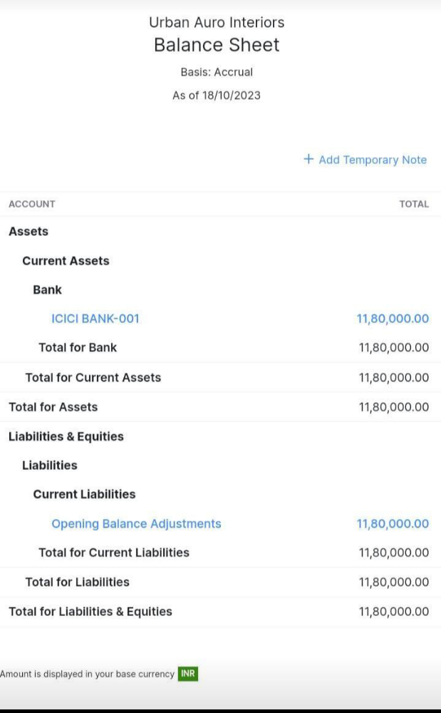
Profit and loss(output)

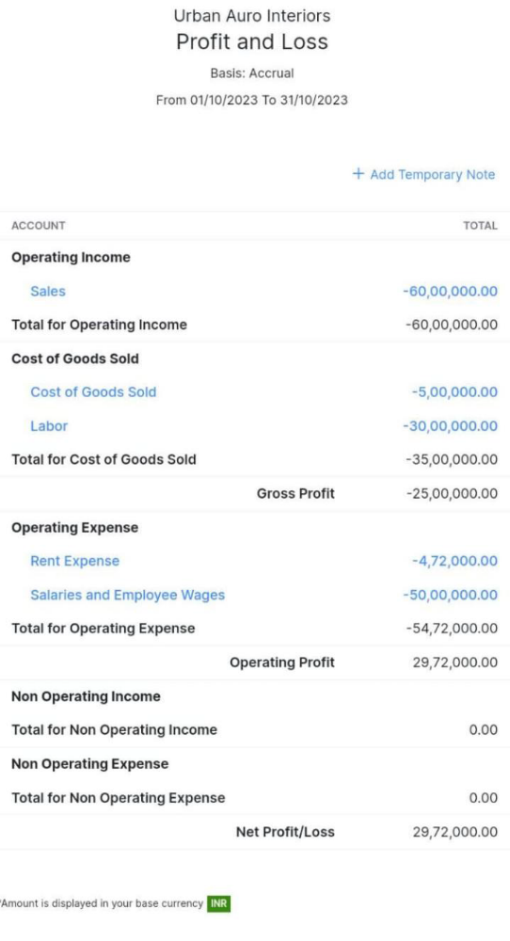

Advantages and disadvantages:
Advantages:
- We learned about business organization.
- We learnt about business transaction
- We learned about GST reports and files.
- We learned about business Accounting system.
Disadvantages:
- We faces more tackles and difficult.
- We face a lot of mental depression.
- There was a time barrior at out work.
- At the beginning of the project, we have no clarity.
- There is a lot of network issue
.
APPLICATION:
WE HAD LEARNED THE ENTIRE PROCESS OF THE Zoho books like creating vendors, creating customers ,bills, invoice,etc.

