Sliding Puzzle Game Application

Test Plan *Template* & Testcases)

Version 1.0

07/15/2017

VERSION HISTORY

|  |  |  |  |  |  |
| --- | --- | --- | --- | --- | --- |
| **Version #** | **Implemented**  **By** | **Revision**  **Date** | **Approved**  **By** | **Approval**  **Date** | **Reason** |
| 1.0 | *Round Rock team* | *07/25/17* |  |  | Test Plan Template draft |
| 2.0 | *Round Rock team* | *08/2/17* |  |  | Updated test cases |
| 3.0 | *Round Rock team* | *08/9/17* |  |  | Updated test case screenshots |

TABLE OF CONTENTS

1 Introduction 6

1.1 Purpose of The Test Plan Document 6

2 COMPATIBILITY Testing 6

2.1 Items to be Tested / Not Tested 6

2.2 Test Approach(s) 6

2.3 Test Pass / Fail Criteria 6

2.4 Test Entry / Exit Criteria 6

3 Functional Testing 7

3.1 Test Risks / Issues 7

3.2 Items to be Tested / Not Tested 7

3.3 Test Approach 7

3.4 Test cases 7

3.4.1 Account Registration 7

3.4.2 Login 8

3.4.3 Logout 9

3.4.4 New Game 10

3.4.5 Solve 11

3.4.6 Save 12

3.4.7 Check Valid/invalid steps; 13

4 Unit Testing 15

4.1 Test Risks / Issues 15

4.2 Items to be Tested / Not Tested 15

4.3 Test Approach(s) **Error! Bookmark not defined.**

4.4 Test Regulatory / Mandate Criteria 15

4.5 Test Pass / Fail Criteria 15

4.6 Test Entry / Exit Criteria **Error! Bookmark not defined.**

4.7 Test Deliverables 15

4.8 Test Suspension / Resumption Criteria **Error! Bookmark not defined.**

4.9 Test Environmental / Staffing / Training Needs **Error! Bookmark not defined.**

5 User Acceptance Testing 15

5.1 Items to be Tested 15

6 Conclusion: 16

# Introduction

## Purpose of The Test Plan Template Document

The Test Plan Template document documents and tracks the necessary information required to effectively define the approach to be used in the testing of end product. This document is created during the Planning Phase of the project and is leveraged when building test cases.

# COMPATIBILITY Testing

## Items to be Tested / Not Tested

|  |  |  |  |
| --- | --- | --- | --- |
| **Item to Test** | **Test Description** | **Test Date** | **Responsibility** |
| execute game in laptop | execute game in laptop with windows 10 | 8/2/2017 | IT Team |
| Execute game in mobile | Execute game in mobile with windows operating system 10 | 8/2/2017 | IT Team |
|  |  |  |  |

## Test Approach(s)

By executing the compatibility test cases we validate that application can be deployed and played in both mobile and laptops.

## Test Pass / Fail Criteria

Success criteria: User should successfully play game in both mobile and desktop editions of windows operating systems.

Fail criteria: If user is unable to play any of the functionality described in SRS, the test deemed as failed.

## Test Entry / Exit Criteria

Entry criteria: Deploy the application, complete the registration and play the game.

Exit criteria: User plays the game successfully.

# Functional Testing

## Test Risks / Issues

If the system is not connected to internet, the test cases related to login and registration would fail.

## Items to be Tested / Not Tested

|  |  |  |  |  |  |  |
| --- | --- | --- | --- | --- | --- | --- |
| **No.** | **Item to Test** | | **Test Description** | **Test Date** | **Responsibility** | |
| 1 | Account Registration | Validate if the user is able to complete Account registration process | | 8/2/2017 | | IT Team |
| 2 | Login | Validate if the user is able to complete Account registration process | | 8/2/2017 | | IT Team |
| 3 | Logout | Validate if the user is able to complete logout process | | 8/2/2017 | | IT Team |
| 4 | Solve | Validate Solve functionality | | 8/9/2017 | | IT Team |
| 5 | Save | Validate Save functionality | | 8/9/2017 | | IT Team |
| 6 | New Game | Validate New Game functionality | | 8/9/2017 | | IT Team |
| 7 | Allowed Steps | Check Valid/Invalid steps | | 8/9/2017 | | IT Team |

## Test Approach

Deploy the application on the emulators before testing the application on actual device. After completion of emulator testing, game is deployed on a device and validate all scenarios again.

## Test cases

### Account Registration

|  |  |  |  |
| --- | --- | --- | --- |
| **Execution step** | **Expected output** | **Actual output** | **PASS/ FAIL** |
| START |  |  |  |
| Execute application to start the game | Game login screen is displayed | Login Screen displayed | Pass |
| Fill in required details and hit “Register” | User is created in database and game home page is displayed | Register and move to game screen | Pass |
| END |  |  |  |

Registration Screenshots

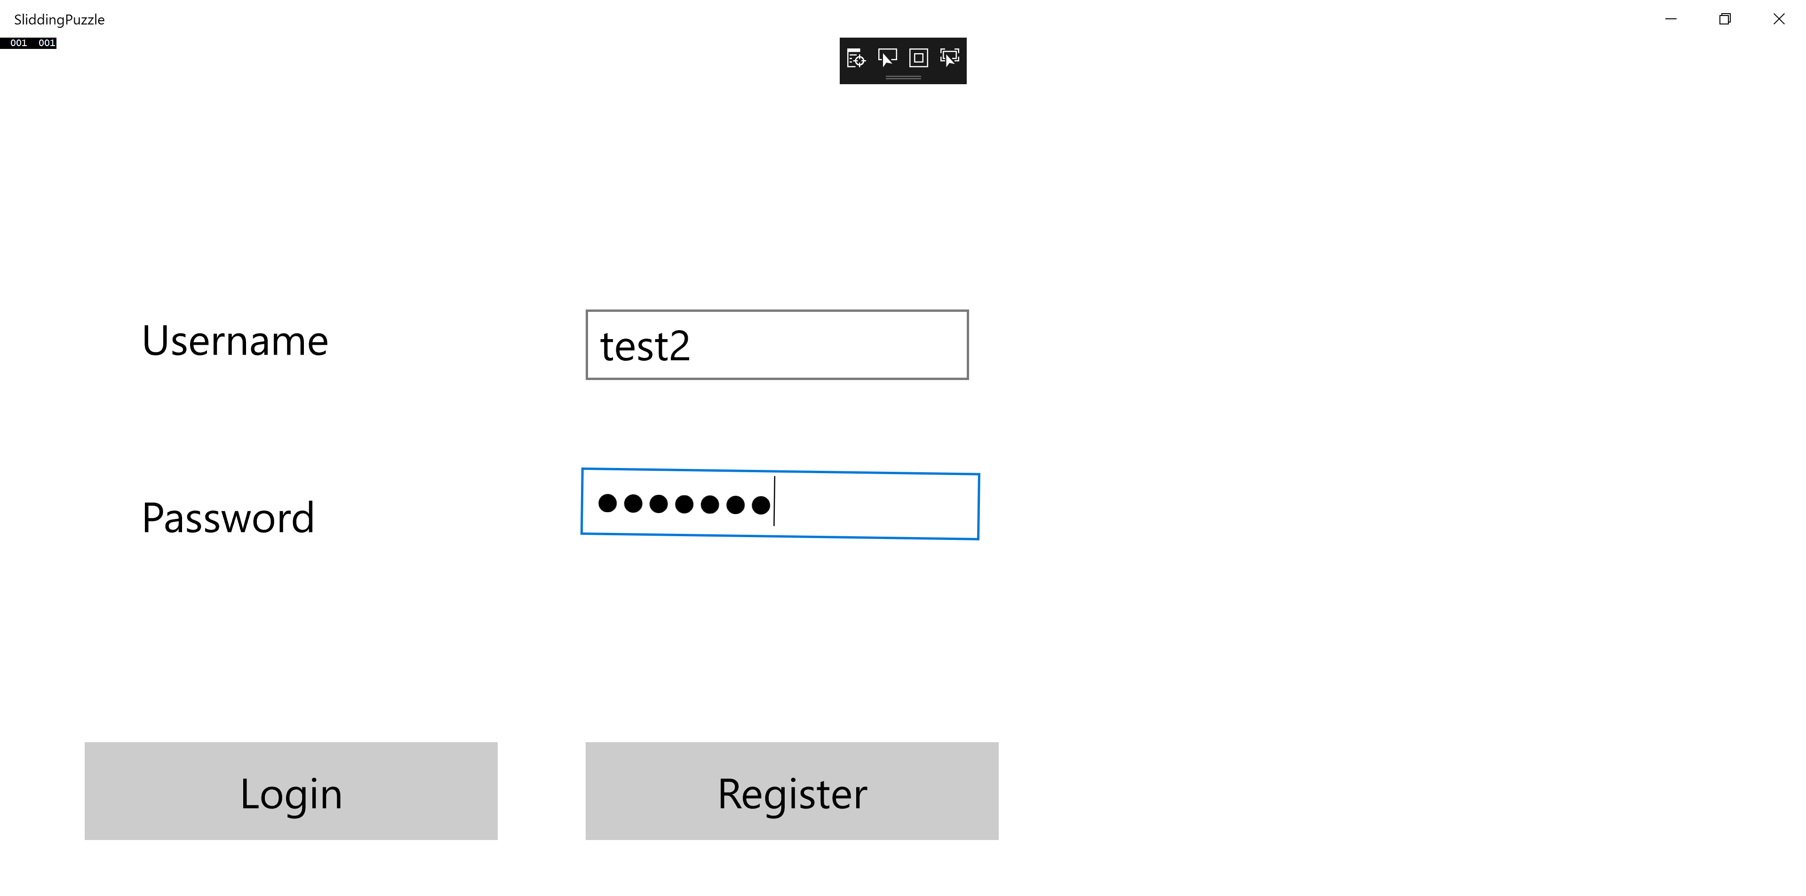

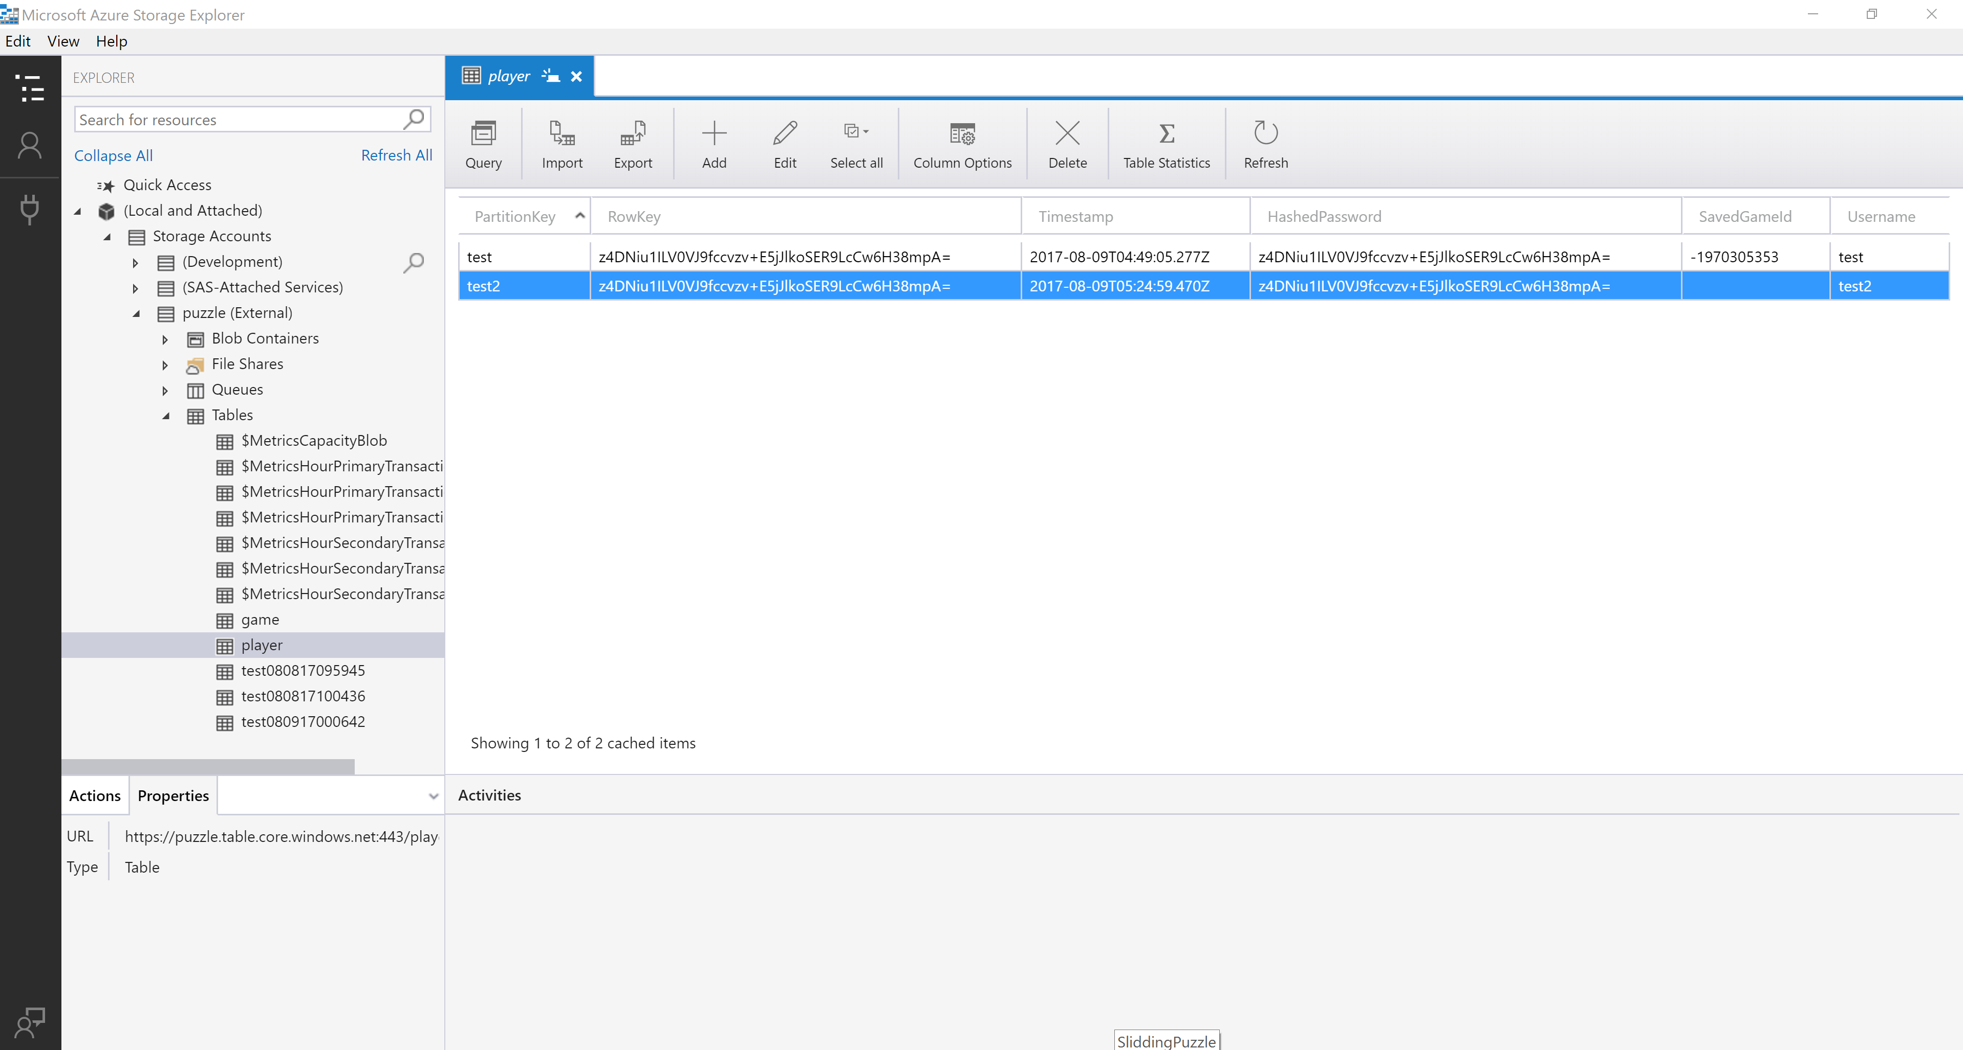

### Login

|  |  |  |  |
| --- | --- | --- | --- |
| **Execution step** | **Expected output** | **Actual output** | **PASS/ FAIL** |
| START |  |  |  |
| Execute application to start the game | Game login screen is displayed | Login Screen displayed | Pass |
| Fill in required details and hit “Login” | If existing user, previous session of the game is displayed | Go to game screen | Pass |
| END |  |  |  |
|  |  |  |  |

Login Screenshots

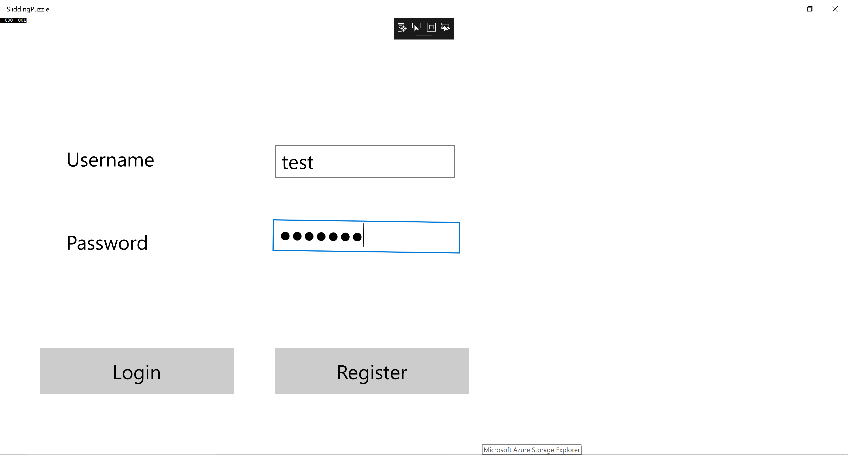

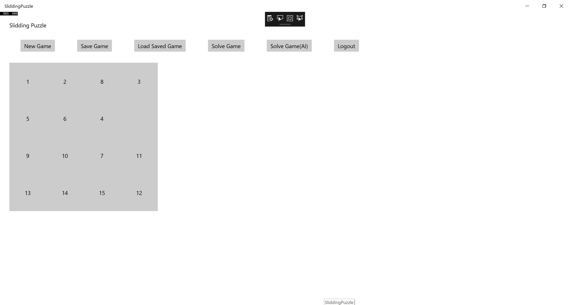

### Logout

|  |  |  |  |
| --- | --- | --- | --- |
| **Execution step** | **Expected output** | **Actual output** | **PASS/FAIL** |
| START |  |  |  |
| Execute application to start the game | Game login screen is displayed | Login Screen displayed | Pass |
| complete login functionality | User is successfully logged in | Go to game screen | Pass |
| Click logout button | User is logged out and a login button is displayed. | Login page displayed | Pass |
| END |  |  |  |

Logout screenshots



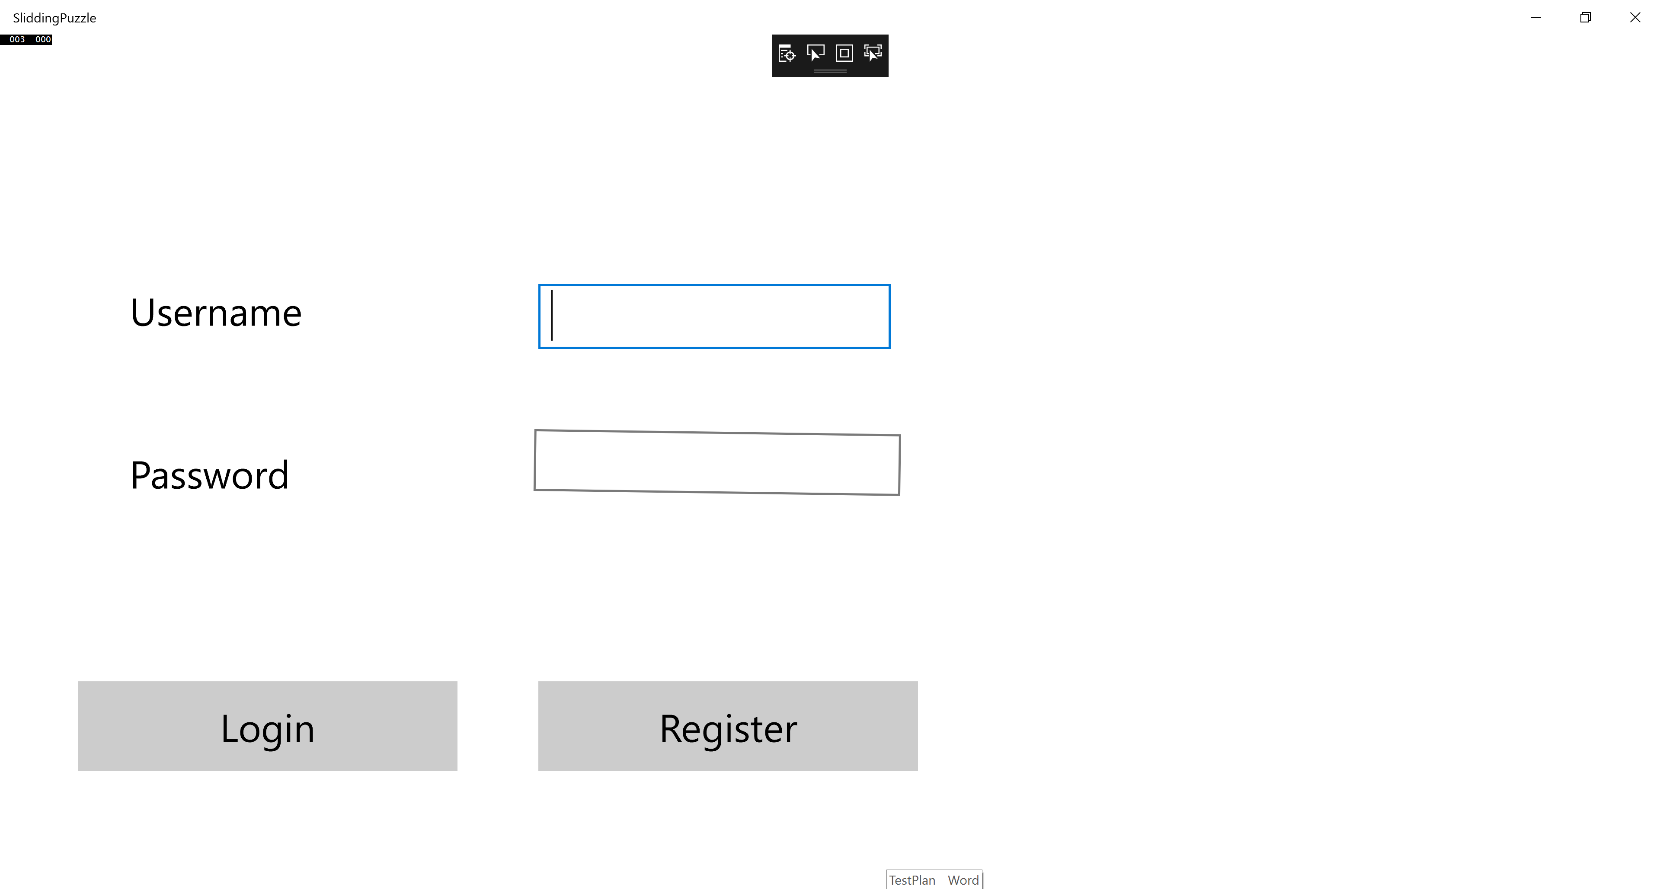

### New Game

|  |  |  |  |
| --- | --- | --- | --- |
| Execution step | Expected output | Actual output | PASS/FAIL |
| START |  |  |  |
| Execute application to start the game | Game login screen is displayed | Login displayed | Pass |
| Click New game button to start a new game | New game shall be started | New game started | Pass |
| END |  |  |  |

New Game screenshots

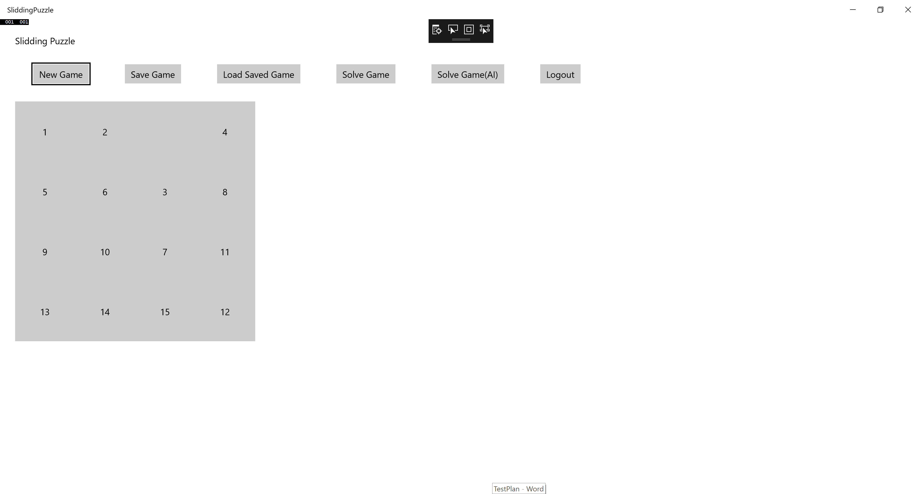

### Solve

|  |  |  |  |
| --- | --- | --- | --- |
| Execution step | Expected output | Actual output | PASS/FAIL |
| START |  |  |  |
| Execute application to start the game | Game login screen is displayed | Login displayed | Pass |
| Click New game button to start a new game | New game shall be started | New game started | Pass |
| Play the game for few steps | User shall be able to slide the numbers based on the expected moves | Able to move | Pass |
| Click solve | Game would revert to initial state and numbers shall start sliding to re organize in ascending order. | Solved in pop-up screen | Pass |
| END |  |  |  |

Solve Screenshot

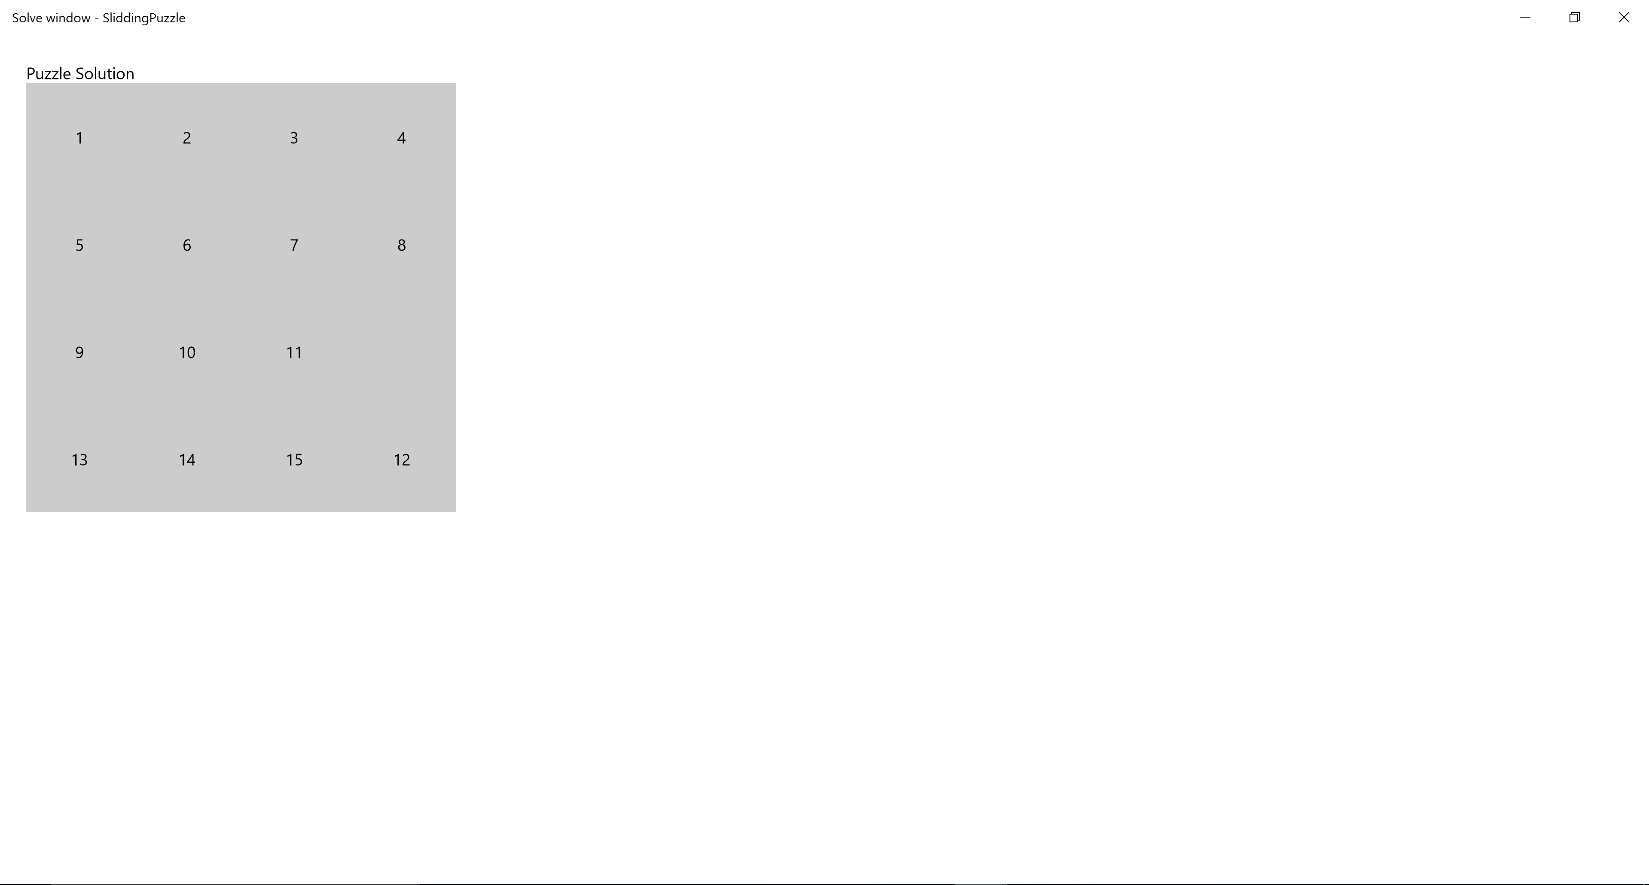

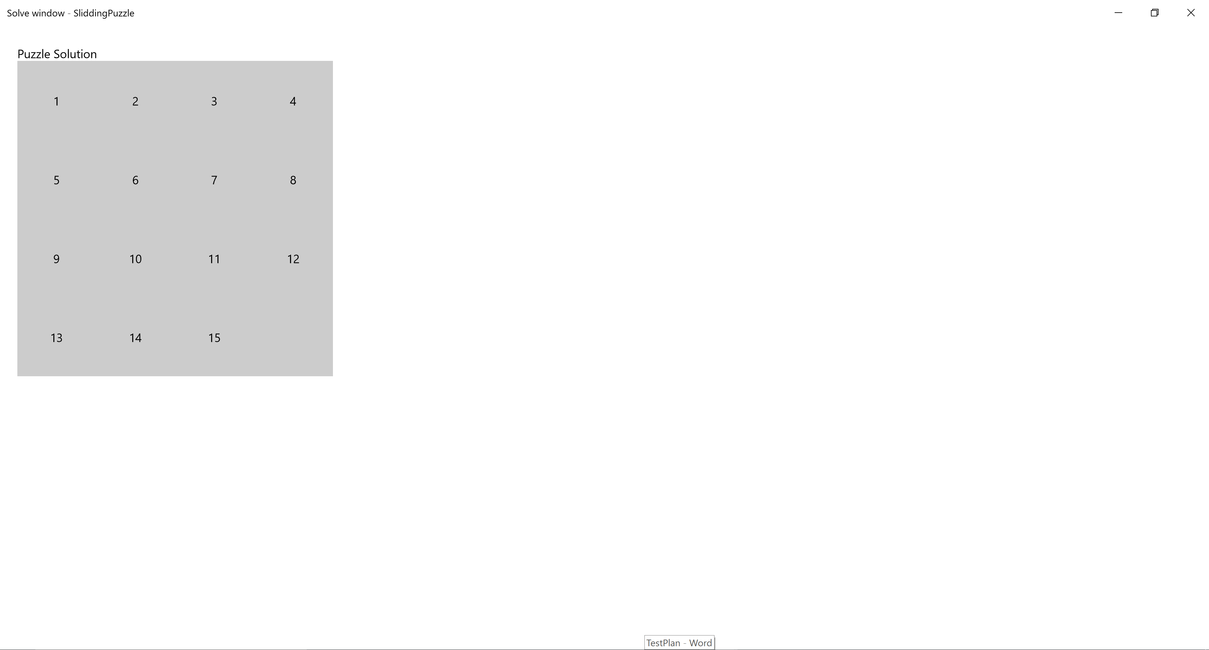

### Save

|  |  |  |  |
| --- | --- | --- | --- |
| Execution step | Expected output | Actual output | PASS/FAIL |
| START |  |  |  |
| Execute application to start the game | Game login screen is displayed | Login displayed | Pass |
| Click New game button to start a new game | New game shall be started | New game started | Pass |
| Play the game for few steps | User shall be able to slide the numbers based on the expected moves | Able to move | Pass |
| Click Save button | User game data is saved | Saved | Pass |
| Close the application | Application is closed | Closed app | Pass |
| Restart the application and login as the same user | Game shall be resumed from where left off if clicked load saved game. | Game loaded | Pass |
| END |  |  |  |

Save screenshot

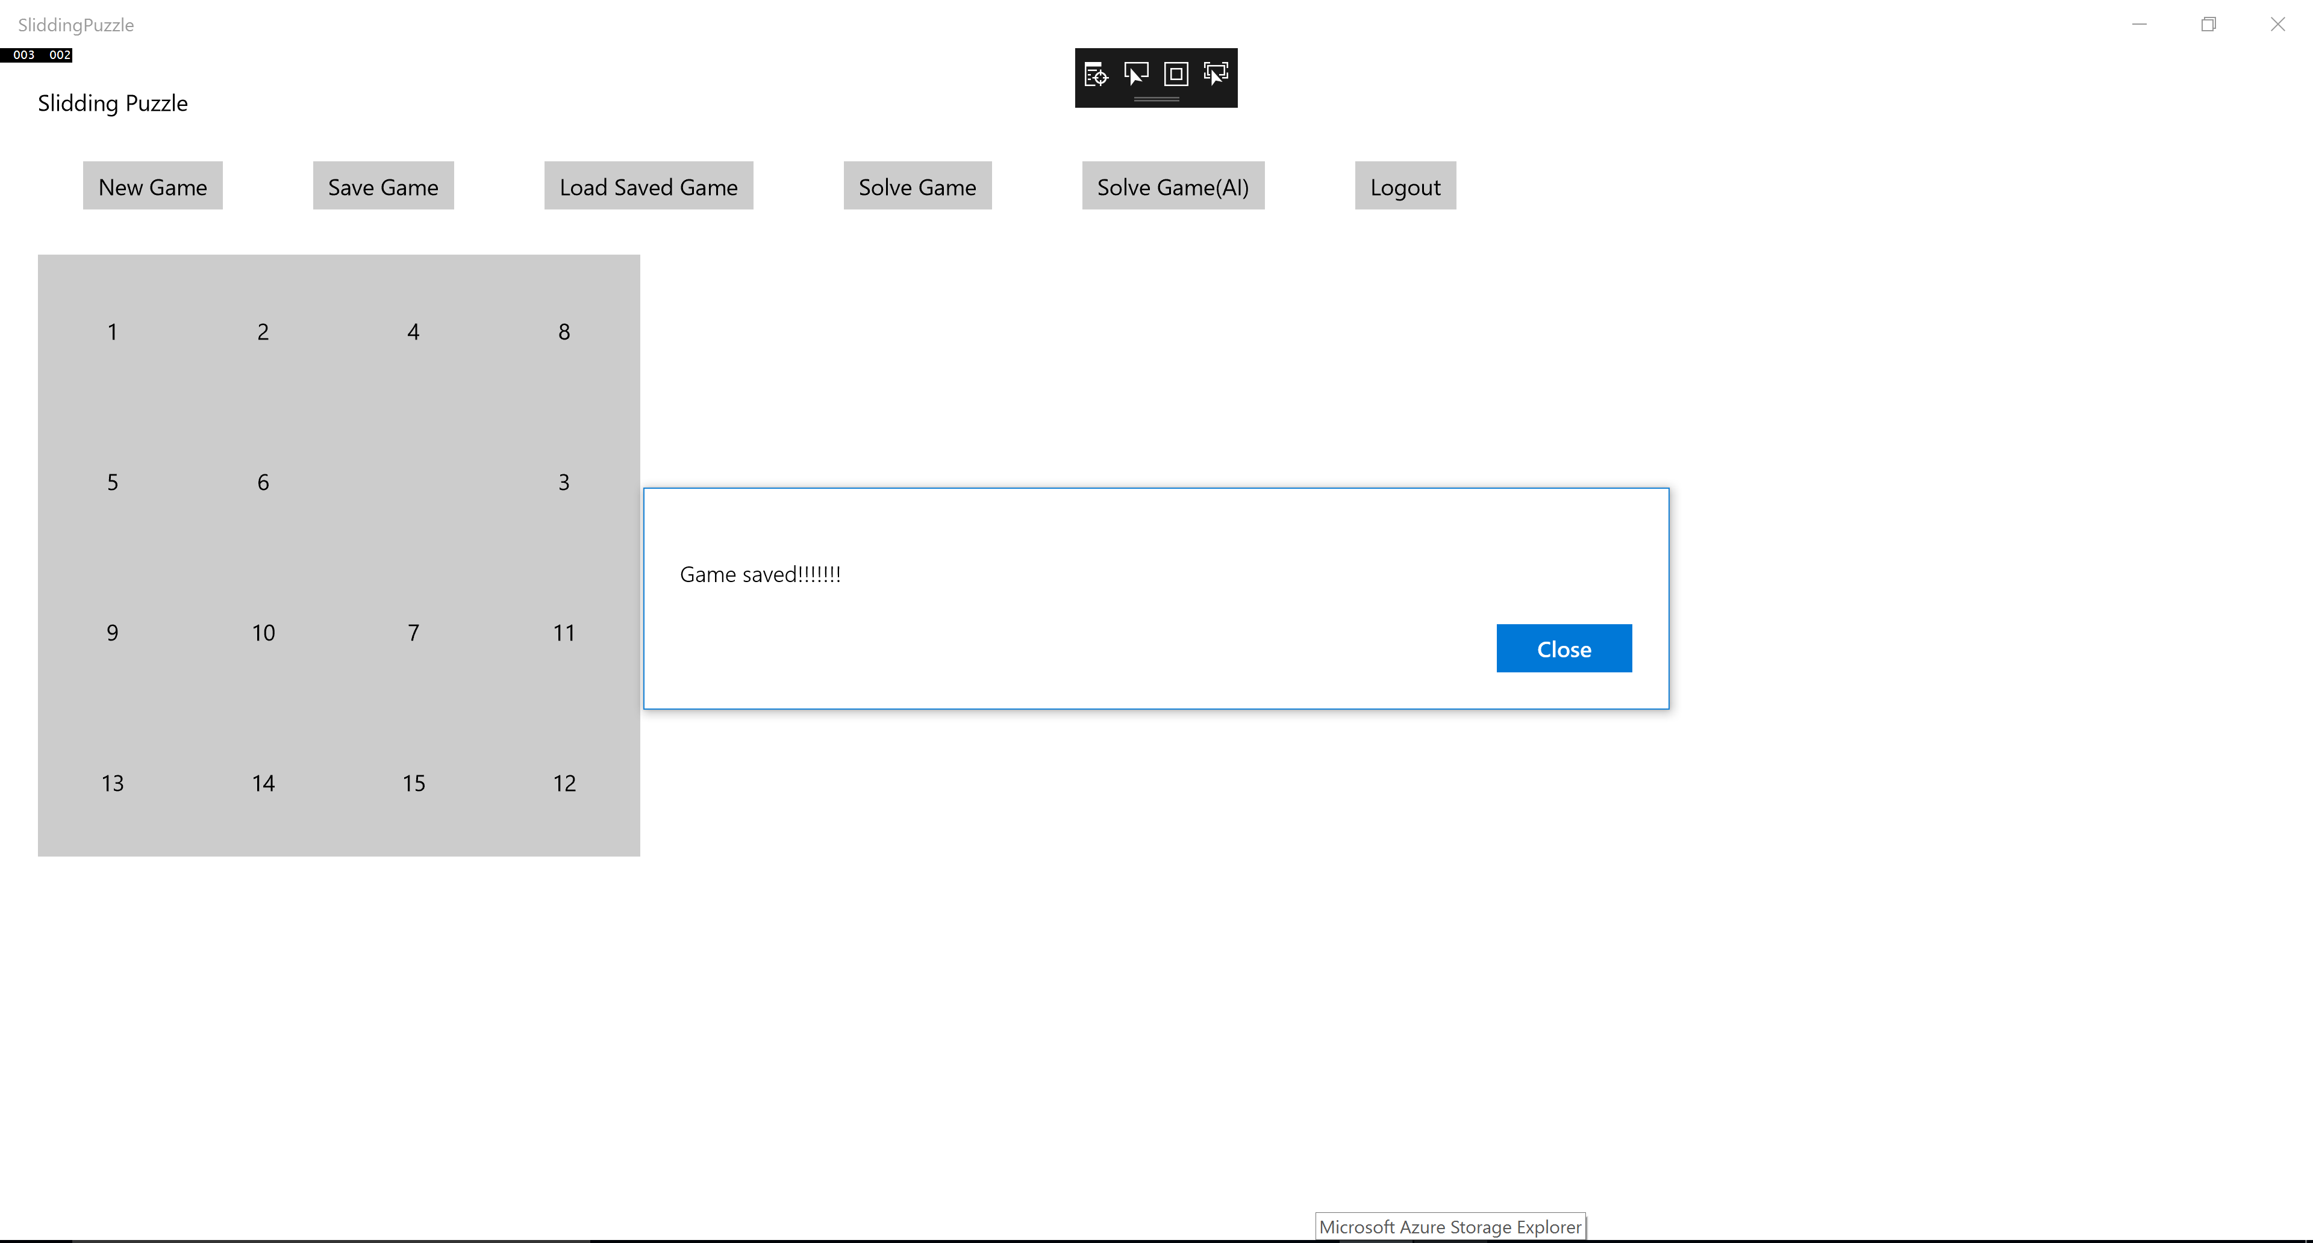

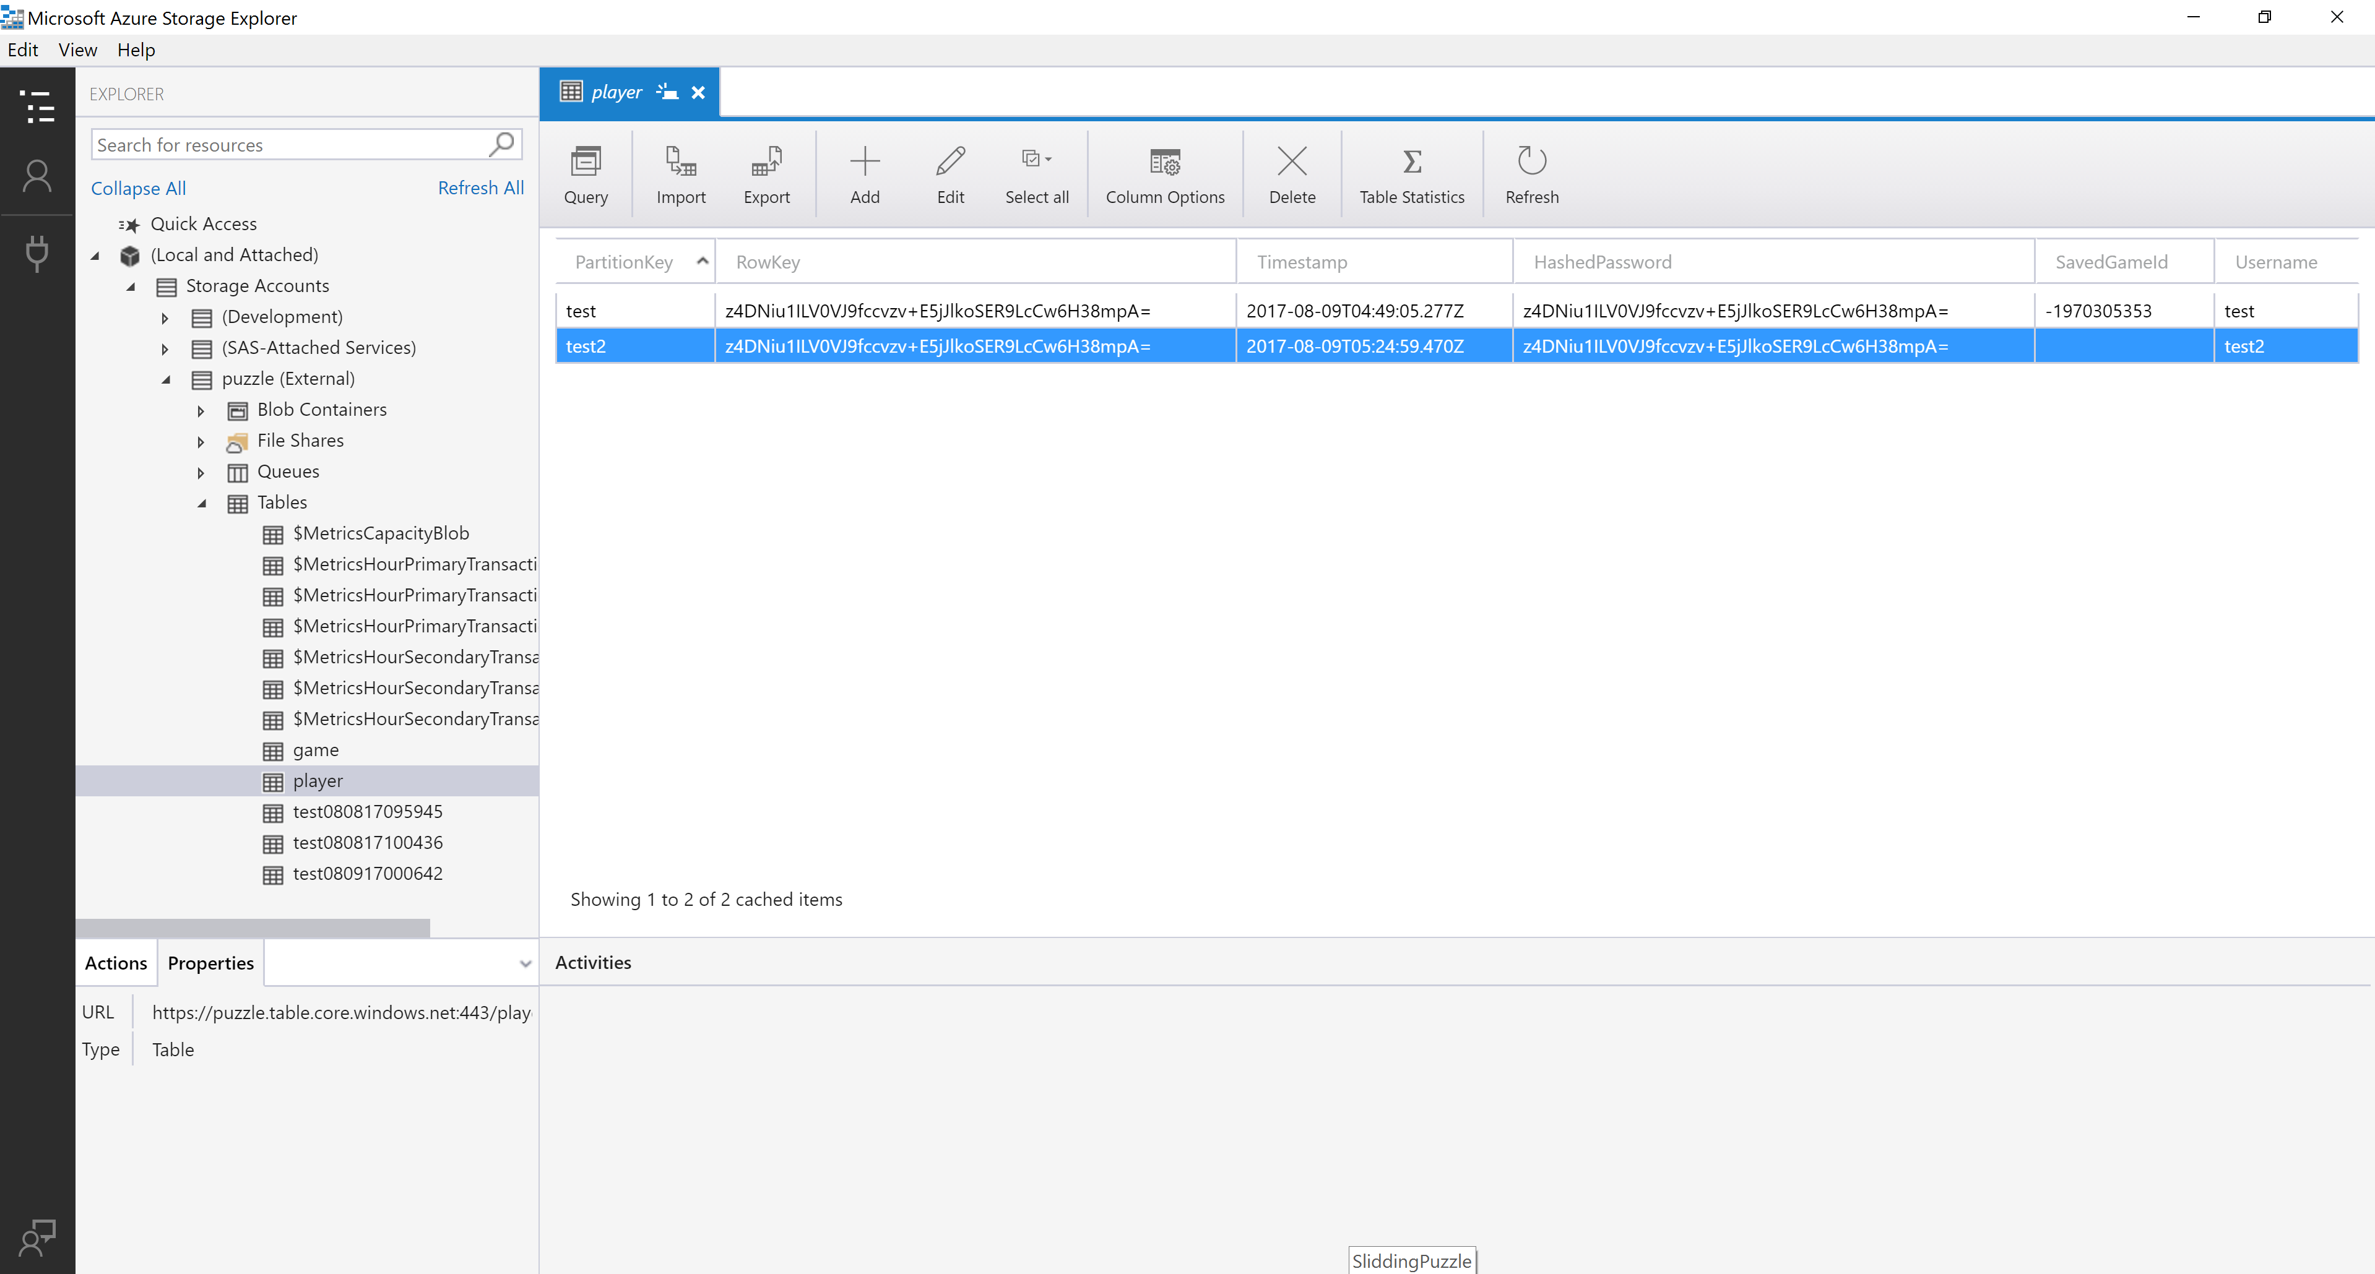

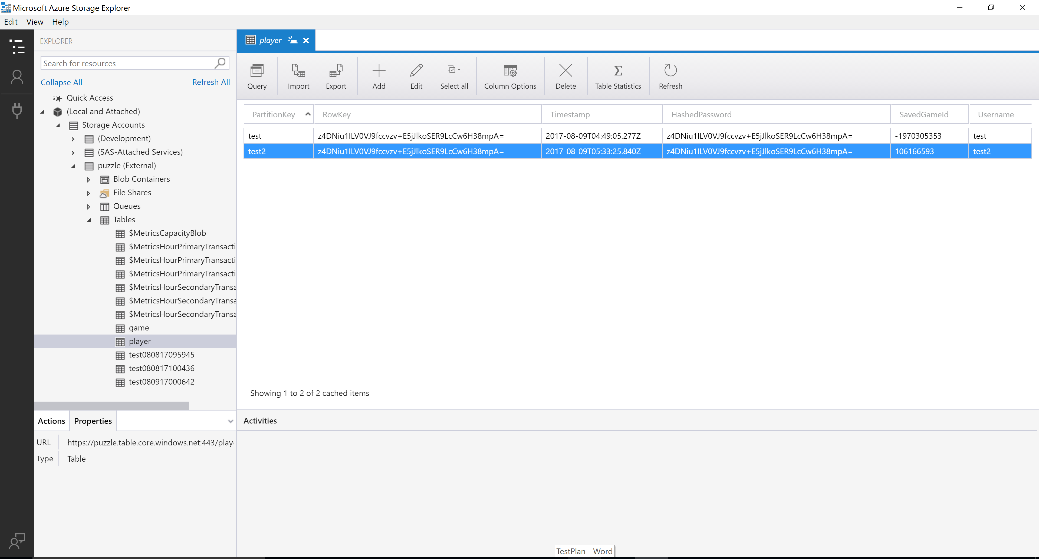

### Check Valid/invalid steps;

|  |  |  |  |
| --- | --- | --- | --- |
| Execution step | Expected output | Actual output | PASS/FAIL |
| START |  |  |  |
| Execute application to start the game | Game login screen is displayed | Login displayed | Pass |
| Click New game button to start a new game | New game shall be started | New game started | Pass |
| Play the game for few steps | User shall be able to slide the numbers based on the expected moves | Able to move | Pass |
| Check Valid steps:  Move slide by 1 slot | The tile can slide only into adjacent empty slot | Invalid move intimation | Pass |
| Check invalid steps  Move tile into a non empty slot | The tile cannot slide into non empty slot | Invalid move intimation | Pass |
| Check invalid steps  Move tile into an empty slot whose distance is more than one slot. | The tile cannot slide into a slot which is not adjascent. | Invalid move intissmation | Pass |
| END |  |  |  |

Error Message screenshot

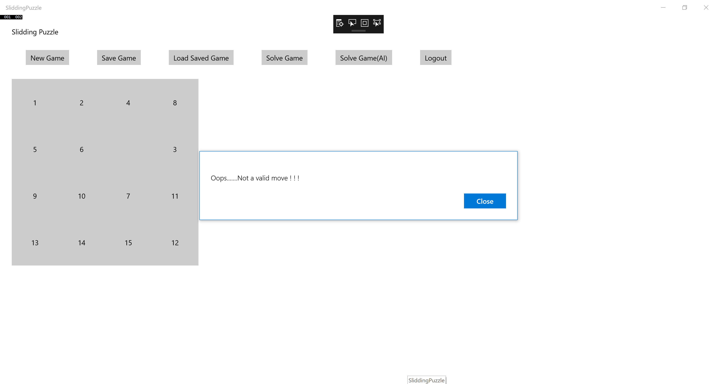

# Unit Testing

## Test Risks / Issues

View cannot be tested. Only model and view model can be tested.

## Items to be Tested / Not Tested

All model classes must be tested. Unit test goal is 75 % coverage using Resharper testing tool.

## Test Regulatory / Mandate Criteria

Unit test goal is 75 % coverage.

## Test Pass / Fail Criteria

All assert statement must pass or return true for a test to pass.

## Test Deliverables

Test project with unit test case code, screenshot of tests passing and coverage results will be the deliverables.

# User Acceptance Testing

## Items to be Tested

|  |  |  |  |
| --- | --- | --- | --- |
| **Item to Test** | **Test Description** | **Test Date** | **Responsibility** |
| New User is able to register | Validate New user registration process |  |  |
| User can resume from a saved state | Validate if user can resume a previous game |  |  |
| User interface has the expected functionality as displayed in SRS. | UI is as shown in the diagram in SRS document |  |  |
| User can solve a puzzle | Validate if user can solve the puzzle |  |  |
| Tiles movement | Tiles are moved only to adjacent empty slots |  |  |

# Conclusion:

The test cases mentioned in this document ensures the application developed is thoroughly tested and validated against expected outputs.