Let us say we wish to delete the Tap Dance connection which is created by Tim and Used/Rsvp by Jacob.

Login with Tim (creator of the connection)

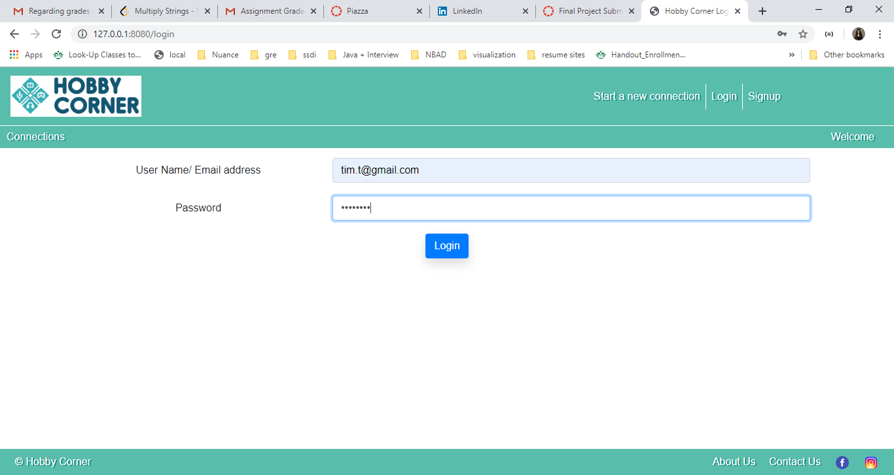

**Go to Manage My connections**

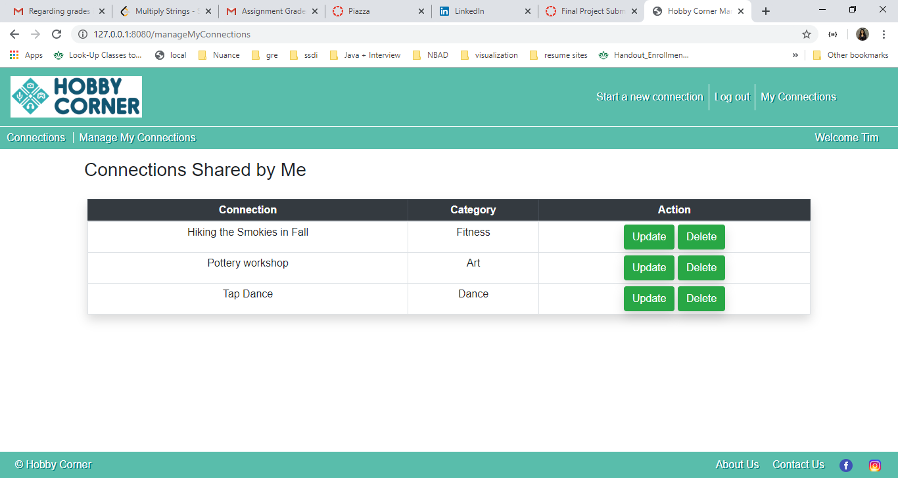



Logging in with user who has used the connection (Jacob in our case). Here we see that Jacob has rsvp to the Tap dance connection which was created by Tim. Once Tim deletes the connection it should automatically delete from this table.

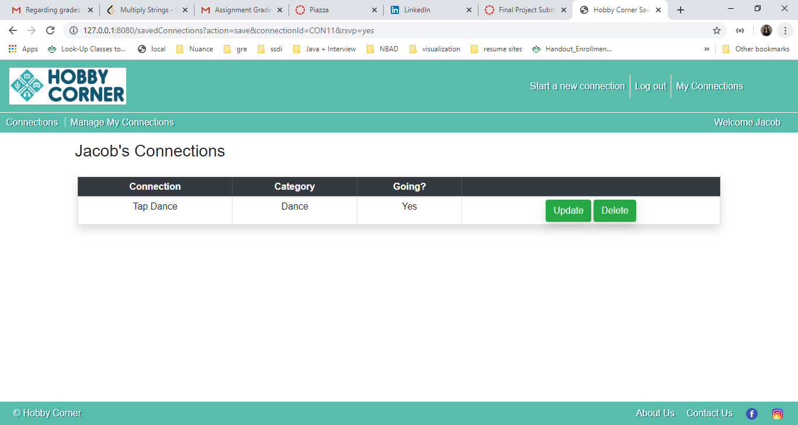

Logging in with creator user Tim

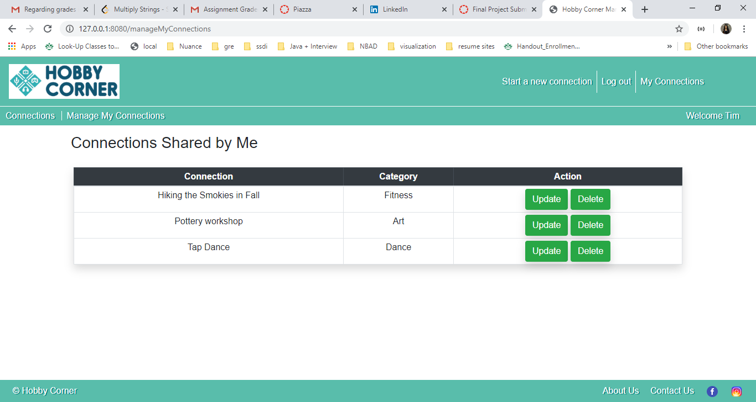



Deleting Tap dance

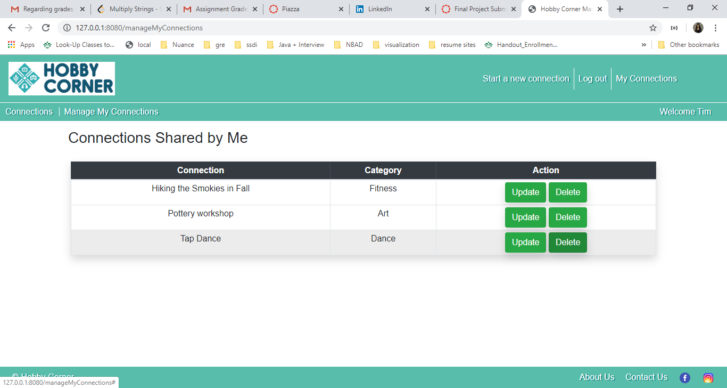



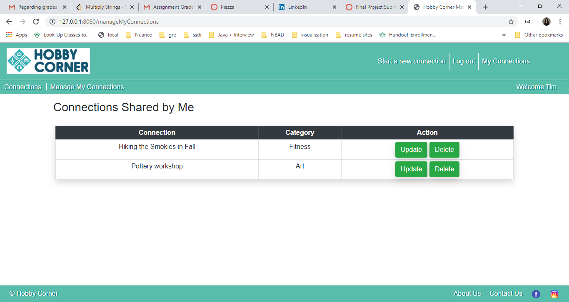

Connections view does not show Tap dance any longer

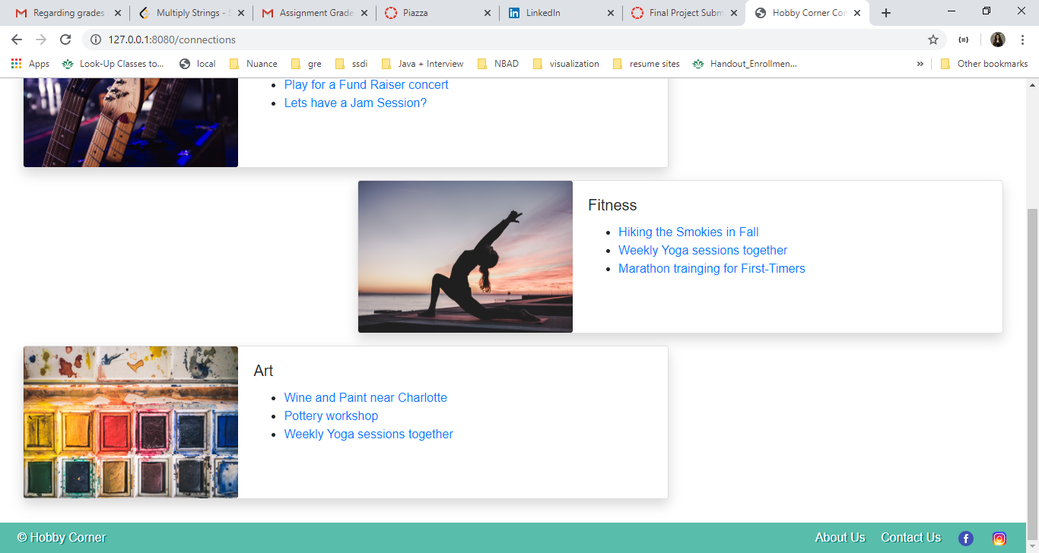

Loggin in with User who was using the connection (Jacob ) which was deleted

