DEFECT REPORT : 1

1.Defect ID: DEF_001
2.Module Name: Second Largest Number API
3.Summary: API returns incorrect second largest number when duplicate values exist in the array.
4.Test Case ID: TC_003
5.Severity: High
6.Priority: High
7.Status: New
8.Reporter: Aarti Chaudhary
9.Brief Description: While testing the Second Largest Number API, it was observed that when the input array contains duplicate values, the API returns the largest number instead of the second largest distinct number.
10.Steps to Reproduce:1) Open the API request in Postman.
2) Select POST method.
3) Enter the endpoint /second-largest
4) Add the request body:
{
"arr": [5,5,4,5]
}

11.Expected Result: The API should return 4 as the second largest number.
12.Actual Result: The API returns 5 as the second largest number.
13.Attachment:
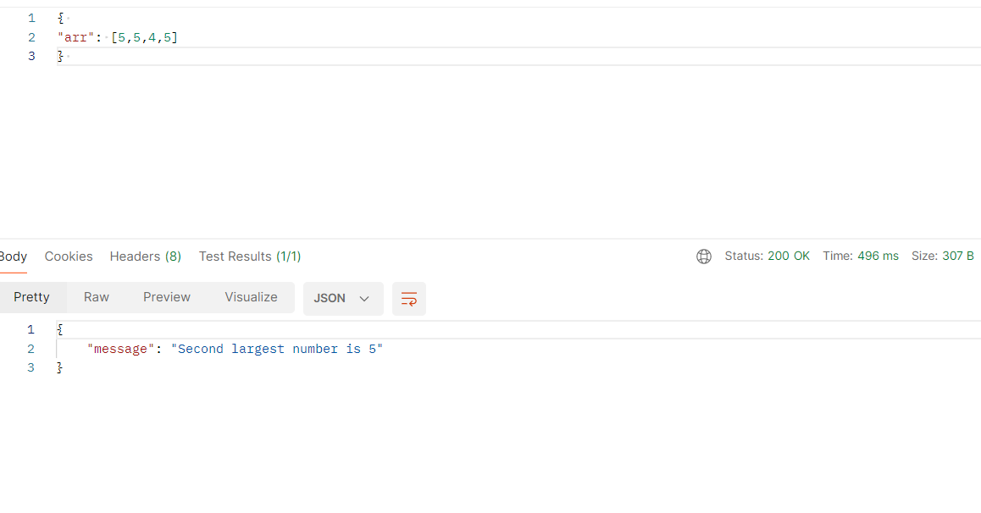

DEFECT REPORT : 2

1.Defect ID: DEF_002
2.Module Name: Second Largest Number API
3.Summary: API returns incorrect second largest number when array contains negative values
4.Test Case ID: TC_010
5.Severity: High
6.Priority: High
7.Status: New
8.Reporter: Aarti Chaudhary
9.Brief Description: While testing the Second Largest Number API, it was observed that the API returns an incorrect value when the input array contains negative unsorted numbers.
10.Steps to Reproduce:1) Open the API request in Postman.
2) Select POST method.
3) Enter the endpoint /second-largest
4) Add the request body:
{
"arr": [-1,-9,-3,-8,-2]
}

11.Expected Result: The API should return -2 as the second largest number.
12.Actual Result: The API returns -9 as the second largest number.
13.Attachment:
