
MAHARASHTRA STATE BOARD OF TECHNICAL EDUCATION,MUMBAI

GOVERNMENT POLYTECHNIC,BEED
[Institute Code:0032 ]



MICROPROJECT

Course & Code: Advanced Computer Network.(22520 )

Title of Micro project: Next Generation IP.

Subject Teacher Head of Department Principal

Seal of institute

MAHARASHTRA STATE BOARD OF TECHNICAL EDUCATION,MUMBAI

CERTIFICATE OF MICROPROJECT

This is to certify that following students of CM3I (Division-A/B) of Diploma in COMPUTER ENGINEERING of the institute GOVERNMENT POLYTECHNIC,BEED, Institute code:0032, have satisfactorily completed MICROPROJECT work in subject/Course: for academic year 2021-22 as prescribed in the curriculum.
Roll No. | Exam Seat No. | Name of Student | Title of Microproject
1416 |  | Aarti Deepak Swami | Next Generation IP.
1444 |  | Shravani Ravindra Mugalikar
1445 |  | Mrunal Manoj Sangole

Place:Beed Date:-- /-- -/2021

Subject Teacher Head of Department Principal
Seal of institute

Teacher Evaluation Sheet
Name of Student: Aarti Deepak Swami Enrollment No. 2000320118
Shravani Ravindra Mugalikar 2000320154
Mrunal Manoj Sangole 2000320155
Programme: Computer Technology Semester: fifth semester.
Course Title & Code:ACN (22520 ) Roll no: 1416,1444,1445.
Title of the Micro-Project: Next Generation IP.

Course Outcomes Achieved : CO1:- Learned about next generation of IP (IPV6).
CO2:- also able to know about IPV6 Addressing ( Unicast, Multicast, Anycast).
CO3:- Learned about how to do transition IPV4 to IPV6 .
CO4:- Able to understand the Address Space and their allocation.

Evaluation as per Suggested Rubric for Assessment of Micro Project
Sr. No. | Characteristic to be assessed | Poor  ( Marks 1 - 3 ) | Average  ( Marks 4 - 5 ) | Good  ( Marks 6 - 8 ) | Excellent  ( Marks 9- 10 )
[A] Process and Product Assessment (Convert total marks out of 06)
1 | Relevance to the course
2 | Literature Review/information collection
3 | Completion of the Target as per project proposal
4 | Analysis and data representation
5 | Quality of Prototype/Model
6 | Report Preparation
Total Marks Out of (6)
[B] Individual Presentation/Viva (Convert total marks out of 04)
1 | Presentation
2 | Viva
Total Marks Out of (4)
Micro-Project Evaluation Sheet
Process and Product Assessment  (6 marks)  (Note: The total marks taken from the above Rubrics is to be converted in proportion of ‘6’ marks) | Individual Presentation/Viva  (4 marks) | Total Marks  10
Name and designation of the Teacher: Dated Signature……………………………

Annexure –I
Part – A Micro-Project Proposal
(Format for Micro-Project Proposal A about 2-3 pages)

Title of Micro-Project: Next Generation IP .

Aims/Benefits of the Micro-Project (minimum 30-50 words):

- Known about IPV6(Next Generation of IP).

- Also known about the structure of IPV6.

- IPV6 addressing their types, address space and their allocation.

- Learned To do transition for IPV4 to IPV6. That’s why we able to do transition from one header to another.

- Able to know about Transition Methods.

- Able to understand IPV6 packet format.

Course Outcomes Addressed:

CO1:- Learned about next generation of IP (IPV6).

CO2:- also able to know about IPV6 Addressing (Uni,Multi,Anycast)

CO3:- Learned about how to do transition IPV4 to IPV6 .

CO4:- Able to understand the Address Space and their allocation.

Proposed Methodology:
(Procedure in brief that will be followed to do the micro-project) in about 100 to 200 words).
Step 1: Study the micro project.
First of all group members will go through the micro project list. The discussion will be done in group. After the topic will be finalized. The guide will help to clear the doubts and problem in project making.
Step 2: Collecting information from internet, books.
The work will be distributed among the group members. And different format will be collected for report making like certificate, teacher evaluation sheet, annexure-A and B
Step 3: Finalizing the formats in collaboration.
All group member will go through sample collected, then format will be finalized.
Step 4: Finalizing the topic.
After finalizing the format, the topic will be discussed .the topic will be discussed unanimously and as per the availability of material.
Step 5: Listing the stationary items required for project along with budget.Everyone will give stationary list required for report writing.
Step 6: Discussion of budget in group and finalize the amount.
The group members will discuss their views and budget will be finalized.
Step 7: Collection of photos and information/contents.
Every group member will collect their data from different website, books and from personal visit to industry and give it to project guide for proof reading. After proof reading the data along with photo will be finalized and every group member will be proceed for their job.
Step 8: Printing/Drawing.
Printing or drawing will be done and shown to project guide
Step 9: Explanation/Preparation.
During oral/viva project will be explained.

5.0 Action Plan (Sequence and time required for major activity)

Sr. No. | Details of activity | Planned Start date | Planned Finish date | Name of Responsible Team Members
1 | Collecting different formats
2 | Finalization of formats in collaboration
3 | Finalizing topic title
4 | Listing stationary items required for project along with budget
5 | Discussion of budget in group and finalize the amount
6 | Information collection by each group member
7 | Report writing/Printing

6.0 Resources Required (major resources such as raw material, some machining facility, software etc.)

S. No. | Name of Resource/material | Specifications | Qty | Remarks
 | Computer,Mobile,Internet,Printer,Scanner | PC | 01
 | Text book,Youtube,google | Techknowledge,www.youtube.com,www.google.co.in | -

Names of Team Members with Roll Nos.

Roll No. | Name of student
1416 | Aarti deepak swami
1444 | Shravani Ravindra Mugalikar
1445 | Mrunal Manoj Sangole

Annexure – II

Part – B Micro-Project Report
(Outcomes after Execution) Format for Micro-Project Report (Minimum 6 pages)

Title of Micro-Project: Next Generation IP.

1.0 Rationale
(Importance of the project, in about 30 to 50 words. This is a modified version of the earlier one written after the work)
After this project we are aware about IPV6 Addressing in IPV6 there are representation, address space, address space allocation, Autoconfiguration, Renumbering. In Transition from IPV4 to IPV6 there is a three methods : Duel Stack,Tunneling,Header Transition . Along with IPV6 protocols in that there is a Packet format and extention header. All of we are able to understand after this project.

Aims/Benefits of the Micro-Project :

- Known about IPV6(Next Generation of IP).
- Also known about the structure of IPV6.
- IPV6 addressing their types, address space and their allocation.
- Learned To do transition for IPV4 to IPV6. That’s why we able to do transition from one header to another.
- Able to know about Transition Methods.
- Able to understand IPV6 packet format.

Course Outcomes Achieved (Add to the earlier list if more CO’s are addressed)
CO1:- Learned about next generation of IP (IPV6).
CO2:- also able to know about IPV6 Addressing (Uni,Multi,Anycast)
CO3:- Learned about how to do transition IPV4 to IPV6 .
CO4:- Able to understand the Address Space and their allocation.

Actual Methodology Followed :
Step 1: Study the micro project.
First of all group members derived the micro project list form the project guide and went through the topics. The discussion will be done in group. After the topic will be finalized. The guide will helped to clear the doubts and problem in project making.
Step 2: Collecting information from internet, books.
Then the work was distributed among the group members.the preliminary search was collection of different formats required for microproject.this responsibility was given to Aarti Swami and Shravani Mugalikar both of them made search of welding form different websites,books,magazines etc.for this they took help of teachers, parents, neighbours,and visited some places also and the collection was done by them,
Step 3: Finalizing the formats in collaboration.
All group member will go through sample collected, everyone expressed their views on making of job using welding and requirement of data.After one hour discussion on it all members finalized the annexure A,B
Step 4: Finalizing the topic.
After finalizing the format, the topic will be discussed . the different field were discussed by the members.among that it was decided to prepare microproject on topic “Next Generation IP”. the topic will be discussed unanimously and as per the availability of material.and everyone was given deadline for that.
Step 5: Listing the stationary items required for project along with budget.
Everyone was told to prepare stationary list required for report writing and information collection and keep ready budget for it.
Step 6: Discussion of budget in group and finalize the amount.
In the next week every group members discussed their views and budget was finalized.it was Rs __________each and it was told budget of group should not exceed than the above amount.
Step 7: Collection of photos and information/contents.
Every group member will collected their data from different website, books and from personal visit to industry and gave it to project guide for proof reading. After proof reading the data along with photo were be finalized and every group member started their job.
Information collected and included in this report
Step 8: Printing/Drawing.
We all decided to make report in print format,one member took printout of report,it was shown to project guide by every member and collected tips for presentation.
Step 9: Explanation/Preparation.
Everyone did good preparation of microproject which was needed for viva.

Next Generation IP (IPV6)

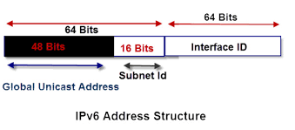

- An IPV6 address is 128 bit long. It consists of 16 bytes as shown in fig. Thus the IPV6 address is times longer than that of IPV4.
- IPV6 is the next generation internet protocol designed as the next step of IP version 4. IPV6 was designed to enable high performance and larger address space. This was achieved by overcoming many of the weakness of IPV4 protocol and by adding several new features.
- IPV6 was developed due to the address depletion of IPV4.
- The Structure of IPV6 is fundamentally different than that of IPV4. Therefore there is absolutely no possibility of address depletion taking place in future.

IPV6 Address space:-
Since IPv6 addresses are 128 bits long, the theoretical address space if all addresses were used is 2128 addresses. This number, when expanded out, is 340,282,366,920,938,463,463,374,607,431,768,211,456, which is normally expressed in scientific notation as about 3.4*1038 addresses. That's about 340 trillion, trillion, trillion addresses. As I said, it's pretty hard to grasp just how large this number is.

There are three types of addresses:-
- Unicast Address.
- Multicast Address.
- Anycast Address.
- Unicast Address :-
Unicast addresses represent a single interface. Packets addressed to a unicast address will be delivered to a specific network interface.
There are three types of IPv6 unicast addresses:
Global unicast – similar to IPv4 public IP addresses. These addresses are assigned by the IANA and used on public networks. They have a prefix of 2000::/3, (all the addresses that begin with binary 001).
Unique local – similar to IPv4 private addresses. They are used in private networks and aren’t routable on the Internet. These addresses have a prefix of FD00::/8.
Link local – these addresses are used for sending packets over the local subnet. Routers do not forward packets with this addresses to other subnets. IPv6 requires a link-local address to be assigned to every network interface on which the IPv6 protocol is enabled. These addresses have a prefix of FE80::/10.

- Multicast Address:-
Multicast addresses in IPv6 are similar to multicast addresses in IPv4. They are used to communicate with dynamic groupings of hosts, for example all routers on the link (one-to-many distribution).

Here is a graphical representation of the IPv6 multicast packet:

IPv6 multicast addresses start with FF00::/8. After the first 8 bits there are 4 bits which represent the flag fields that indicate the nature of specific multicast addresses. Next 4 bits indicate the scope of the IPv6 network for which the multicast traffic is intended. Routers use the scope field to determine whether multicast traffic can be forwarded. The remaining 112 bits of the address make up the multicast Group ID.
- Anycast Address:-
An anycast address is an address that is assigned to a set of interfaces that typically belong to different nodes. A packet sent to an anycast address is delivered to the closest interface (as defined by the routing protocols in use) identified by the anycast address. Anycast addresses are syntactically indistinguishable from unicast addresses, because anycast addresses are allocated from the unicast address space. Assigning a unicast address to more than one interface makes a unicast address an anycast address. Nodes to which the anycast address is assigned must be explicitly configured to recognize that the address is an anycast address.

Address Space Allocation:-
- Address space allocation in IPV6 is a progress which divides address space of IPV6 in several blocks. Each block is allocated for some special purpose and has a different size.
- Most of the blocks in IPV6 are not assigned yet and will be used in future.
- The entire address space in IPV6 has been divided into eight equal ranges as shown in fig.
- Fig shown below:-
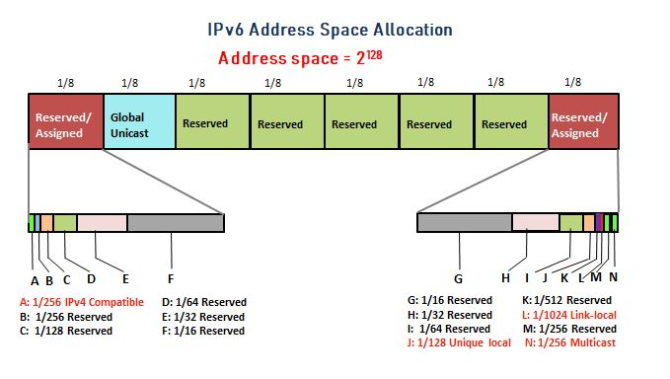
- The number of addresses in each section is one eighth of the total address space. So number of addresses in each section is equal to 2 raise to 125.

LoopBack Address :-
Loopback address is a special IP number that is designated for the software loopback interface of a machine. The loopback interface has no hardware associated with it, and it is not physically connected to a network.
The loopback interface allows IT professionals to test IP software without worrying about broken or corrupted drivers or hardware.
IPv6 Loopback address is 0:0:0:0:0:0:0:1
It can also be expressed as ::1

Transition From IPV4 to IPV6
Three Methods of transition:-
- Dual stack
- Tunneling
- Header Translation

- Dual Stack:-
Before completely migrating to version 6 it is recommended that all hosts should have a dual stack of protocols at the time of transition.
Simultaneously station should run IPV4 and IpV6 until the internet uses IPV4.
A source host send query to DNS for deciding which version to use while sending a packet to a destination.
A source host sends IPV4 packet if an IPV4 address returned by DNS , and sends IPV6 packet if DNS returns IPV6 address.

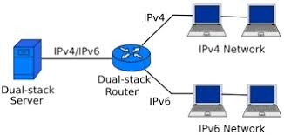

- Tunneling :-
Tunneling provides a way to use an existing IPv4 routing infrastructure to carry IPv6 traffic.
The key to a successful IPv6 transition is compatibility with the existing installed base of IPv4 hosts and routers. Maintaining compatibility with IPv4 while deploying IPv6 streamlines the task of transitioning the Internet to IPv6. While the IPv6 infrastructure is being deployed, the existing IPv4 routing infrastructure can remain functional, and can be used to carry IPv6 traffic.
IPv6 or IPv4 hosts and routers can tunnel IPv6 datagrams over regions of IPv4 routing topology by encapsulating them within IPv4 packets.

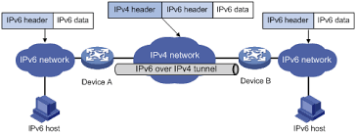

Fig : Tunneling diagram.

- Header Translation :-
This is another important method of transition to IPv6 by means of a NAT-PT (Network Address Translation – Protocol Translation) enabled device. With the help of a NAT-PT device, actual can take place happens between IPv4 and IPv6 packets and vice versa.
A host with IPv4 address sends a request to an IPv6 enabled server on Internet that does not understand IPv4 address. In this scenario, the NAT-PT device can help them communicate. When the IPv4 host sends a request packet to the IPv6 server, the NAT-PT device/router strips down the IPv4 packet, removes IPv4 header, and adds IPv6 header and passes it through the Internet. When a response from the IPv6 server comes for the IPv4 host, the router does vice versa.

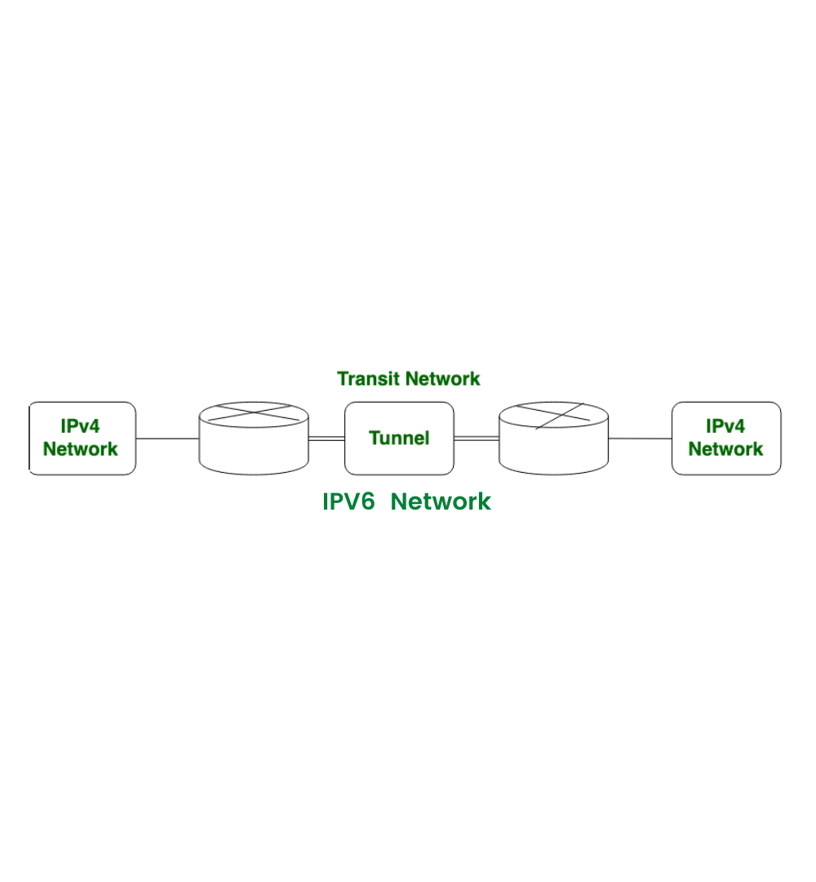
Fig : Header Translation.

Difference between IPV4 to IPV6

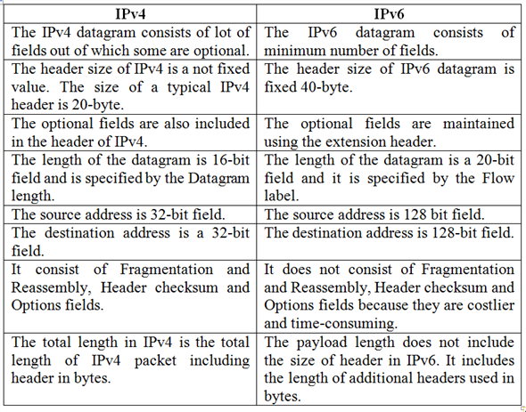

IPV6 Packet Format

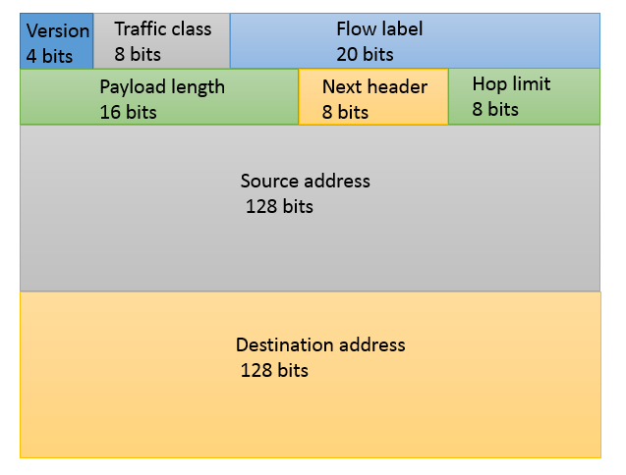
Explanation of all fields :-
Version (4-bits): Indicates version of Internet Protocol which contains bit sequence 0110.
Traffic Class (8-bits): The Traffic Class field indicates class or priority of IPv6 packet which is similar to Service Field in IPv4 packet. It helps routers to handle the traffic based on the priority of the packet. If congestion occurs on the router then packets with the least priority will be discarded.
As of now, only 4-bits are being used (and the remaining bits are under research), in which 0 to 7 are assigned to Congestion controlled traffic and 8 to 15 are assigned to Uncontrolled traffic. Uncontrolled data traffic is mainly used for Audio/Video data. So we give higher priority to Uncontrolled data traffic.
The source node is allowed to set the priorities but on the way, routers can change it. Therefore, the destination should not expect the same priority which was set by the source node.
Flow Label (20-bits): Flow Label field is used by a source to label the packets belonging to the same flow in order to request special handling by intermediate IPv6 routers, such as non-default quality of service or real-time service. In order to distinguish the flow, an intermediate router can use the source address, a destination address, and flow label of the packets. Between a source and destination, multiple flows may exist because many processes might be running at the same time. Routers or Host that does not support the functionality of flow label field and for default router handling, flow label field is set to 0. While setting up the flow label, the source is also supposed to specify the lifetime of the flow.
Payload Length (16-bits): It is a 16-bit (unsigned integer) field, indicates the total size of the payload which tells routers about the amount of information a particular packet contains in its payload. The payload Length field includes extension headers(if any) and an upper-layer packet. In case the length of the payload is greater than 65,535 bytes (payload up to 65,535 bytes can be indicated with 16-bits), then the payload length field will be set to 0 and the jumbo payload option is used in the Hop-by-Hop options extension header.
Next Header (8-bits): Next Header indicates the type of extension header(if present) immediately following the IPv6 header. Whereas In some cases it indicates the protocols contained within upper-layer packets, such as TCP, UDP.
Hop Limit (8-bits): Hop Limit field is the same as TTL in IPv4 packets. It indicates the maximum number of intermediate nodes IPv6 packet is allowed to travel. Its value gets decremented by one, by each node that forwards the packet and the packet is discarded if the value decrements to 0. This is used to discard the packets that are stuck in an infinite loop because of some routing error.

Some Examples of IPV6 Address :-
- 2001 : db8: 3333 : 4444 : 5555 : 6666 : 7777 : 8888
- 2001 : db8 : 3333 : 4444 : CCCC : DDDD : EEEE : FFFF
- : : (implies all 8 segments are zero)
- 2001: db8: : (implies that the last six segments are zero)
- : : 1234 : 5678 (implies that the first six segments are zero)
- 2001 : db8: : 1234 : 5678 (implies that the middle four segments are zero)
- 2001:0db8:0001:0000:0000:0ab9:C0A8:0102 (This can be compressed to eliminate leading zeros, as follows: 2001:db8:1::ab9:C0A8:102 )

Some Compressed IPV6 examples:-

6.0 Actual Resources Used (Mention the actual resources used):

S. No. | Name of Resource/material | Specifications | Qty | Remarks
1 | Computer,Mobile,Internet,Printer | PC | 01
2 | Text book,Youtube,google | Techknowledge,www.youtube.com,www.google.co.in | -

Skill Developed / Learning outcome of this Micro-Project :-

Through this microproject the following things are learnt and the skill developed by the group
*The concept of project understood.
- The structure and requirement of proposal and report understood.
- The necessity of team work is understood.
- What is the role of group leader and team member? It well understood.
- The importance of time management and good communication skill is understood.
- How to search information and use of different online tools came to know.
- The writing in English skill is developed.
- The new words are collected.
- The computer access skill is developed.
- Able to tackle and solve the problem arised due to miscommunication and misunderstanding.
- The decision making ability is developed but needed good cooperation.

