**Assignment No-1**

**Name:** Pawar Aarti Arvind

**PRN:**

**Roll No:** 45

**Class:** MCA-I (Sem II)

**<html>**

**<head>**

**<title></title>**

**</head>**

**<body>**

**<table>**

**<tr>**

**<td><img src="l2.png" ></td>**

**<td><h1><center>BHARATI VIDYAPEETH</center></h1>**

**<h2><center>(DEEMED TO BE UNIVERSITY), PUNE.</center></h2>**

**<h1><center>YASHWANTRAO MOHITE INSTITUTE OF MANAGEMENT, KARAD</center></h1>**

**</td>**

**<td><img src="l1.jpg"></td>**

**</tr>**

**</table> <br><br>**

**<a href="CET_Timetable.html">**

**<center><img src="i1.webp" height="500px" width="800px"></center>**

**</a> <br><br>**

**<marquee scrollamount="20">**

**<a href="CET_Timetable.html">**

**<table border="2px solid black" align="center" bgcolor="green" text-decoration-color="white" border-collapse="collapse" width="100%" height="100px">**

**<tr>**

**<td ><center><h1 style="color:white;"><b>Admission open 2025 Click here</b></h1></center></td>**

**</tr>**

**</table>**

**</a>**

**</marquee>**

**</body>**

**</html>**

**Output:-**

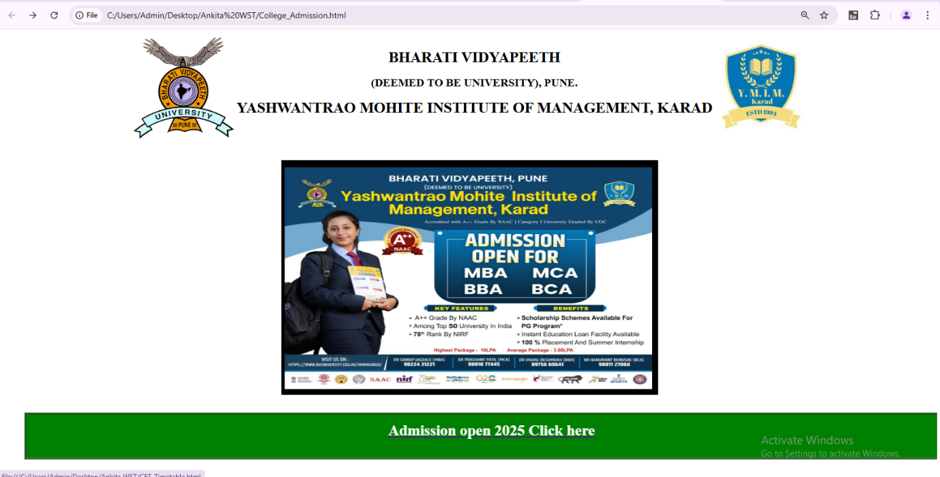

**CET Time-Table**

**<html>**

**<head>**

**<title></title>**

**</head>**

**<body>**

**<table>**

**<tr>**

**<td><img src="l2.png" ></td>**

**<td><h1><center>BHARATI VIDYAPEETH</center></h1>**

**<h2><center>(DEEMED TO BE UNIVERSITY), PUNE.</center></h2>**

**<h1><center>YASHWANTRAO MOHITE INSTITUTE OF MANAGEMENT, KARAD</center></h1>**

**</td>**

**<td><img src="l1.jpg"></td>**

**</tr>**

**</table> <br><br>**

**<center><h1>CET Entrance Exam Time Table </h1>**

**<table height="400px" width="500px" border="2px solid black">**

**<tr>**

**<th>Course</th>**

**<th>Date</th>**

**<th>CET Fee</th>**

**</tr>**

**<tr align="center">**

**<td>MCA</td>**

**<td>1/3/2025</td>**

**<td>2000</td>**

**</tr>**

**<tr align="center">**

**<td>MBA</td>**

**<td>1/3/2025</td>**

**<td>2000</td>**

**</tr>**

**<tr align="center">**

**<td>BCA</td>**

**<td>1/3/2025</td>**

**<td>2000</td>**

**</tr>**

**<tr align="center">**

**<td>BBA</td>**

**<td>1/3/2025</td>**

**<td>2000</td>**

**</tr>**

**</table>**

**</body>**

**</html>**

**Output:-**

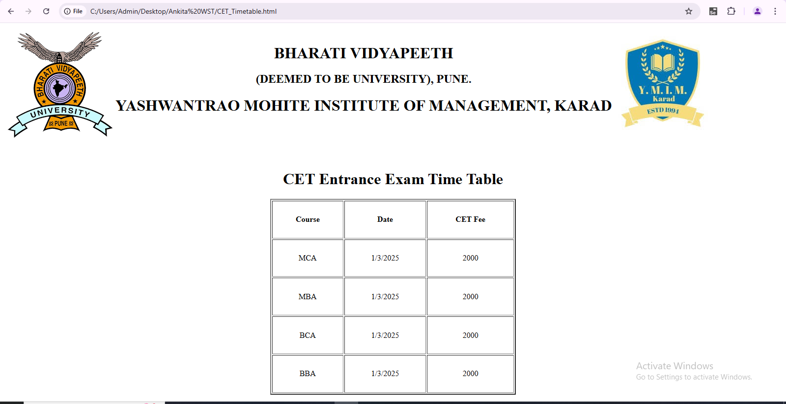

**Assignment No-2**

**Name:** Pawar Aarti Arvind

**PRN:**

**Roll No:** 45

**Class:** MCA-I (Sem II)

**<!DOCTYPE html>**

**<html lang="en">**

**<head>**

**<meta charset="UTF-8">**

**<meta name="viewport" content="width=device-width, initial-scale=1.0">**

**<title>Timetable</title>**

**</head>**

**<body>**

**<center>**

**<table>**

**<tr>**

**<td>**

**<img src="ulogo.jpg" height="150px" width="150px">**

**</td>**

**<td>**

**<h1><b>BHARATI VIDYAPEETH(DEEMED TO BE UNIVERSITY),PUNE</b></h1>**

**<h2 align="center"><u>Yashwantrao Mohite Institute of Management,Karad</u></h2>**

**</td>**

**<td>**

**<img src="clglogo.png" height="150px" width="150px">**

**</td>**

**</tr>**

**</table>**

**<hr style="width:100%;text-align:left;margin-left:0" color="black"><br><br>**

**<table border="2px solid black" style=" border-collapse: collapse;"; height="550px" width="600">**

**<tr>**

**<th></th>**

**<th>Monday</th>**

**<th>Tuesday</th>**

**<th>Wednesday</th>**

**<th>Thursday</th>**

**<th>Friday</th>**

**<th>Saturday</th>**

**<th>Lecture Hall/lab</th>**

**</tr>**

**<tr align="center">**

**<td>10.30-11.30AM</td>**

**<td>-</td>**

**<td>-</td>**

**<td>OOSE<br>[PRR]</td>**

**<td>CC<br>[PPP]</td>**

**<td>CC<br>[PPP]</td>**

**<td>CC<br>[PPP]</td>**

**<td>Multi</td>**

**</tr>**

**<tr align="center">**

**<td>11.30-12.30AM</td>**

**<td>Python-Lab<br>[SVD]</td>**

**<td>Python-Lab<br>[SVD]</td>**

**<td>Python-Lab<br>[SVD]</td>**

**<td>WST Lab<br>[AAP]</td>**

**<td>WST Lab<br>[AAP]</td>**

**<td>WST Lab<br>[AAP]</td>**

**<td>Lab-3</td>**

**</tr>**

**<tr align="center">**

**<td>12.30-1.30AM</td>**

**<td>WST<br>[AJ]</td>**

**<td>WST<br>[AJ]</td>**

**<td>WST<br>[AJ]</td>**

**<td>OOSE<br>[PRR]</td>**

**<td>OOSE<br>[PRR]</td>**

**<td>Python<br>[HNR]</td>**

**<td>Lab-3</td>**

**</tr>**

**<tr align="center">**

**<td>2.00-3.00AM</td>**

**<td>DWDM<br>[SVD]</td>**

**<td>DWDM<br>[SVD]</td>**

**<td>Python<br>[HNR]</td>**

**<td>Python<br>[HNR]</td>**

**<td>DWDM<br>[SVD]</td>**

**<td>-</td>**

**<td>Lab-3</td>**

**</tr>**

**<tr align="center">**

**<td>3.00-4.00AM</td>**

**<td>T-Python</td>**

**<td>DT<br>[PRR]</td>**

**<td>DT<br>[PRR]</td>**

**<td>Project<br>[PRR]</td>**

**<td>T-OOSE<br>[PRR]</td>**

**<td>-</td>**

**<td></td>**

**</tr>**

**<tr align="center">**

**<td>4.00-5.00AM</td>**

**<td>-</td>**

**<td>T-CC<br>[PPP]</td>**

**<td>T-DWDM<br>[SVD]</td>**

**<td>-</td>**

**<td>-</td>**

**<td></td>**

**<td></td>**

**</tr>**

**</table><br>**

**<table border="2px solid black" style="border-collapse: collapse"; height="500px" width="500">**

**<tr align="center">**

**<th>Sr.No</th>**

**<th></th>**

**<th>Subject Name</th>**

**<th>Faculty Name</th>**

**</tr>**

**<tr align="center">**

**<td>201</td>**

**<td>OOSE</td>**

**<td>Object Oriented Software Engineering</td>**

**<td>Prof.P.R.Rasal</td>**

**</tr>**

**<tr align="center">**

**<td>202</td>**

**<td>CC</td>**

**<td>Cloud Computing Concepts </td>**

**<td>Dr.P.P.Patil<br>Class Coordinator</td>**

**</tr>**

**<tr align="center">**

**<td>203</td>**

**<td>DS</td>**

**<td>Data Structure using Python</td>**

**<td>Dr.H.N.Renushe</td>**

**</tr>**

**<tr align="center">**

**<td>204</td>**

**<td>DWDM</td>**

**<td>Data Warehousing and Data Mining</td>**

**<td>Dr.Mrs.Sheetal Deshmukh</td>**

**</tr>**

**<tr align="center">**

**<td>205</td>**

**<td>WST</td>**

**<td>Web Supporting Techonology</td>**

**<td>Mrs.Archana Jadhav</td>**

**</tr>**

**<tr align="center">**

**<td>206</td>**

**<td>Lab on Ds</td>**

**<td> Lab on Data Structure using Python </td>**

**<td>Dr.Mrs.Sheetal Deshmukh</td>**

**</tr>**

**<tr align="center">**

**<td>207</td>**

**<td></td>**

**<td>Minor Project-I</td>**

**<td>Dr. P.P.Patil</td>**

**</tr>**

**<tr align="center">**

**<td>208<br>209</td>**

**<td><hr></td>**

**<td>MOOCS-II*<br>Open Course-II*-Digital Techonology</td>**

**<td>Dr.P.P.Patil<hr>Prof.P.R.Rasal</td>**

**</tr>**

**</tr>**

**</table>**

**</center>**

**</body>**

**</html>**

**Output:-**

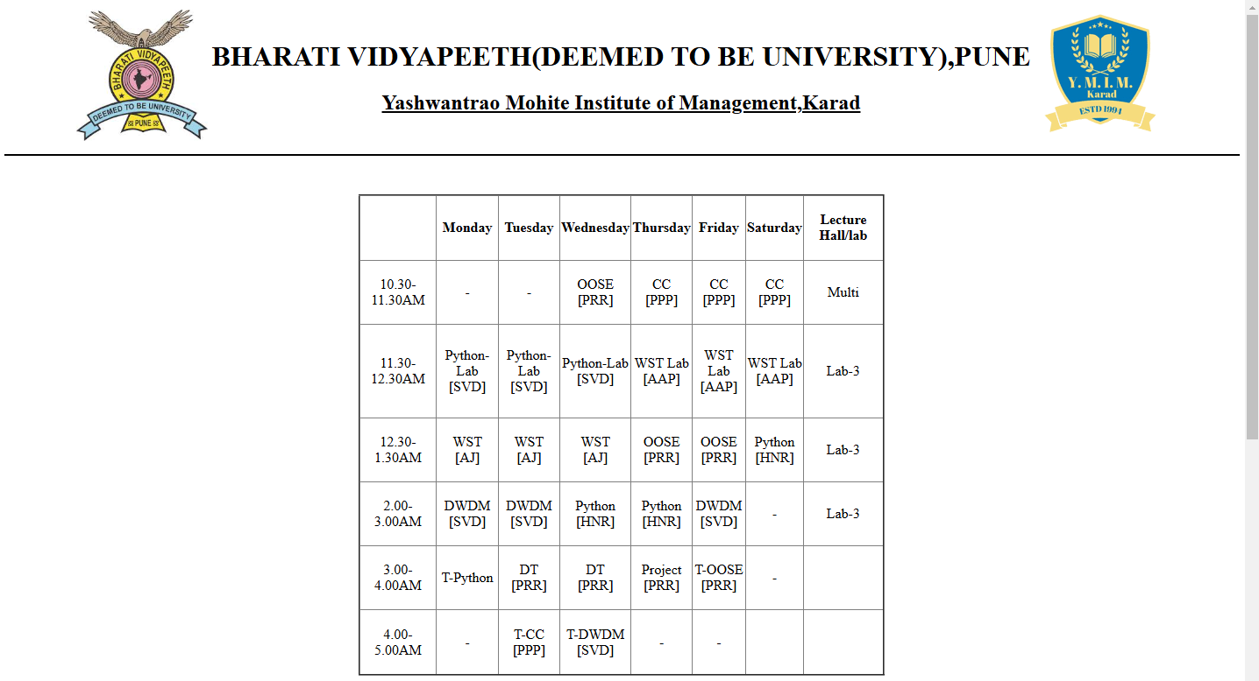

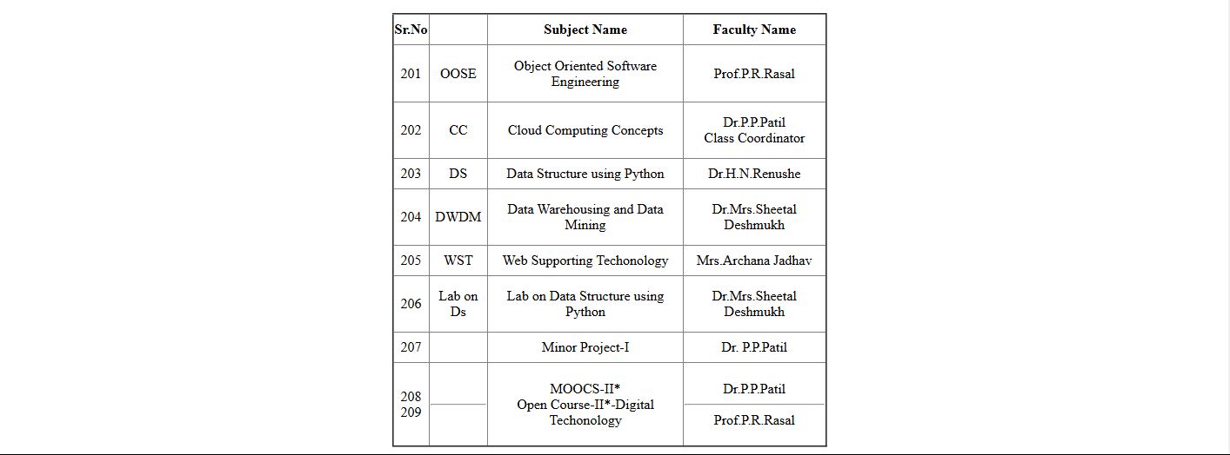

**Assignment No:3**

**Name:** Pawar Aarti Arvind

**PRN:**

**Roll No:** 45

**Class:** MCA-I (Sem II)

**<!DOCTYPE html>**

**<html lang="en">**

**<head>**

**<meta charset="UTF-8">**

**<meta name="viewport" content="width=device-width, initial-scale=1.0">**

**<title>Document</title>**

**</head>**

**<frameset cols="45%,50%,45%">**

**<frame src="frame1.html">**

**<frame src="frame2.html">**

**<frame src="frame3.html">**

**<frame>**

**</frameset>**

**</html>**

**Frame1:-**

**<!DOCTYPE html>**

**<html lang="en">**

**<head>**

**<meta charset="UTF-8">**

**<meta name="viewport" content="width=device-width, initial-scale=1.0">**

**<title>Document</title>**

**</head>**

**<body><br>**

**<h2>Burger Menu</h2></center>**

**<ul>**

**<li>Cheese Burger</li>**

**<br>**

**<li>American Burger</li>**

**<br>**

**<li>Greek Burger</li>**

**<br>**

**<li>Meat Burger</li>**

**</ul><br>**

**<h2>Sandwich Menu</h2></center>**

**<ul>**

**<li>Cheese Sandwich</li>**

**<br>**

**<li>American Sandwich</li>**

**<br>**

**<li>Greek Sandwich</li>**

**<br>**

**<li>Meat Sandwich</li>**

**</ul><br>**

**<h2>Pizza Menu</h2></center>**

**<ul>**

**<li>Cheese Pizza</li>**

**<br>**

**<li>American Pizza</li>**

**<br>**

**<li>Greek Pizza</li>**

**<br>**

**<li>Meat Pizza</li>**

**</ul>**

**</body>**

**</html>**

**Frame2:-**

**<!DOCTYPE html>**

**<html lang="en">**

**<head>**

**<meta charset="UTF-8">**

**<meta name="viewport" content="width=device-width, initial-scale=1.0">**

**<title>Document</title>**

**</head>**

**<body>**

**<img src="COLOURBOX29535510.webp" height="750px" width="530px">**

**</body>**

**</html>**

**Frame3:-**

**<!DOCTYPE html>**

**<html lang="en">**

**<head>**

**<meta charset="UTF-8">**

**<meta name="viewport" content="width=device-width, initial-scale=1.0">**

**<title>Document</title>**

**</head>**

**<body>**

**<table border="1px solic-black" style="border-collapse: collapse;" height="570px" width="500px">**

**<th>Menu</th>**

**<th>Price</th>**

**</tr>**

**<tr>**

**<td>Cheese Burger</td>**

**<td align="center">50/-</td>**

**</tr>**

**<tr>**

**<td>American Burger</td>**

**<td align="center">60/-</td>**

**</tr>**

**<tr>**

**<td>Greek Burger</td>**

**<td align="center">70/-</td>**

**</tr>**

**<tr>**

**<td>Meat Burger</td>**

**<td align="center">80/-</td>**

**</tr>**

**<tr>**

**<td>Cheese Sandwich</td>**

**<td align="center">50/-</td>**

**</tr>**

**<tr>**

**<td>American Sandwich</td>**

**<td align="center">60/-</td>**

**</tr>**

**<tr>**

**<td>Greek Sandwich</td>**

**<td align="center">70/-</td>**

**</tr>**

**<tr>**

**<td>Meat Sandwich</td>**

**<td align="center">80/-</td>**

**</tr>**

**<tr>**

**<td>Cheese Pizza</td>**

**<td align="center">50/-</td>**

**</tr>**

**<tr>**

**<td>American Pizza</td>**

**<td align="center">60/-</td>**

**</tr>**

**<tr>**

**<td>Greek Pizza</td>**

**<td align="center">70/-</td>**

**</tr>**

**<tr>**

**<td>Meat Pizza</td>**

**<td align="center">80/-</td>**

**</tr>**

**</table>**

**</body>**

**</html>**

**Output:-**

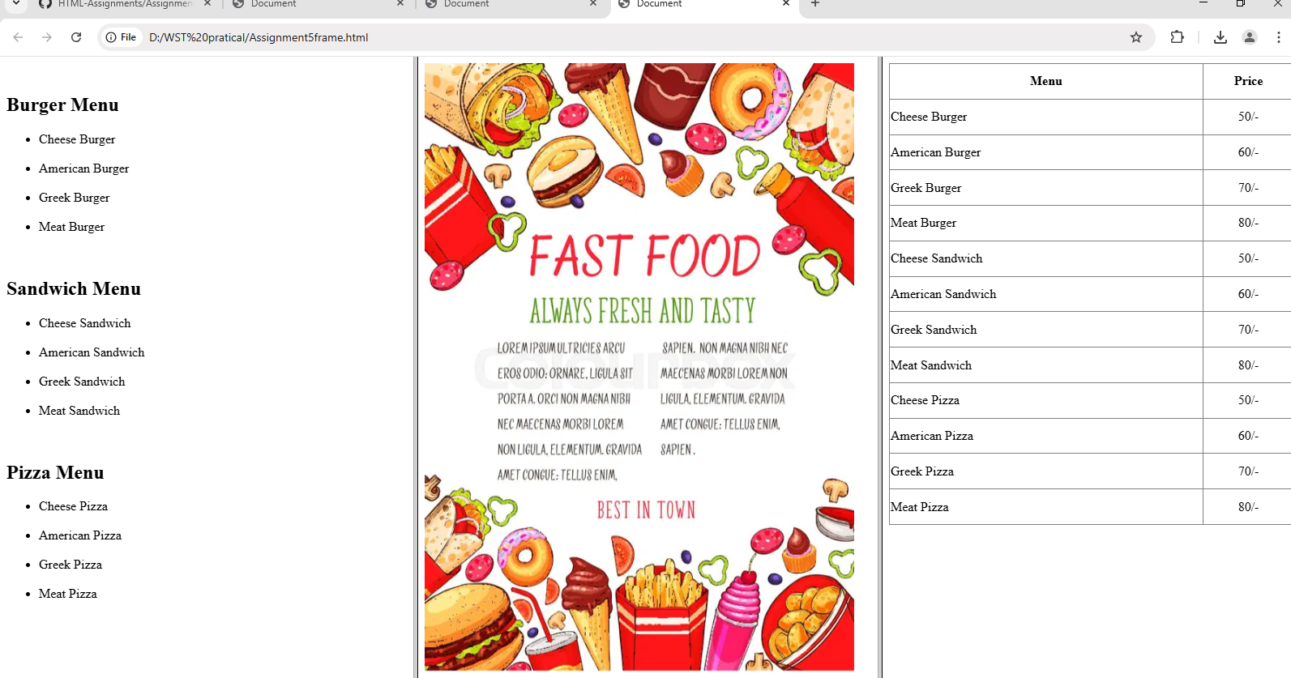

**Assignment No:4**

**Name:** Pawar Aarti Arvind

**PRN:**

**Roll No:** 45

**Class:** MCA-I (Sem II)

**<!DOCTYPE html>**

**<html lang="en">**

**<head>**

**<meta charset="UTF-8">**

**<meta name="viewport" content="width=device-width, initial-scale=1.0">**

**<title>Audio vedio tag</title>**

**</head>**

**<body color:"cyan">**

**<center>**

**<table>**

**<tr>**

**<td>**

**<img src="ulogo.jpg" height="150px" width="150px">**

**</td>**

**<td>**

**<h1><b>BHARATI VIDYAPEETH(DEEMED TO BE UNIVERSITY),PUNE</b></h1>**

**<h2 align="center"><u>Yashwantrao Mohite Institute of Management,Karad</u></h2>**

**</td>**

**<td>**

**<img src="clglogo.png" height="150px" width="150px">**

**</td>**

**</tr>**

**</table>**

**<hr style="width:100%;text-align:left;margin-left:0" color="black">**

**<br><br>**

**<video width="700" height="500" controls>**

**<source src="movie.mp4" type="video/mp4">**

**<source src="movie.ogg" type="video/ogg">**

**Your browser does not support the video tag.**

**</video><br>**

**<audio controls>**

**<source src="C:\Users\Admin\Desktop\Sakshi_Mca\horse.ogv" type="audio/ogg">**

**<source src="horse.mp3" type="audio/mpeg">**

**Your browser does not support the audio tag.**

**</audio>**

**</center>**

**</body>**

**</html>**

**Output:-**

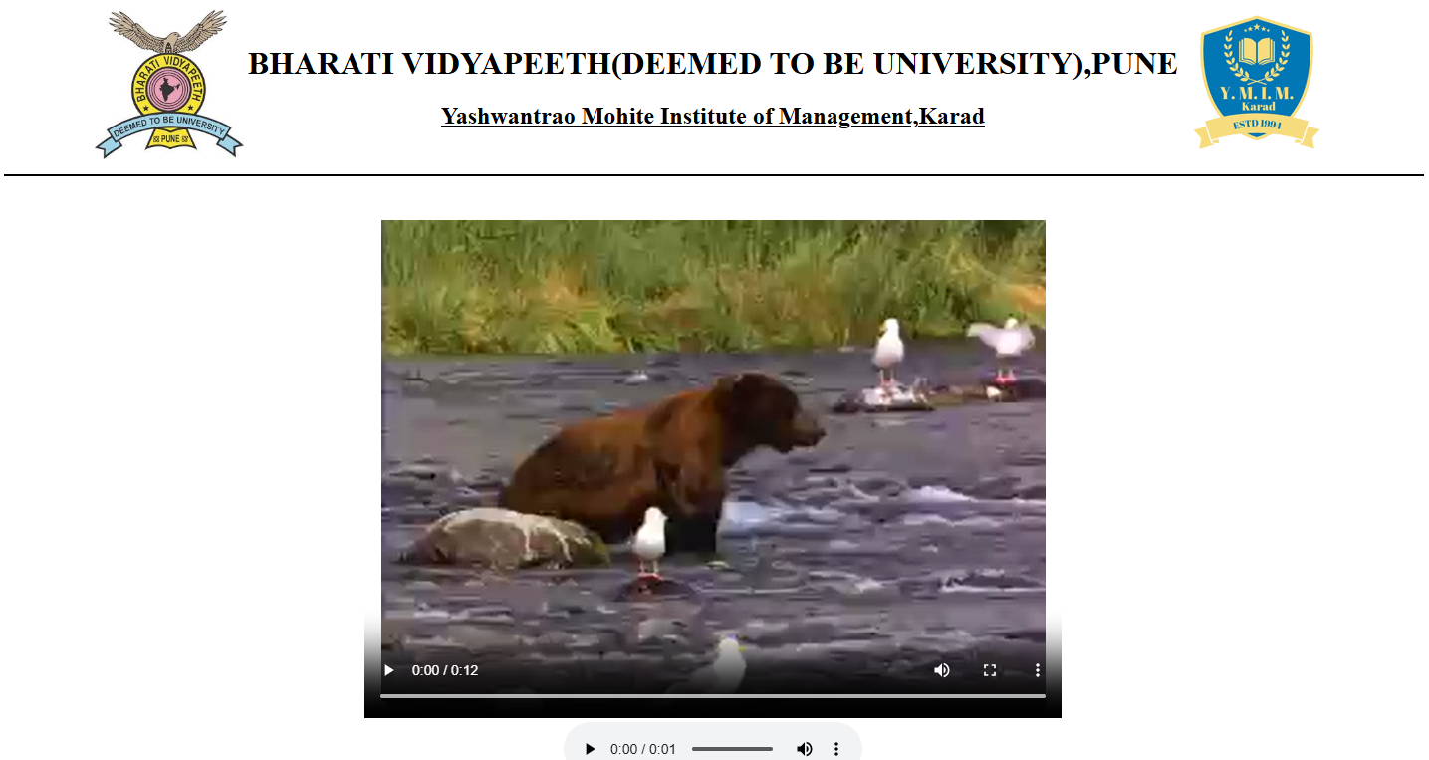

**Assignment No-5**

**Name:** Pawar Aarti Arvind

**PRN:**

**Roll No:** 45

**Class:** MCA-I (Sem II)

**<html>**

**<head>**

**<title>List</title>**

**</head>**

**<body>**

**<br><center><br>**

**<table><tr>**

**<td> <img src="images1.jfif" height="140px" style="margin-right:200px;"></td>**

**<td><h1 align="center" style="margin-right:180px;">BHARTI VIDYAPEETH DEEMED UNIVERSITY, PUNE</h1>**

**<h1 style="margin-right:150px;">YESHWNATRAO MOHITE INSTITUTE OF MANAGEMENT,</h1></center>**

**<h1 align="center" style="margin-right:150px;">KARAD</h>**

**</td>**

**<td><img src="images2.png"></td></tr></table>**

**<hr>**

**<h1>Web Supporting Technology</h1></center>**

**<br>**

**<ol type="I" start="1" style="margin-left: 150px;">**

**<li><h3>Basics of Internet</h3></li>**

**</ol>**

**<ul type="square" style="margin-left: 150px;">**

**<li>-Understanding internet & intranet, difference between internet and intranet</li>**

**<li>-Introduction to W.W.W, Concept of Client and server</li>**

**<li>-Introduction to web server and web browser,using Apache as web server</li>**

**</ul>**

**<br>**

**<ol type="I" start="2" style="margin-left: 150px;">**

**<li><h3>Introduction to HTML</h3></li>**

**</ol>**

**<ul type="square" style="margin-left: 150px;">**

**<li>-Overview of HTML,Concept of tag</li>**

**<li>-Types of HTML Tags,Structure of HTML program</li>**

**<li>-Text formatting through HTML</li>**

**</ul>**

**<br>**

**<ol type="I" start="3" style="margin-left: 150px;">**

**<li><h3>Cascading Style Sheet</h3></li>**

**</ol>**

**<ul type="square" style="margin-left: 150px;">**

**<li>-Introducing CSS, Types of Style Sheet: Inline, embedded and external Style Sheets</li>**

**<li>-Working with CSS properties</li>**

**<li>-Various types of CSS, External Style Sheets</li>**

**</ul>**

**<br>**

**<ol type="I" start="4" style="margin-left: 150px;">**

**<li><h3>Introduction to JavaScript</h3></li>**

**</ol>**

**<ul type="square" style="margin-left: 150px;">**

**<li>-Introduction to Scripting</li>**

**<li>-Overview of JavaScript and its advantages</li>**

**<li>-Client Side JavaScript,Capturing user input</li>**

**</ul>**

**<br>**

**<ol type="I" start="5" style="margin-left: 150px;">**

**<li><h3>Forms</h3></li>**

**</ol>**

**<ul type="square" style="margin-left: 150px;">**

**<li>-Intractive Web Pages and Concepts</li>**

**<li>-Difference between static and dynamic web pages</li>**

**<li>-Concept of form and how form works</li>**

**</ul>**

**<br>**

**<ol type="I" start="6" style="margin-left: 150px;">**

**<li><h3>JavaScript Events</h3></li>**

**</ol>**

**<ul type="square" style="margin-left: 150px;">**

**<li>-What is an Event? Onclick Event Type</li>**

**<li>-OnSubmit Event Type,Onmouseover Event Type and mouseout, monchange</li>**

**<li>-Concept of Cookies and sessions, when and how to use cookies and sessions</li>**

**</ul>**

**<br>**

**<ol type="I" start="7" style="margin-left: 150px;">**

**<li><h3>Introduction to PHP</h3></li>**

**</ol>**

**<ul type="square" style="margin-left: 150px;">**

**<li>-Server-side Web Scripting</li>**

**<li>-Adding PHP to HTML</li>**

**<li>-PHP Control Structure</li>**

**</ul>**

**</body>**

**</html>**

**OUTPUT:-**

