1. **CREATE table(roll_no ,name ,division,branch,city,marks)**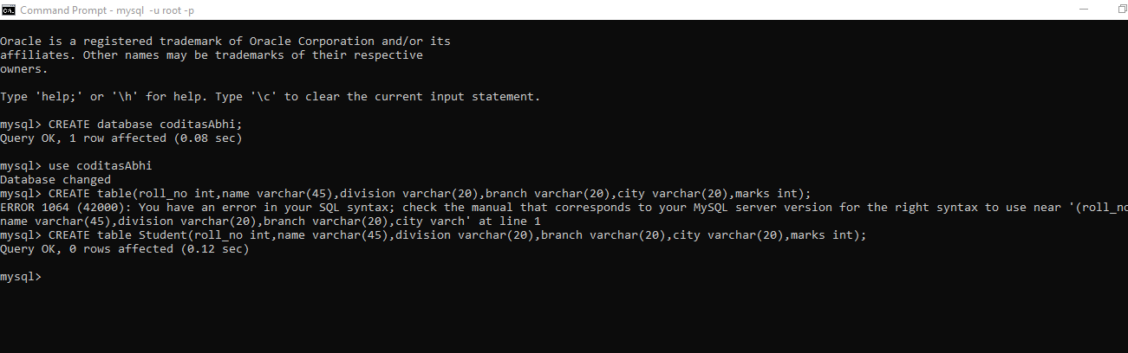

**2.)Insert 10 records to the table Student:-**

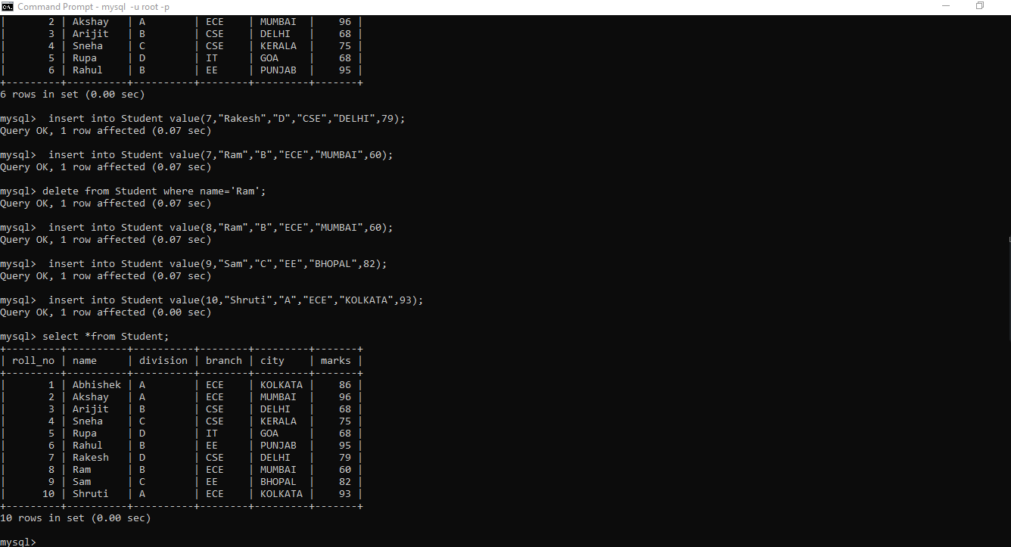

**3.List all the student name according to their corresponding city:-**

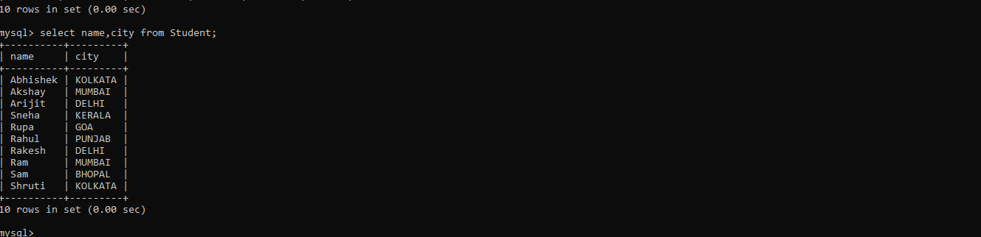

**4.)List all the distinct names of the students:-**

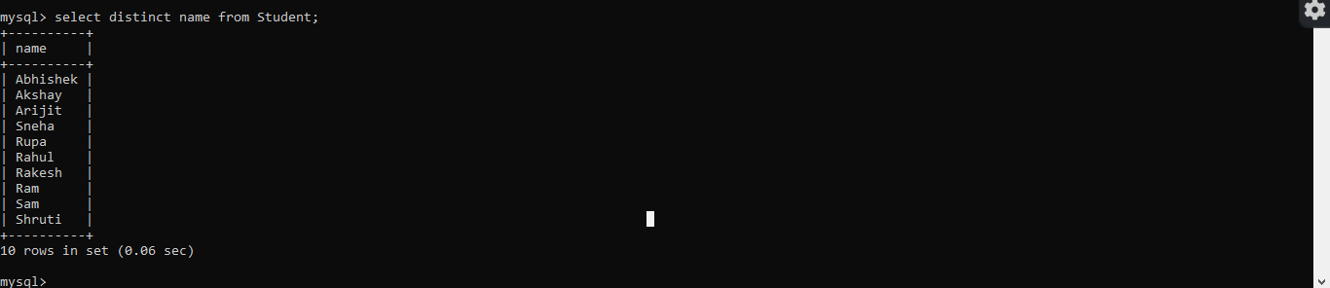

**5.)List all the records of the students with all the attributes:-**

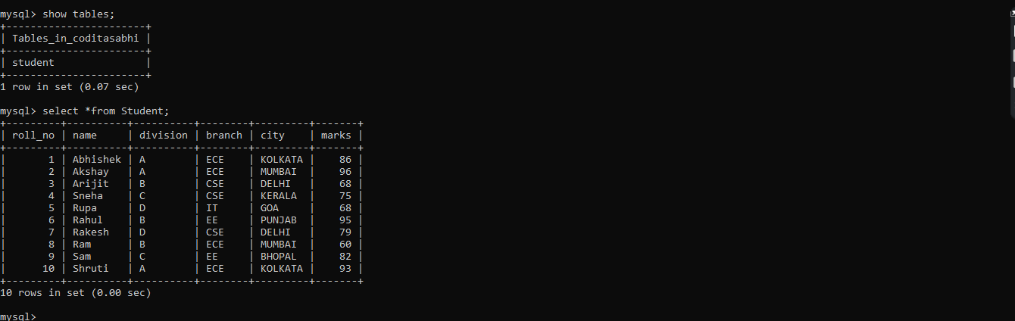

**6.)List all the students whose marks are greater than 75:-**

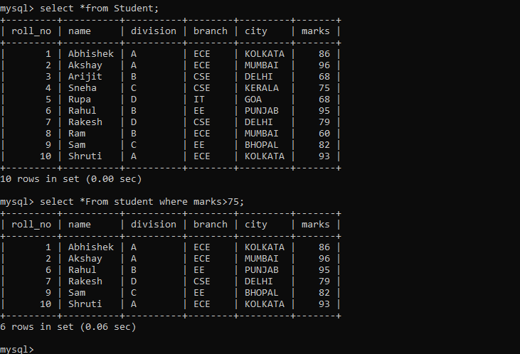

**7.)List all the students whose name starts with S:-**

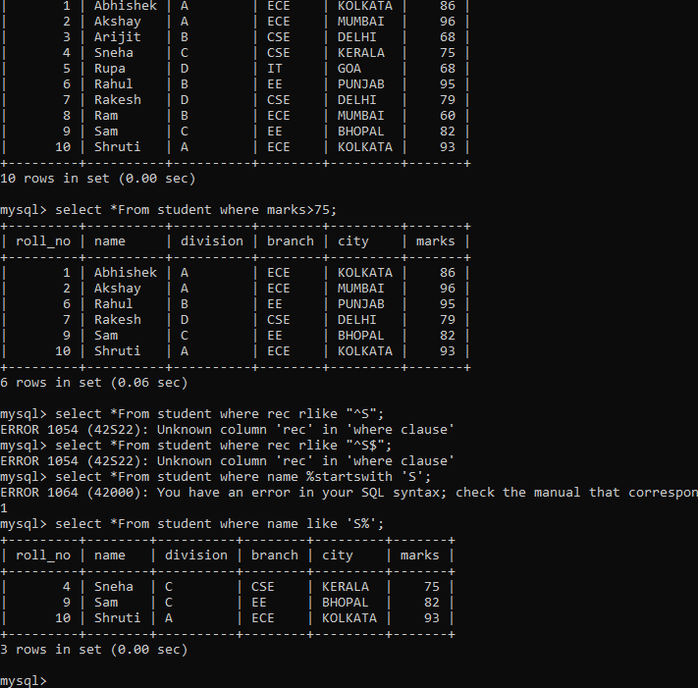

**8.)List all the students whose whose marks are in the range 50 to 70:-**

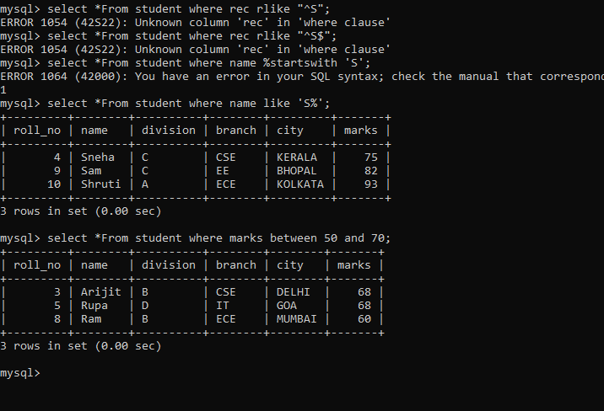

**9.)List all the students whose branch is ECE and city is MUMBAI:-**

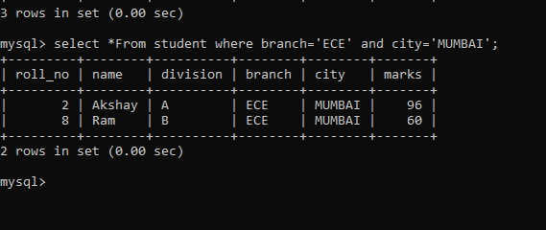

**10.)Update the branch of the student to IT whose ROLL NUMBER is 9:-**

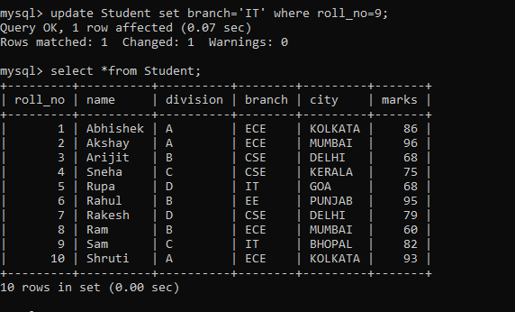

**11.)Delete the student record whose Division is D:-**

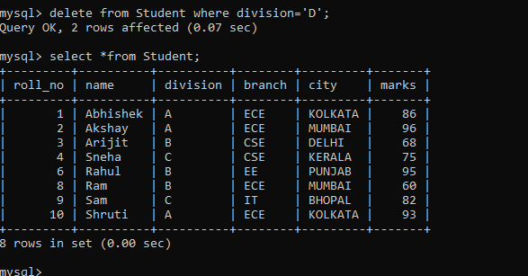

**12.)Create another table with TE_Student with schema(roll_no,name):-**

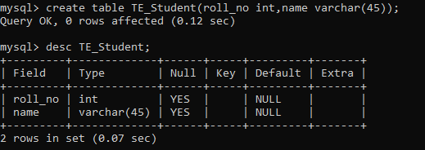

**13.)List all the roll numbers unionly in the relations Student and TE_Student:-**

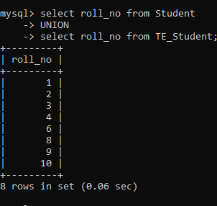

**14.) Display name of all the students belonging to relation student in Upper case:-**

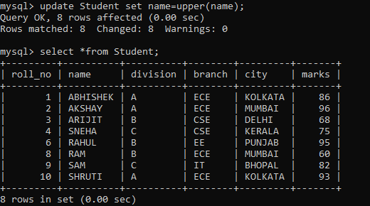

**15.)Display The binary and hexadecimal equivalent of the marks for all students belonging to student relation :-**

