**ASSIGNMENT :1 :- DAY 6 CORE JAVA**

**Q:1)Which one is platform independent and dependent among JDK,JRE and JVM?**

**ANS:1) JVM: s**tands for java virtual machine .It provides the runtime environment in which java bytecode can be executed.

**JVM is platform dependent** because for each software and hardware we have different JVM configurations.

**JRE:- (JVM +Set of libraries):** stands for Java Runtime Environment.It is the implementation of JVM.

**JRE is platform dependent as** the JRE is present inside the JVM which in turn is platform dependent.

**JDK:-(JRE+Development Tools):**stands for Java development kit.Development kit includes the debugger ,compiler and javaDoc .

**JDK is platform dependent** as the JDK includes JRE which in turn includes JVM hence we can conclude it is platform dependent.

**Q:2) Can we use or download JREdirectly without downloading JDK?**

**Ans:2)**While an employee works on some project, they need JDK for they need to write code as well as compile it. But after the development process completes, the software is ready to deliver and the client's machine will have to choose whether JDK is needed or the JRE.Preferably the clients can just install the JRE because they don't have to compile the codes.

**Q:3) Create a simple class HelloWorld and print “HelloWorld”?**

**Ans:3)**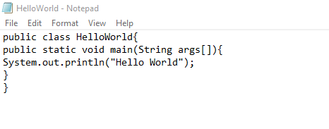

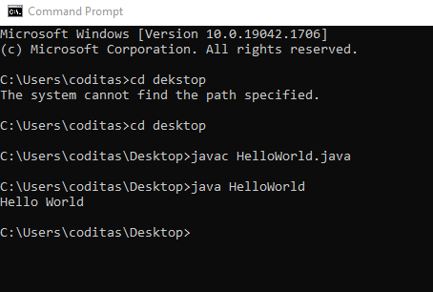

**Q:4)Use the above mentioned class and save this file as “HelloWorld_Batch2” and try to execute the code?**

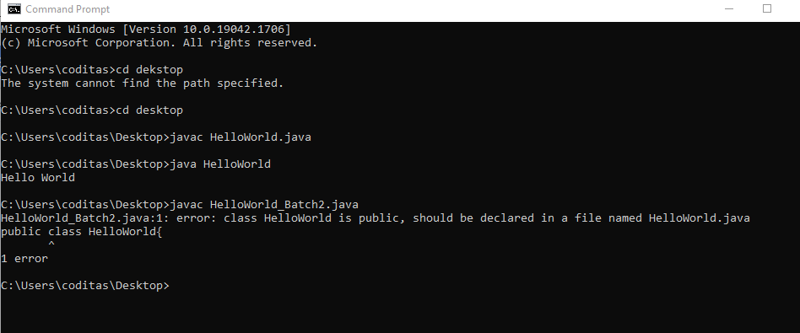

**Q:5)Create simple program Calculator?**

